CURRICULUM VITAE

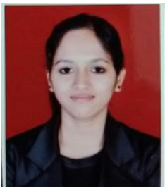

Mouthusi Sarkar

E-mail​​ id: ​​ mehekonline@gmail.com
​​​​​​​​​​​​​​​​​​​​​​​​​​​​​​​​​​​​​​​​​​​​​​​​​​​​​​​​​​​​​​​​​​​​​​​​​​​​​​​​​Contact#​​ +91-​​​9176228980, +918667826239
“Team Leader - AR Operation at Primera Medical Technology”

CAREER OBJECTIVE
Searching a position to take up creative assignments and have innovative ideas implemented in the field of medical billing, to bring about improvement at my place of work & to gain knowledge, skills & ability with a sense of professionalism to grow up with an organization that adheres to higher quality norms excellence in overall management.

WORK EXPERIENCE

Experienced Operations Team Lead with a demonstrated history of working in the US Health Industry. Skilled in Claims Resolution of ATB, Resolute Hospital Billing, Global Issues, Inventory Management, Team Management, Quality Assurance, Revenue Analysis & Business Intelligence to understand the billing trends and patterns.

FIRST ORGANIZATION

Organization : AGS Healthcare, Chennai – India
Duration : Nov’2015 to Nov’17
Designation : Sr. AR associate

PREVIOUS ORGANIZATION

Organization : 3Gen Consulting Service Pvt. Ltd, Pune – India
Duration : Dec’2017 to Apr’18
Designation : Sr. AR associate (Aligned as to Process Trainer)

CURRENT ORGANIZATION

Organization : Primera Medical Technology, Hyderabad – India
Duration : June’2018 to till date
Designation : Joined as an SME, got promoted as a Team Leader within 6months (through IJP)

MANAGEMENT SKILLS

- Possess Good Team and Client Handling skill.
- Excellent People Management, Communication Skills (both written & verbal)
- Ability to grasp, relate and quick response

Brief Profile:

- Customer Service orientated, assimilate with co-employees, potential for learning and enhancing own skill set.
- Interaction with team members (17 members) at regular intervals, share knowledge and information.
- Production Planning & Control, Process monitoring, Assignment & review of workload, analysis of SLA parameters viz. team performance and planning continuous improvement in performance, process optimization, adherence to reporting schedules and maintaining all necessary process documentation.
- Organizing and scheduling resource, providing constructive feedback to the aligned employees thru monthly One-on-One meetings and Performance Review Meetings at the regular intervals.
- Maintain EWS Tracker for the team with understanding obtained from the One-on-One conducted with the team members in order to capture the forecasted attrition
- Maintaining cordial relationship with team members in order to build a congenial work environment to reduce the stress among the team members and boost their morale.
- Commitment, Logical Thinking, Deliberate the decisions, Play a role model, grievance handling, open for suggestion.
- Always choose smart way to analyze AR Inventory or ATB in order to find out easy fix to the pending revenue collections.
- Counselling on regular basis for minimizing absenteeism and rate of attrition.
- Maintaining discipline in the production area.
- Analysis for the team members and identifying training needs for the team communication thereon.
- To follow the norms required to maintain Quality Standards.
- Introduce and refine measures supporting and enhancing quality on the production floor.
- To conduct daily team huddles.
- Proper communication within the team and escalate the related issues to the Management for timely resolution.
- Strictly adhere to the SLA/benchmark while making external communication.
- Generate daily/weekly/monthly/quarterly/annual deck for the purpose of internal and external use
- Monitoring day-to-day activities of the executives.
- Interact with Clients or to the Onshore Team for Captive Units.
- Leave management of the executives, SMEs & Co-Ordinator’s.
- Operate as a key contributor to the team to set standard and manage.
- Worked on outstanding hospital claims and followed up with federal, state & commercial payers.
- Also managed teams of RCM Business Intelligence, Billing Trends & Patterns
- Have hands-on experience in Hospital Medicare claims, worked on DDE.
- Analyzing Denial claims, eligibility validation and pre-authorization,
- Followed up with payer to check claim status, appeal status, patient eligibility etc.
- Worked on both the Front End & Backend of Appeals.
- Have knowledge on revenue code, CPT code, condition codes, occurrence code and value codes, etc.
- Well versed with UB04.
- Analyzing claims by online check, eligibility check etc.
- Reviewing EOB to analyses claims by identifying Global Causes.
- Worked majorly for high dollar accounts and old aged claims
- Preparing Paper claims, billed Electronic Claims, sent patient letter & Appeals etc.
- Have knowledge on online submission of claims through clearing house (Zirmed) & Promise portal for Medicaid claims.
- Also worked on rejected claims with rejection team.
- Resolved plenty number of global claims for coding issues.
- Analyzing and resolving denials and pending claims to reduce A/R days for cash flow.
- Have experience in Home Health Medical Billing
- Billing of Hospice, Home Health Rap & Final Claims
- Resolved by Calling & analyzing the Home Health claims with denials of Pricing Criteria, Episode timing & etc. for Medicaid.
- Providing training to the new joiners as a team trainer
- Live audits, also auditing the client returned accounts by following the project protocol
- Always highlighted the loop holes for revenue collection.
- Present Project Status in Weekly Business Review/MBR to the Higher Management

ACADEMIC PROFILE
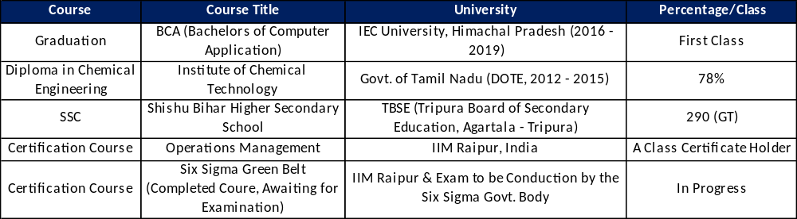

Computer Knowledge

- MS-Word
- MS-Excel
- EPIC, Medipac, HealthWyse & Meditech – Client Software’s

- AUTO​​CAD​​2011

- Micro-station​​V8i
- Basic Knowledge of Internet, Skype & Outlook.

- DDE (Direct Data Entry)
- Have clear understanding in the work cycle of clearing house (Zirmed, Relay Assurance, SSI), also able to understand and analyze the negative 277CA report, 276, 871 reports.

ACHIEVEMENTS/PROJECTS

- Got ​​Certified ​​Of ​​Appreciation from​ ​“JAGADISH ​​BOSE​ ​NATIONAL ​​TALENT ​​SEARCH ​​IN CHEMICAL​ ​SCIENCE”.​
- Appreciated from “ALL​​ INDIA​ ​CAMEL ​​COLOUR” ​​CONTEST ​​OF PAINTING, ​​RUNNING​ ​RACE ​​CHAMPION ​​IN ​​SCHOOL ​​& ​​COLLEGE ​​LEVEL ​​COMPETITIONS”.
- Achieved best performer pinnacle award for highest productivity and Quality in AGS.
- Rewarded best Performer award on Quarterly R & R – Pinnacle Award
- Worked​​ under ​​the ​​project​ ​of ​​“Vanderbilt ​​Hospital​​-​​Tennessee,​​USA​​(Hospital ​​Billing)” continuous​​ for​ ​two ​​years ​​& ​​maintained ​​the ​​consistency ​​of ​​being ​​one ​​of ​​the ​​top performer​​ in ​​the​​ organization​​ “Adroit​​ Global ​​Solution​​-​​AGS,​​Chennai”. Worked for “SpiriTrust Lutheran HomeCare & Hospice – Pennsylvania, USA (Home Health & Hospice Billing)”. Currently working for direct client from India under Captive Unit (Primera Medical Technology) of Prime Healthcare (One of the leading hospitals in US with 45 branches across the country owned by Dr. Prem Reddy)
- Certified AR Denial Management Specialist.

PERSONAL SKILLS

- Sincere, Punctual, Confidence, ​​love ​​to ​​take ​​initiative ​​and​ ​possess​ ​leadership ​​qualities.
- Hard​​ working, Quick Learner, ​Adaptable ​​and ​​having ​​pleasant ​​personality.

PERSONAL INFORMATION
Name : Mouthusi Sarkar
Father’s Name : Mr. Debasish Sarkar
Mother’s Name : Mrs. Shila Sarkar
Nationality : Indian
Language ​​Known : English, ​​Hindi, ​​Bengali,​​ Tamil
​​​ Permanent Address​ ​: ​​​Agartala, ​​Tripura
Current Address : Kondapur, Hyderabad

​​​DECLARATION
I ​​do ​​here by ​​declare ​​the​​ information ​​furnished ​​above ​​is ​​true ​​to ​​the ​​best ​​of ​​my ​​knowledge.

​​​​​​​​​​​​​​​​​​​​​​​​​​​​​​​​​​​​​​​​​​​​​​​​​​​​​​​​​​​​​​​​​​​​​​​​​​​​​​​​​​​​​​​​​​​​​​​​​​​​​​​​​​​​​​​​​​​​​​​​​​​​​​​​Date:
City: Hyderabad (​Mouthusi Sarkar​)

