KUNAL KAMBLE
Result-oriented professional, targeting senior-level assignments in Human Resources with an organization of high repute; open to work with any industry
Location Preference: Anywhere in India / Overseas
LinkedIn URL: https://www.linkedin.com/in/kunal-kamble/
kamble.kunal@outlook.com +91 9833638645


Profile Summary
Competent Professional with over 12 years of enriched experience in Human Resources with experience of Managing more than 2400 employees
Expertise in Talent Acquisition, Employee Relations, Performance Management Systems, HRIS Implementation, Organizational
Development, Learning and Development, Strategic Business Partnering, Stake Holder Management
Proven track record of driving Change Management at a large scale through community programs and promoting creativity & innovation to facilitate Culture Building
Proficiency in Merger and Acquisitions, Wages and Benefits administration, Statutory and Legal Compliance, Projects Management, Employee Engagement Survey and Compensation and Benefits
Versatile, high-energy professional, successful in achieving business growth objectives within rapid changing environment with excellent communication, people management & problem-solving skills



Career Timeline

Core Competencies
Strategic HR Management & Operations HRIS Implementation
May’10-Sep’14
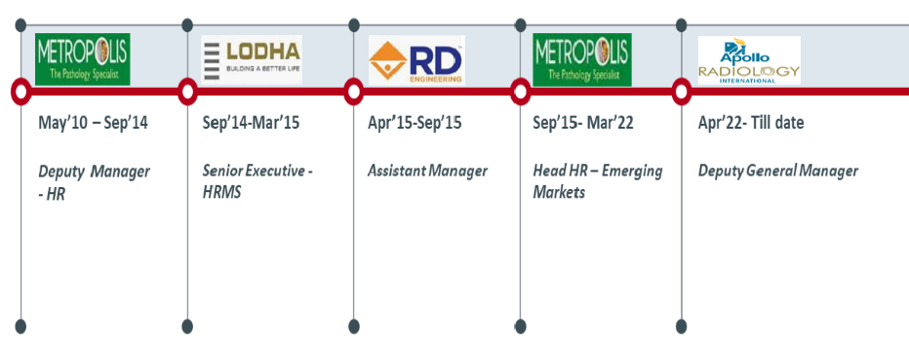 Apr’15-Aug’15
Sep’14-Mar’15 Sep’15-Mar’22
Education & Credentials
Employee Engagement & Retention Talent Survey / Grievance Management Statutory Compliance & HR Audits Stakeholder Relationship Management Workforce / Performance Management Succession Planning/ People Management Team Management

 2019
MDP on Predictive Analytics in HR by S. P. Jain Institute of Management & Research in

2009
Master of Management Studies (Human Resources) from YTIET College, Mumbai, University of Mumbai

2006
Bachelor of Science (Chemistry) from University of Mumbai, Mumbai

 Organizational Experience

Apr’22 – Till date with Apollo Radiology International Pvt. Ltd as Deputy General Manager – Human Resources
Sep’15 – Mar’22 with Metropolis Healthcare Ltd., Mumbai as Head – Human Resources (West SBU)
Apr’15 – Aug’15 with R.D. Engineering, Mumbai as Assistant Manager – Human Resources
Sep’14 – Mar’15 with Lodha Group, Mumbai as Senior Executive – HRMS
May’10 – Sep’14 with Metropolis Healthcare Ltd., Mumbai as Deputy Manager – Human Resources

Key Responsibilities:
- Leadership and Management of the human resources function, which includes Talent Acquisition, Talent Management, Compensation and Benefits, HRIS, Employee Relations and Organizational Effectiveness
- Managing the Business Partnerships of the designated Business Units; guiding and mentoring the Team
- Creating Strategic Annual Plan as per the business requirement and conducting Business Performance Reviews; Collaborating with Senior Management for Successful Manpower Planning, Resourcing and Deployment
- Strategizing and implementing the complete Performance Management System for employees across the business units; managing the appraisal process with help of team. Substantiating the PMS to linked to Rewards Management
- Strategizing the Reward and Recognition to ensure the alignment with business and to ensure business growth as per budgeted growth Identification of training needs and role-based skill mapping, as well as an analysis of existing competencies, tracking training progress, and informing management of ROI
- Prepare and implement an employee engagement plan, as well as allocate the necessary budgets.
- Provide HR counsel and advice on people-related complex issues to senior management, line managers, and functional heads.
- Prepare and analyze MIS / Statistics to understand the areas of concern and suggest the plan of action and recommendations accordingly
- Examine compensation plans to ensure that they are competitive and in line with the overall performance of the company. Spearheading day to day HR Operations like Salary and Wages Administration, Statutory and Legal Compliance to ensure minimizing the risk and suggesting the plan of action to the management as in when required
Responsible for monthly / Quarterly and Annual Audits as per the guidelines

Notable Accomplishments Across the Career

Apollo Radiology International, Hyderabad

Implemented HRIS within short span of 45 days

Implemented Statutory Compliance along with necessary Registration

Implementation of Performance Management System, RVUs

Introduced productivity analysis for key roles

Hired more than 30 Radiologists (including full-time / part-time) in span of 3 months, which helped reduced outsourced cost by 10%

Metropolis Healthcare Ltd., Mumbai
- Led a team that delivered 800 internal & external hires per year with Talent & Acquisition Team
- Worked on Future Ready Structure with one of the Big-5 Consultant and implemented the structure across the functions which in return brought Manpower Cost from 25% to 23% against revenue
- Brought HC low by 7% with implementation of Future Ready Structure
- Introduced Productivity Analysis of the Operations key roles to support Manpower hiring decisions
- Worked on change of Performance Management System from simple feedback system to Score Card approach Played a key role in restructuring compensation across all levels during the appraisal cycles from 2012 till date
- Reduced the salary discrepancy problems and issues by 10% and almost zeroed it using measures such as automation of attendance system, continuous payroll audit for locations
- Monitored and constantly reduced the costs of the recruitment process by 10% through the application of promoting referral hiring, vendor negotiations and IJPs
- Assisted the organization in 100% alignment of newly acquired / merged units with Metropolis policies, procedures and culture Played major role in restructuring the profit centers & aligning key functions to ensure proper workflow, better coordination and teamwork
- Played critical role in HRIS planning and 100% implementation

Date of Birth 31st August 1984
Languages Known English, Hindi & Marathi
Passport No. K 6540738 (Valid up to Apr’2023)
Permanent Address Room No. 7, Priyanka Darshan, Kalunagar, Opp. Shankar & Sai-baba Temple, Dombivli (West) – 421202

