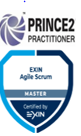
 Shembu_prabhu@yahoo.co.in
 +91- 9003208363 & +91- 9840402384
 Chennai, India
 | https://www.linkedin.com/in/shembaka-pandiyan-s-aa156156/

z
Shembaka Pandiyan. S
https://in.linkedin.com/in/shembaka-pandiyan-aa156156
https://in.linkedin.com/in/shembaka-pandiyan-aa156156

Career Objective:

To work for an Organization that provides a leading career in Delivery & Sales Operations (Revenue, P&L, Pipeline Management etc.), Program Management, to make a strong contribution to the organizational goals using my diverse skill set acquired from various roles.

Summary of Skills:

- 14+ years rich industry experience with key focus on global delivery and sales operations and project / program management – key functions will include, P&L management, budget planning, pipeline analysis, MIS & resource Ops with peak P&L size of $200 Mn & headcount of 1450+
- Hands on experience in creating and managing highly efficient and motivated small to medium size teams. Demonstrated strong analytical and problem-solving skills
- Proven ability to coordinate multiple tasks (Adhoc/routine) with cross functional teams and meet deadlines under pressure
- Excellent communication skills & demonstrated ability to understand and address the critical requirements of the leadership team

Summary of Work Experience:
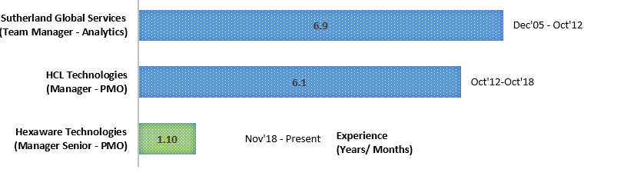
Educational Qualifications:

Qualification | Institute / University
Post Graduate Diploma in Management  (Information Systems) | Institute of Management Technology (IMT), Ghaziabad
Bachelors In Psychology (B.Sc) | University of Madras, Chennai

Computer Skills:

- Executive Development Program in Data Science and Machine Learning from IIM Raipur
- Highly proficient in MS-Office Tools (Excel, PowerPoint, MS-Word, Visio, Publisher, Project Plan).
- Certified Agile Scrum Master
- Certified Prince 2 Foundation and Practitioner
- Extensive working knowledge on ERP and CRM tools as an end user.
- Good working Knowledge on Tableau. Trained on Tableau Desktop 10.4

Hexaware Technologies & HCL Technologies
HCL Designation: Manager (Global Sales & Delivery Operations)

Hexaware Designation: Manager Senior (Global Sales & Delivery Operations)

Responsibilities: Delivery Operations (PMO)

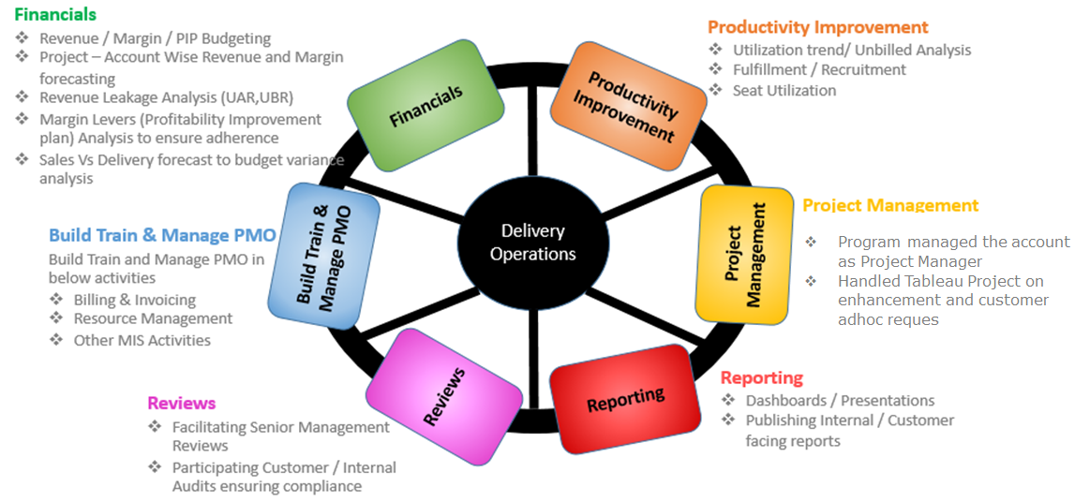
Responsibilities: Sales Operations (PMO)

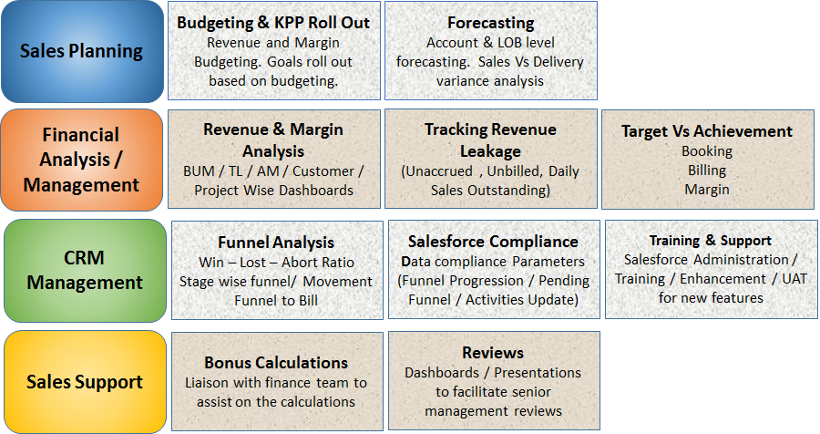

Achievements/ Learnings:
- Benchmarked Data compliance standards in the organization
- Have contributed significantly in bringing consistency and accuracy in Reporting and Analytics.
- Key Member of the Online Onboarding tool for Lifesciences Healthcare and Public Services Sales team. The success led other verticals to follow the footsteps
- Played a key role in bringing process improvements to the team’s functions, Annual Business Planning and also contributed to the SFA functional enhancement
- Successfully created PMO Functions in Hexaware and received lot of accolades from senior management
- Automated the traditional way of excel forecasting to tool based (System based input source – Resource allocation, CRM Opportunities, RR’s and Manual adjustments (Discount, License , etc)

Sutherland Global Services
Designation: Team Manager – Delivery PMO (Supporting Marquee Clients)

Responsibilities:
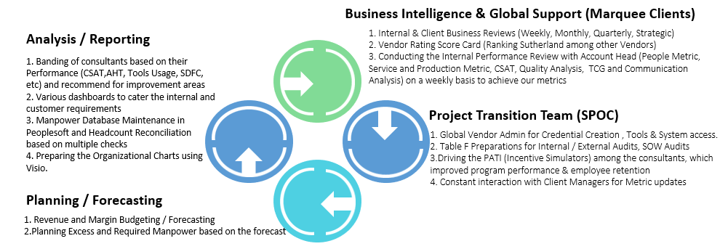
Achievements/ Learnings:
- Awarded with prestigious special performance award for the year 2008 & 2007 by Microsoft Client. Awarded with the Special Performance award for 2010
- Awarded with Bronze Belt for Execution Excellence Certification (A Sutherland Initiative to achieve Platinum Status among the competitive Vendor)
- Implemented an incentive plan “PATI” (Performance Attendance Tenure Incentive Plan) has run successfully for more than 5 years with 100% Accuracy. Based on the PATI success in Microsoft, we extended to Dell, Symantec, Hughes, AT&T
- Handling the SWAT (Strength Weakness Analysis Team) helped in achieving the program performance
- Constantly providing business inputs through advanced reporting structure for Microsoft Store, which is a Sales process. This has helped to yield positive results to great extent in terms of Sales with Good Customer satisfaction
Quality Courses / Workshops attended
- Six Sigma Green Belt (AHT Reduction, CTC) with Project Experience
- Project Management Program (PMP) Training from Knowledge Woods
- Consolidated Business Intelligence and Execution Excellence
- Sales Force and its linked programs

Personal Details:
Father’s Name : Dr. Soundararajan (Late)
Date of Birth : 30th May 1984
Marital Status : Married
Languages Known : English, Tamil, Malayalam ,Hindi & Russian
Visa : B1Visa – US (Valid Till 2024)

Senior Industry References
Available on Request

