Contact No. : | Communication Address: | Permanent Address:
+91 74900 06150  +91 97277 27471 | Flat No. – 270  Ground Floor,  Sector 51A,  Chandigarh - 160047 | Flat No. – 402  Ratnakar Enclave  Suvidha Park Society, Karelibagh  Vadodara, Gujarat – 390018

Objective

Working experience at managerial roles in Quality System Management, Audit & compliance, CAPA Implementation and Regulatory Remediation Plan. Looking for work with passion and drive to excel in quality field and continue effectively and decisively to the pharmaceutical society.

Profile Summary

- Skilled quality professional in pharmaceutical manufacturing operation with 28 years of experience and proven knowledge of quality-driven management with experience in implementation of quality management system, regulatory compliance and remediation.
- Decisive leader, pragmatic and focused in dynamic and fluid environments with proven success in implementing effective process improvements and collaboration of high-performing teams to drive measurable results.
- Currently working as Head – Site Quality (Injectable-Oncology & Oral Dosage Blocks) with Panacea biotec pharma limited, Baddi.
- Well versed in quality audits & inspections, compliance with CAPA implementation, regulatory remediation planning and execution, management review and audit of bioequivalence and clinical study audit.
- Rich exposure of representing the management in various Audits including USFDA (7 times for formulations and 3 for BA/BE, WHO (Geneva), MHRA, ANVISA, Indian FDA and ROW Audits for formulations and BA/BE.
- Drove excellence in quality system audit and compliance, procedure improvisation, deviation investigations, CAPA management, market complaint investigation, development of cleaning procedure with validation and computerized system validations.
- Worked for oral dosage form and Injectable formulations, API stability and BA/BE studies as Quality Control and Quality Assurance lead in different organizations.
- Experience of injectable products analysis and quality assurance at various organizations in formulation activity.
- Excellence in transforming quality function into a robust quality unit that delivers maximum output with right first time and driving capability improvement of processes, systems & people through implementation of quality systems.
- Monitor departmental budget, quality plans, KPI, skill development of team members for conformance to standards and customer satisfaction.
- Pursuing certification in “Lean Operation Management and Six Sigma (LOM-Six sigma)” as alumni of IIM, Rohatak.

Core Competency | Soft Skills
- Quality Strategy/ Quality Review, Audits & Compliance | - Working with quality and work ethics with integrity
- Quality Assurance & Control | - Problem solving with risk management and team building
- Risk Assessment / FMEA Analysis | - Flexibility and adaptability to demanding situations
- Cross-functional Coordination/ Stakeholder Management | - Effective communication with conflict resolution
- Process Validation/Cleaning Validation | - Open mind and learning ability
- OOS & OOT Investigation, with CAPA management
- Training & Team Management

Notable Accomplishment
- Drove strategic effort in development and harmonization of Cleaning procedure with Validation at different organizations as QA/Quality Head.
- Spearheaded the projects on GAP Assessment of quality management system, project on inspection readiness and remediation activities at IPCA, Zydus and Panacea Biotec pharma limited.
- Harmonization and implementation of quality procedures across IPCA’s Formulations Units as lead for the project. Implemented more than 40 corporate harmonized procedures throughout all formulation manufacturing locations.
- Implemented quality systems to conduct BA/BE studies for regulatory submissions and achived sucessful US FDA inspection at Alemic as Head-Quality (Analytical and Clinical function).
- Played a key role in designing and implementation of Track wise & electronic document management system software for Quality Management System at IPCA and at Zydus.
- Promoted and participated in implementation of operational excellence initiatives like product capacity enhancement “Yield Improvements” at Unichem, IPCA and Zydus cadila.
- Worked towards sucessful implementation of computerized system validation, eBMR and eLogbook.

Regulatory Inspections
- Completed US FDA inspection as Head site-QA at Panacea.
- Completed US FDA audit for 3 times as General Manager – QA at Cadila.
- Completed US FDA, MHRA, NDA-Uganda, MOH-Oman, Ukraine and audit for formulation at Unichem as a Head – site quality.
- Successfully completed US FDA audit for formulation and Bioequivalence division in Mar & May 2011 at Alembic as a role of in-charge site quality.
- Faced US FDA (2 times), Anvisa (03 times), WHO (03 times) and EU audit for BA/BE and clinical studies at GVK Biosciences as leading position in QA department.
- Active participation in ANVISA audits for formulation at IPCA Athal as In-charge quality control.
- Audits experience of TGA (01 times), WHO (03 times) and several other regulatory inspections for pharmaceutical formulations.

Current Profile

Panacea Biotec Pharma Limited, Baddi: From Jan’ 2021 till date
Designation: Sr. General Manager – Quality (Injectable-Oncology & Oral Dosage)

Nature of Job
- Responsible for quality activity (QA & QC) of oral dosage form and Oncology injectable formulations.
- Lead a team of >130 quality personnel to comply the quality system requirements towards cGMP regulations and critical activities during regulatory audits held at location.
- Leading a site team towards remediation for FDA compliance related to injectable block.
- Providing quality support to meet business need of organization and maintain the all-time readiness of site for any upcoming audits.
- Management of quality systems as per cGMP, and applicable regulatory requirements for formulations.
- Reviewing of personnel key result area / review / preparation of budgetary requirements of Quality Assurance.

Timeline and Work Profile (Recent 4)

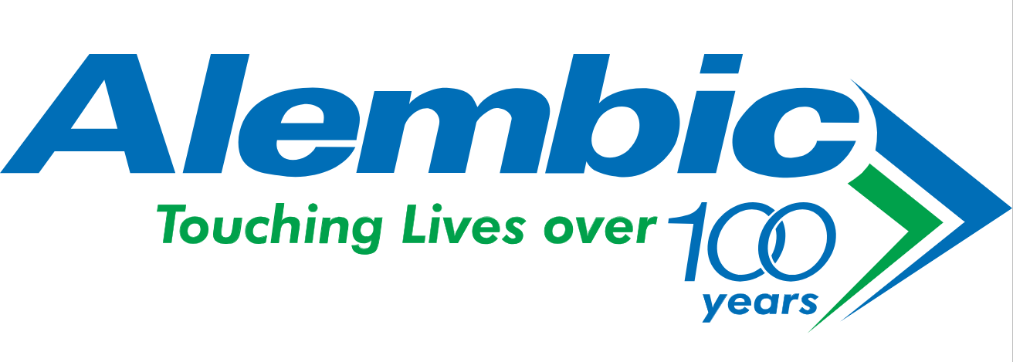 |  |  |  |  |  | 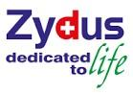
Sep’ 08 - Jan’ 12 |  | Jan'12 - Nov'14 |  | Dec'14 - Jul'16 |  | Aug’ 16 - Jan' 21

- Cadila Healthcare Limited, Ahmedabad: From Aug’ 2016 to Jan’ 2021
Designation: General Manager – Quality Assurance (OSD)

Nature of Job
- Lead a team of >120 personnel to comply the quality system requirements towards cGMP regulations and critical activities during regulatory audits held at location.
- Responsible for quality assurance activity of oral solid dosage form and in-change for non-OSD as 2nd responsibility.
- Looked after the QA of Analytical Laboratory for commercial and stability areas.
- Assigned with role of QMS harmonization.
- Responsible for implementation & gap assessments of global corporate policy related to Injectable as well as Oral solid dosages.
- Providing quality support to meet business need of organization and maintain the all-time readiness of site for any upcoming audits.
- Management of quality systems as per cGMP, and applicable regulatory requirements for formulations.
- Reviewing of personnel key result area / review / preparation of budgetary requirements of Quality Assurance.

- Ipca Laboratories Limited, Mumbai: From Dec’ 2014 to Jul’ 2016
Designation: DGM – Corporate Quality Assurance- Audit & Compliance
Nature of Job
- Responsible for audit and compliance for all formulation sites including dry powder and small volume injections.
- Responsible for all time readiness of Injectable and sold oral manufacturing sites for regulatory inspections.
- Harmonization of operating procedures as corporate standard operating procedure (CSOP).
- cGMP regulations and critical activities during US FDA, MHRA, and other audits held at location.
- Management of quality systems as per cGMP, and applicable regulatory requirements for formulations.

- Unichem Laboratories Limited, Ghaziabad: From Jan’ 2012 to Nov’ 2014
Designation: DGM – Quality
Nature of Job
- Responsible for overall quality related matters for formulation (solid orals, liquid orals, and small volume injections).
- Leading the team of 56 QA and QC personnel to comply the quality system requirements towards cGMP regulations and critical activities during US FDA, MHRA, and other audits held at location.
- Responsible for qualification of equipments related to manufacturing activity.
- Responsible for qualification of Terminal sterilized ampoule line for media fill and all equipments involved in the manufacturing including Autoclave, DHS, Tunnel, and Terminal sterilizer.

- Alembic Ltd. Vadodara: From Sep’ 2008 to Jan’ 2012
Designation: Sr. Manager – Quality Assurance
Nature of Job
- Faced MHRA and USFDA audit successfully for Formulation division as an in-charge site quality.
- Successfully conducted US FDA and ANVISA Audit for bioequivalence studies submitted from Alembic Bioequivalence center.
- Established Quality Systems for conduct of BA/BE studies for regulatory submissions and responsible for formulation QA activities as leading role.

Previous Industrial Experience
- Alembic Ltd. Vadodara: Sep’ 2008 to Jan’ 2012; Designation: Sr. Manager – Quality Assurance.
- GVK Biosciences Pvt. Ltd., Hyderabad: Dec’ 2005 to Sep’ 2008; Designation: Scientist (Quality Assurance)
- BA Research India Ltd., Ahmedabad: Dec’ 2004 to Dec’ 2005; Designation: Sr. Research Scientist-II (QA)
- Ipca Laboratories Ltd. Athal: Dec’ 2003 to Dec’ 2004; Designation: Asst. Manager Quality Control
- Aurobindo Pharma Ltd. Hyderabad: Feb’ 2003 to Dec’ 2003; Designation: Asst. Manager Quality Control
- Cadila Healthcare ltd. Ahmedabad: Dec’ 2001 to Feb’ 2003; Designation: Quality Control Executive
- Aristo Pharmaceuticals Ltd. Mandideep: Apr’ 1997 to Dec’ 2001; Designation: Quality Assurance Executive
- Berds International, Hyderabad : Jan’ 1995 to Apr’ 1997; Designation: Quality Control In-charge

PERSONAL DETAILS

Name : SANJAY KUMAR
Date of Birth : 03-04-1966.
Sex : Male.
Marital Status : Married.
Nationality : Indian.
Contact Number : +91 74900 06150, +91 97277 27471
Languages Known : English and Hindi.

Current CTC: ~ 55 L/Annum

EDUCATIONAL QUALIFICATION

- Masters Degree in Chemistry, (M. Sc.), with an aggregate of 63%, from Bihar University Muzaffarpur (Year: 1989)
- Bachelors Degree in Science, (Chemistry Hons.), with an aggregate of 57%, from Bihar University Muzaffarpur (Year: 1986)
- H.S.C (+2) with an aggregate of 57%, from Bihar Intermediate Education Council, Patna (Year: 1983)
- S.S.C (10) with an aggregate of 67%, from B S E B, Patna (Year: 1981)

DECLARATION

I hereby declare that the above written particulars are true to the best of my knowledge and belief.
Sanjay Kumar

