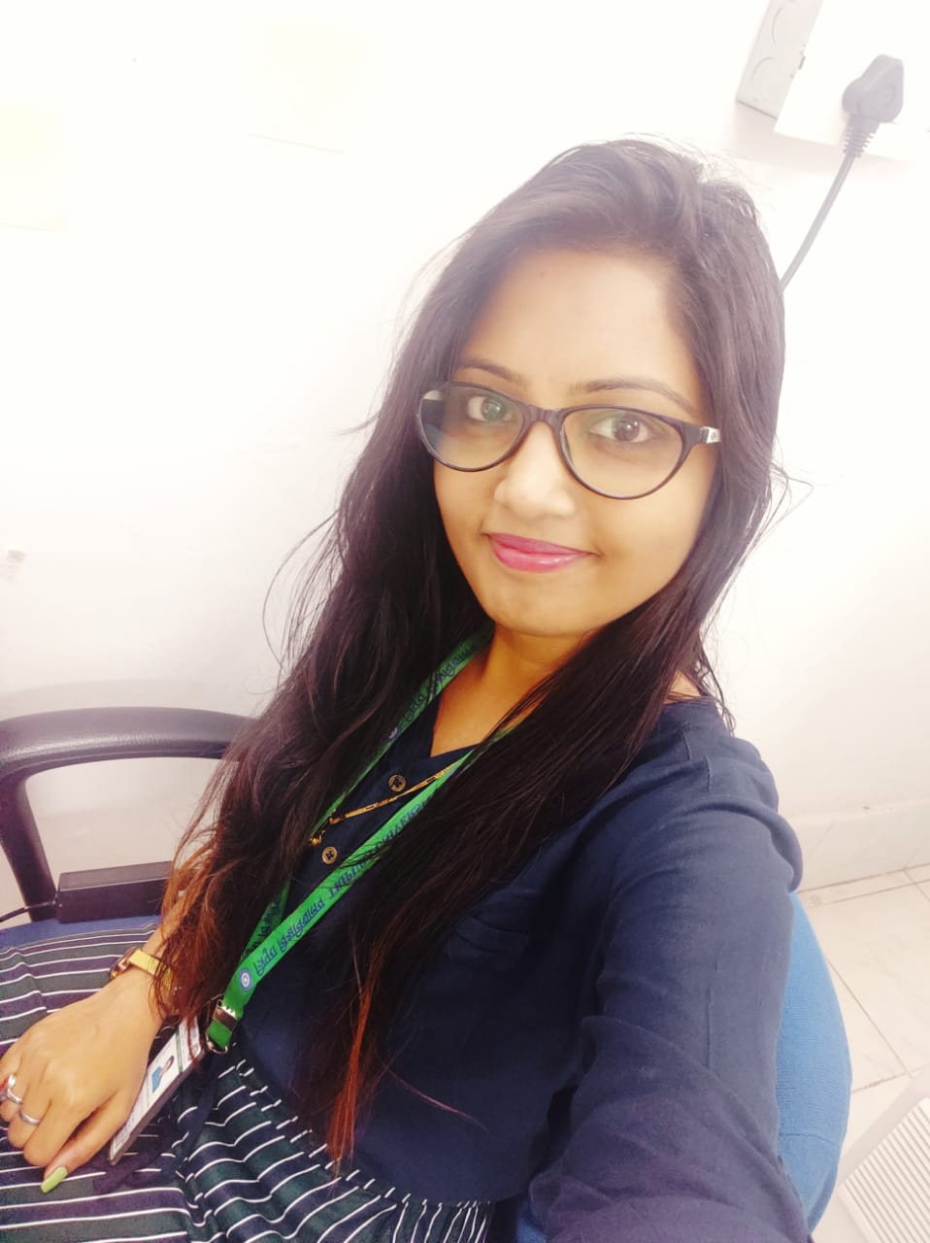 |  | priyambada  PRAKASH  Chemical & Polymer Engineer  Profile  A highly motivated, productive, reliable, efficient and responsible recent master student in Chemical and Polymer Engineering (Agartala), B. Tech in Chemical Engineering scoring 80% (Chennai) with over three years of experience in government core industry (Ordnance factory) as well as in private sales companies, dedicated lab work individual with flawless preparation of presentation research reports.  Seeking position as chemical Engineer with reputable company in which I can enhance my skills and knowledge and company growth.
CONTACT:  MOBILE NO- 9678824322  EMAIL: priyambadaprakash1990@gmail.com  Nationality- Indian  Marital status – unmarried  Date of birth- 20/02/1990 |  | EDUCATION  [TRIPURA UNIVERSITY]  [2018-2020]  M.TECH in Chemical and Polymer Engineering  Class topper with maintained SGPA of 9.67  Bagged certificates as active participants of few seminars and other activities.  Scored 86%  RESEARCH-  I have done my Master’s research on the “Synthesis and characterization of superabsorbent cellulose-based hydrogel for agriculture application”. In this study, we developed cellulose-based hydrogels which swells and releases water to agricultural plants to improve availability of water during cultivation in arid and semi-arid areas with maximum water retention capacity.  We have also published our paper in well-known publisher “WILEY”.  [SATHYABAMA UNIVERSITY]  [2008-2012]  B.E in Chemical Engineering  Scored 80%  Bagged certificates as subject topper, dancing participant as well as volunteer in college FEMFESTs.  RESEARCH-  PROJECT TITLE: “DESIGN OF CHILLER FOR THE PRESERVATION OF RAW SKIN(GOAT)” with the help of solar panels  Duration: 6 months  Description: Have done the collection of raw skin to preserve at three different temperatures in the chiller and operate the chiller with Ac and Dc at all three temperatures which is 2°, 3° and 4 degree and in result we found at 4-degree (DC) heat loss is less.  [NALANDA MAHILA COLLEGE]  2006  12th [H.S.C]  Scored 56%  [S.S GIRLS HIGH SCHOOL]  2004  Scored 62.5%  WORK EXPERIENCE  [BIONICS ENVIRO PVT. LTD , SALES EXECUTIVE]  [SEP 2023 TO JAN 2024]  - Answer the queries of customers  - Take requirements  - Suggest them according to their need  - Send them quotation  - Follow up  - Take the order and forward to senior  [SETTLIN, BUYERS ,CONSULTANT]  [JUNE 2023 to Aug 2023]  - Answer the queries of customers.  - Taking their requirements  - Suggest as per their need  - Follow up  - Scheduling the visits and fixing meetings.  [VISVAK ENGINEERS PVT LTD., BUSSINESS DEVELOPMENT MANAGER]  [ Nov 2022 to March 2023]  - Answer the queries of customers.  - Suggest them product as per their requirements.  - Selection of final products.  - Sending quotation.  - Follow up the customers on daily basis.  - Documentation.  [YAMUNA INDUSTRIES LTD., PRODUCTION, PLANNING AND RESEARCH ENGINEER]  [Sep 2020 To April 2022]  - Planning smooth production.  - Managed Production Planning strategy (raw materials requirements according to customer demand, cost analysis, capital requirement).  - Focused on Cost effective and efficient methods.  - Planning of number of Manpower’s required and assigned individual’s work.  - Coordinated with all the workers, supervisors, manager, accountants, venders and other related staffs.  - Ensured quality control standards are maintained.  - Managed multi productions at various stages of production.  - Strong schedule maintenance experience with strict follow ups with all the related staffs of project to deliver the final product on or before the committed time.  - Proactively emphasized on quality check of the final product, analyzed problems and advised multiple groups on area of improvements.  - Raw material requirement management, to guide the supervisors and follow up with them as well as marketing team.  - Quality check of the final product before delivering as per customer requirement.  - Research and synthesis of cost effective and environment friendly materials  [WAY2WEALTH PRIVATE, LTD. KOLKATA]  [July 2016- OCT 2017]  - To coordinate between Banks and company as well as Franchises.  - Follow-up the entire process starting from documentation till disbursement.  - Weekly and monthly MIS update.  [SAI ROOF REAL ESTATE, KOLKATA]  [CUSTOMER RELATIONSHIP EXECUTIVE]  [ AUGUST 2014 – JUNE 2016]  - Customer interaction  - Generating the leads  - Sending quotations  - Fixing the appointments  [ORDNANACE FACTORY, NAGPUR]  [GRADUATE APPRENTICE]  [Sep 2013- May 2014]  - Graduate apprentice trainee  SKILLS
- Skilled in polymer synthesis & characterization.
- Experience in cellulose synthesis for development of super absorbents polymers.
- A basic knowledge of ASPHEN software.
- Can work under pressure.
- Good in team handling.
- Production, planning and scheduling with leadership quality.
- Maintenance planning (cost reduction).
- Skilled in presentation preparation, report writing and computer software.
- Excellent organizing, planning and negotiating skills.
- Aggressive approach towards work to complete it before time limit.
- Hard working, reliable and honest.

CERTIFICATION

Doing an online certification course on ‘Soil and Erosion” by
NPTEL.

DECLARATION

I hereby declare that all the above information is true to the best of
my knowledge.

Priyambada Prakash

