Ganpat Swarup Pathak
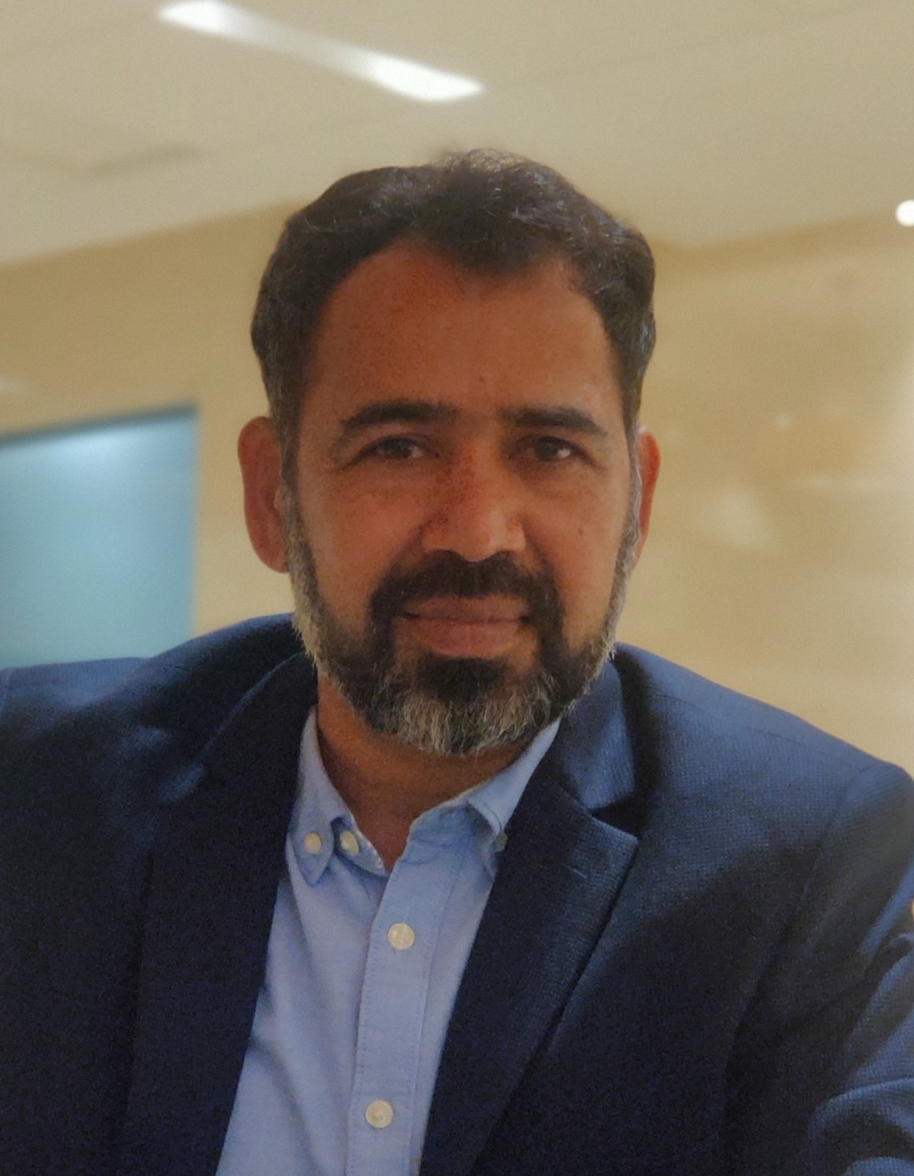
Educator, Author and Theatre Director

BL-4, The Scindia School campus,
Fort Gwalior-474008, MP, India
Mobile: 7024360830, 9303100933
E-mail: pganpatswarup@gmail.com
Blog: www.vichaar-meemaansaa.blogspot.com

“My objective is to become an Educational Leader to provide an environment to nurture all those who aspire to achieve the highest levels of distinction in academic and personal growth by making learning an enjoyable and life-long experience.”
- Develop trusting relationships that encourage learning and risk-taking for students to reach their full academic, emotional, and social potential.
- Encourage collective value and mutual bond among colleagues and ensure alignment to the organizational mission and vision, and consistency in efforts to achieve.
- Committed to develop and enhance systems, procedures, and protocols.

Academic & Professional Qualification:
- Enrolled for Advanced Leadership and Change Management Certificate program from IIM-Vishakhapatnam.
- Teachers Professional Development-2020 (80 hours) by Full Sail University, USA
- Webinar-DRAMA in EDUCATION- A Curtain Raiser, by TRINITY COLLEGE LONDON
- Online Diploma in Teachers’ Training, Cambridge University, UK [2006]
- B. Ed. from Career College, Bhopal. [2001]
- M. A. in Hindi Literature from Hamidia College, Bhopal. [2000]
- B. A. from Govt. Swami Vivekaananda College, Raisen. [1996]
- Basic Teachers’ Training Certificate from DIET Raisen [MP] [1992-94]
- Higher Secondary from Govt. Higher Secondary School, Raisen, MP [1992]
- Basic training course in Screenplay Writing from FTII, Pune during pandemic.
- MA-Theatre Art (Undone) from Atal Bihari Hindi Vishwa Vidyalaya, Bhopal
- “Round Square Leaders Training Workshop” by Liz Grey, International Co-Ordinator for Round Square Social Service Projects. [17 and 18 of September at Dheerubhai Ambani International School, Mumbai}

Teaching & Administrative Experience: 30+ Years
- The Scindia School, fort Gwalior, CBSE [ Since 25 June, 2018]
- PGT-Hindi and board examiner. Master in charge of Cricket Set.
- Master in charge of Hindi Anchoring for 125th Founder’s Day, CG, PM Modi
- Editor-in-Chief, Hindi Annual Literary Magazine. “UPLABDHI”
- Resident Tutor (Assistant House Master) in Jeevaji House (from 2018 to 2024)
- Teacher in charge of Hindi Dramatic Society and Annual Hindi Play.
- Coordinator & Anchoring Master in charge for Kavi Sammelan, Teachers’ Programme, cultural/special events.

- The Sanskaar Valley School, Bhopal, ICSE, IGCSE [15 March 2008 to 3 April 2018]
- Senior Hindi Teacher and Staff Rep.
- Language Teacher for Cambridge Classes.
- Project Head for Round Square International Social Service Project-2012.
- Teacher Escort for Round Square-Service Projects, such as Doon School, Dheerubhai Ambani International School and Rajkumar College.
- Created original Hindi Quiz- Koun Banega Sirmour in 2016
- Resource person for Theatre classes in SUPW and Street Plays during founder’s Day.
- Coordinator of Theatre excursions. Boarding students used to visit Bharat Bhavan to have experience of watching national/international plays.
- Master in charge of Videography and Photography.
- Delhi Public School, Panipat City, CBSE [28 June 2007 to 04 March 2008]
- Trained Graduate Teacher- Hindi & Sanskrit.
- Worked as House Master for senior wing.
- Created a special learning material for teaching Hindi for South Korean students.
- S. N. Kansagra School, Rajkot, ICSE, IGCSE [02 June 2005 to 06 July 2007]
- TGT-Hindi, [IX-X & VIII]
- Attended afternoon English classes by Mala Ma’am for improving English.
- Attended “7 habits of highly effective people” workshop and practiced the leadership.
- Attended Online Diploma in Teachers’ Training, (DTT) Cambridge University, UK [2006] Learned to create effective and detailed Lesson Plan in due course.
- Learned to prepare Power Point Presentation.
- Prepared and presented many plays with students and teachers.
- Compeer the mega dance show of Avani Shah an assistant artist to Farah Khan.
- Videography and Photography: covered many events like bird watching camp.

- Delhi Public School, Chittorgarh [30 June 2003 to 31 May 2005]
- PRT-Hindi [Classes-VI to VIII]
- Taught Hindi to Korean students.
- Learned to work in WORD to prepare Question Paper and Assignments.
- Play “Shastra Dekho Shastra” stood first in Birala Schools’ Samaagam–2004.

- Delhi Public School, Bhopal [03 April 2001 to 28 June 2003]
- PRT-Hindi, [Classes-VI to VIII] House Mentor for the students of Kachnar House.
- Founding in charge along with Ms Nishtha Kapoor to establish DPS Shiksha Kendra under the valuable direction of Principal Mrs. Meeta Mazumdar and Pro Vice Chairman Mr. Hari Mohan Gupt.
- Theatre Master in Charge for SUPW.
- Written and directed a play “Ateet Ki Smriti….” in its first founder’s day
- Founded a ’theatre group-THE THROB and organized performance in Bharat Bhavan, consecutive years, 2002 and 2003.

- Bal Bharati Public School, Bhopal [30 July 1998 to 31 March 2001]
- TGT-Hindi [Taught IV to XI] Mentor for Guru Nanak House.
- Dramatics in SUPW and Stationary-Store in charge
- Directed many plays for Annual Function and other special occasions.
- Learned leadership qualities and school administration from Mr. K. B. Kain, the founder principal.

- Saraswati Vidyaa Mandir, Raisen [04 August 1994 to 15 October 1997]
- Assistant Teacher-Hindi and Social Studies. [Classes-X, IX, VIII]
- Taught English for classes 3rd and 10th.
- Examination in charge for District Board Exams for 5th class.
- Morning Prayer in charge.
- Written and prepared many plays for Annual Function and special occasions.
.
Computer Proficiency:
- OFFICE 365, Basic Video editing work in Premiere and other online platforms like ADOBE.
- Quick Assessment through Quizzes, Teams, Zoom, Edmodo, Kahoot.
- Expertise in Power Point Presentation and video presentation.
- Poster and Brochure designing in CANVA, online software.
- Hindi Typing, online and offline both.
- Use of CHAT-GPT or similar apps for enhancement of the class-content.

Workshops/Seminars/Courses:
- Attended webinar-DRAMA in EDUCATION- A Curtain Raiser, by TRINITY COLLEGE LONDON, July 2020
- Attended 2-week online course in “Screen Play Writing” by FTII-Pune
- “Round Square Leaders Training Workshop” by Liz Grey, International Co-Ordinator for Round Square Social Service Projects. [17 and 18 of September at Dheerubhai Ambani International School, Mumbai}
- “Bhasha ki padhaayee mein Sahitya” by famous Author Prof. Krishn Kumar, New Delhi.
- Workshop on “Hindi Bhasha shikshan ki samasyaayein” By famous writer, editor and educationist Dr. Pradeep Kumar Jain organized by MADHUBAN [25 August 2012].
- “VAANI CERTIFICATE COURSE” Certified by All India Radio, New Delhi.
- “The 7 Habits of Highly Effective People” By Mr. Nikunj Punjani from 15 to 18 May 2005 at Rajkot.
- “Natya Lekhan Shivir” Under the direction of renowned theatre personality Padm-Vibhushan Shri Habib Tanveer Organized by N S D, New Delhi.
- “Hindi Bhasha ki dashaa evam dishaa aur uska aadhyaapan” By famous writer, editor and educationist Shrimati Sanyuktaa Ludara organized by MADHUBAN [09 April 2005].
- Participation in ROUND SQUARE Service project at The Doon School, Dehradun (4 to 14 June 2011)
- Participation in ROUND SQUARE Service project at Dheerubhai Ambani International School. (18 December to 23 December 2011)
- Some other workshops/Certification were: Del Carnegie, Cambridge Curriculum, Heartfulness, Adolescence, POCSO ACT, Microsoft Educator, Digital Citizenship etc.

As an Author:
- Wrote a grand historical play “SA VRAA” published by Kitab Mahal, New Delhi.
- Chaanv Bargad Ki a Poetry Book by Manjul Publication, Bhopal.
- Wrote many Nukkad Natak and plays. Screen Plays and stories.
- Play “Vikram aur Vaitaal” published by Abhivyakti Rajya Sansadhan Kendra, Bhopal.
- Published many poems and write-ups in famous Hindi daily newspapers like Dainik Bhaskar, Dainik Jagran, Sandhya Prakash, Deshbandhu etc.

As an Actor and Director:
- In 2002 and 2003, performed at Abhimanch, National School of Drama, New Delhi in BHARANGAM.
- “Apani-Apani Mati, Apani-Apani Gati” based on Premchand’s Stories staged in Bharat Bhavan on 9/11/16. https://www.youtube.com/watch?v=B2OQsWwS1Kg
- “Shastra Dekho Shastra” and “Girgit” has been staged in BHARAT BHAVAN
- “Charan Daas Chor” in 2004 in Utsav Club Adityapuram.
- Oedipus in Phoenician Women, Subhas Chandra Bose and Ramkrishn Paramhans in Vande Mataram, Hayawadan in Hayawadan, Prof. N. P, Tiwari in Wardi Wale, Shri Krrishn in Janmejay ka Nagyagya, Hira Kaka in Mahabhoj, Zaheer in Chhoti Dhyodhiwaliyan, Jailer in Vladimir ka Hero.
- Performed some significance role in tv serials, short movies and films.
- Worked under renown actors and directors like Habib Tanvir, Gold medalist Alok Chatterjee, Lokendra Trivedi, Ashok Bulani, K. G. Trivedi, Manoj Nayar, Sarfaraz Hasan, Parzania fame Rahul Dholakiya, Welcome to Sajjanpur fame script writer Ashok Mishra and Ravi William.

References:
- Dr. Madhav Deo Saraswat, Academician/Advisor/Educational Consultant, former Principal Good Shepherd International School. Contact: 9425705707
- Mr. Dheerendra Singh, Principal, Birla School, Pilani, Rajasthan. Contact: 9575151985
- Dr. Mukta Sharma, Vice Principal, DPS Bhopal. Contact: 9977014399
- Mr. Sangeet Khandait, my student, Strategy and consulting Manager at Accenture Song. Contact: 9742559569
- Dr. Rritu Dua, a parent, Gynecologist. Contact: 9455740734

Personal Details:
- Date of Birth: May 23, 1974 PASSPORT: V9023860
- Marital Status: Married to Ms. Pallawi Swarup Pathak (Home Care)
- Children: Krrishn. Lee. (Perusing BA (English-Honors from Miranda House, Delhi University) Prrithvee (Class XI-Science from The Scindia School, fort Gwalior)
- My father: Shri Deep Chand Pathak, Retired Head Master. My Mother: Smt. Leela Devi, a great teacher of my life.
- Reference Links: (1) https://amzn.in/d/dMCxVwk
- (2) https://rekhtabooks.com/products/chhanv-bargad-ki?srsltid=AfmBOorV9RO0OnzvNrnhBr3rQo9_1_4k3tCG9-Yjhyl_WeUHUzLUeAzz
- (3) https://youtu.be/2qr56ig6BqA?si=5yZIWg68WEYKQgXa

