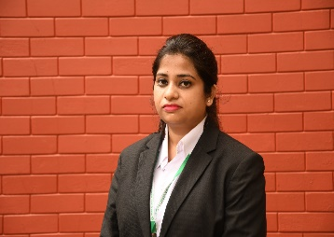

Curriculum Vitae

ANAMIKA KUMARI Email:kumarianamika2510@gmail.com
Mobile: +91-7903283147

. Seeking a challenging environment, that encourages continuous learning and creativity that will provide exposure to new ideas and stimulate personal and professional growth

ORGANIZATION | DESIGNATION | EXPERIENCE
IDBI BANK Pvt Ltd | Assistant Manager | February 2022 – Present Date
Planetspark | Product Manager | August-December 2022

WORK EXPERIENCE

IDBI BANK

Role: Assistant Manager

Responsibilities:

  - Ensure sourcing of business through different channels.
  - Appointment , Training and driving of DSA and DST.
  - Making log and credit the file and other relevant data entry in ALPS.
  - Maintain List of Approved Projects and monitor the progress as well exposure.
  - Design and development of Product. Policy and Processes for secured business-Lap, HL
  - Handling Team of 10 peoples
  - Create presentation on industry trends
  - Work with other company departments to improve the analysis and presentation of Products.

PLANETSPARK:
Role: Product manager
- Responsibilities :-
- Evaluate the company products and compare them against industry trends.
- Develop an understanding of company products to meet the company current and future needs.
- Assist the company in achieving short and long-term goals relating to product growth.
- Work with other company departments to improve the analysis and presentation of products.
- Analyze metrics to continually improve company products.

EDUCATION
IIM VISAKHAPATNAM
Executive certificate Program in Business Analytics and Data-Driven Decision Making.

Master of Business Administration (MBA)

KIIT School of Management (KSOM),Bhubneswar
2019-2021(7.3 CGPA)- Analytics and Marketing

Bachelor of Business Management(BBM),Commerce
Anugrah Memorial college ,Gaya ,Bihar
2015-2018(65.5%)

Seniour secondary (12th,CBSE),Science
AL-Momin International School ,Gaya,Bihar
2013-2015(62.2%)

Secondary/10th CBSE
Pragya Bharti Public School ,Gaya ,Bihar,(8 CGPA)

SKILLS
- MS Excel, Google analytic certified by google, Marketing research &Market Trends .Product management certificate certified by Google
- MS Power point, MS word, SWOT analysis, Interpersonal skill.
- SQL, Presentation, Training & Mentoring, Team Leadership
- Data visualization tools, Tableaue , Presentation, Customer & data analysis.

Language
English and Hindi

