RICE Prioritization
Gut feelings, lack of relevant data, emotional decision-making and the loudest person in the room—these are some of the challenges when it comes to prioritization. What can a PM do to bring more grounded information into this process?
You have your one true metric or goal, then multiple ideas you think could help you achieve it. Frameworks like the RICE method can help you quantify those big ideas using calculations that give you a way to push back on stakeholder gut feelings in a more reasonable and structured way.
In this post, we’ll walk you through everything you need to know to get started with RICE scoring. We talked to Sean McBride, who co-developed RICE prioritization as a PM at Intercom and wrote the original article). Currently, Sean works at Range, a team success platform that helps teams stay in sync, focus on what matters, and get more done.
What’s a RICE score? Where did it come from?
RICE—which stands for Reach, Impact, Confidence and Effort—is a simple prioritization framework for quantifying the potential value of features, project ideas and initiatives. A RICE score helps product managers quantify the estimated value of a feature or project idea so they’re easier to sort when it’s time to decide the order they should be worked on.
The formula looks like this:

Product managers have a hundred different initiatives they can work on at any given time. The main issue of prioritization comes down to knowing what to work on first. An easy framework like RICE can standardize this process for product managers.
Like all ad-hoc inventions, RICE was born out of a necessity. Sean—who was a PM working with the Intercom Growth team responsible for new signups from the website converting to active, paying users—needed something that could help remove gut feelings from their prioritization process.
“We wanted to come up with a more structured method of comparing many different project ideas in terms of their potential impact on a single goal (conversions),” says Sean.
Intercom’s Growth team needed a way to break down the definition of impact into categories that could later be applied to other projects in a standardized way. And so the RICE method was born.
Here's a quick look at what each letter stands for (we'll go over each one in more detail later):

We’ve recently implemented the RICE framework as a template in Roadmunk. Start surfacing high-impact ideas by scoring them using RICE prioritization principles. Try it for yourself here.
Calculating Reach
The reach factor is an estimate of how many relevant users any given idea might reach within a time period. Here, it’s up to you to define who those users are and what that reach looks like. This can be the reach that a feature idea will have on any given segment that’s relevant to your product, whether it’s existing or new users.
Here’s an example of a Reach score using a fictional banking app. Let’s say the team is working on a budget warning feature that will be used by all users who regularly log in to check their budget balance at the end of every month. Let’s say that’s 100 users per month, for a total of 300 users per quarter.
‘Reach is about asking yourself: how many customers or people will this project idea affect?’ says Sean. ‘If you have one idea that will affect everyone who comes through your signup process, and another idea that will only affect 5% of those people, then the first idea has a higher reach and thus a bigger potential outcome.’
When the Reach score is...out of reach
Some PMs find the Reach calculation a nightmare to tackle. How do you confidently predict and estimate how far and wide a feature will be used across all user segments? One thing is pulling data from cohort charts and analytics dashboards that tell you how your users are currently behaving, but that’s not a silver bullet for predicting future behaviour.
This is especially difficult within products that serve different audiences with different pricing cohorts, industries and audiences (like B2B products).
Clement Kao, PM and co-founder of Product Manager HQ (one of the best communities for product professionals), gets around the issue of quantifying Reach by scoring Reach + Impact together into a projected revenue upside score.
“After all,” says Clement, “It doesn't really matter if you'll impact all users positively if it doesn't change the percentage retention of the contract or if it doesn't create an upsell revenue opportunity.”
Rather than trying to figure out how many users he’ll reach and what the impact is, Clement abstracts it to the account level. He asks questions like: Which of my accounts will this hit? And what revenue will it unlock?
“In B2C, reach assumes that each user is worth the same,” Clement adds, “In B2B you can't do that, since impacting 10 small customers with $1k contracts may not yield the same revenue as impacting your biggest customer with a $100k contract.”
Calculating Impact
While the reach score is an educated attempt at putting a number to the question: How many people will this idea affect?, Impact attempts to quantify the follow up question: By how much?
Impact is about how much you think an idea could impact a specific goal for an individual customer. Using an example from Sean’s Growth team at Intercom, let’s say impact is measured by how much an idea could affect a single potential customer’s likelihood to convert into a long-term paying customer.
Sean used a multiple choice scale to standardize those impact values as much as possible for the equation:
- 3 = massive impact
- 2 = high impact
- 1 = medium impact
- 0.5 = low
- 0.25 = minimal
In Roadmunk’s version of RICE prioritization, this value is scored using a scale from 1 to 5. Here's what it looks like:
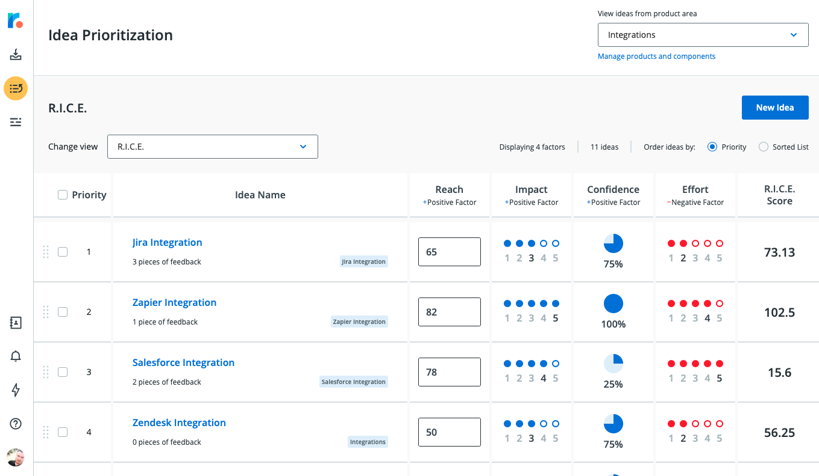
Sean believes that defining strong goals is half the battle when it comes to using a RICE score. Before you sit down with pen to paper or marker to whiteboard, it’s important to spend time working with teams and stakeholders to get clarity on what the goal for that quarter will be. A shared understanding of what the team is trying to accomplish can make prioritization conversations go a lot smoother.
“When using RICE, it’s important to have a single goal in mind as you’re comparing project ideas,” says Sean. “If you’re thinking one project could help with goal A, but this other project could help with goal B, it’s difficult to directly compare those things. Which goal is most important right now? The goal could be a customer/usage goal or an internal business goal, whatever is most important to your team at the moment.”
Impact can be a combined weighted score that combines all those factors that constitute impact at your organization like revenue generation and higher usage and adoption rates.
Calculating Confidence
A confidence score acts as a bias brake that offsets overly-optimistic impact scores. Confidence just lets you put a number to the question: How sure am I of those reach, impact and effort scores I gave each project idea?
So, let’s say you’ve put numbers to the scores of reach, impact and effort but you still feel there are gaps in the knowledge you need to be confident in those numbers. By adding a confidence score, the formula takes that uncertainty into consideration.
Here’s the scale Sean proposed (with some examples):
- 100% is high confidence. I am 100% confident in this idea because 100% of users used the new design successfully
- 80% is medium confidence. I am 80% confident in this idea. I'm not 100% because the development team highlighted some cost factors I didn't take into account in my estimations.
- 50% is low confidence. I have low confidence in this idea because, while there are some customers expressing a need for it, I haven’t done any research to see why they might think they need it
- Anything below 50% is a wild card. I have no confidence in this idea because I haven't done any testing or in-depth research into user or market data.
In Roadmunk’s RICE prioritization template, this value is represented by a percentage score in the shape of a Harvey ball with possible values of 0%, 25%, 50%, 75%, and 100%.
The clear caveat that emerges here is the fact that in order to gain that confidence they need, PMs need to go look for it. When a project or feature idea is met with low confidence, it forces PMs to ask themselves why that is. In asking that why, PMs set themselves on a path to validate, with data, whether an idea is as good as it sounds.
High confidence scores should be rooted in user context and data like research and experimentation, the success (or failure) of rough mockups and designs, just to name a few examples. And when it comes to effort and cost estimates, the confidence for those numbers should also take into account technical documents that outline engineering scope.
‘A project with low confidence might be one where all you have is a quick sketch on a whiteboard and a gut feeling,’ says Sean. ‘Another way to use the RICE score is as a framework for looking at how to develop ideas. Do you have an idea that you think could have a huge reach and impact, but the confidence is really low? If yes, then what type of user research or technical exploration could your team do to learn more and raise the confidence level?’
Calculating Effort
All the factors in the RICE equation so far are a sum of the potential benefits an idea will have towards a specific goal. Now it’s time to factor in the negative factor: the Effort score. This is where you calculate how much time a project will demand from your teammates. The units are estimated as the amount of work one team member can do within a month (so the units are either number of “person-months” or “person-weeks”).
So, for example, a project that requires 5 different people to work on it for a week would have an effort score of 5 person-weeks. Another project that would require 1 person to work on it for 5 weeks would also have an effort score of 5 person-weeks.
This makes it possible to fairly compare projects that may run for less than the entire quarter or cycle that you're planning for.
In order to do this, it’s wise to work in conjunction with tech leads and software engineers in order to come up with rough estimates that are grounded in valid information that’s rooted in reality. Effort estimates are driven by the complexity of the project and the reality of the existing technical systems.
“Effort is another aspect of the framework that can spark creative thinking around project scoping,” says Sean. “If you have a project idea with high reach and impact, but really high effort dragging the score down, you might ask whether there’s a different version of the project you could do that cuts down on the effort while retaining most of the reach and impact.”
Why do product managers like to use a RICE score for prioritization?
A RICE score isn’t some kind of mathematical alchemy that can turn vague, unvalidated ideas into dollar signs. A RICE score is just one exercise you can use to organize the order in which you should tackle ideas, based on how expensive they are to tackle in relation to the impact each idea can potentially have on a goal.
‘It’s just a structured framework for breaking down one big estimate into four smaller estimates that are easier for the human mind to think about without getting bogged down,’ says Sean.
In a nutshell, RICE’s power comes from how it helps PMs solve prioritization-related pain points like:
- It encourages data-informed prioritization. It takes emotion and opinions out of the prioritization and estimation discussions.
- Categorical flexibility. It can be used to assess feature ideas, projects, product updates and enhancements
- It can be a great tool for alignment. A RICE score informs stakeholders about the different factors that went into making product decisions
- Assessing the right metrics. It can help product teams reevaluate the metrics that define the success of their business.
OK, I like the sound of this RICE score. How can I start using it?
You can go through the process once per quarter, once per month or at the start of whatever time measures your team works within. At Intercom, the Growth team went through the process at about once per quarter. Each quarter, the team would start with a blank slate: starting with establishing what the main goal would be for that quarter. Then, gather ideas from teams and stakeholders.
One easy way to do this is by using a feedback and idea management platform like Roadmunk. Using our Chrome extension, you can invite Sales, CS and development teams to submit the feature requests they’re getting as well as any relevant feedback that could be the foundation for future project ideas. Within Roadmunk, ideas and feedback can be discussed by teams using a commenting and tagging system.
Learn more about how our idea management platform can help improve your ideation process here.
After gathering a set of ideas and projects from all these different sources, run the ideas by the RICE score. You should have all the information and context you need by now, but sometimes you’ll have to reach out and ask questions (for example, to the development team on cost estimates) and gather user research and data analytics.
“When it came to estimating effort, I would usually sit down with my tech lead and we would do those estimates together, so that they were more accurate than my own sometimes-wishful thinking,” says Sean.
Now you have a RICE score for each idea (and a tool for easily sorting them from highest to lowest or vice versa). It’s time to analyze the results. For Sean, this means looking at the list of ranked ideas and asking if anything was unexpected:
- Is there an idea that I expected to rank low but came out really high?
- Is there an idea I was really excited about that ended up ranked low?
If you answered yes to one or both of these questions for any of the ideas on your RICE board, run the idea again through those estimates just to be sure. Here’s where you make the choice to change one of those estimates or accept that your gut feeling about the project is just that—a gut feeling.
“Finally, I would choose a set of things that I thought we should focus on for the quarter, and then discuss them with the rest of the team,” says Sean. “The set I chose was not always strictly based on a RICE score. Sometimes things were chosen because the team was really excited about it, or a stakeholder was demanding it. But if the score for that idea was really low, then it gave me a tool to push back on that stakeholder in a more reasoned and structured way.”
Some final best practices
The prioritization process should work really well in fulfilling the needs of the organization—not the other way around. If you find yourself spending too much time trying to get exact numbers from a RICE score, or fretting endlessly over achieving Ultimate Objectivity among stakeholders, it’s time to take a step back and remember that there’s no silver bullet when it comes to building products.
Here are Sean’s parting words of wisdom when it comes to using the RICE method efficiently:
- Focus on one goal. If you have a small team, you’re probably not going to be able to push forward projects supporting 3-5 goals in a single quarter. Can you narrow it down to just the most important goal? If a quarter is too slow, then focus on a single goal for a 2-6 week period and then decide if you’ve made enough progress to move on to a different goal after that.
- Organize your team by sub-goals. If you have a larger team, instead of having everyone work towards multiple goals, consider splitting the team up into sub-teams that each get to own one goal. It’s easier for people to get excited and motivated about their work when they have a clear objective.
- Give your team autonomy. Consider scoring project ideas with RICE, but then leaving it to members of your team to decide which projects to pick up and work on first. Nobody likes to feel like everything is being dictated to them.
Using RICE in Roadmunk
Roadmunk allows you to build a customer-driven backlog full of product ideas that are rooted in real user needs. You can link ideas directly to all the relevant pieces of feedback coming from users and customers. The best part? Anyone at your company with access to our Chrome extension can submit these ideas and pieces of feedback into one centralized inbox.
That way, you’ll never miss another customer-validated idea that could have a potential impact on your goals.
We offer two prioritization templates in Roadmunk: RICE and value vs. effort + 8 other prioritization frameworks favored by PMs). After scoring ideas using one of those templates, you can then systematically rank the ideas from highest to lowest score—surfacing which ideas your team should focus on next. You can also prioritize your ideas using your own criteria.

