R. C. Coleman distributes a variety of food products that are sold through grocery store and supermarket outlets. The company receives orders directly from the individual outlets, with a typical order requesting the delivery of several cases of anywhere from 20 to 50 different products. Under the company’s current warehouse operation, warehouse clerks dispatch order-picking personnel to fill each order and have the goods moved to the warehouse shipping area. Because of the high labor costs and relatively low productivity of hand order-picking,
management has decided to automate the warehouse operation by installing a computer-controlled order-picking system, along with a conveyor system for moving goods from storage to the warehouse shipping area.
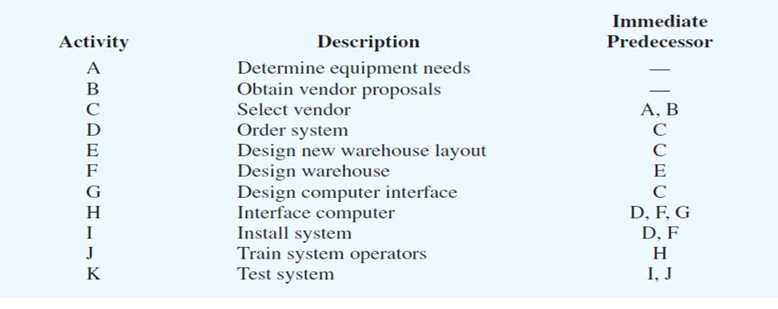
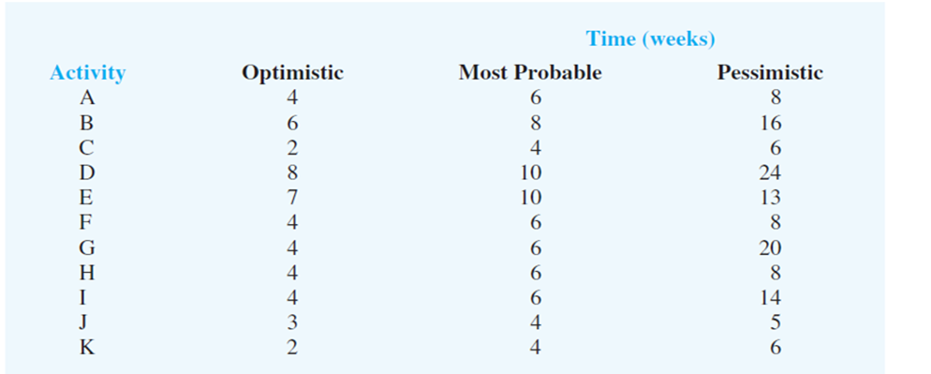
R. C. Coleman’s director of material management has been named the project manager in charge of the automated warehouse system. After consulting with members of the engineering staff and warehouse management personnel, the director compiled a list of activities associated with the project. The optimistic, most probable, and pessimistic times (in weeks) have also been provided for each activity.
Based on the given data, top management asked the director to prepare a report for the warehouse expansion project.
a) As the director of material management, what would be your plan of action for this project?
b) R. C. Coleman’s top management established a required 40-week completion time for the project. Can this completion time be achieved? Include probability information in your discussion.
c) What recommendations do you have if the 40-week completion time is required?

