Multiple Linear Regression
(Concept Note)

- Regression Modeling Algorithm

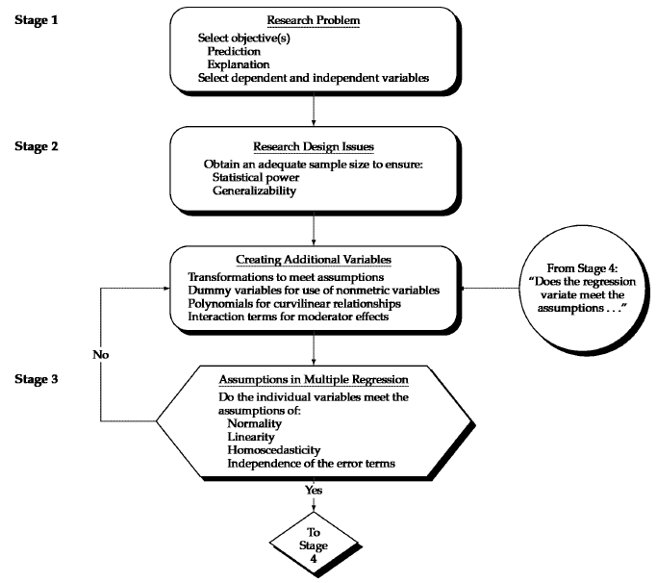

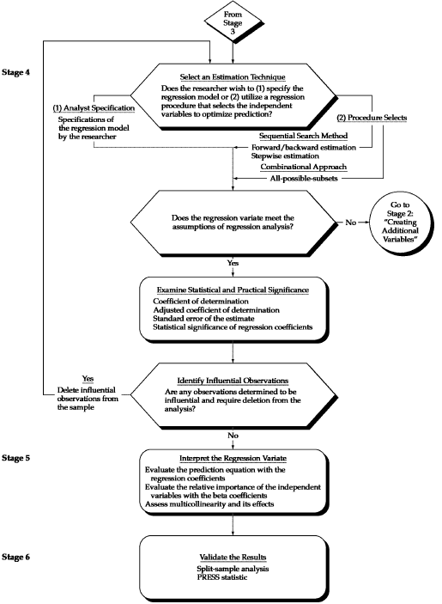

- Objectives of Model Fitting
  - Understanding the relationship between the variables [Statistical Approach]
  - Predicting the outcome of new cases [Data Mining Approach]

- Applications
  - Predicting customer activity on credit cards from their demographics and historical activity patterns
  - Predicting the time to failure of equipment based on utilization and environment conditions
  - Predicting expenditures on vacation travel based on historical frequent flyer data
  - Predicting staffing requirements at help desks based on historical data and production and sales information
  - Predicting sales from cross selling of products from historical information
  - Predicting the impact of discounts on sales in retail outlets

- Concept of Ordinary Least Squares
  - R² and Adj. R².

$$R^{2}=\frac{SSR}{SST}= 1-\frac{SSE}{SST}$$

$$Adj. R^{2}=1-\frac{n-1}{n-p-1}\left(1-R^{2}\right)$$

  - F-Test
  - t-tests, Standardized beta and Significance values
  - Variate

Variate value = w₁X₁ + w₂X₂ + w₃X₃ + …… + w_{n}X_{n}

In Multiple Linear Regression the variate is so determined so as to best correlate with the variable being predicted.

  - Criteria for subset selection (in case of predictive modeling) – Mallow’s Cp

$$C_{p}=\frac{SSE}{{\hat{σ}}_{full}^{2}}+2\left(p+1\right)-n$$

- Explanatory Vs Predictive Modeling
  - Important to have a model that predicts better on new values rather than a model that fits well on the data
  - Division of dataset into training and test / validation dataset
  - Split the dataset using seed
  - Performance is measured by predictive accuracy (how well the model predicts new cases)

- Assumptions in Regression Modelling
  - Check for influential observations
    - Check for Mahalanobis Distance (Check the option in Save tab in Regression). Compare with Critical Chi-square: x²_{0.05, k} where ‘k’ is the number of explanatory variables. Value greater than are possible outliers
    - Check for Cooks’s distance. Value above 4/(n-(k+1)) are possible outliers, where k is the number of explanatory variables and n is the number of observations.

  - Examine Heteroscedasticity (variance of residuals should be homogeneous across levels of predicted values)
    - Examine residual Plot (Plot between standardized residuals with predicted value)
    - Remedy is to Transform predictors

  - Multivariate Normality (The noise or the dependent variable follows a normal distribution)
    - If the variation from normality is sufficiently large, all statistical tests are invalid
    - Check using Histogram of unstandardized residual
    - Q-Q Plot of unstandardized residual
    - Skewness and Kurtosis should be near zero
    - Kolmogorov-Smirnov Test (Should be insignificant for normality)
    - Shapiro-Wilk’s Test (Should be insignificant for normality)
    - Normality assumption may be relaxed when split sample validation is done (Predictive Modeling)
    - REMEDY: Transformation (Also check other assumptions first)

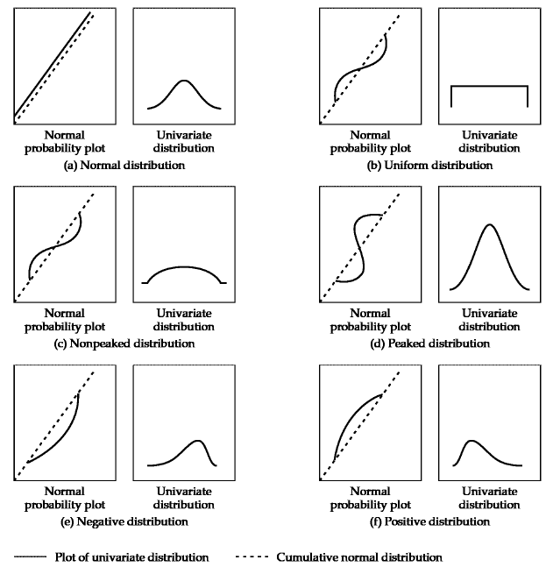

  - Multicollinearity
    - Bivariate Correlations: If correlations are greater than 0.8, multicollinearity is very like to exist. Ok if less than 0.6.
    - Tolerance and VIF values: VIF values greater than 4 indicate possible multicollinearity
    - Collinearity Diagnostics (Check for variance proportions): Condition index greater than 30 indicate serious multicollinearity
    - An excluded variable may be tested for its possible inclusion by checking its actual t-value = sqrt(VIF)*t-value

  - Non-Linearity (Variables are linearly related to the dependent variable)
    - Scatterplots
    - REMEDY: Transformations (Usually Log Transformation)

  - Model Mis-specification
    - Take predicted value and squared predicted value as predictors of the actual value and run the regression. If the squared of predicted value is significant then the model is mis-specified and more variables need to be added.

  - Absence of correlated errors (The cases are independent of each other)
    - Durbin-Watson Statistic: The Durbin-Watson statistic has a range from 0 to 4 with a midpoint of 2. 2 implies no autocorrelation. Value below 2 is positive autocorrelation and value above 2 is negative autocorrelation
    - REMEDY: Include the omitted causal factor into the multivariate analysis

  - Test for Linearity, Homoscedasticity and Correlated Errors
    - Plot of Studentized Residual Vs Predicted Dependent values

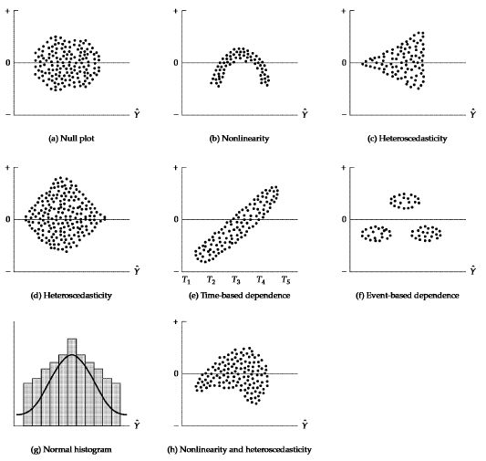

- Transformations
  - For non-normal distributions, the two most common patterns are ‘flat’ distributions and ‘skewed’ distributions. For the flat distribution, the most common transformation is the inverse transformation (1/y, or 1/x).
  - Skewed distributions can be transformed by taking the square root, logarithms or even the inverse of the variable. Negatively skewed distributions are best transformed by using a square root transformation and positively skewed distributions are best transformed by using logarithmic transformation.
  - Heteroscedasticity: If the cone in residuals opens to the right, take the inverse transformation. If the cone opens to the left, take the square root transformation
  - Some transformations to achieve linearity are shown below:

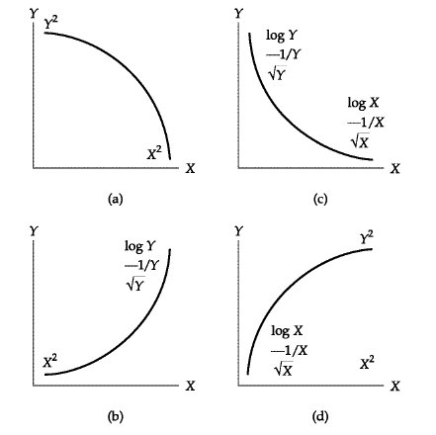

- Model Validation (On Test / Validation Data Set)

  - Root Mean Square Error: $RMSE= \sqrt{\sum_{i=1}^{n}{{\left(\frac{{Predicted}_{i}-{Actual}_{i}}{n}\right)}^{2}}}$

  - Mean Absolute Percentage Error: $MAPE= \sum_{i=1}^{n}{\left(\frac{{Predicted}_{i}-{Actual}_{i}}{{Actual}_{i}}\right)}$

