MoSCoW Prioritization
What is MoSCoW Prioritization?
MoSCoW prioritization, also known as the MoSCoW method or MoSCoW analysis, is a popular prioritization technique for managing requirements.
The acronym MoSCoW represents four categories of initiatives: must-have, should-have, could-have, and won’t-have, or will not have right now. Some companies also use the “W” in MoSCoW to mean “wish.”
What is the History of the MoSCoW Method?
Software development expert Dai Clegg created the MoSCoW method while working at Oracle. He designed the framework to help his team prioritize tasks during development work on product releases.
You can find a detailed account of using MoSCoW prioritization in the Dynamic System Development Method (DSDM) handbook. But because MoSCoW can prioritize tasks within any time-boxed project, teams have adapted the method for a broad range of uses.
How Does MoSCoW Prioritization Work?
Before running a MoSCoW analysis, a few things need to happen. First, key stakeholders and the product team need to get aligned on objectives and prioritization factors. Then, all participants must agree on which initiatives to prioritize.
At this point, your team should also discuss how they will settle any disagreements in prioritization. If you can establish how to resolve disputes before they come up, you can help prevent those disagreements from holding up progress.
Finally, you’ll also want to reach a consensus on what percentage of resources you’d like to allocate to each category.
With the groundwork complete, you may begin determining which category is most appropriate for each initiative. But, first, let’s further break down each category in the MoSCoW method.
Start prioritizing your roadmap
Download Guide
MoSCoW Prioritization Categories
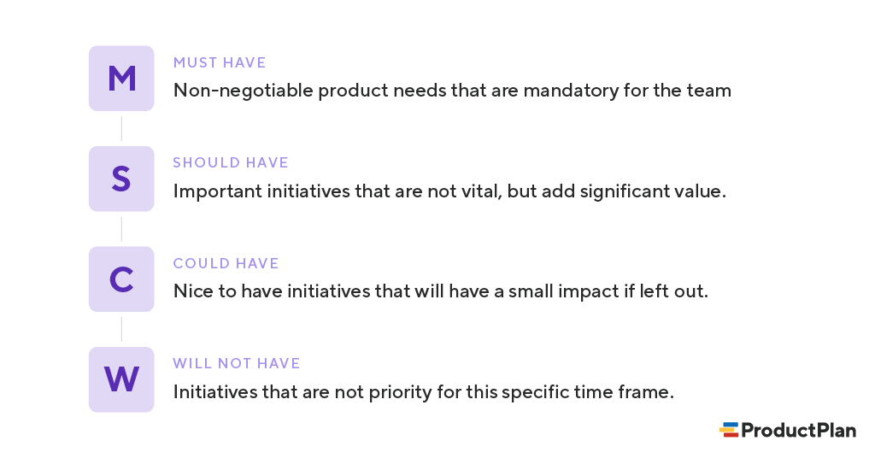
1. Must-have initiatives
As the name suggests, this category consists of initiatives that are “musts” for your team. They represent non-negotiable needs for the project, product, or release in question. For example, if you’re releasing a healthcare application, a must-have initiative may be security functionalities that help maintain compliance.

The “must-have” category requires the team to complete a mandatory task. If you’re unsure about whether something belongs in this category, ask yourself the following.
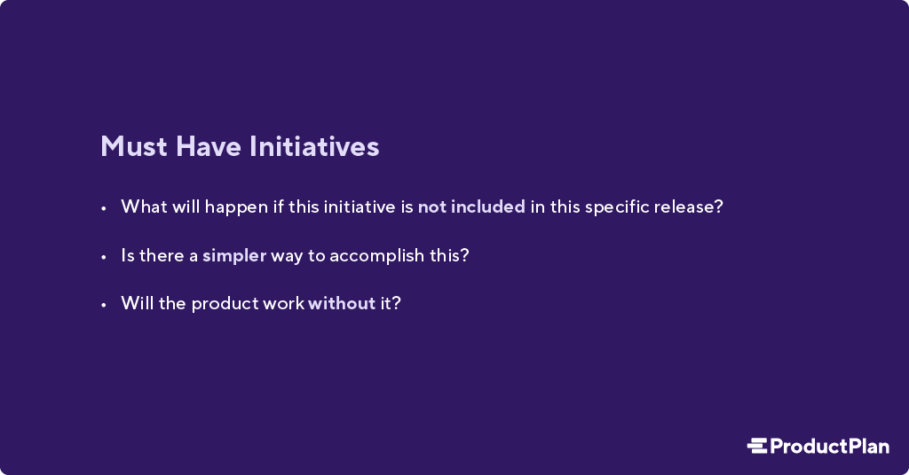
If the product won’t work without an initiative, or the release becomes useless without it, the initiative is most likely a “must-have.”
2. Should-have initiatives
Should-have initiatives are just a step below must-haves. They are essential to the product, project, or release, but they are not vital. If left out, the product or project still functions. However, the initiatives may add significant value.
“Should-have” initiatives are different from “must-have” initiatives in that they can get scheduled for a future release without impacting the current one. For example, performance improvements, minor bug fixes, or new functionality may be “should-have” initiatives. Without them, the product still works.
3. Could-have initiatives
Another way of describing “could-have” initiatives is nice-to-haves. “Could-have” initiatives are not necessary to the core function of the product. However, compared with “should-have” initiatives, they have a much smaller impact on the outcome if left out.
So, initiatives placed in the “could-have” category are often the first to be deprioritized if a project in the “should-have” or “must-have” category ends up larger than expected.
4. Will not have (this time)
One benefit of the MoSCoW method is that it places several initiatives in the “will-not-have” category. The category can manage expectations about what the team will not include in a specific release (or another timeframe you’re prioritizing).
Placing initiatives in the “will-not-have” category is one way to help prevent scope creep. If initiatives are in this category, the team knows they are not a priority for this specific time frame.
Some initiatives in the “will-not-have” group will be prioritized in the future, while others are not likely to happen. Some teams decide to differentiate between those by creating a subcategory within this group.
How Can Development Teams Use MoSCoW?
Although Dai Clegg developed the approach to help prioritize tasks around his team’s limited time, the MoSCoW method also works when a development team faces limitations other than time. For example:
Prioritize based on budgetary constraints.
What if a development team’s limiting factor is not a deadline but a tight budget imposed by the company? Working with the product managers, the team can use MoSCoW first to decide on the initiatives that represent must-haves and the should-haves. Then, using the development department’s budget as the guide, the team can figure out which items they can complete.
Prioritize based on the team’s skillsets.
A cross-functional product team might also find itself constrained by the experience and expertise of its developers. If the product roadmap calls for functionality the team does not have the skills to build, this limiting factor will play into scoring those items in their MoSCoW analysis.
Prioritize based on competing needs at the company.
Cross-functional teams can also find themselves constrained by other company priorities. The team wants to make progress on a new product release, but the executive staff has created tight deadlines for further releases in the same timeframe. In this case, the team can use MoSCoW to determine which aspects of their desired release represent must-haves and temporarily backlog everything else.
What Are the Drawbacks of MoSCoW Prioritization?
Although many product and development teams have prioritized MoSCoW, the approach has potential pitfalls. Here are a few examples.
1. An inconsistent scoring process can lead to tasks placed in the wrong categories.
One common criticism against MoSCoW is that it does not include an objective methodology for ranking initiatives against each other. Your team will need to bring this methodology to your analysis. The MoSCoW approach works only to ensure that your team applies a consistent scoring system for all initiatives.
Pro tip: One proven method is weighted scoring, where your team measures each initiative on your backlog against a standard set of cost and benefit criteria. You can use the weighted scoring approach in ProductPlan’s roadmap app.
2. Not including all relevant stakeholders can lead to items placed in the wrong categories.
To know which of your team’s initiatives represent must-haves for your product and which are merely should-haves, you will need as much context as possible.
For example, you might need someone from your sales team to let you know how important (or unimportant) prospective buyers view a proposed new feature.
One pitfall of the MoSCoW method is that you could make poor decisions about where to slot each initiative unless your team receives input from all relevant stakeholders.
3. Team bias for (or against) initiatives can undermine MoSCoW’s effectiveness.
Because MoSCoW does not include an objective scoring method, your team members can fall victim to their own opinions about certain initiatives.
One risk of using MoSCoW prioritization is that a team can mistakenly think MoSCoW itself represents an objective way of measuring the items on their list. They discuss an initiative, agree that it is a “should have,” and move on to the next.
But your team will also need an objective and consistent framework for ranking all initiatives. That is the only way to minimize your team’s biases in favor of items or against them.
When Do You Use the MoSCoW Method for Prioritization?
MoSCoW prioritization is effective for teams that want to include representatives from the whole organization in their process. You can capture a broader perspective by involving participants from various functional departments.
Another reason you may want to use MoSCoW prioritization is it allows your team to determine how much effort goes into each category. Therefore, you can ensure you’re delivering a good variety of initiatives in each release.
What Are Best Practices for Using MoSCoW Prioritization?
If you’re considering giving MoSCoW prioritization a try, here are a few steps to keep in mind. Incorporating these into your process will help your team gain more value from the MoSCoW method.
1. Choose an objective ranking or scoring system.
Remember, MoSCoW helps your team group items into the appropriate buckets—from must-have items down to your longer-term wish list. But MoSCoW itself doesn’t help you determine which item belongs in which category.
You will need a separate ranking methodology. You can choose from many, such as:
- Weighted scoring
- Value vs. complexity
- Kano model
- Buy-a-feature
- Opportunity scoring
For help finding the best scoring methodology for your team, check out ProductPlan’s article: 7 strategies to choose the best features for your product.
2. Seek input from all key stakeholders.
To make sure you’re placing each initiative into the right bucket—must-have, should-have, could-have, or won’t-have—your team needs context.
At the beginning of your MoSCoW method, your team should consider which stakeholders can provide valuable context and insights. Sales? Customer success? The executive staff? Product managers in another area of your business? Include them in your initiative scoring process if you think they can help you see opportunities or threats your team might miss.
3. Share your MoSCoW process across your organization.
MoSCoW gives your team a tangible way to show your organization prioritizing initiatives for your products or projects.
The method can help you build company-wide consensus for your work, or at least help you show stakeholders why you made the decisions you did.
Communicating your team’s prioritization strategy also helps you set expectations across the business. When they see your methodology for choosing one initiative over another, stakeholders in other departments will understand that your team has thought through and weighed all decisions you’ve made.
If any stakeholders have an issue with one of your decisions, they will understand that they can’t simply complain—they’ll need to present you with evidence to alter your course of action.

Chapter 10: MoSCoW Prioritisation
Previous chapter: 9 Workshops
More in this section... Chapter 1: Introduction Chapter 2: Choosing DSDM Chapter 3: Philosophy Fundamentals Chapter 4: Principles Chapter 5: Preparing for Success Chapter 6: Process Chapter 7: Roles and Responsibilities Chapter 8: Product Chapter 9: Workshops Chapter 10: MoSCoW Prioritisation Chapter 11: Iterative Development Chapter 12: Modelling Chapter 13: Timeboxing Chapter 14: Peoples, Teams and Interactions Chapter 15: Requirements and user stories Chapter 16: Project Planning and Control Chapter 17: Tailoring the DSDM Approach Chapter 18: Appendix A Glossary Chapter 19: Appendix B Project Approach Questionnaire (PAQ) Chapter 20: Appendix C Index Chapter 21: Disclaimer and Copyright
10.1 Introduction
In a DSDM project where time has been fixed, it is vital to understand the relative importance of the work to be done in order to make progress and keep to deadlines. Prioritisation can be applied to requirements/User Stories, tasks, products, use cases, acceptance criteria and tests, although it is most commonly applied to requirements/ User Stories. (User Stories are a very effective way of defining requirements in an Agile style; see later chapter on Requirements and User Stories for more information.)
MoSCoW is a prioritisation technique for helping to understand and manage priorities. The letters stand for:
- Must Have
- Should Have
- Could Have
- Won’t Have this time
The use of MoSCoW works particularly well on projects. It also overcomes the problems associated with simpler prioritisation approaches which are based on relative priorities:
- The use of a simple high, medium or low classification is weaker because definitions of these priorities are missing or need to be defined. Nor does this categorization provide the business with a clear promise of what to expect. A categorisation with a single middle option, such as medium, also allows for indecision
- The use of a simple sequential 1,2,3,4… priority is weaker because it deals less effectively with items of similar importance. There may be prolonged and heated discussions over whether an item should be one place higher or lower
The specific use of Must Have, Should Have, Could Have or Won’t Have this time provides a clear indication of that item and the expectations for its completion.
10.2 The MoSCoW Rules
10.2.1 Must Have
These provide the Minimum Usable SubseT (MUST) of requirements which the project guarantees to deliver. These may be defined using some of the following:
- No point in delivering on target date without this; if it were not delivered, there would be no point deploying the solution on the intended date
- Not legal without it
- Unsafe without it
- Cannot deliver a viable solution without it
Ask the question ‘what happens if this requirement is not met?’ If the answer is ‘cancel the project – there is no point in implementing a solution that does not meet this requirement’, then it is a Must Have requirement. If there is some way around it, even if it is a manual and painful workaround, then it is a Should Have or a Could Have requirement. Categorising a requirement as a Should Have or Could Have does not mean it won’t be delivered; simply that delivery is not guaranteed.
10.2.2 Should Have
Should Have requirements are defined as:
- Important but not vital
- May be painful to leave out, but the solution is still viable
- May need some kind of workaround, e.g. management of expectations, some inefficiency, an existing solution, paperwork etc. The workaround may be just a temporary one
One way of differentiating a Should Have requirement from a Could Have is by reviewing the degree of pain caused by the requirement not being met, measured in terms of business value or numbers of people affected.
10.2.3 Could Have
Could Have requirements are defined as:
- Wanted or desirable but less important
- Less impact if left out (compared with a Should Have)
These are the requirements that provide the main pool of contingency, since they would only be delivered in their entirety in a best case scenario. When a problem occurs and the deadline is at risk, one or more of the Could haves provide the first choice of what is to be dropped from this timeframe.
10.2.4 Won’t Have this time
These are requirements which the project team has agreed will not be delivered (as part of this timeframe). They are recorded in the Prioritised Requirements List where they help clarify the scope of the project. This avoids them being informally reintroduced at a later date. This also helps to manage expectations that some requirements will simply not make it into the Deployed Solution, at least not this time around. Won’t Haves can be very powerful in keeping the focus at this point in time on the more important Could Haves, Should Haves and particularly the Must Haves.
10.3 MoSCoW Relating to a Specific Timeframe
In a traditional project, all requirements are treated as Must Have, since the expectation is set from the start that everything will be delivered and that typically time (the end date) will slip if problems are encountered. DSDM projects have a very different approach; fixing time, cost and quality and negotiating features. By the end of Foundations, the end dates for the project and for the first Project Increment are confirmed.
In order to meet this commitment to the deadline, DSDM projects need to create contingency within the prioritised requirements. Therefore the primary focus initially is to create MoSCoW priorities for the project. However, when deciding what to deliver as part of the Project Increment, the next focus will be to agree MoSCoW priorities for that Increment. So at this point, a requirement may have two priorities; MoSCoW for the project and MoSCoW for the Increment. Finally, when planning a specific Timebox (at the start of each Timebox) the Solution Development Team will allocate a specific priority for the requirements for this Timebox. At this point, the majority of requirements are Won’t Have (for this Timebox). Only requirements that the Solution Development Team plan to work on in the development timebox are allocated a Must Have, Should Have or Could Have priority.
Therefore requirements may have three levels of priority:
- MoSCoW for the project
- MoSCoW for the Project Increment
- MoSCoW for this Timebox
For example:
Even if a Must Have requirement for an IT solution is the facility to archive old data, it is very likely that the solution could be used effectively for a few months without this facility being in place. In this case, it is sensible to make the archive facility a Should Have or a Could Have for the first Project Increment even though delivery of this facility is a Must Have before the end of the project. Similarly, a Must Have requirement for a Project Increment may be included as a Should Have or a Could Have (or a Won't Have) for an early Timebox.
It is important that the bigger picture objectives (completion of the Project Increment and delivery of the project) are not forgotten when working at the Timebox level.
One simple way to deal with this is to create a separate Timebox PRL, a subset of the project PRL that is specifically associated with an individual Timebox and leave the priorities unchanged on the main PRL for the project.
10.4 Ensuring effective prioritisation
10.4.1 Balancing the priorities
When deciding the effort allocated for Must Have requirements, remember that anything other than a Must Have is, to some degree, contingency, since the Must Haves define the Minimum Usable SubseT which is guaranteed to be delivered.
DSDM recommends:
- Getting the percentage of project/Project Increment Must Haves (in terms of effort to deliver) to a level where the team’s confidence to deliver them is high – typically no more than 60% Must Have effort
- Agreeing a pool of Could Haves for the project/Project Increment that reflects a sensible level of contingency - typically around 20% Could Have effort. Creating a sensible pool of Could Haves sets the correct expectations for the business from the start – that these requirements/User Stories may be delivered in their entirety in a best case scenario, but the primary project/Project Increment focus will always be on protecting the Must Haves and Should Haves
This spread of priorities provides enough contingency to ensure confidence in a successful project outcome.
NB When calculating effort for a timeframe, Won’t Haves (for this timeframe) are excluded.
DSDM’s recommendations reflect a typical project scenario. The important thing to make MoSCoW work is to have some visible flexibility in the level of requirements which must be delivered.
The safe percentage of Must Have requirements, in order to be confident of project success, is not to exceed 60% Must Have effort.
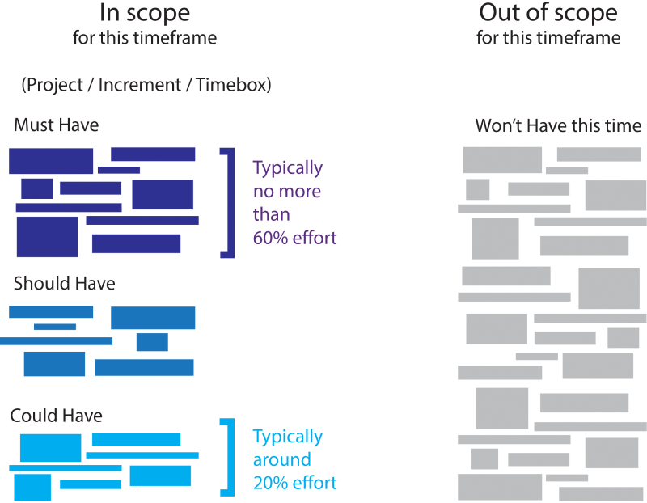
Figure 10a: MoSCoW – balancing priorities
Levels of Must Have effort above 60% introduce a risk of failure, unless the team are working in a project where all of these criteria are true:
- Estimates are known to be accurate
- The approach is very well understood
- The team are “performing” (based on the Tuckman model)
- The environment is understood and low-risk in terms of the potential for external factors to introduce delays
In some circumstances the percentage of Must Have effort may be significantly less than 60%. However this can be used to the benefit of the business, by providing the greatest possible flexibility to optimise value delivered across a larger proportion of Should Haves.
The exact split of effort between Musts, Shoulds, and Coulds is down to each project team to agree, although DSDM also recommends creating a sensible pool of Could Haves, typically around 20% of the total effort. Effective MoSCoW prioritisation is all about balancing risk and predictability for each project.
10.4.2 Agreeing up front how priorities will work
DSDM defines what the different priorities mean – the MoSCoW Rules. But whereas the definition of a Must Have is not negotiable, the difference between a Should Have and a Could Have can be quite subjective. It is very helpful if the team agree, at the start of their project, how these lower level priorities will be applied. Understanding in advance some objective criteria that separate a Should Have from a Could Have and ensuring that all roles on the project buy into what has been agreed can avoid much heated discussion later. Look for defined boundaries that decide whether a requirement is a Should Have or a Could Have?
For example:
At what point does the number of people impacted raise a Could Have to a Should Have? Or, what value of benefits would justify dropping this requirement from a Should Have to a Could Have?
Ideally this agreement is reached before the requirements are captured.
10.4.3 When to prioritise
very item of work has a priority. Priorities are set before work commences and the majority of this prioritisation activity happens during Foundations. However, priorities should be kept under continual review as work is completed. As new work arises, either through introduction of a new requirement or through the exposure of unexpected work associated with existing requirements, the decision must be made as to how critical it is to the success of the current work using the MoSCoW rules. When introducing new requirements, care needs to be taken not to increase the percentage of Must Have requirement effort beyond the agreed project level. The priorities of uncompleted requirements should be reviewed throughout the project to ensure that they are still valid. As a minimum, they should be reviewed at the end of each Timebox and each Project Increment.
10.4.4 Discussing and reviewing priorities
Any requirement defined as a Must Have will, by definition, have a critical impact on the success of the project. The Project Manager, Business Analyst and any other member of the Solution Development Team should openly discuss requirements prioritised as Must Have where they are not obvious Must Haves (“Without this would we cancel the project/increment?”); it is up to the Business Visionary or their empowered Business Ambassador to explain why a requirement is a Must Have.
The escalation of decision-making processes should be agreed early on, e.g. Business Ambassador and Business Analyst to Business Visionary to Business Sponsor, and the level of empowerment agreed around decision-making at each level.
At the end of a Project Increment, all requirements that have not been met are re-prioritised in the light of the needs of the next Increment. This means that, for instance, a Could Have that is not met in one Increment may be reclassified subsequently as a Won’t Have for the next Increment, because it does not contribute enough towards the business needs to justify its inclusion. However, it could just as easily become a Must Have for the next Increment, if its low priority in the first Increment was based on the fact it was simply not needed in the first Solution Increment.
10.5 Using MoSCoW to Manage Business Expectations
The MoSCoW rules have been defined in a way that allows the delivery of the Minimum Usable SubseT of requirements to be guaranteed. Both the Solution Development Team and those to whom they are delivering share this confidence because the high percentage effort of Shoulds and Coulds provides optimum contingency to ensure delivery of the Must Haves.
The business roles can certainly expect more than delivery of only the Must Haves. The Must Haves are guaranteed but it is perfectly reasonable for the business to expect delivery of more than the Minimum Usable SubseT in the timeframe, except under the most challenging of circumstances.
DSDM’s recommendation to create a sensible pool of Could Have contingency – typically around 20% of the total project/increment effort - identifies requirements that are less important or which have less impact if not delivered, in order to protect the more important requirements. This approach implies that the business can reasonably expect the Should Have requirements to be met, in addition to all of the Must Haves. It also implies that in a best case scenario, the Could Have requirements would also be delivered.
The Solution Development Team cannot have the confidence to guarantee delivery of all the Must Have, Should Have and Could Have requirements, even though these have all been estimated and are included in the plan. This is because the plan is based on early estimates and on requirements which have not yet been analysed in low-level detail. Applying pressure to a team to guarantee delivery of Musts, Shoulds and Coulds is counter-productive. It usually results in padded estimates which give a false perception of success. “We always achieve 100% (because we added significant contingency to our figures”).
So, combining sensible prioritisation with timeboxing leads to predictability of delivery and therefore greater confidence. This also protects the quality of the solution being delivered. Keeping project metrics to show the percentage of Should Haves and Could Haves delivered on each Project Increment or Timebox will either re-enforce this confidence, if things are going well, or provide an early warning of problems, highlighting that some important (but not critical) requirements may not be met at the project level.
10.6 How does MoSCoW Relate to the Business Vision
10.6.1 The Business Sponsor’s perspective
The starting point for all projects is the business vision. Associated with the business vision are a set of prioritised requirements that contribute to delivery of the vision. Also associated with the business vision is a Business Case that describes the project in terms of what value it will deliver back to the business. Depending on the organization, this Business Case may be an informal understanding or it may be defined formally, showing what Return On Investment (ROI) is expected in order to justify the cost of the project.
The MoSCoW priorities are necessary to understand the Minimum Usable SubseT and the importance of individual requirements. The Business Visionary must ensure that the requirements are prioritised, evaluated in business terms, and delivered to provide the ROI required by the Business Case, in line with the business vision.
10.7 Making MoSCoW Work
Requirements are identified at various levels of detail, from a high-level strategic viewpoint (typically during Feasibility) through to a more detailed, implementable level (typically during Evolutionary Development). Highlevel requirements can usually be decomposed to yield a mix of sub-requirements, which can then be prioritised individually. This ensures the flexibility is maintained, so that if necessary, some of the detailed less important functionality can be dropped from the delivered solution to protect the project deadline.
It is this decomposition that can help resolve one of the problems that often confront teams: that all requirements appear to be Must Haves.
If all requirements were genuinely Must Haves, then the flexibility derived from the MoSCoW prioritisation would no longer work. There would be no lower priority requirements to be dropped from the deliverables to keep a project on time and budget. This goes against the DSDM ethos of fixing time and cost and flexing features (the triangles diagram in the Philosophy and Fundamentals chapter). Believing everything is a Must Have is often symptomatic of insufficient decomposition of requirements.
Remember that team members may cause scope creep by working on ”interesting” things rather than the important things. MoSCoW can help avoid this.
10.8 Tips for Assigning Priorities
1. Ensure that the business roles, in particular the Business Visionary and the Business Analyst, are fully up to speed as to why and how DSDM prioritises requirements.
2. Consider starting with all requirements as Won’t Haves, and then justify why they need to be given a higher priority.
3. For each requirement that is proposed as a Must Have, ask: ‘what happens if this requirement is not met?’ If the answer is ‘cancel the project; there is no point in implementing a solution that does not meet this requirement’, then it really is a Must Have. If not, then decide whether it is Should Have or a Could Have (or even a Won’t Have this time)
4. Ask: ‘if I come to you the night before Deployment and tell you there is a problem with a Must Have requirement and that we can’t deliver it – will you stop the Deployment?’ If the answer is ‘yes’ then this is a Must Have requirement. If not, decide whether it is Should Have or a Could Have.
5. Is there a workaround, even if it is a manual one? If a workaround exists, then it is not a Must Have requirement. When determining whether this is a Should Have or a Could Have requirement, compare the cost of the workaround with the cost of delivering the requirement, including the cost of any associated delays and any additional cost to implement it later, rather than now.
6. Ask why the requirement is needed – for this project and this Project Increment.
7. Is this requirement dependent on any others being fulfilled? A Must Have cannot depend on the delivery of anything other than a Must Have because of the risk of a Should Have or Could Have not being delivered.
8. Allow different priorities for acceptance criteria of a requirement.
For example:
'The current back-up procedures need to ensure that the service can be restored as quickly as possible.' How quick is that? Given enough time and money, that could be within seconds. A smarter definition would be to say it Should happen within four hours, but it Must happen within 24 hours.
9. Can this requirement be decomposed? Is it necessary to deliver each of these elements to fulfil the requirement? Are the decomposed elements of the same priority as each other?
10. Tie the requirement to a project objective. If the objective is not a Must Have, then probably neither is the requirement relating to it.
11. Does the priority change with time? For example, for an initial release a requirement is a Should Have, but it will become a Must Have for a later release.
12. Prioritise testing, using MoSCoW.
13. Use MoSCoW to prioritise your To Do list. It can be used for activities as well as requirements.
10.9 Summary
MoSCoW (Must Have, Should Have, Could Have, Won’t Have this time) is primarily used to prioritise requirements, although the practice is also useful in many other areas. On a typical project, DSDM recommends no more than 60% effort for Must Have requirements on a project, and a sensible pool of Could Haves, usually around 20% effort. Anything higher than 60% Must Have effort poses a risk to the success and predictability of the project, unless the environment and any technology is well understood, the team is well established and the external risks minimal.

Understanding the MoSCoW prioritization | How to implement it into your project
August 30, 2023
Hi community, it's Lucas from DevSamurai and I would like to bring you a closer look at one of the popular prioritization methods: MoSCoW. In this article, we will discover what the MoSCoW method is, its benefits, and how you can implement it into your project for better management.

Projects, irrespective of their size or complexity, often juggle numerous tasks and requirements. In such a scenario, MoSCoW prioritization becomes essential to ensure the successful completion of the project.
Besides, it is also a very effective way to manage project priorities. With a straightforward and adaptable approach, the MoSCoW method helps manage stakeholder expectations and improve project outcomes.
What is the MoSCoW prioritization technique?
The MoSCoW method is a prioritization matrix widely used in project management and software development. The term MoSCoW is an acronym that stands for Must have, Should have, Could have, and Won’t have, each denoting a level of priority.
Here is the breakdown of the MoSCoW method:
- Must have: These are critical requirements that the project cannot be completed without them. If these are not fulfilled, the project is considered a failure.
- Should have: These are important but not critical features of a project, and these are high-priority items that are not as time-sensitive as the Must-haves.
- Could have: These are desirable features that do not affect the overall project’s success. Therefore, they can be included if time and resources permit.
- Won’t have: These features are the lowest priority or are not necessary for the current delivery cycle. They are agreed upon and recognized but are dropped for the project’s current timeline.

The method’s roots trace back to the Dynamic Systems Development Method (DSDM), a framework used in agile project management. Its simplicity and effectiveness have made it popular across various industries, helping teams prioritize their tasks more effectively.
Why should you use the MoSCoW prioritization method?
Based on its simplicity and clarity, MoSCoW makes it easy for all stakeholders to understand the project priorities. Besides, this method is also highly adaptable and can be applied across different types of projects and industries.

Moreover, it plays a crucial role in managing stakeholder expectations by clearly defining the project’s needs and wants. It provides a shared understanding of what’s crucial for the project’s success and what can be set aside if needed.
Compared to other prioritization methods, MoSCoW focuses on both inclusion (Must, Should, Could) and exclusion (Won’t). As a result, it offers a distinct advantage in managing stakeholder expectations and scope.
Benefits of using MoSCoW prioritization
If you're still skeptical about applying the MoSCoW method to your project, then why not take a look at these benefits? Surely, they will encourage you to have second thoughts.
1. Provide clear prioritization
This prioritization technique provides a clear and easy-to-understand framework for prioritizing project requirements. By dividing requirements into each value of MoSCoW, teams can easily distinguish between what is necessary, what is important, and what can be postponed or removed from the current iteration or cycle.
2. Simplify the decision-making process
By categorizing tasks based on their importance and urgency, MoSCoW helps streamline decision-making processes. As a result, it empowers teams to focus on what’s crucial for the project’s success, thereby reducing the time spent on less critical tasks.
3. Enhance communication
The MoSCoW prioritization method enhances communication among project stakeholders. Additionally, it provides a shared vocabulary that all project team members, sponsors, and stakeholders can understand.
Therefore, this shared understanding helps align everyone’s expectations, minimizing potential conflicts or misunderstandings.
4. Improve stakeholder management
This method offers an effective way to manage stakeholder expectations. By identifying and agreeing on the values of MoSCoW, stakeholders have a clear understanding of what to expect from the project.
5. Provide great project flexibility
The MoSCoW method encourages flexibility by allowing requirements to move between categories as the project evolves and new information becomes available. As a result, this makes it particularly useful for agile development methodologies where flexibility and adaptation are key.
6. Allocate resources effectively
By clearly defining the priorities, MoSCoW plays a role in the effective allocation of resources. Teams can assign resources and schedule time based on the tasks’ priority level, ensuring the most critical tasks are completed first.
7. Offer risk management
MoSCoW prioritization helps mitigate risks by focusing on the completion of “Must-have” tasks. These are the most critical to the project, and by ensuring they are completed first, teams can prevent the project from failing.
How to implement MoSCoW in your project
With such benefits, you will undoubtedly want to implement this prioritization method in your project.
Here is the step-by-step guide on how to do it:
- Begin by listing all project requirements.
- Initiate discussions with your stakeholders to categorize each requirement into the Must Have, Should Have, Could Have, and Won’t Have sections.
- Next, you should facilitate negotiations among stakeholders when there is disagreement on the categorization of certain requirements.
- Document the categorization and make it available to all stakeholders.
- Review and adjust priorities throughout the project as necessary.
Mistakes to avoid while using MoSCoW
While the MoSCoW method is simple, certain common mistakes can affect its effectiveness and your project as a whole.
For example, categorizing too many features as “Must have” can lead to confusion and delay. Therefore, it is essential to maintain a realistic and balanced distribution of requirements across the categories.
Another common misunderstanding is the belief that “Won’t have” features are not necessary.
These are the features that could bring additional value to the project but are not feasible in the current delivery cycle due to time or resource constraints. As a result, you can easily sleep on these potential features without knowing that they could be the turning point of your project.
To avoid such mistakes, you should remember to look back and review all criteria. This practice will help you avoid overrating specific features while underestimating others.
Final thoughts on the MoSCoW prioritization
The MoSCoW prioritization technique provides a straightforward and effective way to manage project requirements effectively. By providing clear categorization, it simplifies decision-making, facilitates communication, and helps manage stakeholder expectations.
Whether you’re in software development, event management, or any industry involving project management, MoSCoW can prove to be a valuable tool.

I hope this article will give you a better understanding of the MoSCoW prioritization method, its benefits, and how to use it to manage your project more effectively.
If you are looking for a way to make prioritization while managing your projects along the way, you can try our app with prioritization for Jira for free.

