Indian Institute of Management Rohtak
Integrative Exercise
Programme (APMP)
Faculty: Dr. Ashwani Kumar

Project Crashing
Exercise 1. The network and durations given below shows the normal schedule for a project. You can decrease (crash) the durations at an additional expense. The Table given below summarizes the time-cost information for the activities. The owner wants you to you to finish the project in 110 days. Find the minimum possible cost for the project if you want to finish it on 110 days. (Assume that for each activity there is a single linear, continuous function between the crash duration and normal duration points).

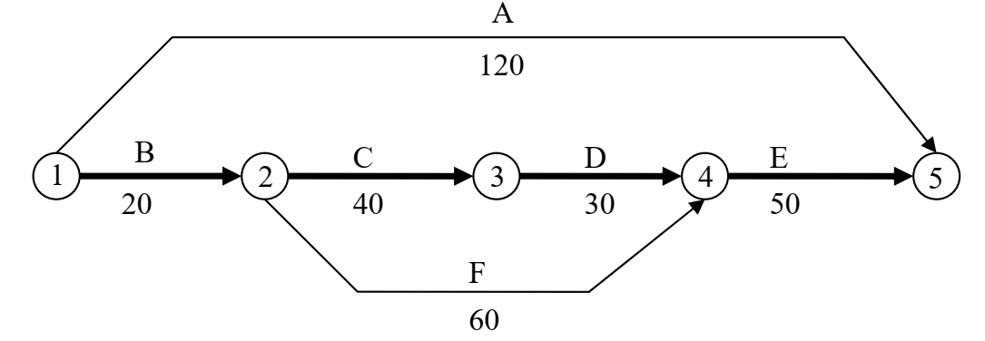

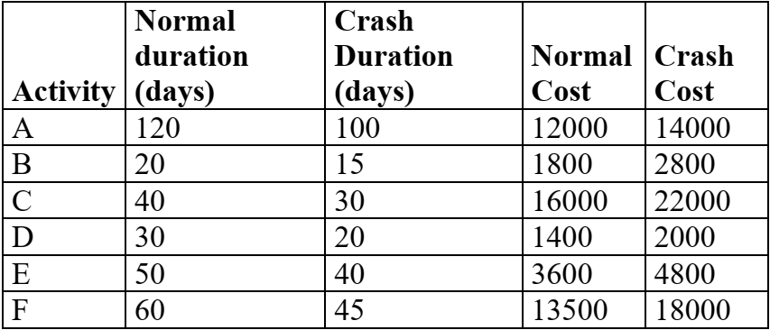
Exercise 2. For a network shown below, normal time, crash time, normal cost, crash cost are given in table. Contract the network by crashing it to optimum value and calculate optimum project cost. Indirect cost = Rs 100/- per day.
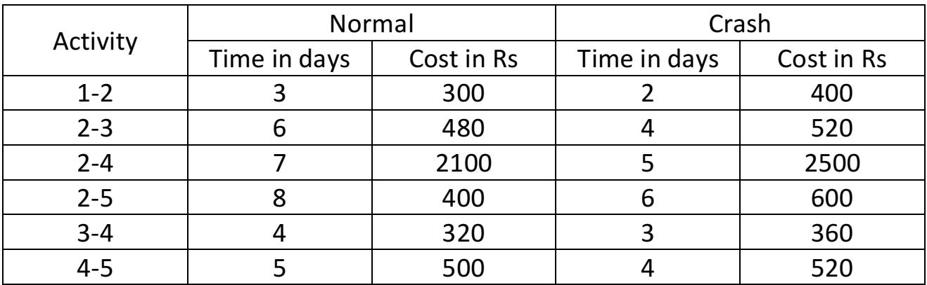

Network Construction
Exercise 3. A project consists of the following activities and time estimates.
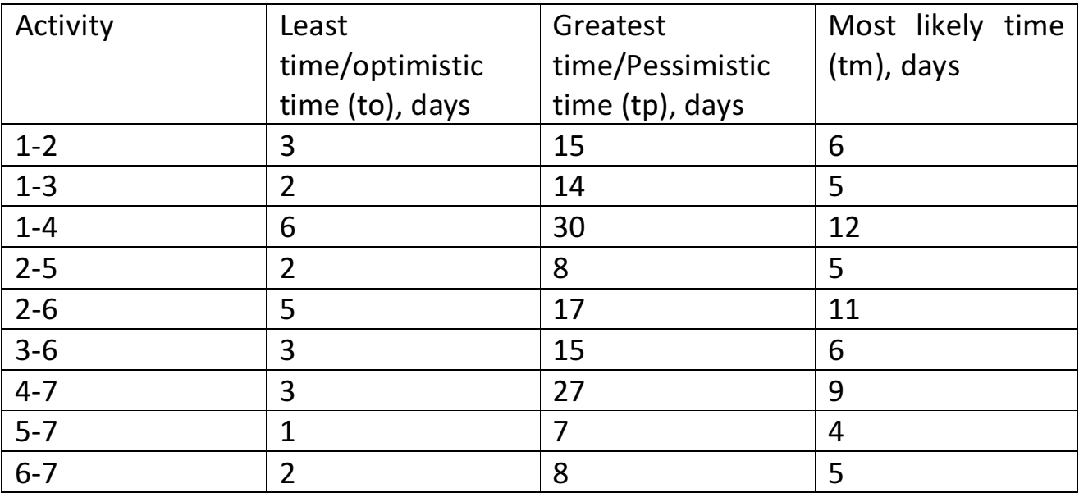
a) Construct the network.
b) Determine the expected task time.
c) Show the critical path.
d) What is the project duration?

Exercise 4. A project consists of the following activities and time estimates.
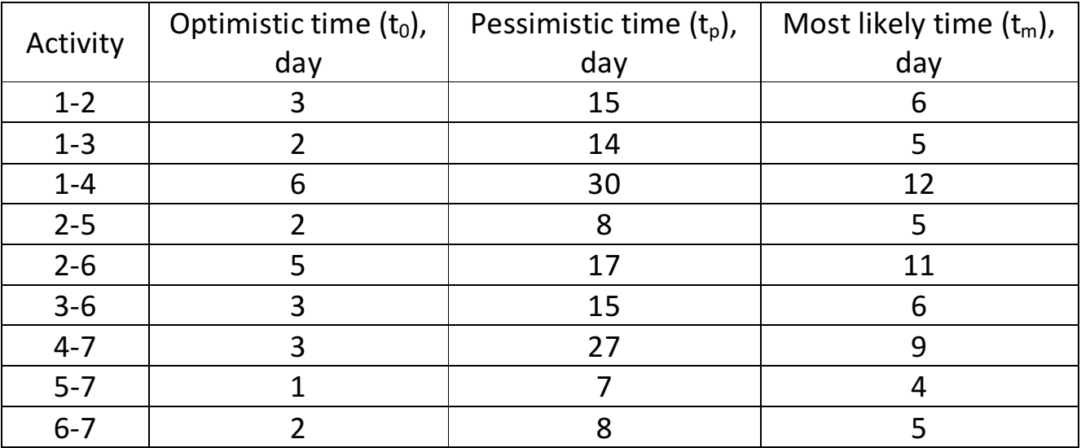
a) What is the project duration?
b) What is the probability that the project will be completed in 27 days?

