Installing PowerBI Desktop (only Windows users)

- Go to https://powerbi.microsoft.com/en-gb/desktop/ and click on “See download or language options”.

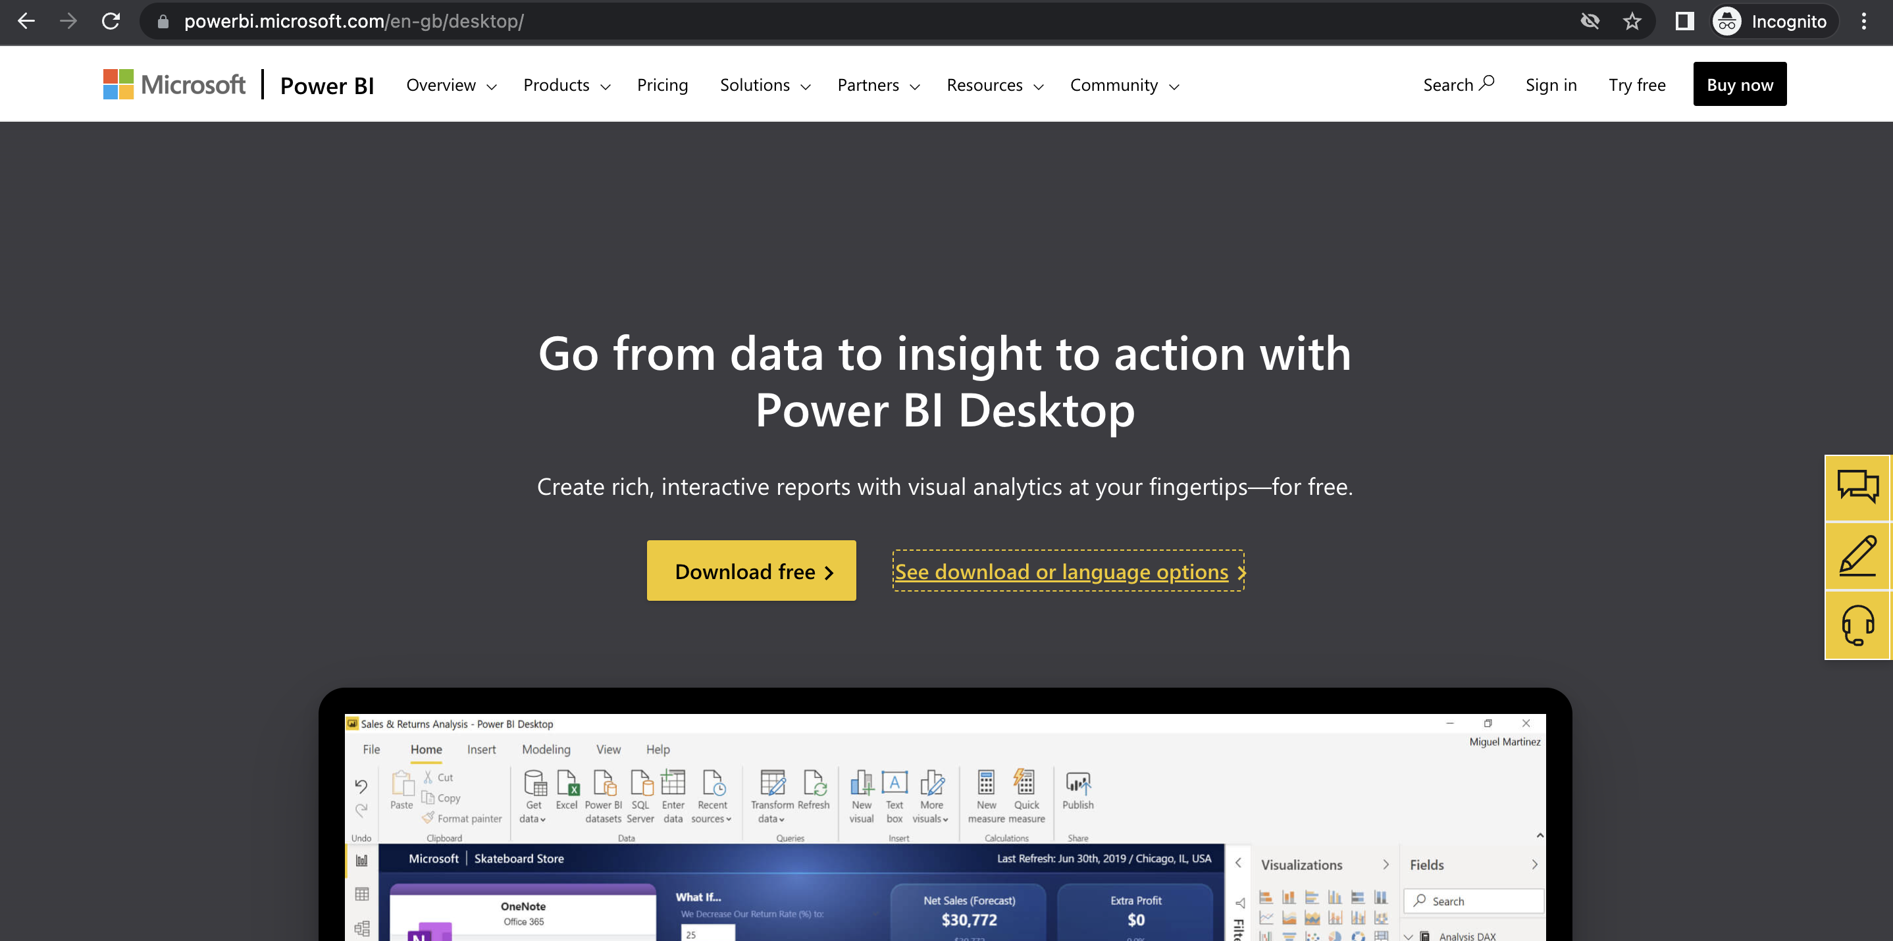

- Click on Download button

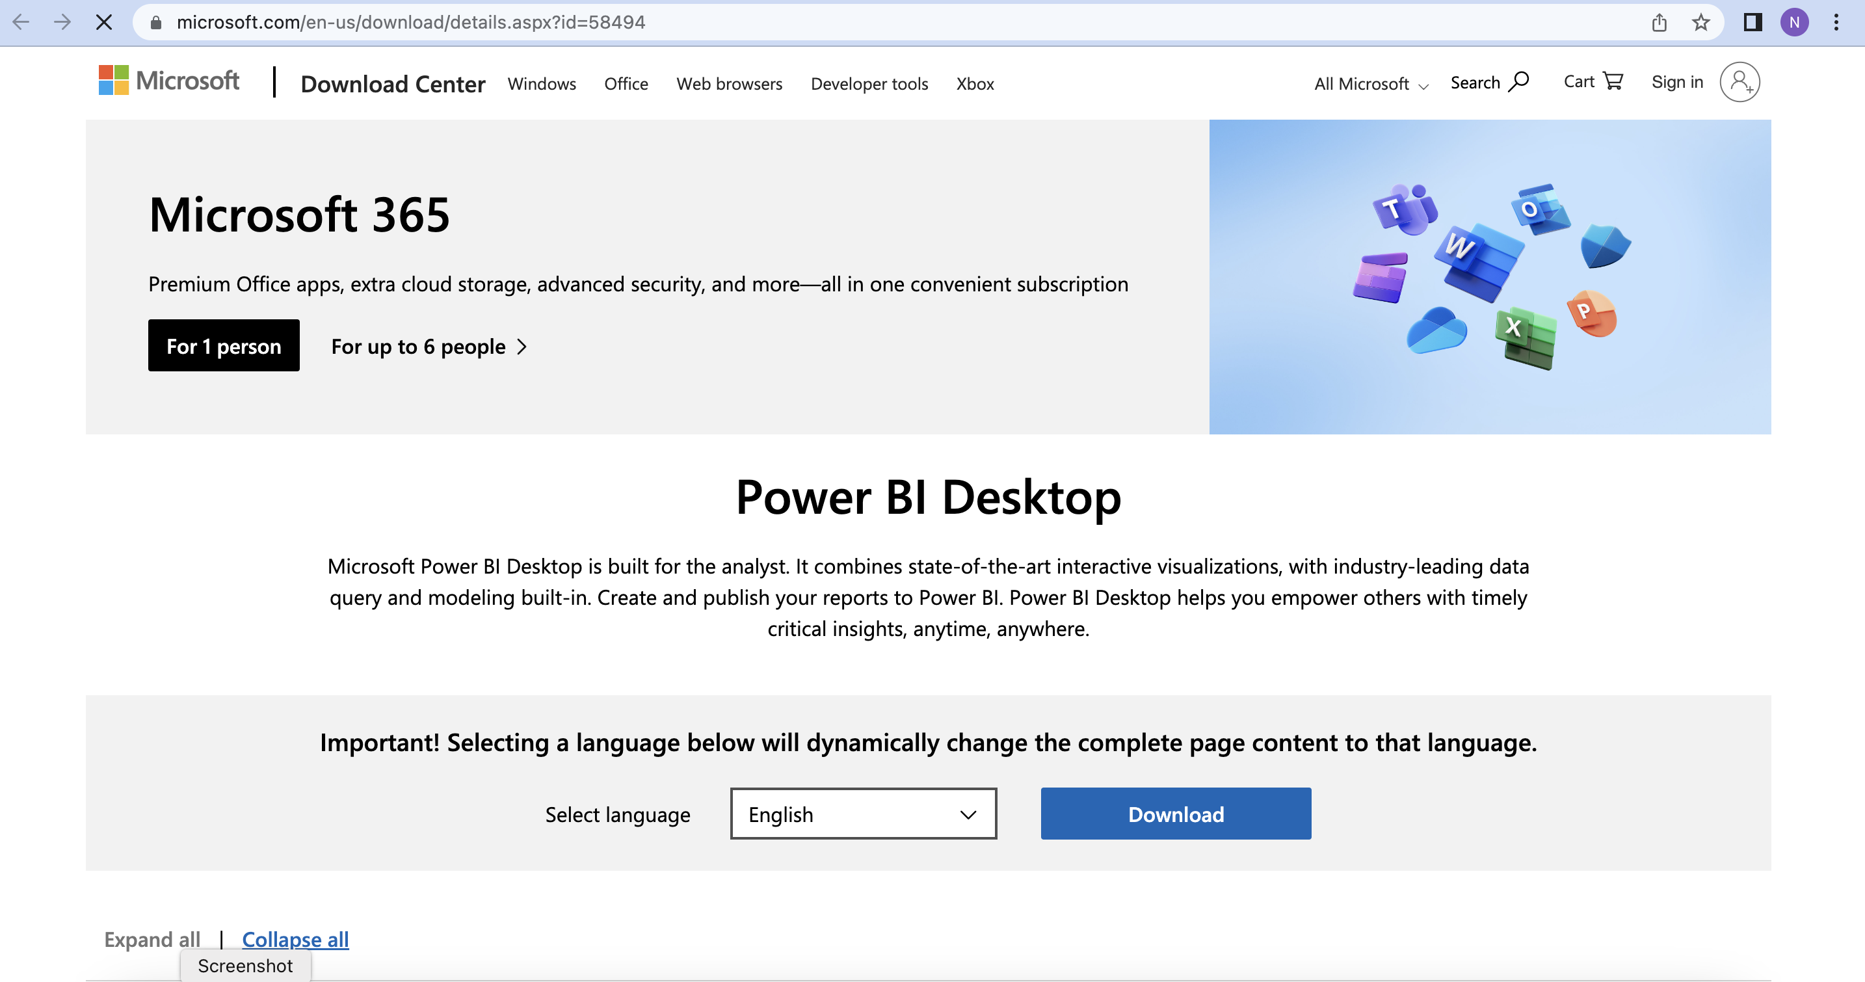

- Choose the appropriate option

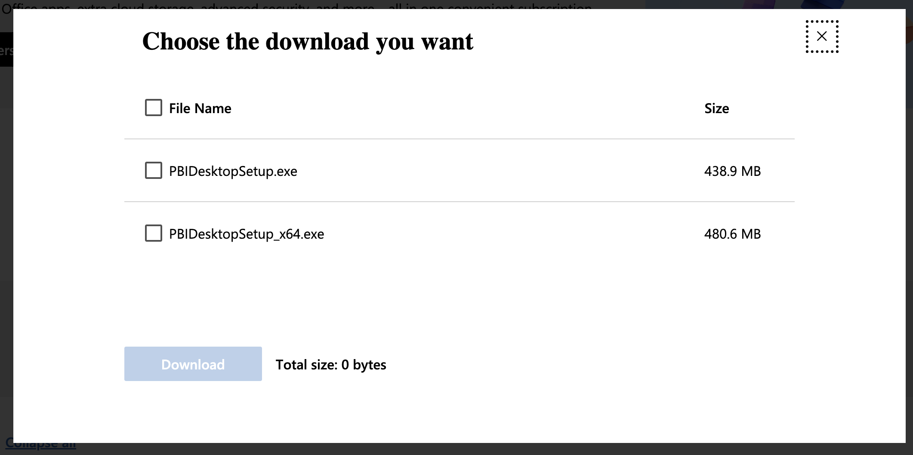

- This will download the setup file. Complete installation using the setup file and launch PowerBI. You should be able to see the following screen.

