Guidelines to Install MS Project

Click on the below link.
https://signup.microsoft.com/get-started/signup?products=204a8e44-c924-4bfb-aa90-ddf42dc0e18a&ru=https://admin.microsoft.com/adminportal/home?ref=setupwizard&ali=1&culture=en-in&country=IN
You are required to create your credentials for the same to login.

Once logged in the following page will appear.
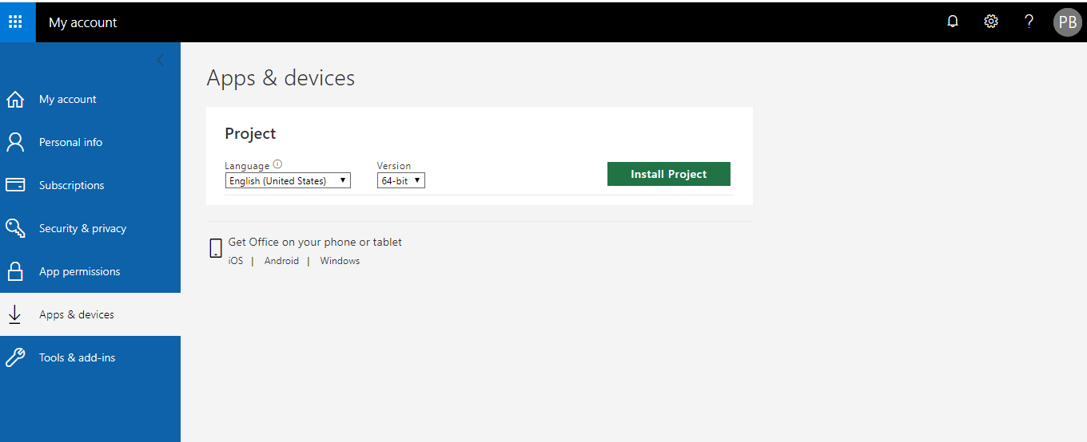
Check your operating system is running on 32-bit or 64-bit.
How to check the version of your system.

- Go to my computer and right click
- Select properties

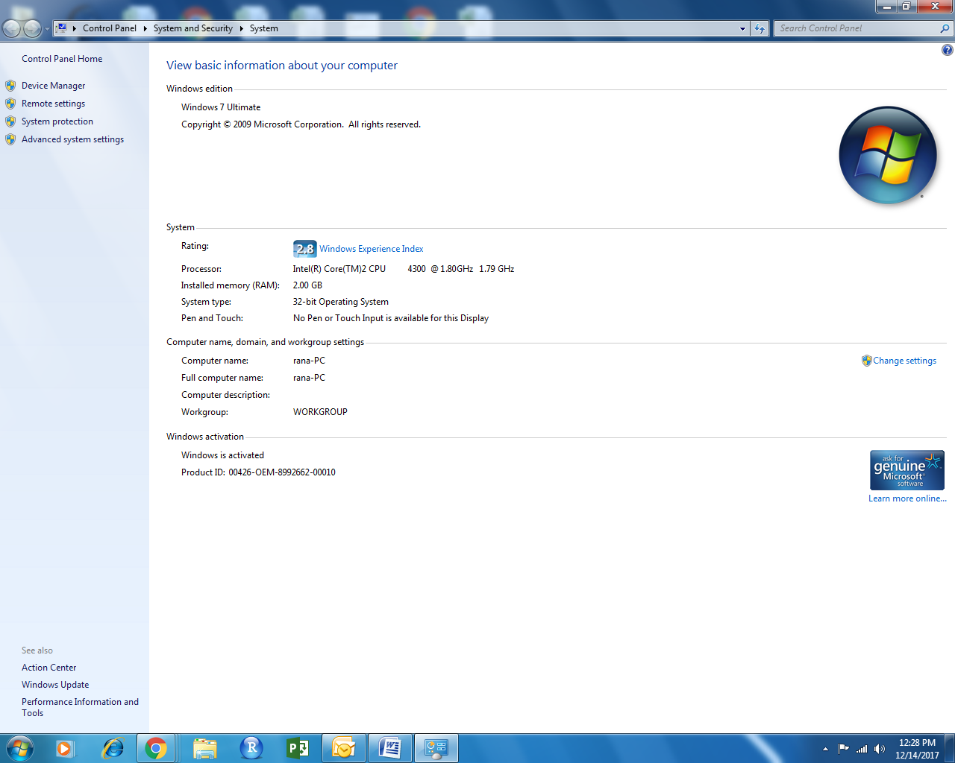

- Select the appropriate version and Click on install.
- An exe file will download on your system, Once downloaded open the file and run it
(as shown in the screenshot below)
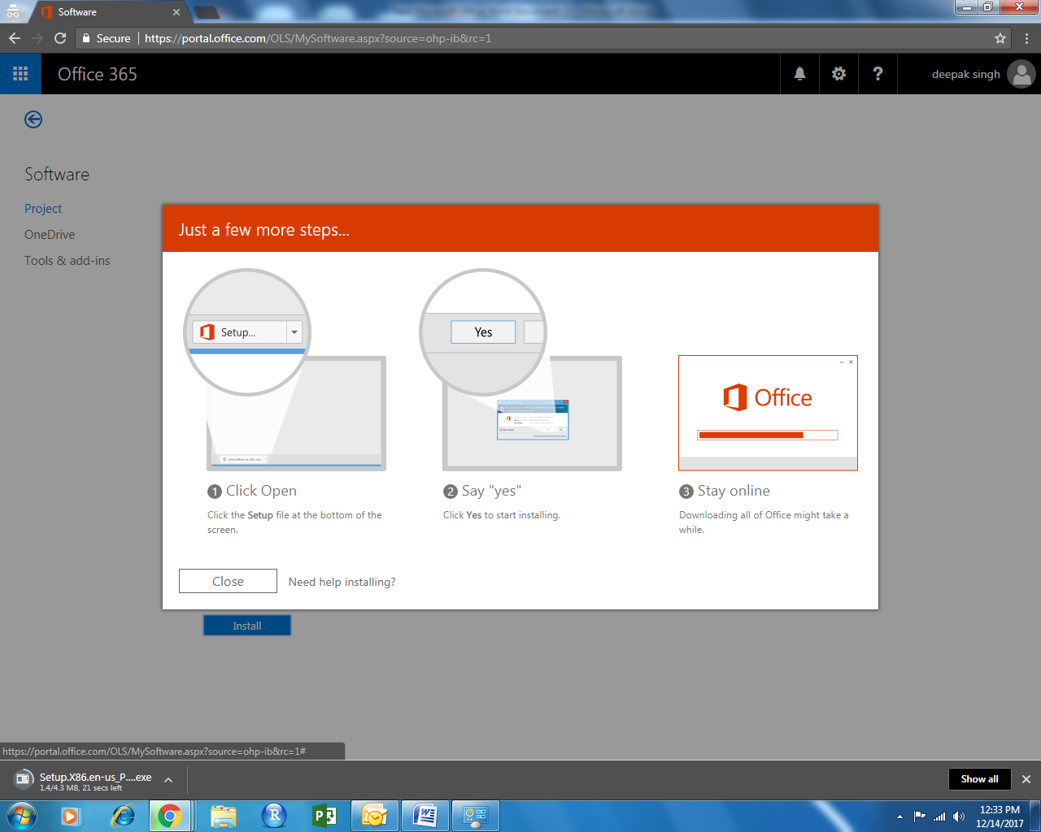

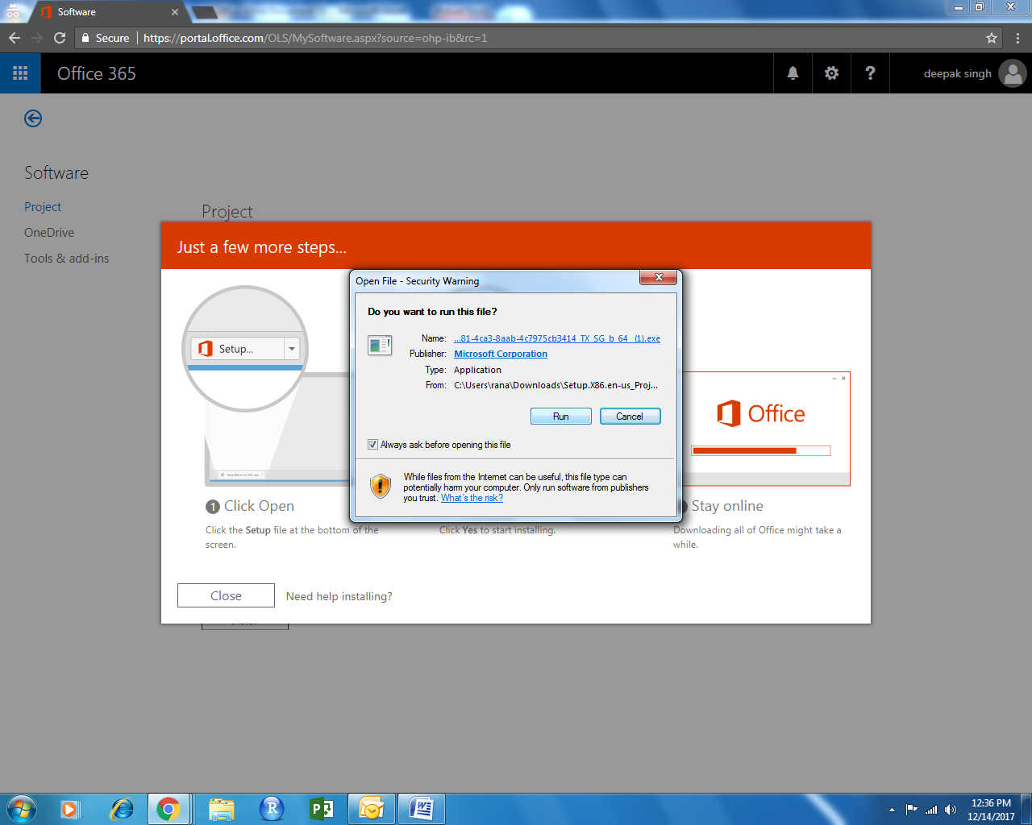

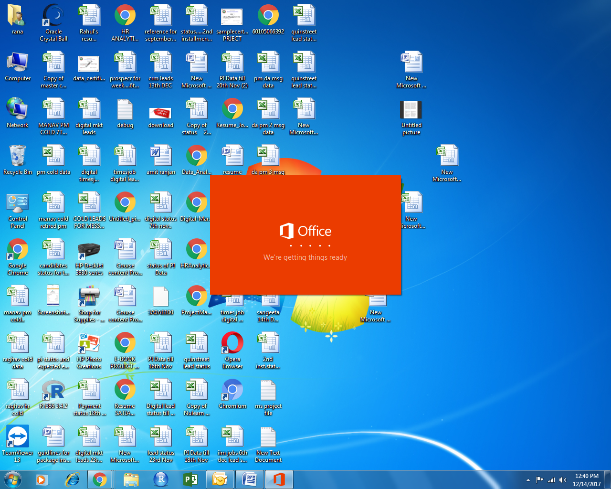
It will take 15 to 20 minutes, please do not shut down your system during the installation.

Later it will be shown like this on your screen.

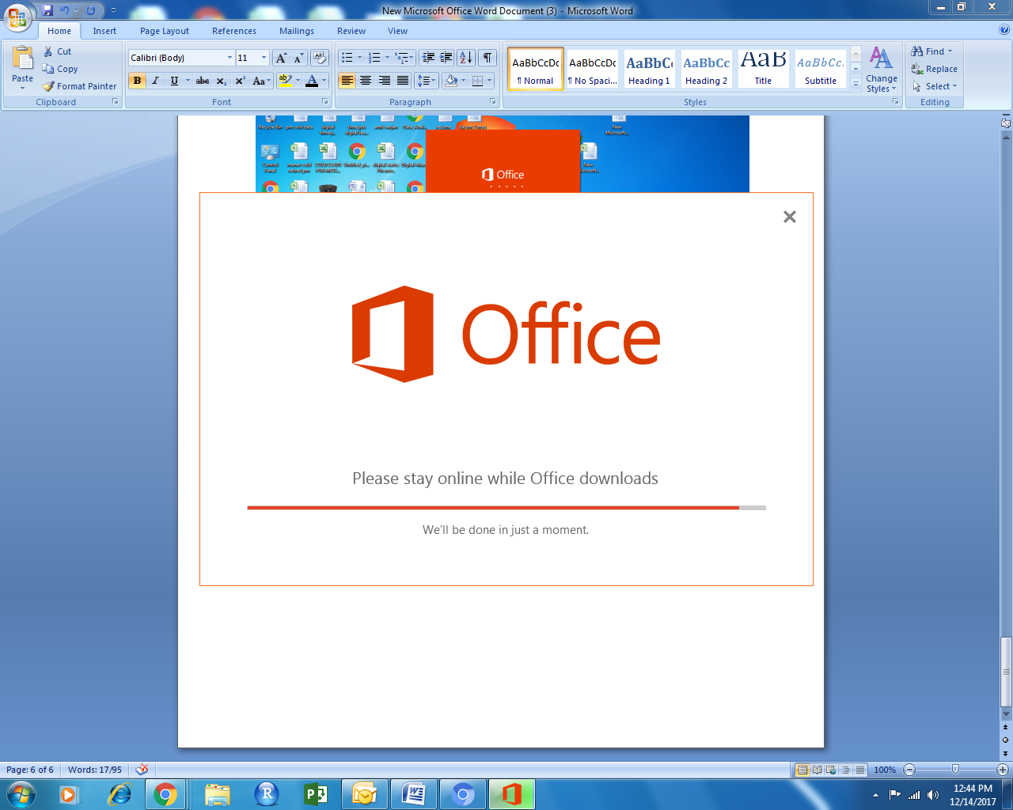

Once it done, close it.

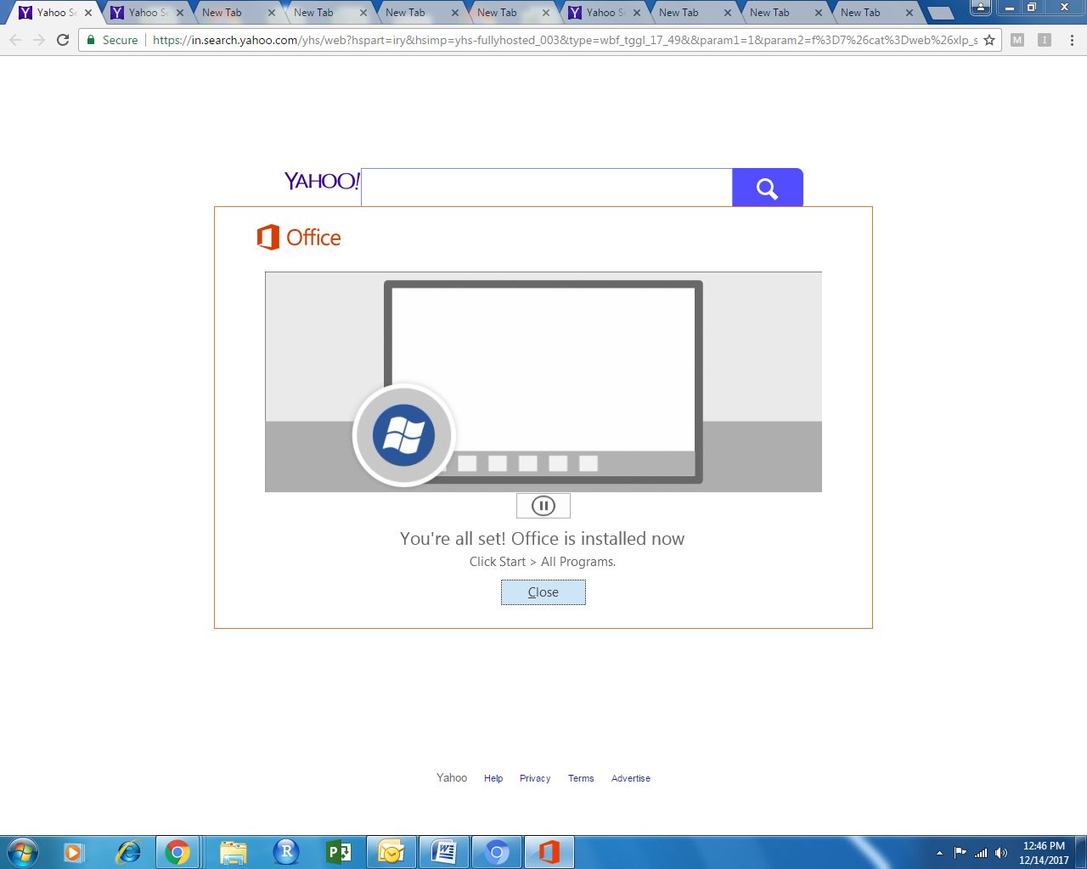

Now it will show a icon on your taskbar.

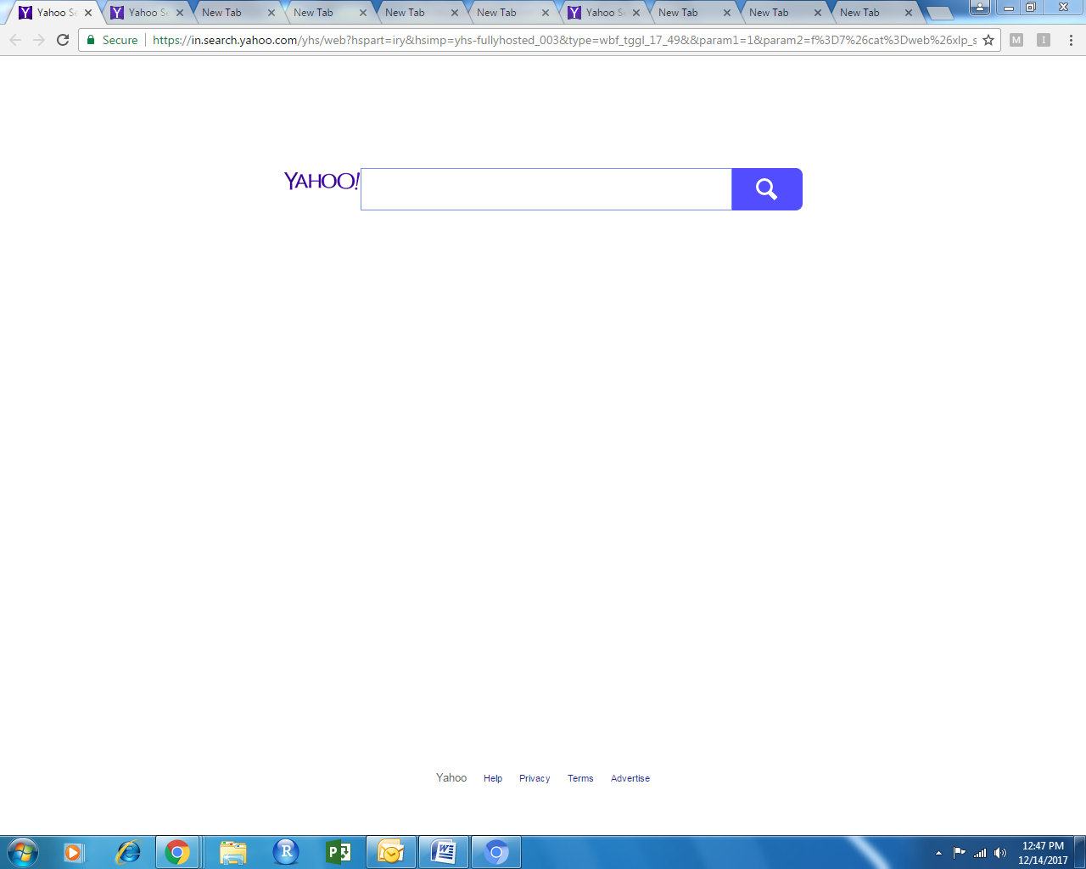

Or you can search it manually as well –

Click on start and type project in search box.

Open project 2016.
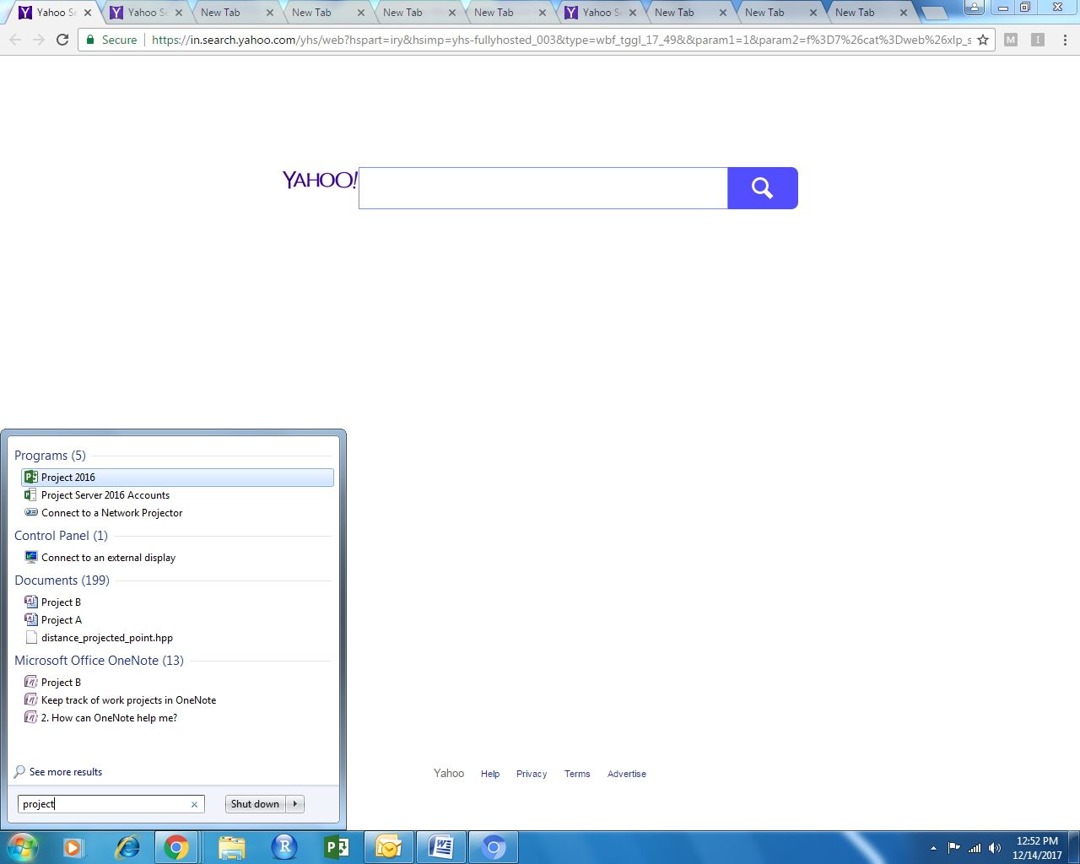

Installation is complete for MS Project.

