General Laws
Lesson 1 of 69

Title VII (U.S.)
This 1964 law prohibits employers from discriminating against employees on the basis of sex, race, color, national origin, and religion. It applies to employers with 15 or more employees, including federal, state, and local governments. Further, this is one of the few U.S. laws that applies to U.S. workers, working for U.S. companies, outside of the U.S.
Title VII can come into play when employers treat women differently than men out of concern for safety and health. An example is the practice of refusing international assignments for women out of fear of terrorism, cultural adaptability concerns or other safety concerns. When such requirements have a disparate impact on women, employers leave themselves open to charges of sex bias under Title VII.
Age Discrimination in Employment Act (US)
Age Discrimination in Employment Act of 1967 (ADEA) Prohibits arbitrary age discrimination against employees or applicants age 40 and older. 1986 amendments abolished mandatory retirement of employees of any age, with a few exceptions. Amendments also require employers to continue making full contributions to employees’ retirement plan accounts until they retire. This is another law that applies to the employees of American-based organizations that are located outside of the United States.
Age Discrimination in Employment Act (US)
Age Discrimination in Employment Act of 1967 (ADEA) Prohibits arbitrary age discrimination against employees or applicants age 40 and older. 1986 amendments abolished mandatory retirement of employees of any age, with a few exceptions. Amendments also require employers to continue making full contributions to employees’ retirement plan accounts until they retire. This is another law that applies to the employees of American-based organizations that are located outside of the United States.
Immigration Reform and Control Act (US)
To ensure that employers do not employ or continue to employ people who are not authorized to work in the United States, the federal Immigration Reform and Control Act (IRCA) provides for an employment verification system. The system requires all employers or other persons that hire, recruit, or refer an individual for employment to:
- Require the employee to produce documents that establish both the employee’s authorization to work in the United States and his or her identity;
- Examine those documents to ensure that they appear to be genuine; and
- Attest on the Employment Eligibility Verification Form (Form I-9) under penalty of perjury that it has verified that the employee is not an unauthorized alien by examination of the documents establishing employment authorization and identity.
An employer complies with IRCA’s document examination requirement when it has examined the employee’s documents and they reasonably appear to be genuine on their face. The employer need not require the production of other documents.
E-Verify
U.S. law (IRCA) requires companies to employ only U.S. citizens, or foreign citizens who have the necessary authorization to legally work in the United States. E-Verify is an Internet-based system that compares information from an employee’s Form I-9, Employment Eligibility Verification, to data from U.S. Department of Homeland Security and Social Security Administration records to confirm employment eligibility.
It compares the applicant’s records against millions of government documents and is very precise in predicting the legality of the application within just a few seconds. Federal contractors are required to use E-verify for all new hires. It is voluntary for most other employers.

North American Free Trade Act (US/Mexico/Canada)
The North American Free Trade Agreement (NAFTA), “Temporary Entry for Business Persons,” authorizes Canadian and Mexican citizens engaged in business activities at a professional level to be employed in the United States by a specific employer.
Foreign Corrupt Practices Act (U.S.)
This act makes it unlawful for certain classes of persons and entities to make payments to foreign government officials to assist in obtaining or retaining business. There are 2 main provisions: (1) addresses accounting transparency requirements under the Securities Exchange Act of 1934, and (2) concerns bribery of foreign officials. It was passed in 1977.

Federal Privacy Act (Australia)
Passed in 1988, this act regulates how personal information is handled. The Privacy Act defines personal information as: “information or an opinion, whether true or not, and whether recorded in a material form or not, about an identified individual, or an individual who is reasonably identifiable” (OAIC.gov.au). Common examples are an individual’s name, signature, address, telephone number, date of birth, medical records, bank account details, and commentary or opinion about a person. It also regulates the privacy component of the consumer credit reporting system, tax file numbers, and health, and medical research.
Americans with Disabilities Act (U.S.)
The ADA (1990) prohibits discrimination and guarantees that people with disabilities have the same opportunities as everyone else to participate in the mainstream of American life — to enjoy employment opportunities, to purchase goods and services, and to participate in State and local government programs and services. Disability is defined as a physical or mental impairment that substantially limits one or more major life activities, a person who has a history or record of such an impairment, or a person who is perceived by others as having such an impairment. (ada.gov)

Directive 95/46/EC, AKA Data Privacy Directive (E.U.)
The Data Privacy Directive of 1995 limits the use of employee information for non-EU countries, like the U.S.
HIPAA (U.S.)
The Health Insurance Portability and Accountability Act of 1996 provides the ability to transfer and continue health insurance coverage when an American changes or loses their job. It was intended to reduce health care fraud and abuse. It also mandates the protection and confidential handling of protected health information (HHS.gov).

Bribery Act (U.K.)
Passed in 2010, this law made it illegal to bribe foreign officials to obtain a business advantage. It identified 4 prime offences: 2 general offences covering the offering, promising, or giving of an advantage, and requesting, agreeing to receive, or accepting of an advantage; 1 discrete offence of bribery of a foreign public official; and 1 new offence of failure by a commercial organization to prevent a bribe being paid to obtain or retain resources/business. (transparency.org.uk)

Employment Contract Act (China)
China has a huge labor force. On June 2016, China’s population was 1.382 billion, according to the United Nations, and makes up 18.72% of the world’s population. Of this number, 764 million are employed in the labor pool. To provide a sense of perspective, the labor pool is more than twice as populated as every man, woman, and child in the United States.
Because of a growing economy, geographic changes, and China’s surplus labor pool, the Chinese government decided to revise the existing labor law. The first major change to it occurred in the mid-1990s, in order to improve workers’ rights by formalizing standards in labor contracts, rights of temporary workers, and severance pay privileges.
The major provisions of this update law are as follows:
- Workers shall be employed under the terms of a contract (either fixed or unfixed-term contracts).
- Employers may only terminate employees during their probationary period for demonstrated failure to perform.
- Workers must receive at least 80% of the standard pay during the probationary period.
- The employment contract may include language about confidentiality and non-compete matters relating to maintaining the confidentiality of trade secrets of the employer and intellectual property.
- Employers are required to consult with the trade union at least 30 days in advance before reducing headcount by 20 employees or more or 10% of the staff.
- Terminated workers shall be paid severance pay based on the number of years worked with the employer at the rate of one month’s wages for each full year worked.
- Union or employee representatives, in equal number with employer representatives, have the right to negotiate and sign a collective bargaining contract that governs labor compensation, working time, rest, leave, work safety and hygiene, insurance, benefit, etc.
- Part-time workers (less than 24 hours per week) are not required to have an employment contract.
Additionally, more changes came into effect on January 1, 2008. It made significant changes from the previous employment laws. The changes in the employment law provide more protection to employees. According to the Association of Corporate Council, the 2 main updates include:
- The employment relationship begins when the employee starts work. The law requires a written employment contract to be entered into when such a relationship is established. However, if the employment relationship is established before a written contract is entered into, then the parties have one month to work on an employment agreement.
- The information on the employment contract must include:
  - The employer’s name, domicile, legal representative, or major person-in-charge;
  - The employee’s name, domicile, identity card number, or other valid identity certificate number;
  - The term of the labor contract;
  - The job descriptions and work locations;
  - The work hours and break time;
  - The remuneration;
  - The Social Security information;
  - The employment protection, work conditions, and protection against and prevention of occupational harm; and
  - Other items that shall be included in the labor contract under any laws or regulations.

Contract Labor Act (India)
The Contract Labor Act (CLA) in India applies to any establishment that employed 20 or more workmen on any given day in the preceding 12 months. Essentially, this law forbids the hiring of temporary workers. Further, it calls for a myriad of physical facilities to be provided for workers (e.g. canteen, restrooms, drinking water, first aid facilities, etc.) Also, women may not be employed on night shifts.
The use of contract labor was a common occurrence in India. Historically, workers did not work directly for the company but were hired through a contractor. Contractors/employers traditionally hired and discarded these contracted temporary workers using substandard and deplorable techniques (e.g. failed to pay promised wages, unsafe working conditions, etc).
The CLA was established to regulate the contract employment industry. Now, contractors must:
- Pay workmen on time and in the presence of a company representative, and
- Create and maintain a muster roll (roster).
Workmen must sign off on their pay slips. The government may require the principal employer to absorb workers into the company as full-time, regular employees if the “contracted employment relationship” was a ruse to avoid hiring permanent workers even though they are being worked in a semi-permanent system.
Labor Law (UK)
U.K. Labor Law is the body of law which regulates the rights, and obligations of trade unions, workers and employers in the United Kingdom. Labor law, often also referred to as employment law has developed rapidly over the past forty years, due to a historically strong trade union movement and the United Kingdom’s former membership in the European Union (joined in 1973; left in 2017). In its current form, it is largely a creature of statute rather than common law. Leading employment law statutes include the Employment Rights Act of 1996, the Employment Act of 2002 and various legislative provisions outlawing discrimination on the grounds of sex, race, disability, sexual orientation, religion and, from 2006, age.
The UK Employment Law system is broadly similar across the whole of the UK. Although there are some differences in the common law between England, Wales, Scotland, there is little difference in employment law across this region. One exception to the region is Northern Ireland’s extra anti-discrimination legislation that deals religion, community affiliation or political affiliation, which is quite distinct from the laws on religious discrimination in Great Britain.
Employment Rights Act 1996
The Employment Rights Act 1996 (ERA) was passed originally by the Conservative government in 1996. It consolidated a number of previous statutes dating from the Contracts of Employment Act of 1963. It deals with rights that most employees can get when they work, including unfair dismissal, reasonable notice before dismissal, right to a tribunal, written contract, flexible work, time off rights for parenting, redundancy, lost earnings, and more.
Employment Act of 2002
The main areas covered by the Act are maternity leave and pay, paternity and adoption leave and pay, dismissal, disciplinary and grievance procedures, flexible working and fixed term employee rights. Fixed term workers now have a right not to be treated less favorably than comparable permanent employees, on the grounds that they are fixed term employees.

Workforce Relations Introduction
Lesson 2 of 69
Global corporations are challenged with the complications that arise when dealing with a number of different legislative frameworks and a variety of linguistic and cultural relationships while simultaneously maintaining a happy and productive international workforce. The specific strategies of engaging a global staff vary from country to country but the mission of achieving the most advantageous productivity levels remains the same.
The key to developing a world class operation is talent management. Talent retention through superior employee relations, implementation, and execution is the foundation for managing a culturally diverse workforce. By bringing stability to the workforce, the organization is able to develop a consistency of service and performance to the markets they serve, even in different countries and cultures.
Standardization versus localization is a critical issue that organizations must balance in order to succeed. Whether to go with one global system that is equally applied in all international locations or to allow for local adaptation, global corporations must keep the gaps in structures and policies to a minimal level in order to achieve consistent performance.
While many aspects of the international system may be standardized, localizing grievance procedures, disciplinary issues, and investigations brings flexibility and greater employee acceptance. Applying blanket and rigid homogeneity in global policy across all geographical locations is often catastrophic. Taking a one size fits all approach to global employee relations has limited applicability. Thus, a standard employee relations program, with the ability to localize, has superior benefits and approval by local workforces.
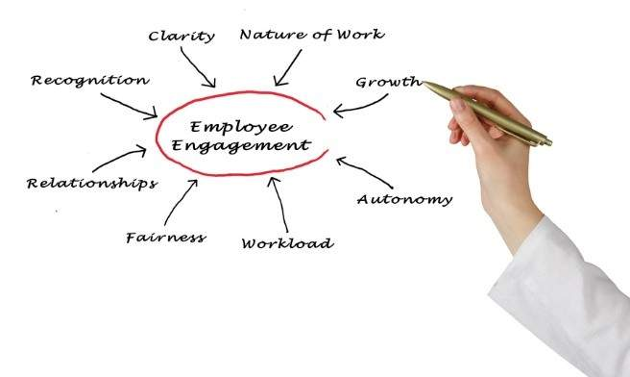
Employee Engagement
Global Human Resource professionals have intuitively known for years that an engaged workforce provides many intangible benefits and can be linked to retention. Employee engagement is the extent to which workforce commitment, both emotional and intellectual, exists relative to accomplishing the work, mission, and vision of the organization. Employee engagement can be seen as a heightened level of ownership, where each employee wants to do whatever they can for the benefit of their internal and external customers, and for the success of the organization as a whole. The three commonly accepted components of employee engagement are: employee commitment, how well they participate in the work, and their longevity.
It has been routinely found that employee engagement scores account for as much as half of the variance in customer satisfaction scores. This translates into millions of dollars for companies if they can improve their scores. Studies have statistically demonstrated that engaged employees are more productive, more profitable, more customer-focused, safer, and less likely to leave their employer.
Employee relations programs (how employees are treated) serve a large role in creating, developing, and maintaining employee engagement.
Assessment of Employee Attitudes
In today’s multinational corporations, the employee attitude survey is both a tool for collecting information and a way to facilitate strategic decision-making.
However, surveys take time to design and analyze properly, and they require a commitment from management to consider and respond to the results.
As a diagnostic tool measuring employee attitudes, surveys are extremely valuable in the development of HR programs that promote shared values and a common purpose.
Surveying employees enables management to:
- Gather data on attitudes to use as a yardstick in measuring change;
- Identify the causes and solutions for such problems as an increase in turnover or a downturn in productivity; and
- Give meaning to the phrase “employees are our most valuable resource,” by showing employees that their opinions count.
The popularity of employee attitude surveys has increased over the past six decades to the point that surveys are now a common HR practice. Most early workforce surveys measured job satisfaction or employee morale, emphasizing that a satisfied worker is a more productive worker. In recent years, however, employers have found many other uses for attitude surveys.
One method of improving organizational effectiveness through surveys is known as action research.
Action research is a development process that uses employee attitude surveys to provide a framework for action planning, implementation, and change management.
An entire survey project cycle consists of three sequential phases:
Design Phase
The research process begins by defining objectives, determining priorities, establishing realistic expectations, and custom-developing a questionnaire that covers a limited set of relevant topics.
Data Collection Phase
Once the questionnaire has been developed and the decision made to proceed, data collection begins.
Deployment Phase
The most important part of a successful action research program is using the results to put words into action. Deployment begins with a feedback process that includes refining the results (i.e., looking behind the numbers) and continues through the action planning process.
The choice of statistics and the format for reporting results can appear to be objective, but data analysis is a process that leaves room for judgment and interpretation. Data analysis is not neutral. Data can be analyzed, summarized, interpreted, and presented in a variety of ways. The same data can reveal a variety of simple frequencies, such as “85% did not feel the balance sheet approach adequately compensated them for their international assignment” or “55% of employees had neutral responses about the competitiveness of our benefits package for assignees” or “Only 30% thought our benefits are uncompetitive.”

Human Resource Management (HRM)
There are two broad approaches to the management of the HR function: Hard HRM versus Soft HRM. Hard HRM treats employees as a resource of the business, just like a machine. Soft HRM treats employees as if they truly are the most important resource in the business and a source of competitive edge.
Most global HR departments adopt elements of both approaches depending on the countries of operation and the degree of standardization applied to international policies and practices. However, to be successful on the GPHR exam, the certification candidate must understand the differences between these two conflicting theories.
Hard HRM
- Autocratic leadership style.
- Appraisals are focused on performance evaluation.
- Pay only enough to attract and retain a staff.
- Short term focus on staffing levels. Very reactionary.
- Strong link with corporate business planning in regards to their availability and cost.
- Minimal communication from top down.
- Little focus on employee engagement.
- Pyramid management structure.
- Identifies the needs of the business and staffs accordingly (hiring, laying off, etc.).
Soft HRM
- Democratic or Theory Y leadership style.
- Appraisals are focused on professional development.
- Competitive pay with performance related rewards such as profit sharing, bonuses, etc.
- Strategic focus on long-term staffing levels. Proactive approach.
- Employees are valued for their individuality and their needs are accommodated.
- Two-way communication systems are established and used.
- Employees are engaged and empowered.
- Decentralized and flattened management structure.
- Concentration on the needs of the employees.
The “hard” approach to HR might be expected to result in a more cost-effective workforce where decision-making is quicker and focused on senior managers. However, such an approach pays relatively little attention to the needs of employees and a business adopting a genuinely “hard” approach might expect to suffer from higher absenteeism and staff turnover and less successful recruitment. Also, there is a persuasive argument for an approach which rewards employee performance and motivates staff more effectively. However, the danger of taking too “soft” an approach is that when all the employee benefits are added up, the cost of the workforce leaves a business at a competitive disadvantage.
Psychological Contract
The psychological contract is the unwritten relationship between the employee and the employer that binds them together in the pursuit of both organizational and personal success. In its simplest form, the employer expects the employee to perform well in return for being treated and paid well. However, this issue is much deeper and complex.
This relational balance between the employer and employee is somewhat explained by Vroom’s “Expectancy Theory.” As stated above, employees who perform well, expect to be treated and rewarded well. Employees who perform poorly should expect poor relations with their employer. In other words, the more the employee puts into the job, the higher the expectation for favorable treatment by the employer.
Additionally, employee expectations may form the basis of the psychological contract when they feel they have been promised something by a superior. This is especially common when miscommunications during the onboarding process result in the creation of expectations that fail to materialize. It is important to note that this is not one-sided. Sometimes, the employee fails to deliver on their potential or promise in regards to job performance. This is often too common of a result for workers on international assignment. More on this later.
This sense of expectation creates an unwritten and undefined bond between both parties. This bond is a tenuous relation that can be shattered when one or the other breaks the “rules,” such as what happens during layoffs, mergers, obsolescence, etc. It is common for laid off workers to feel anger and resentment towards their employer since they have not broken the covenants of the psychological contract and done nothing personally to deserve the loss of their job.
Even employees who were not personally affected by a layoff may suffer negative morale by observing the treatment of their fellow workers. Perceptions that the psychological contract has been violated may result in performance declines, reduced loyalty/engagement, lack of commitment, and an increase in employee misbehavior.
Procedural Justice
Procedural justice is concerned with providing employees a structured system for resolving disputes that is considered to be fair and impartial. People feel affirmed if the procedures that are adopted treat them with respect and dignity, making it easier to accept even outcomes they do not like. The idea of “due process” is critical to the concept of procedural justice.

Alternative Dispute Resolution (ADR)
Alternative dispute resolution (ADR) is a general term used to describe problem-solving mechanisms other than lawsuits or government agency investigations. ADR is a method for resolving employer and employee grievances without involving a court system. Employers using ADR mechanisms typically have two goals: to prevent lawsuits and to minimize the time and expense of resolving employees’ complaints.
The explosion in the quantity and cost of employment litigation has inevitably led to the use of innovative alternative dispute resolution techniques— mediation, conciliation, arbitration, negotiated rulemaking, and other consensual methods of resolving disputes. ADR is considered to be faster, less contentious, and more economical than litigation.
ADR— in the form of negotiated grievance and arbitration procedures— has been the norm for decades in some countries. The continuing increase in employment litigation has led to calls for the use of ADR from employers, government agencies, and the legal system. Typical examples of ADR include mediation and arbitration.
Mediation and Conciliation
Mediation is a non-binding dispute resolution technique in which parties discuss their disputes with a trained, impartial outsider who assists them in attempting to reach a mutually acceptable agreement. While mediators may suggest a variety of means through which to settle a dispute, mediators do not have the authority to impose a settlement on the parties.
Internal mediation, in which the mediator is a neutral party from inside the company, is becoming a popular variation. Although it increases the ease and lowers the cost of obtaining a mediator, internal mediation presents management with a more difficult burden in demonstrating the mediator's neutrality and confidentiality, which are crucial in inducing employees' meaningful participation.
Employers can use mediation as the exclusive means of resolving disputes, or mediation can coexist with other forms. For example, grievances that remain unresolved after several steps of a grievance procedure can be submitted to mediation. Similarly, mediation may be permitted or required as a prelude to arbitration. Some countries require disputes to be mediated prior to submittal to the legal system.
Arbitration
Arbitration is a semiformal trial before one or more trained arbitrators who receive testimony and evidence from the parties. The arbitrator can make factual determinations and award relief. Usually, the arbitrator's decision is binding on the parties, although an employee might later file a lawsuit disputing the binding nature of the arbitration proceeding.
A variant of arbitration is non-binding arbitration. This is an agreement between the parties that the opinion of the arbitrator is advisory only. This procedure is more in the nature of fact-finding. It lacks the finality of typical arbitration procedures and therefore may not represent the best investment of time and resources.
Arbitration as the Final Step to Other ADR Procedures
Arbitration is often combined with a grievance procedure and/or mediation, which precede a formal arbitration hearing. Under this arrangement, the matter will proceed to arbitration only if the dispute cannot be resolved through these less formal processes.
Ombudsman
A corporate ombudsman is an individual appointed to investigate internal complaints, report findings, and facilitate equitable settlements. According to surveys, appointing an internal ombudsman is one of the most-often used forms of ADR. Mediation is also frequently used.
The ombudsman’s tasks are to listen, decide whether and how to intervene, and provide feedback. Unlike HR and employee relations officials, who represent management, ombudsmen are neutral.
An ombudsman may have exceptional latitude in deciding how to intervene, but no power to impose a binding result. One view is that any intervention should aim toward making the organization's existing structures— such as a grievance procedure— work properly. To that end, a rule of thumb is to intervene at the lowest possible management level

Cultural Sensitivity and Global Diversity
Lesson 3 of 69

A critical challenge for a multinational enterprise (MNE) is to balance its organization-wide employee relations programs with the complexities of a global workforce. Different legislative frameworks, and a variety of linguistic and cultural relationships add to the mix. Usually, handling cultural sensitivity and global diversity are the greatest test to the international organization.
Being sensitive to cultural differences and nuances is just one aspect of an overseas assignment. Today, recognizing those differences is crucial now that more and more companies target fast-growing foreign markets, while requiring their managers and executives to have international experience. This global experience is essential to help organizations understand commonly held assumptions about national cultural differences between peoples, such as:
- Germans dislike uncertainty.
- French are inclined to be skeptical and self-critical.
- Japanese place a high importance on correct form and ceremony.
- Swedes prefer decision-making based on consensus.
- British have a high tolerance for ambiguity and use humor in ways that foreigners often find puzzling.
- Americans are less formal than Europeans.
Translators and Interpreters
One way to bridge the gap between cultures is to employ/consult with translators and/or interpreters. These people are specifically trained to take into account certain nuances and behaviors (a handshake with the left hand, or a specific phrase) that could help or harm a budding business relationship. According to the NOTA Translators in Ohio, interpreters deal with spoken language and translate orally, while translators deal with written text, transforming the source text into a comprehensible and equivalent target text.
The key skill of a good translator is the ability to write well and express oneself clearly in the target language. That is why professional translators almost always work in only one direction, translating only into their native language. Even bilingual individuals rarely can express themselves in a given subject equally well in two languages, and many excellent translators are far from being bilingual.
The key skills of the translator are the ability to understand the source language and the culture of the country where the text originated, and, using a good library of dictionaries and reference materials, render that material into the target language. An interpreter, on the other hand, has to be able to translate in both directions, without the use of any dictionaries, on the spot.
Expatriates
The number of Americans working overseas, most commonly referred to as “expatriates,” has increased in recent years. Most multinational corporations (MNCs) expect this growth to continue. Many of those who work abroad see an international assignment as an exciting, rewarding, sometimes even glamorous career move. Still, gaining those new-found business and management skills may come as a culture shock for the uninitiated. It can also mean a loss for the company that doesn't utilize the skills of these wayfaring employees upon their return.
Both the employee and the company must be clear on the reasons why the assignment is being undertaken and what is expected.
The successful expatriate is an open-minded, flexible individual, who is willing to take risks. They need more than just professional and technical skills to thrive; they must also have the ability to adapt to different cultures. This is known as a “global mindset.”
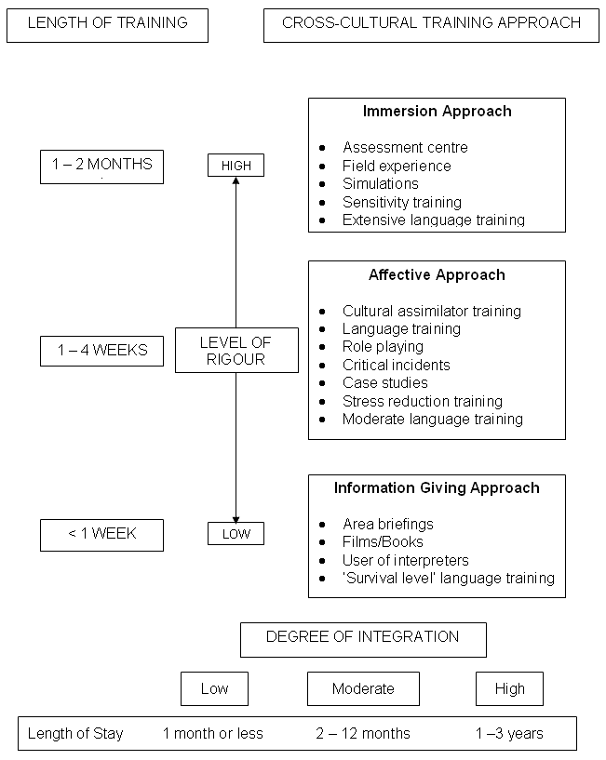
Figure 1.1: Example of Pre-Departure Training
Source: Chew, J. (2004). Managing MNC Expatriates through Crises: A Challenge for International Human Resource Management, Research and Practice in Human Resource Management, 12(2), 1-30.
That’s where cross-cultural training is important. Yet, despite the increase in the number of overseas assignments, many U.S. firms don’t provide employees with cultural and language education. A recent survey conducted by Runzheimer International, a Wisconsin-based management consulting firm, found only 42% of the 54 multinational companies polled had any formal training program for acculturating expatriates with their host country.
Even those employees who are independent and well-traveled should get some form of cultural or language training before departing. For example, some expatriates may expect America’s strong work ethic to cross all borders. As a result, they may misinterpret the more relaxed attitude towards work seen in many European countries as laziness, for example. The key to global competency is to develop the skills to cope, and that means integrating into the dominant culture and realizing how to properly interpret and analyze behavior.

Cultural Diversity
Lesson 4 of 69
The business case for diversity theorizes that in a global marketplace, a company that employs a diverse workforce (both men and women, people of many generations, people from ethnically and racially diverse backgrounds, etc.) is better able to understand the demographics of the marketplace it serves, and is thus better equipped to thrive in that marketplace than a company that has a more limited range of employee demographics.
An additional corollary suggests that a company that supports the diversity of its workforce can also improve employee satisfaction, productivity, and retention. This portion of the business case, often referred to as inclusion, relates to how an organization utilizes its various relevant diversities. If a workforce is diverse, but the employer takes little or no advantage of that breadth of experience, then it cannot monetize whatever benefits background diversity might offer.
Most modern industrialized countries have employment laws that forbid discriminatory exclusion of classes of peoples. Examples include:
Directive 76/207/EEC Equal Treatment (European Union)
The purpose of this 1976 Directive is to require the Member States of the EU to implement and enforce the principle of equal treatment for men and women in regards to access to employment. Included in this is:
- Promotion
- Vocational training
- Working conditions
- Social Security
The equal treatment of male and female workers constitutes a fundamental objective of the EU Community, in so far as the harmonization of living and working conditions are maintained.
The most recent amendment was in 2006 where Council Directive 2006/54/EC was passed. It has been described as a Directive “on the implementation of the principle of equal opportunities and equal treatment of men and women in matters of employment and occupation.”

Employment Equity Act (Canada)
The 1995 Employment Equity Act refers to Canadian policies that require or encourage preferential treatment in employment practices for certain designated groups:
- Women
- People with disabilities
- Aboriginal peoples
- Visible minorities
Employment equity goes beyond mere non-discrimination in requiring these specific groups be targeted for proactive treatment.
In most Canadian universities, people of Aboriginal background normally have lower entrance requirements and are eligible to receive exclusive scholarships. Some provinces and territories also have affirmative action-type polices. For example, in the Northwest Territories, Aboriginal people are given preference for jobs and education. In some instances, people are hired for jobs that have lesser credentials than other people applying, because their status is higher.
Extraterritorial Application of U.S. Laws
U.S. multinational organizations must comply with three specific U.S. anti-discrimination statutes. The Age Discrimination in Employment Act (ADEA), the Americans with Disabilities Act (ADA), and the Title VII Civil Rights Act of 1964 apply to U.S. citizens employed by U.S. companies anywhere in the world. These laws enable U.S. expatriates to bring lawsuits against American employers for alleged violations in any country in the world. The lawsuit would be filed in a U.S. court. Thus, an employee terminated based on age in Brazil may file suit in the U.S. against the parent company.
Generally, expatriates in foreign countries must obey the local laws since they hold precedence in any legal matters. In many cases, a multinational corporation (MNC) must understand that the local laws, not its home laws, hold precedence, although in some cases home laws still apply.
Next, let’s take a look at the European Union and the way this large conglomerate of countries has evolved its employee relations programs and regulations

European Union
Lesson 5 of 69
The European Union (EU) is a supranational and intergovernmental union of approximately 30 democratic member states in Europe (the number of members is continually changing).
The EU was established under that name in 1992 by the Treaty on European Union (Maastricht Treaty). Many aspects of the Union existed before then through a series of predecessor relationships, dating back to 1951.
The process of the European integration is considered to be open-ended. Membership, competences, tasks, and goals have expanded since the Treaty of Rome (the treaty that established the European Economic Community). While supporters believe the integration is a necessary answer to globalization, critics fear that it will ultimately deprive member states of their national sovereignty.
The EU has evolved from a western European trade body into the supranational and intergovernmental body that it is today. After the Second World War, an impetus grew in Western Europe for institutional forms of cooperation between states, driven by the determination to rebuild Europe and eliminate the possibility of another World War. Eastern Europe, on the other hand, was largely within the Soviet sphere of influence, and only in the 1990s did the EU see central and eastern European states as potential members.
The most prominent policy goal of the European Union is the development and maintenance of an effective single market.
Significant efforts have been made to create harmonized standards designed to bring economic benefits through creating larger, more efficient markets. Since the Treaty of Rome, policies have implemented free trade of goods and services among member states, and continue to do so. Common EU competition law restricts anti-competitive activities of companies (through antitrust law and merger control) and member states (through the State Aids regime).
The EU promotes free movement of capital between member states and other European Economic Area (EEA) states. The members have a common system of indirect taxation, the Value Added Tax (VAT), as well as common customs duties and excises on various products. They have a common external customs tariff, and a common position in international trade negotiations. Other single-market policies include energy market policy and the European Common Aviation Area.
The introduction of the euro, not yet adopted by all member states, created the Eurozone, a single-currency area including about half of the member states with more than 300 million people. A second major goal has been the free movement of persons.
Citizens of member states can live and work anywhere within the EU with their spouses and children, provided they can support themselves. They may freely move between member states for employment reasons without the necessity of visas or other documentation/permission. This also applies to other EEA states and Switzerland.
Important EU institutions and bodies include the European Commission, the Council of the European Union, the European Council, the European Central Bank, the European Court of Justice, and the European Parliament, which is directly elected by EU citizens once every five years.

European Commission
The European Commission (formally the Commission of the European Communities) is the executive body of the European Union. Alongside the European Parliament and the Council of the European Union, it is one of the three main institutions governing the Union.
Its primary roles are to propose and implement legislation, and to act as “guardian of the treaties” which provide the legal basis for the EU. The Commission consists of 28 Commissioners, one from each member state of the EU, supported by an administrative body of about 23,000 European civil servants divided into departments called Directorate-General. The term “the Commission” is generally used to refer to both the administrative body in its entirety, and the team of Commissioners who lead it.
Unlike the Council of the European Union, the Commission is intended to be a body independent of member states.
The Commission is headed by a President. Its headquarters are located in Brussels, in a building known as the Berlaymont, and its working languages are English, French, and German.

Global Privacy Laws
Lesson 6 of 69
Directive 95/46/EC Protection of Personal Data (EU)
Directive 95/46/EC addresses the protection of individuals with regard to the processing of personal data and the free movement of such data. The right to privacy is a highly developed area of law in Europe. All the member states of the EU are also signatories of the European Convention on Human Rights (ECHR). Article 8 of the ECHR provides a right to respect for one's “private and family life, his home, and his correspondence,” subject to certain restrictions.
The two overall objectives of the Directive are the protection of information privacy by Member States of the EU, and the prevention of restrictions on free flow of personal information between EU Member States. The Directive, therefore, aims to create a European zone of free information flow in relation to personal information, by requiring a uniform minimum standard of privacy protection across the EU, while at the same time restricting the flow of privacy information outside the zone. Additionally, the Directive requires that transfers of personal data take place only to non-EU countries that provide an “adequate” level of privacy protection.
There are heavy restrictions on transfer of personal data between Member States and the laws aim to regulate how companies transmit personal information to countries the EU says lack “adequate” privacy laws, including the United States. To date, the U.S. has no single, overarching privacy law comparable to the EU Directive.
Some restrictions include:
- Limits on the amount of information companies can collect.
- Curbs on a company's ability to share personal data with marketers or even its own affiliates.
- Allowances for individuals to see and correct their information.
- Requirements for companies to erase personal data after a short time.
With the advent of the internet and especially email, multinational companies must take precautions when attempting to publish employee data to branches located outside of the EU.
The level of protection is essentially the same in both the public and private sectors, with no formal distinction made between the rules applying in the two sectors.
Seven Principles of Privacy
In 1980, in an effort to create a comprehensive data protection system throughout Europe, the Organization for Economic Cooperation and Development (OECD) issued its “Recommendations of theCouncil Concerning Guidelines Governing the Protection of Privacy and Trans-Border Flows of Personal Data.” The seven principles governing the OECD’s recommendations for protection of personal data were:
- Notice – data subjects should be given notice when their data is being collected,
- Purpose – data should only be used for the purpose stated and not for any other purposes,
- Consent – data should not be disclosed without the data subject’s consent,
- Security – collected data should be kept secure from any potential abuses,
- Disclosure – data subjects should be informed as to who is collecting their data,
- Access – data subjects should be allowed to access their data and make corrections to anyinaccurate data, and
- Accountability – data subjects should have a method available to them to hold data collectorsaccountable for following the above principles.
To diminish uncertainty and provide a more predictable framework for data transfers, the U.S Department of Commerce has adopted these seven principles under its statutory authority to foster, promote, and develop international commerce. These principles will assist and facilitate trade and commerce between the United States and European Union. They are intended for use solely by U.S. organizations receiving personal data from the European Union for the purpose of qualifying for the safe harbor and the presumption of “adequacy” it creates.

Safe Harbor Privacy Provisions
A safe harbor is a provision of a statute or a regulation that reduces or eliminates a party's liability under the law, on the condition that the party performed its actions in good faith. Legislators include safe-harbor provisions to protect legitimate or excusable violations. One such example is the agreement between the United States and the European Union in regard to the protection of personal data regarding employees. Personal data is data about an identified or identifiable individual that is recorded in any form.
While the United States and the European Union share the goal of enhancing privacy protection for their citizens, the United States takes a different approach to privacy from that taken by the European Community. The United States uses a sectored approach that relies on a mix of legislation, regulation, and self-regulation. Given those differences, many U.S. organizations have expressed uncertainty about the impact of the EU-required “adequacy” standard on personal data transfers from the European Community to the United States.
The old US-EU Safe Harbor was a streamlined process for U.S. companies to comply with the EU Directive 95/46/EC on the protection of personal data. Intended for organizations within the EU or U.S. that store customer data, the Safe Harbor Principles are designed to prevent accidental information disclosure or loss. U.S. companies can opt into the program if they adhere to the seven principles outlined in the Directive.
Per the European Union website, “the EU-US Privacy Shield reflects the requirements set out by the European Court of Justice in its ruling on October 6, 2015, which declared the old Safe Harbor framework invalid. The new arrangement will provide stronger obligations on companies in the U.S. to protect the personal data of Europeans and stronger monitoring and enforcement by the U.S. Department of Commerce and Federal Trade Commission (FTC), including through increased cooperation with European Data Protection Authorities. The new arrangement includes commitments by the U.S. that possibilities under U.S. law for public authorities to access personal data transferred under the new arrangement will be subject to clear conditions, limitations and oversight, preventing generalized access. Europeans will have the possibility to raise any enquiry or complaint in this context with a dedicated new Ombudsperson.” This information is too new to be included on the current version of the test, but will likely be amended on any future versions.
Federal Privacy Act (Australia)
The Federal Privacy Act of 1988 is Australia’s national law for the protection of personalinformation, when handled by federal and Australian Capital Territory (ACT) government agencies and many private sector organizations. The Act provides rights for individuals to access and correct personal information about themselves. The Privacy Commissioner issues guidelines under the Privacy Act and administers the Act.
Generally, the Information Privacy Principles give people the right to:
- Know why personal information is being collected, and who it will be given to;
- Have access to their records;
- Have inaccurate information about them amended; and
- Be sure that information about them can only be used and disclosed for particular reasons, such as threats to life or health.
The Privacy Act of 1988 provides protection of personal information such as information about a person’s disability. Privacy principles set the basic rules for handling people’s information, but their intent is also, and importantly, to encourage agencies and organizations to be open with people about how they handle their information and to develop trust relationships with them about this

European Works Council
Lesson 7 of 69

A works council is a “shop-floor” organization representing workers, which functions as a local/firm-level complement to national labor negotiations. Works councils exist with different names in a variety of related forms in a number of European countries, including Germany (Betriebsrat), the Netherlands and Belgium (Ondernemingsraad), France (Comité d'Entreprise), Belgium (Conseil d'Entreprise), and Spain (Comité de empresa).
A works council is a deliberative assembly, composed of working class members, intended to facilitate workers’ self-management or workers’ control.
Unlike in a trade union, in a works council the workers are assumed to be in actual control of the workplace, rather than merely negotiating with employers through collective bargaining. They are a form of “workplace democracy.”
Council Directive 94/45/EC (EU)
Council Directive 94/45/EC of September 22, 1994 allows for the establishment of a European Works Council or a procedure for informing and consulting employees in every community-scale undertaking and every community-scale group of undertakings, following agreement between the central management and a special negotiating body.
The special negotiation body, comprising a minimum of 3 and a maximum of 18 members will:
- Have the task of determining, with the central management, by written agreement, the scope, composition, competence, and term of office of the European Works Council(s), or the arrangements for implementing a procedure for the information and consultation of employees;
- Decide, by at least two-thirds of the votes, not to open negotiations or to terminate the negotiations already opened; such a decision would stop the procedure to conclude the agreement and would nullify the provisions of the Annex; and
- Not be authorized to reveal any information which has expressly been provided to them in confidence; this pertains to members of the special negotiating body, the European Works Council, and any experts who assist them.
Subsidiary Requirements
Subsidiary requirements, laid down by the legislation of the Member State in which the central management is situated, will apply where:
- The central management and the special negotiating body so decide, or;
- The central management refuses to commence negotiations within 6 months of the initial request to convene the special negotiating body, or;
- After 3 years from the date of this request, they are unable to conclude an agreement to establish a European Works Council or an information and consultation procedure, and the special negotiating body has not taken the decision not to open negotiations or to terminate the negotiations.
These subsidiary requirements must satisfy the provisions set out in the Annex (an addition to the EU Council Directive), whereby:
- The competence of the European Works Council will be limited to information and consultation on matters which concern the Community-scale undertaking as a whole or at least two establishments or group undertakings situated in different Member States;
- The European Works Council is to have a minimum of 3 and a maximum of 30 members and, where its size so warrants, is to elect a select committee from among its members, comprising at most 3 members;
- 4 years after the European Works Council is established, it is to consider whether to open negotiations for the conclusion of the agreement on the arrangements for implementing the information and consultation of employees, or to continue to apply the subsidiary requirements adopted in accordance with the Annex;
- The European Works Council will have the right to meet with the central management once a year in order to be informed and consulted on the basis of a report drawn up by the central management, and on the progress of the business of the Community-scale undertaking or Community-scale group of undertakings and its prospects;
- Where there are exceptional circumstances affecting the employees' interests to a considerable extent (particularly in the event of relocation, closure, or collective redundancy), the select committee (or the European Works Council if there is no committee) will have the right to be informed;
- The members of the European Works Council are to inform the employees' representatives of the content and outcome of the information and consultation procedure; and
- The operating expenses of the European Works Council are to be borne by the central management; in compliance with this principle, the Member States may lay down budgetary rules regarding the operation of the European Works Council.
Background
The purpose of Council Directive 94/45/EC is to improve the right of employees in community-scale undertakings and community-scale groups of undertakings to be informed and consulted.
Directive 97/74/EC extends the scope of this directive to the United Kingdom

Transfer of Undertakings and Protection of Employment (TUPE)
Lesson 8 of 69
The Transfer of Undertakings (Protection of Employment) Regulations 2006 (SI 2006/246, also referred to as TUPE 2006) is the main piece of legislation governing the transfer of an undertaking (aka a business), or part of one, to another in the EU. The regulations are designed to protect the rights of employees in a transfer situation, enabling them to enjoy the same terms and conditions, with continuity of employment, as formerly. TUPE 2006 entirely replaces the Transfer of Undertakings (Protection of Employment) Regulations 1981 (SI 1981/1794).
TUPE regulations were introduced to comply with relevant EC Directives concerning transfers of undertakings. The main Directives are:
- Acquired Rights Directive (77/187/EEC)
- Acquired Rights Directive (98/50/EC)
- Acquired Rights Amendment Directive (2001/23/EC).
TUPE has been found to apply to:
- Mergers,
- Sales of a businesses by sale of assets,
- A change of licensee or franchisee,
- The gift of a business through the execution of a will,
- Contracting out of services, or
- Changing contractors where all or part of a sole trader’s business or partnership is sold or otherwise transferred.
However, TUPE does not apply to:
- Transfers by share take-over;
- Transfers of assets only (for example, the sale of equipment alone would not be covered, but the sale of a going concern – i.e. it has enough resources to stay afloat and not go bankrupt –including equipment would be covered);
- Transfers of a contract to provide goods or services where this does not involve the transfer of a business or part of a business; or
- The supply of goods for the client’s use, for example, supplying food to a client to sell in its staff canteen, rather than a situation where the contractor runs the canteen for the client.
The table below sets out different categories of dismissal and whether they are fair or unfair under TUPE.
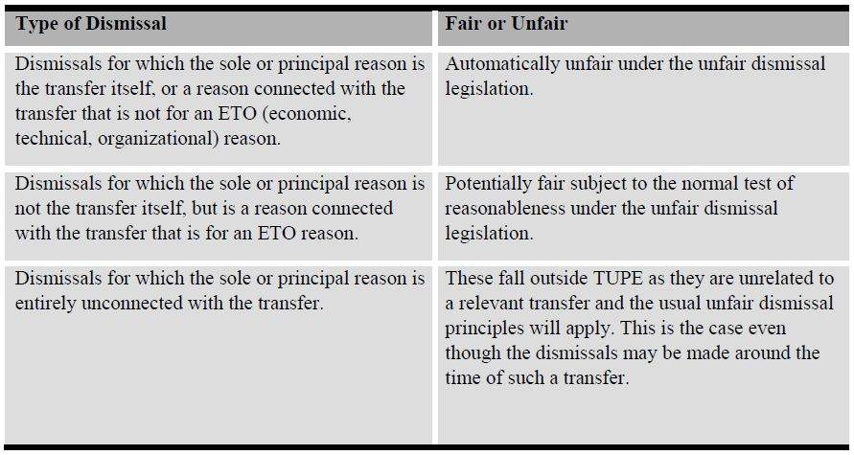
The economic, technical, or organizational (ETO) reason relating to the entity which is being transferred is one of the few legitimate factors for the basis of a refusal to take on the transferor's workforce by the prospective transferee. The reason has to be the main cause of the dismissal, thus making the dismissal justifiable provided an employment tribunal decides that the employer acted reasonably in all circumstances. If it can be shown that the economic reasons were a “sham,” and that the workforce were not taken on in order to avoid the application of the TUPE regulations, then the transferee could be liable for potential claims.
Employees with less than one year of service cannot usually present claims under TUPE as employment protection rights have not been accrued.
TUPE is a complex area, so it is essential to seek legal advice for individual circumstances. When a business (or part of one) is being transferred, both parties (the transferor and the transferee) should seek legal advice at the earliest possible stage. It may be possible for a legal representative to negotiate an indemnity which will provide a partial or total cushion against the financial impact of any claims resulting from the application of TUPE.
Acquired Rights Directive
Acquired Rights Directive is an essential element of TUPE. It is the part that protects employees whose business is being transferred to another business within the European Union. The regulation’s main aims are to ensure that:
- Employees are not dismissed before or after the transfer solely because a transfer occurred (unlessthere is an economic, technical, or organizational reason);
- Employees' most important terms and conditions of contracts are not worsened before or after thetransfer (unless there is an ETO reason); and
- Affected employees are informed and consulted through representatives (usually a workscouncil).
Example: Let’s assume a multinational company has acquired a company within the EU and subsequently decides to tender out the company janitorial crew and hires an outside contractor. In this case, the employer will probably be deemed to have committed an unfair dismissal, and the employer will be liable for any statutory claims arising as a result.
Directive 2002/14/EC Informing and Consulting Employees (EU)
Another offshoot of TUPE is Directive 2002/14/EC. The objective of this Directive is to establish a general framework for informing and consulting employees in the European Community in order to fill the gaps and counter the shortcomings in the provisions in force at national and community levels.
The Directive was adopted by the Council of Ministers and the European Parliament on March 11, 2002. By March 2005, Member States were required to implement the Directive in national legislation and lay down procedures through which companies would have to inform their employees about their employer’seconomic situation, and to inform and consult them on issues concerned with employment and work organization. It covers companies with at least 50 employees. Member States can choose which threshold should apply to them

International Labor Organization (ILO)
Lesson 9 of 69

The ILO is a specialized agency of the United Nations (UN) to deal with labor issues. Its headquarters is in Geneva, Switzerland. Founded in 1919, it was formed through the negotiations of the Treaty of Versailles, and was initially an agency of the League of Nations. It became a UN body after the demise of the League and the formation of the UN at the end of World War II. Its constitution, as amended to date, includes the Declaration of Philadelphia (1944) on the aims and purposes of the organization. Its secretariat is known as the International Labor Office.
The organization seeks to strengthen worker rights, improve working and living conditions, create employment, and provide information and training opportunities. ILO programs include the occupational safety and health hazard alert system, and the labor standards and human rights programs.
Historically, one of the functions the ILO has performed has been the establishment of international standards for workers’ conditions, which have then become the basis for trade union and other activism in individual countries.
Decent Work Agenda
Decent work is a concept that encapsulates both the quality of employment as well as the imperative of providing high quality jobs globally.
The decent work agenda seeks not just the creation of jobs, but of high quality jobs around the world.
According to the ILO, decent work has four pillars:
- Full employment;
- A social safety net;
- Fundamental workers’ rights; and
- Mutually beneficial partnerships between business, labor, and governmental actors.
The decent work agenda both affirms and broadens the ILO’s core labor standards, which include the:
- Elimination of discrimination in employment,
- Eradication of forced labor and child labor,
- Freedom of association, and
- Right to bargain collectively.
The ILO is at the helm of the international campaign to provide decent work to people around the world. In a recent report, the World Commission on the Social Dimension of Globalization, established by the ILO, put the spotlight on decent work by identifying it as central to enabling all people to benefit from globalization. Decent work advocates believe that providing quality jobs globally can lift all boats rather than perpetuate a race to the bottom.

SA8000
Lesson 10 of 69

Social Accountability International (SAI) is an international non-profit human rights organization dedicated to the ethical treatment of workers around the world. SAI’s social standard, called SA8000, functions as a highly effective and expedient system for delivering improved social performance to businesses and their supply chain facilities. The SA8000 solution is designed to ensure compliance with the highest ethical sourcing standards by integrating management tools that serve the needs of workers and businesses alike.
SAI’s mission is to promote human rights for workers around the world. SAI works with companies, consumer groups, non-governmental organizations (NGOs), workers and trade unions, local governments, and a network of agencies accredited for SA8000 auditing, to help ensure that workers of the world are treated according to basic human rights principles. SAI’s core performance standards are:
- Convening key stakeholders to build and continually refine consensus-based ethical workplace standards,
- Accrediting qualified organizations to verify compliance with these standards, and
- Promoting the understanding and implementation of social performance standards worldwide.
SA8000 is based on the UN Universal Declaration of Human Rights, Convention on the Rights of the Child, and various International Labor Organization (ILO) conventions. SA8000 covers the following areas of accountability:
- Child labor
- Forced labor
- Workplace safety and health
- The right to organize
- Discrimination
- Workplace discipline
- Working hours
- Wages
- Management system for Human Resources
The industrial sectors with the most certifications include apparel and textiles, building materials, agriculture, construction, chemicals, cosmetics, cleaning services, and transportation. The countries with the most certifications to SA8000 standards include Brazil, India, China, and Italy.
The cost of acquiring a certification for a factory, farm, or office varies with the number of employees and the location. It can range up to $12,000 (U.S. currency) for large facilities.
Dominic A. Tarantino, Chairman of Price Waterhouse World Firm described SA8000 as “the first ever universal standard for ethical sourcing [...] It provides a common framework for ethical sourcing for companies of any size and any type, anywhere in the world.”
SA8000 sets out provisions for issues such as trade union rights, the use of child labor, working hours, health and safety at work, and fair pay.
However, it does not address broader issues of ecology, bribery, or other issues which may require more consumer or executive restraint.

Organization for Economic Cooperation & Development (OECD)
Lesson 11 of 69
The Organization for Economic Cooperation and Development is a unique forum where the governments of 34 market democracies work together to address the economic, social, and governance challenges of globalization as well as to exploit its opportunities.
The organization provides a setting where governments can compare policy experiences, seek answers to common problems, identify good practice, and coordinate domestic and international policies.
The OECD is a forum where peer pressure can act as a powerful incentive to improve policy, and which produces internationally-agreed upon instruments, decisions, and recommendations in areas where multilateral agreement is necessary for individual countries to make progress in a globalized economy.
The OECD is a group of like-minded countries. Essentially, membership is limited only by a country’s commitment to a market economy and a pluralistic democracy. It is rich, in that its 34 members produce almost 60% of the world’s goods and services, but it is by no means exclusive. Non-members are invited to subscribe to OECD agreements and treaties, and the organization shares expertise and exchanges views on topics of mutual concern with more than 70 countries worldwide, from Brazil, China, and Russia to less developed countries in Africa.
Exchanges between OECD governments use information and analysis provided by a secretariat in Paris. The secretariat collects data, monitors trends, and analyzes and forecasts economic developments. It also researches social changes or evolving patterns in trade, environment, agriculture, technology, taxation, and more.
The OECD helps governments foster prosperity and fight poverty through economic growth, financial stability, trade and investment, technology, innovation, entrepreneurship, and developmental cooperation. It is helping to ensure that the environmental implications of economic and social development are taken into account. Other aims include creating jobs for everyone, social equity, and achieving clean and effective governance.
The OECD is at the forefront of efforts to understand and help governments respond to new developments and concerns. These include trade and structural adjustment, online security, and the challenges related to reducing poverty in the developing world.
For more than 40 years, the OECD has been one of the world’s largest and most reliable sources of comparable statistical, economic, and social data. OECD databases span areas as diverse as national accounts, economic indicators, trade, employment, migration, education, energy, health, and the environment.
Over the past decade, the OECD has tackled a range of economic, social, and environmental issues while further deepening its engagement with business, trade unions, and other representatives of civil society. Negotiations at the OECD on taxation and transfer pricing, for example, have paved the way for bilateral tax treaties around the world.
OECD Guidelines for Multinational Enterprises
The OECD Guidelines for Multinational Enterprises (MNEs) are recommendations to enterprises, made by the governments of OECD Member countries. Their aim is to ensure that MNEs operate in harmony with the policies of the countries where they operate. These voluntary standards cover the full range of MNEs’ operations. They provide voluntary principles and standards for responsible business conduct in a variety of areas including employment and industrial relations, human rights, environment, information disclosure, combating bribery, consumer interests, science and technology, competition, and taxation.
Adhering governments have committed to promote the standards among multinational enterprises operating in or from their territories.
The instrument’s distinctive implementation mechanisms include the operations of National Contact Points (NCP), which are government offices charged with promoting the guidelines and handling inquiries in the national context. Adhering countries comprise all 34 OECD member countries, and 7 non-member countries (Argentina, Brazil, Egypt, Latvia, Lithuania, Peru, and Romania). In 2010, Chili, Estonia, Israel, and Slovenia became member countries. It is important to note that in 2014, the OECD suspended talks with the Russian Federation and they are NOT part of the OECD.
The guidelines are voluntary and, consequently, not legally enforceable. However, this does not imply less commitment by OECD Governments to encourage their observance. The Investment Committee has oversight responsibility for the guidelines, which are one part of a broader OECD investment instrument called the Declaration on International Investment and Multinational Enterprises.
The basic approach of the guidelines is that internationally agreed upon guidelines can help to prevent misunderstandings and build an atmosphere of confidence and predictability between business, labor, and governments.

World Trade Organization (WTO)
Lesson 12 of 69
The World Trade Organization is an international, multilateral organization which sets the rules for the global trading system and resolves disputes between its member states (all of whom are signatories to its approximately 30 agreements).
WTO headquarters are located in Geneva, Switzerland. Currently, there are approximately 160+ members in the organization. This is more inclusive than the OECD, and includes many countries that the OECD does not, the Russian Federation being a primary example.
Apart from hosting negotiations on trade rules, one of the principal functions of the WTO is to act as an arbiter of disputes between member states.
Member states can bring disputes to the WTO’s Dispute Settlement Body (DSB) if they believe another member has breached WTO rules. The DSB is the WTO General Council acting in a specialized role under a separate chair. It administers the Understanding on Rules and Procedures Governing the Settlement of Disputes (DSU), which regulates dispute settlement under all covered WTO agreements.

NAFTA
Lesson 13 of 69

The North American Free Trade Area is the trade bloc created by the North American Free Trade Agreement (NAFTA), whose members are Canada, Mexico, and the United States. It came into effect on January 1, 1994.
NAFTA called for immediately eliminating duties on half of all U.S. goods shipped to Mexico, and gradually phasing out other tariffs over a period of about 14 years. Restrictions were to be removed from many categories, including motor vehicles and automotive parts, computers, textiles, and agriculture. The treaty also protected intellectual property rights (patents, copyrights, and trademarks) and outlined the removal of restrictions on investment among the three countries. Provisions regarding worker and environmental protection were added later as a result of supplemental agreements.
Maquiladoras (Mexican factories which take in imported raw materials and produce goods for export) have become the landmark of trade in Mexico.
Other sectors now benefit from the free trade agreement, and the share of exports from non-border states has increased, while the share of exports from maquiladora-border states has decreased. The main non-maquiladora industry that has benefited from NAFTA is the automobile industry. Also, NAFTA permitted the growth of high-tech exports, which now represents one of the largest industrial export percentages in Latin America. The auto and auto parts trade is by far the most important sector within NAFTA for intra-NAFTA trade.
TN status is a special United States immigration status unique to citizens of Canada and Mexico. TN status was created by virtue of the 1994 North American Free Trade Agreement (NAFTA). It allows Canadian and Mexican citizens the opportunity to work in the United States under a somewhat limited set of occupations. It bears a similarity, in some ways, to the H-1B visa, but also has many unique features. Within the TN set of occupations, a Canadian or Mexican immigrant may work for up to a year at a time. The TN status may be renewed indefinitely in 1 year increments, though it is not a “permanent” visa; if U.S. immigration officials suspect it is being used as a de facto substitute for a green card, they may elect to deny further renewals. The set of occupations permitted to petition for TN status is also quite a bit more limited than for the H-1B visa.

Mercosur
Lesson 14 of 69
Mercosur or Mercosul (Spanish: Mercado Común del Sur) (AKA: Southern Common Market) is a Regional Trade Agreement (RTA) among Argentina, Brazil, Paraguay, Uruguay, and Venezuela. Founded in 1991 by the Treaty of Asunción, its purpose is to promote free trade and the fluid movement of goods, people, and currency.
Mercosur origins trace back to 1985 when the Presidents of Argentina and Brazil signed the Argentina-Brazil Integration and Economics Cooperation Program or PICE (Spanish: Programa de Integración y Cooperación Económica Argentina-Brasil). The program also proposed the Gaucho as a currency for regional trade.
Some South Americans understand Mercosur as having the capability to combine resources to balance the activities of other global economic powers, especially NAFTA and the European Union.
After the demise of the Trans-Pacific Partnership (TPP) in 2017, many Pacific presidents indicated they wanted to expand their commercial networks into ASEAN and Mercosur. We have yet to see how this pans out for trade in the area

UN Compact
Lesson 15 of 69
The official UN Global Compact website states its mission is to: create a sustainable and inclusive global economy that delivers lasting benefits to people, communities, and markets. To make this happen, the UN Global Compact supports companies to:
Do business responsibly by aligning their strategies and operations with the 10 Principles on human rights, labor, environment, and anti-corruption; and
Take strategic actions to advance broader societal goals, such as the UN Sustainable Development Goals, with an emphasis on collaboration and innovation.

The 10 Principles are:
- Businesses should support and respect the protection of internationally proclaimed human rights;and
- Make sure that they are not complicit in human rights abuses.
- Businesses should uphold the freedom of association and the effective recognition of the right tocollective bargaining;
- The elimination of all forms of forced and compulsory labor;
- The effective abolition of child labor; and
- The elimination of discrimination in respect of employment and occupation.
- Businesses should support a precautionary approach to environmental challenges;
- Undertake initiatives to promote greater environmental responsibility; and
- Encourage the development and diffusion of environmentally friendly technologies.
- Businesses should work against corruption in all its forms, including extortion and bribery.

Other Multi-Country Associations
Lesson 16 of 69
An industry trade group, also known as a trade association, is an organization founded and funded by businesses that operate in a specific industry. An industry trade association participates in public relations activities such as advertising, education, political donations, lobbying, and publishing, but its main focus is collaboration between companies, or standardization. Associations may offer other services, such as producing conferences, networking, or charitable events, or offering classes and educational materials. Many associations are non-profit organizations governed by bylaws and directed by officers who are also members.
ASEAN
The Association of Southeast Asian Nations (ASEAN) was established on August 8, 1967 in Bangkok by five original Member Countries: Indonesia, Malaysia, Philippines, Singapore, and Thailand. Since then, other countries have joined: Brunei Darussalam in 1984, Vietnam in 1995, Lao PDR and Myanmar in 1997, and Cambodia in 1999.The ASEAN Declaration states that the aims and purposes of the Association are to:
- Accelerate economic growth, social progress, and cultural development in the region; and
- Promote regional peace and stability through abiding respect for justice and the rule of law in the relationship among countries in the region, and adherence to the principles of the United Nations Charter.
The motivation for ASEAN was the desire for a stable external environment (so that its members’ governing elite could concentrate on nation building), the common fear of communism, reduced faith in or mistrust of external powers in the 1960s, as well as the aspiration for national economic development. ASEAN was also a response to Indonesia’s ambition to become a regional hegemony through regional cooperation, and the hope on the part of Malaysia and Singapore to constrain Indonesia and bring it into a more cooperative framework. Unlike the European Union, ASEAN was designed to serve nationalism.
APEC
Asia-Pacific Economic Cooperation (APEC) is a forum for 21 Pacific Rim countries (“member economies”) that promotes free trade throughout the Asia-Pacific region. APEC's objective is to enhance economic growth and prosperity in the region and to strengthen the Asia-Pacific community. Members account for approximately 40% of the world's population, approximately 54% of world GDP, and about 44% of world trade.
APEC currently has 21 members, including most countries with a coastline on the Pacific Ocean.
APEC carries out work in three main areas:
- Trade and Investment Liberalization
- Business Facilitation
- Economic and Technical Cooperation

Global Unionism
Lesson 17 of 69
The variation in both the legal issues and the cultural makeup of international unionism is an important consideration for the global corporation. Managing host-country unionized workers is a challenge for the global leader. Expatriates must allow for country-specific labor unions that are contrasted by growth and decline patterns, by violence levels, and by political activity. In other words, unions do not work the same in all part of the world.”
Many continental European countries, like Austria, the Netherlands, and Sweden, have a social market economy where collective bargaining over wages is done on the national level between national federations of labor unions and employers’ organizations. In Finland, a Comprehensive Income Policy Agreement is likely to be reached during most collective bargaining negotiations. It is collective bargaining taken to its logical maximum, setting a single percentage raise for virtually all wage-earners.

At its peak in the 1950s, union membership was lower in the United States than in most comparable countries. At just under 11% currently, it is the lowest percentage of any developed democracy. According to a 2017 article in Forbes, only 17% of workers in OECD’s countries were part of a union, down from 30% in 1985. Union membership for other developed democracies, are roughly:
- 92% in Iceland
- 67% in Sweden
- 37% in Italy
- 26% in Ireland
- 24% in the United Kingdom
- 17% in Germany
- 11% in France
Over the last several decades there has been a widespread decline in trade union membership throughout most of Western Europe. Since the fall of the Iron Curtain in 1989, unionization in many eastern European states has collapsed at an even more dramatic rate.
As a consequence, 3 out of every 4 people employed in the EU are now not members of a trade union. Furthermore, in every EU country outside Scandinavia (except Belgium), trade union membership is either static or continues to decline. Even in the UK (though now withdrawing from the EU), where a clear formal procedure for trade union recognition was introduced through the 1999 Employment Relations Act, the unionization of employees has remained stable.
Common international trade unions include:
- European Trade Union Congress (ETUC): 74 member organizations from 34 countries and 11industry federations, making a total of 60 million members. This is the umbrella organization for national trade union confederations in Europe.
- Union Network International (UNI): A grouping of 900 trade unions representing a total of 15million individual union members around the world. Its regional section in Brussels is UNI-Europa.
- International Confederation of Free Trade Unions (ICTFU): 234 organizations in 152countries, which represent a total of 148 million individual union members. This is a campaigning body concerned about “globalization” and involved in monitoring the activities of multinational enterprises.
Trade Union Law (China)
There is only one trade union in China, the All-China Federation of Trade Unions (ACFTU). It has a formal national union structure dating back to the 1920’s in support of the Communist Party revolution. While representing workers in multiple disciplines (factory workers, hospitals, schools, etc.), all the various unions belong to the same organization, the ACFTU.
Union membership is high since it is viewed as non-supportive of the Communist Party to not belong and support ACFTU. The stated purpose of the union is to represent and protect the legal rights and interests of workers independently and autonomously, and develop their activities according to the law while ensuring employing units abide by labor disciplines and regulations. Despite its stated purpose, collective bargaining is rarely utilized. The ACFTU officials are appointed to their posts because of political connections or because they “failed” in company management positions. The ACFTU’s main tasks seem to be to organize company social functions, administer welfare programs, assist management with operational decisions, and coordinate employee relations programs with management.
However, as Western influences increasingly polarize workers and industrialization continues to affect business models, the role of ACFTU may evolve. Workers are beginning to seek more rights and want more of a say in their employment agreements. But China is still immersed in a Communist culture. In summary, despite the presence of the union, there is no formalized relationship between worker representatives (people’s voice) and management.

Workplace Safety and Security Risks
Lesson 18 of 69
Workplace safety and security issues fall under the responsibility of the global HR department. HR must plan for and make allowances to keep their expatriates and business travelers safe and healthy while conducting the affairs of the organization around the world. Often, workers resist international assignment due to concerns over these issues.
With the rise in global terrorism and the vulnerabilities of expatriates to extortions, kidnappings, bombings, and physical harassment, the modern corporation must take proactive steps to protect its workers. Despite the high-profile nature of kidnappings and terrorism, the global business travelers’ greatest risks are simple crimes such as theft.
Global Safety Issues
There is little to no consistency between safety and health regulations between different countries. Comparing workplace safety laws to international standards is a mistake.
Of significant concern to global corporations is the moral obligation to keep international travelers safe while on assignment. Travel to third world countries (the developing countries of Asia, Africa, and Latin America) is especially troublesome as modern pharmaceuticals, medical facilities, and competent medical staff is often unavailable. Assignees and travelers must often bring their own medications with them. China is one of the countries where this is a common practice. Additionally, corporate policies should be implemented that address anti-discrimination, anti-harassment, and anti-bullying.
Global HR practitioners must provide for emergency evacuation services should a traveler become injured or seriously ill. There are several organizations that global corporations turn to for help when expatriates need medical assistance: International SOS, Global Assistance Network, or U.S. Assist. These, and other organizations, will provide medical staff, provide hard to find pharmaceuticals, or transport sick/injured workers and dependents to modern medical facilities, even if it means transporting them to another country. Legal counsel in foreign countries, emergency cash for medical expenses, and assistance in retrieving lost documents or having them reissued also are provided by emergency services firms.
Crisis Management and Contingency Planning
A crisis can result from any situation with the potential to cause property loss, financial loss, company image problems, or physical harm to an employee, a customer, or consumer. Some specific examples include:
- Fire or weather-related problems (floods, earthquakes, tornadoes, snow, ice storms, and hurricanes) resulting in facility damage or loss of operating capability.
- On-site crime resulting in injury to a person or persons (murder, robbery, attack, or rape).
- Equipment or construction malfunction (flooding, broken machinery, or structural building problems).
- Accidents resulting in injury or death of an employee or customer, or environmental damage such as toxic spills or leaks.
- Damage, misuse, or theft of intellectual property such as computer files, trade secrets, or patents.
Crisis management is the process by which an organization deals with a major event that threatens to harm the organization, its stakeholders, or the general public. Three elements are common to most definitions of crisis:
- A threat to the organization,
- The element of surprise, and
- A short decision time.
The ability to handle unexpected situations quickly and effectively not only helps to maintain a good reputation with positive community image and customer loyalty, but safeguards profitability as well. All the time and money spent in creating a strong, positive reputation will have been wasted if the company is perceived as having jeopardized customers' or employees' best interests.
In contrast to risk management, which involves assessing potential threats and finding the best ways to avoid those threats, crisis management involves dealing with threats after they have occurred.
Risk management is the identification, assessment, and prioritization of risks (defined in ISO 3100 as the effect of uncertainty on objectives, whether positive or negative) followed by coordinated and economical application of resources to minimize, monitor, and control the probability and/or impact of unfortunate events, or to maximize the realization of opportunities. ISO 3100 is a family of standards relating to risk management codified by the International Organization for Standardization.
Risks can come from uncertainty in financial markets, project failures, legal liabilities, credit risk, accidents, natural causes and disasters, as well as deliberate attacks from an adversary. In ideal risk management, a prioritization process is followed whereby the risks with the greatest loss and the greatest probability of occurring are handled first, and risks with lower probability of occurrence and lower loss are handled in descending order.
Workplace Violence
Workplace violence is any act or threat of physical violence, harassment, intimidation, or other threatening disruptive behavior that occurs at the work site. It ranges from threats and verbal abuse to physical assaults and even homicide. It can affect and involve employees, clients, customers, and visitors.
Homicide is currently the fourth-leading cause of fatal occupational injuries in the United States; transportation incidents are the leading cause. According to the Bureau of Labor Statistics Census of Fatal Occupational Injuries, about 8% of the fatal workplace injuries that occur each year in the United States are workplace homicides; transportation incidents comprise 41% of total fatal occupational injuries (see Figure 1.3). Homicide is the leading cause of death for women in the workplace. However it manifests itself, workplace violence is a major concern for employers and employees in the global workforce.
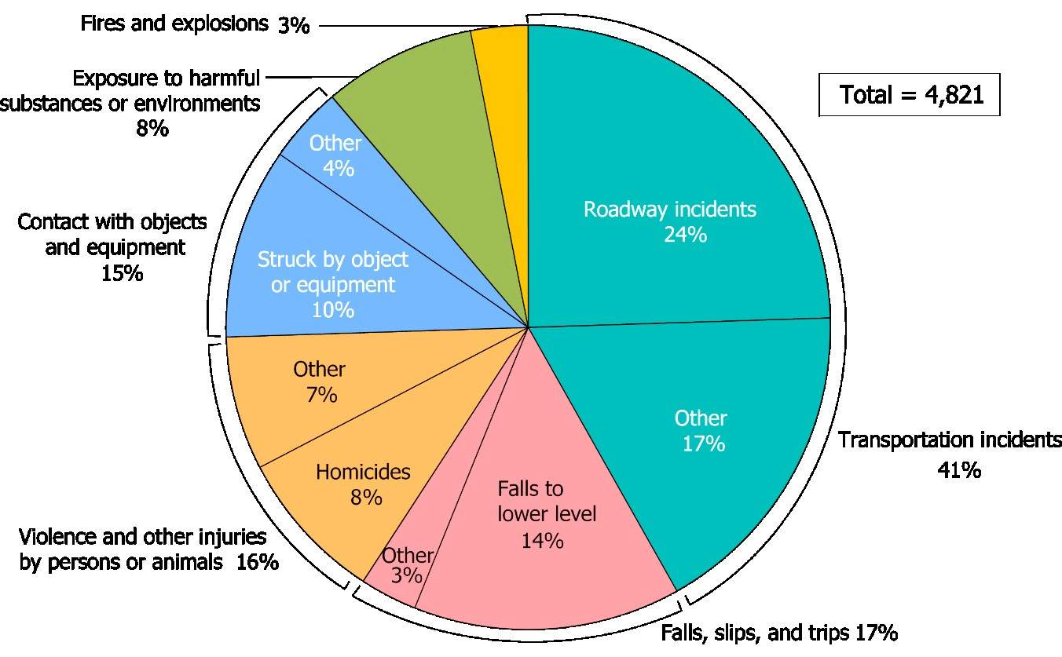
Figure 1.3: Fatal Occupational Injuries by Major Event in the U.S., 2014Source: U.S. Bureau of Labor Statistics, 2016.
Research has identified factors that may increase the risk of violence for some workers at certain worksites. Examples include exchanging money with the public and working with volatile, unstable people. Working alone or in isolated areas may also contribute to the potential for violence. Providing services and care, and working where alcohol is served may also impact the likelihood of violence. Additionally, time of day and location of work, such as working late at night or in areas with high crime rates, are also risk factors that should be considered when addressing issues of workplace violence. Among those with higher risk are delivery drivers, healthcare professionals, public service workers, customer service agents, law enforcement personnel, and those who work alone or in small groups.
In most workplaces where risk factors can be identified, the risk of assault can be prevented or minimized if employers take appropriate precautions. One of the best protections employers can offer their workers is to establish a zero-tolerance policy toward workplace violence. This policy should cover all workers, patients, clients, visitors, contractors, and anyone else who may come in contact with company personnel.
By assessing their worksites, employers can identify methods for reducing the likelihood of incidents occurring. Typically, a well written and implemented Workplace Violence Prevention Program, combined with engineering controls, administrative controls, and training can reduce the incidence of workplace violence.
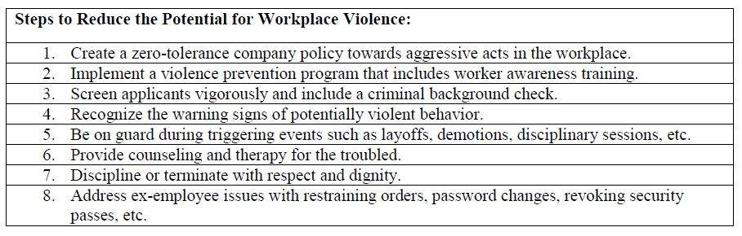
Global Travel Security
With worldwide political tension and the ongoing threat of terrorism, many companies have been forced to rethink their approach to sending employees on international assignments. Few companies have eliminated global travel, but many have reduced their expatriate populations, especially in unsettled regions of the world. To minimize the risk to expatriates, organizations are adopting new measures to keep their personnel safe.
Since September 11, 2001, the SARS epidemic, and a global downturn, organizations are adopting new strategies to avoid international travel and face-to-face encounters with their clients/vendors. Organizations are utilizing more local nationals, developmental assignments, and electronic communication tools to deal with security and financial concerns of international assignment.
The normal reaction to terrorist attacks, executive kidnappings, religious extremism, and other world-wide security concerns is to immediately implement safety/security plans and evacuation plans. Companies then assess the particulars of the situation as they apply to their business operation and their on-site personnel and respond accordingly.
Common tactics include:
- Greater use of assignment volunteers,
- Greater use of single-status assignees without dependents,
- A heightened emphasis on contingency planning, and
- Alternative work options.
Some organizations adjust expatriate pay to include “danger pay” for perceived risks associated with some assignments. Additionally, increased life insurance coverage is often provided for employees assigned to volatile regions.
The biggest threat to international travelers continues to be random violence and crime, not international terrorism.
Although there is no evidence that expatriate placement is on the decline, higher risks and budgetary concerns have limited the freewheeling policies of the 1990’s on international travel.
Kidnapping of Business Travelers
Kidnapping for ransom is a common occurrence in various parts of the world today, and certain cities and countries are often described as the “Kidnapping Capital of the World.” Control Risks, an independent, global risk consultancy specializing in political, integrity and security risk, helps global organizations understand and manage the risks and opportunities of operating in complex or hostile environments. They released a report in 2014 with the most updated information to date (see Chart 1.3 below). Mexico is the current title holder. (Past title holders have included: 2008, Baghdad; 2004, Mexico; and in 2001, Colombia.
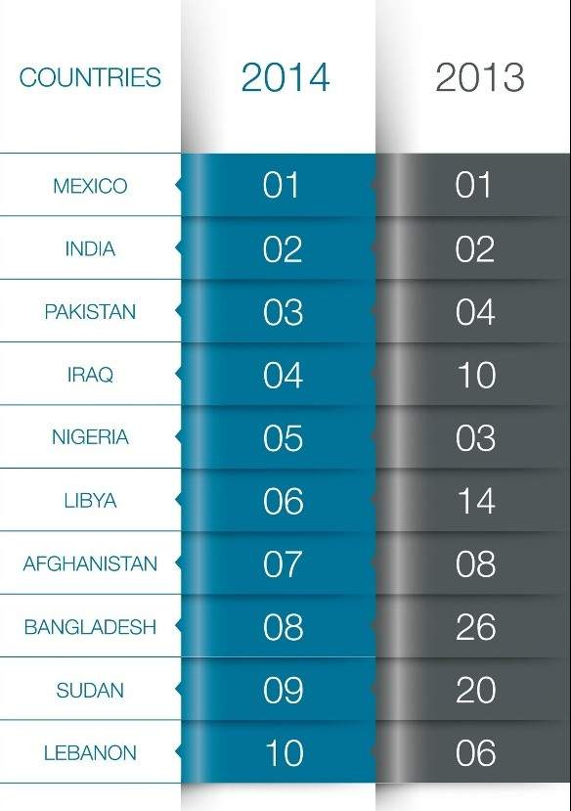
Top 10 Countries for Kidnap for Ransom, 2014. Source: Control Risks, RiskMap Report, 2015
In the past, and presently in some parts of the world (such as southern Sudan), kidnapping is a common means used to obtain slaves and money through ransom. In more recent times, kidnapping is seen as a business activity in poorer regions whereby business men and women are taken and held for ransom.
Kidnapping is rampant in many parts of the world. In fact, it’s a thriving business in many countries. Many governments provides tips on what a traveler should do when things go bad. The following is excerpted from the Department of State Publication 10217: Security Awareness Overseas, An Overview [Bureau of Diplomatic Security - United States Department of State Overseas Security Advisory Council]:
Kidnapping is a terrifying experience, but you possess more personal resources than you may be aware of to cope with the situation. Remember, you are only of value to them alive, and they want to keep you that way.
If taken hostage, your best defense is passive cooperation. You may be terrified, but try to regain your composure as soon as possible and to organize your thoughts. Being able to behave rationally increases your chances for survival. The more time that passes, the better your chances of being released alive.
If taken, try to remember these tips:
- Try to establish some kind of rapport with your captors.
- Maintain your dignity and self-respect at all times.
- Build relations with fellow captives and with the terrorists.
- Maintain your physical and mental health.
- Take note of the characteristics of your captors and surroundings.
Finally, it’s worth keeping in mind three facts about terrorism:
- The overwhelming majority of victims have been abducted from their vehicles on the way to or from work.
- A large number of people taken hostage ignored the most basic security precautions.
- Terrorist tactics are not static. As precautions prove effective, they change their methods. There is a brief “window of vulnerability” while we learn to counter their new styles.
To reduce the likelihood of a kidnapping:
- Do not settle into a routine. Vary times and routes to and from work or social engagements.
- Remember, there is safety in numbers. Avoid going out alone. When traveling long distances by automobile, go in a convoy. Avoid back-country roads and dangerous areas of the city.
- A privately owned car generally offers the best security. Avoid luxury or ostentatious cars. Keep your automobile in good repair and the gas tank at least half full. Driving in the center lane of a multiple lane highway makes it difficult for the car to be forced off the road.
It is important to note that a new type of kidnapping is emerging due to technological advance: cyberextortion. The U.S Government, and many other countries, have instituted laws against cyber extortion and cyber terrorism, but this is still a relatively new area of study. According to the FBI: “The 2008 Comprehensive National Cybersecurity Initiative (CNCI) created the foundation for a whole-of-government approach to protecting the nation from cybersecurity threats. As part of the CNCI, the National Cyber Investigative Joint Task Force (NCIJTF) was established under Presidential Directive. In its role as a headquarters-level task force environment, the NCIJTF enhances collaboration and integrates operations among the represented U.S. Intelligence Community and federal law enforcement partners against:
- Cyber terrorists exploiting vulnerabilities in critical infrastructure control systems,
- Nation-state theft of intellectual property and trade secrets,
- Financially-motivated criminals stealing money or identities or committing cyber extortion,
- Hactivists illegally targeting businesses and government services, and
- Insiders conducting theft and sabotage.
Many organizations opt for insurance when sending business travelers into particularly dangerous areas.” (Cyber Task Forces: Building Alliances to Improve the Nation’s Cybersecurity.)
One recent example of this that made the news:
The hack of Sony Pictures Entertainment in late 2014 has drawn more attention than any previous cyber extortion plot and cost the company millions in revenues and reputational damage. According to U.S. law enforcement, the North Korean government was behind the attack, apparently offended by one of Sony’s soon-to-be-released films, “TheInterview.” When Sony refused to cave in to the hacker’s demands to stop the film’s distribution, the hackers not only released data stolen from the company’s servers, insider emails and sensitive employee data, but also used destructive malware to cripple many of the systems used by Sony’s employees to conduct business.
Organization of Security
The dramatic increase in crime, drug abuse, random violence, kidnapping of corporate officials for ransom, and worldwide terrorism has increased the importance of workplace security. As a result, HR departments are finding themselves more involved in matters of both internal and external security and crisis management because of their responsibility to provide employees with a safe and healthful environment. An organization that pays attention to this aspect of workplace management breeds fear into would-be perpetrators and gains respect and loyalty from its employees, reduces the possibility of adverse and costly consequences, and enhances its image within the community where it is located.
The primary purpose of workplace security is to protect people and to safeguard both tangible and intangible property. The hallmark of an effective security program is its ability to take proactive, defensive measures rather than reactive or police-action measures.
Firms with 1,000 or more employees often assign security responsibility to a security director. The next position most likely to be responsible for that function is the HR manager or director.
Assessing Security Needs
In a total systems approach to workplace security, an effective program should include: (1) physical security measures; (2) procedures or methods to control accessibility, assess vulnerability, and establish accountability; and (3) a initiative to make employees and management aware of their responsibilities under the security program. However, one of the most fundamental aspects of a security program is the security audit.
Security AuditsBefore setting up a security program or making changes in an existing one, perform a thorough audit. Also, once the program is in place, be sure to conduct periodic audits to test its effectiveness. Review the following in an audit:
- Existing risks, hazards, or deficiencies;
- System changes required to accommodate facility or organization revisions;
- Maintenance of security hardware;
- Response time of security personnel to emergency calls or alarms;
- Fire and evacuation drills;
- Alarm system and other hardware tests, and examinations for repairs or replacements; and
- Key property and other property inventory.
The components of the security program center around people and procedures. These include:
- Security personnel;
- Internal staff or contracted staff who are responsible for security tasks;
- Hardware such as locks, walls, fences, safes, and alarm systems;
- Procedures concerning removal of personal and company property from the premises, and procedures concerning visitors on the premises;
- An education and awareness campaign to encourage employees and management to support security measures and abide by them; and
- Investigation and other follow-up procedures on loss or injury to prevent recurrences.

Proprietary Information
Information and ideas are valuable company assets. They can include everything from trade secrets and computer data to customer lists, mailing lists, blueprints, and formulas. Companies often fail to realize the importance of protecting their intellectual property.
The HR department takes the lead in protecting the organization’s international intellectual property. Investing time and money now to acquire a copyright, trademark, or patent can yield a high return later. (Remember that under these protections the company has recourse to the court system if they are infringed upon.) Generally, these information security measures include copyrights, trademarks, and patents.
- Copyrights protect creative works such as photos, graphics, and literary works (computer programs are considered literary works).
- Trademarks preserve names used in association with goods or services, such as a company or product name.
- Patents protect new systems, processes, or inventions.
Training Employees to Maintain Confidentiality
In addition to taking legal and formal measures, such as copyrighting material and requesting employees to sign restrictive covenants, train employees to make them aware of the constant need to keep certain information confidential.
Publicizing Confidentiality Policies
Employees need to be reminded about the importance of confidentiality and given practical examples of what to watch out for.
The high-profile case of Edward Snowden’s leak of classified NSA documents in 2013 highlight the importance of confidentiality policies in the workplace. In this case, Snowden violated his confidentiality agreement, and should he return to the U.S., would likely face multiple felony charges including violation of the U.S. Espionage Act.
Theft and Fraud
Investigations and Preventive Corrections
Investigate every theft or inventory shortage that takes place, no matter how small. Even if an investigation does not reveal who is responsible, employees receive the message that the company is serious about theft and pilferage. In the case of incidents that involve insurance, do not rely solely on the insurance investigator's report. Remember: The insurance company's objective is to limit claims, not necessarily to uncover the responsible party.

Incident Reports
Make sure security personnel complete incident reports in addition to their standard shift reports whenever a theft or suspicion of theft occurs. Depending on the severity of the incident, alert a security supervisor or a member of senior management immediately. Distribute copies of the incident report through the necessary channels. To handle incidents that occur after normal operating hours, make sure security personnel have an on-call schedule, a list of security supervisors, and the phone number of a specific member of management.
Other Follow-up
Issue security alerts to all employees after a theft has occurred to enlist them to serve as the firm's eyes and ears. Remind employees that theft of company property affects the company's bottom line — and them. Investigation of the theft or shortage depends on the nature and size of the loss

Bribery
Lesson 19 of 69

Foreign Corrupt Practices Act (FCPA) (US)
The Foreign Corrupt Practices Act (FCPA) makes it unlawful to bribe foreign government officials to obtain or retain business. With respect to the basic prohibition, there are 5 elements which must be met to constitute a violation of the Act, “according to Latham and Watkins, LLP:
- A payment of – or an offer, authorization, or promise to pay – money oranything of value, directly, or through a third party;
- To (a) any foreign official, (b) any foreign political party or party official, (c) any candidate for foreign political office, (d) any official of a public international organization, or (e) any other person while “knowing” that the payment or promise to pay will be passed on to one of the above;
- The use of an instrumentality of interstate commerce (such as telephone, telex, email, or the mail)by any person (whether U.S. or foreign) or an act outside the U.S. by a domestic concern or U.S. person, or an act in the United States by a foreign person in furtherance of the offer, payment or promise to pay;
- For the corrupt purpose of influencing an official act or decision of that person, inducing that person to do or omit to do any act in violation of his or her lawful duty, securing any improper advantage, or inducing that person to use his influence with a foreign government to affect or influence any government act or decision; and
- In order to assist the company in obtaining or retaining business or in directing business to any person or to secure an improper advantage.”
The FCPA potentially applies to any individual, firm, officer, director, employee, or agent of a firm, and any stockholder acting on behalf of a firm. Individuals and firms may also be penalized if they order, authorize, or assist someone else to violate the anti-bribery provisions or if they conspire to violate those provisions.
U.S. parent corporations may be held liable for the acts of foreign subsidiaries where they authorized, directed, or controlled the activity in question.
Additionally, there are 8 key concepts in regards to the FCPA:
Offers, Payments, Promises to Pay or Authorizations of Payments
A company can be liable under the FCPA not only for making improper payments, but also for an offer, promise or authorization of a corrupt payment, even if its employees or agents do not actually make a payment. In other words, a corrupt act need not succeed in its purpose. (Latham and Watkins, LLP)
Corrupt Intent
The person making or authorizing the payment must have a corrupt intent, and the payment must be intended to induce the recipient to misuse his official position to direct business wrongfully to the payer or to any other person.
You should note that the FCPA does not require that a corrupt act succeed in its purpose. The offer or promise of a corrupt payment can constitute a violation of the statute. The FCPA prohibits any corrupt payment intended to influence any act or decision of a foreign official in his or her official capacity, to induce the official to do or omit to do any act in violation of his or her lawful duty, to obtain any improper advantage, or to induce a foreign official to use his or her influence improperly to affect or influence any act or decision.
Payment
The FCPA prohibits paying, offering, or promising to pay (or authorizing to pay or offer) money or anything of value.
Recipient
The prohibition extends only to corrupt payments to a foreign official, a foreign political party or party official, or any candidate for foreign political office. A “foreign official” means any officer or employee of a foreign government, a public international organization, or any department or agency thereof, or any person acting in an official capacity.
The FCPA applies to payments to any public official, regardless of rank or position. The FCPA focuses on the purpose of the payment instead of the particular duties of the official receiving the payment, offer, or promise of payment, and there are exceptions to the anti-bribery provision for “facilitating payments for routine governmental action” (see below).
Business Purpose Test
The FCPA prohibits payments made in order to assist the firm in obtaining or retaining business for or with, or directing business to, any person. The Department of Justice interprets “obtaining or retaining business” broadly, such that the term encompasses more than the mere award or renewal of a contract. It should be noted that the business to be obtained or retained does not need to be with a foreign government or foreign government instrumentality.
Knowledge
The FCPA does not require proof of actual knowledge that a payment or promise to pay an intermediary will be passed on to a foreign official. The FCPA’s legislative history speaks of “willful blindness,” “deliberate ignorance” and taking a “head-in-the-sand” attitude as constituting knowledge under the statute. (Latham and Watkins, LLP)
Third Party Payments
The FCPA prohibits corrupt payments through intermediaries. It is unlawful to make a payment to a third party, while knowing that all or a portion of the payment will go directly or indirectly to a foreign official. The term “knowing” includes conscious disregard and deliberate ignorance. The elements of an offense are essentially the same as described above, except that in this case the "recipient" is the intermediary who is making the payment to the requisite “foreign official.”
Permissible Payments and Affirmative Defenses
The FCPA contains an explicit exception to the bribery prohibition for “facilitating payments” for “routine governmental action” and provides affirmative defenses which can be used to defend against alleged violations of the FCPA.
Facilitating Payments for Routine Governmental Actions
There is an exception to the anti-bribery prohibition for payments to facilitate or expedite performance of a "routine governmental action." The statute lists the following examples: obtaining permits, licenses, or other official documents; processing governmental papers, such as visas and work orders; providing police protection, mail pick-up and delivery; providing phone service, power and water supply, loading and unloading cargo, or protecting perishable products; and scheduling inspections associated with contract performance or transit of goods across country.
Bribery Act (UK)
The UK Bribery Act of 2010 prohibits bribery or attempted bribery to obtain a business advantage. This includes kickbacks, corrupt commissions, and other forms of illicit business payments to secure business or government contracts.
The UK Bribery Act has ramifications for all organizations that have any dealings or operations within the UK. It effectively eliminates facilitation payments from their commercial activities and requires them to take positive proactive steps to prevent such activities (employee training, written policies, zero tolerance practices).
The law is described as one of the toughest anti-bribery laws in the world and critics argue it puts UK organizations at a competitive disadvantage as it forbids common business practices in some parts of the world.

Homeland Security
Lesson 20 of 69
A substantial amount of immigration legislation has passed into law, most notably the U.S. Patriot Act. These changes are, of course, primarily a response to the unprecedented terrorist activities of 09/11/2001 in the U.S. They have significantly impacted the management of immigration issues within the corporate employment context, particularly with respect to the trans-border activities of foreign national employees.
In 2003, the U.S. Bureau of Citizenship and Immigration Services (BCIS) within the Department of Homeland Security assumed many of the functions of the former Immigration and Naturalization Service (INS).
The services provided by the BCIS include:
- The adjudication of family and employment-based petitions;
- Issuance of employment authorization documents;
- Asylum and refugee processing;
- Naturalization; and
- Implementation of special status programs such as Temporary Protected Status.
At the same time, other INS functions were incorporated into two additional new bureaus under the Department of Homeland Security. The two new bureaus are:
- Bureau of Immigration and Customs Enforcement (BICE) - The BICE brings together the investigative and interior enforcement functions of the INS, U.S. Customs Service, and the Federal Protective Services.
- Bureau of Customs and Border Protection (BCBP) - The BCBP focuses its operations on the movement of goods and people across our borders, ensuring consistent inspection procedures and coordinated border enforcement.
The shift of most immigration oversight functions to the Department of Homeland Security means the immigration process is now characterized by a significant emphasis on security. While the focus on security may be beneficial in terms of minimizing the risk of terrorism, it has lengthened the visa process considerably.
National Entry-Exit System
There is a higher level of scrutiny and longer delays in U.S. visa processing. Visa applicants are advised to expect substantial processing delays of six to eight weeks or more due to security procedures put in place as a reaction to the 09/11/2001 terrorist attacks. All visa applicants, including employees of American companies on non-immigrant work visas such as H-1B, are advised to take into account these delays when making travel plans.
The U.S. State Department has announced that additional security checks and a waiting period of at least 20 days will now be required during visa processing for nationals or citizens of the below specified countries. Moreover, nationals or citizens of the below countries may no longer apply for U.S. visas at U.S. Consular posts located in Canada or Mexico. The checks generally apply to male applicants between the ages of 16 and 45.
The countries specified are:
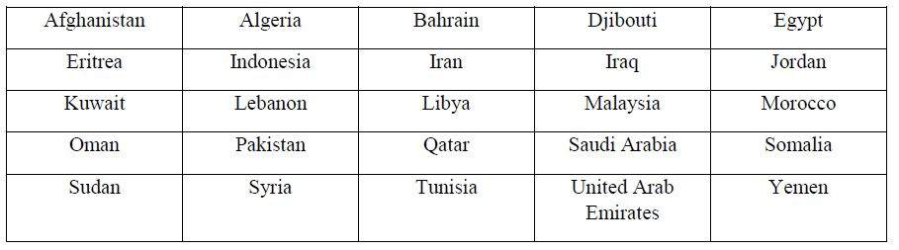
The cap on the number of H1-B visas that can be issued annually is 65,000.
L-1 Visas
L-1 visas are temporary, non-immigrant visas that permit companies to transfer key foreign employees from operations outside the United States into operations within the United States. In order to be eligible, the employee must have worked for the company abroad for a minimum of 1 continuous year out of the preceding 3 years and must be coming to the U.S. as a manager, executive, or person with “specialized knowledge.”
Originally intended to allow companies to rotate key personnel through international assignments and to benefit from their international experience, the L-1 visa program has been used by companies to bring foreign workers into the U.S. to work onsite at client locations. Displaced technology workers and their supporters argue that the companies are outsourcing L-1 visa holders to perform regular information technology work that could—and should—be provided by U.S. employees. In addition, they argue that L-1 visas make it easy for companies to undercut U.S. workers—unlike H1-B visas, which require abachelor’s degree, contribution to a fund for training American workers, and minimum salary requirements, L-1 visa regulations do not have any education, funding, or compensation provisions.
Planning Ahead
While Congressional action on either issue is uncertain, employers can count on at least one thing—the process for bringing employees to the U.S. to work is likely to remain daunting and lengthy for the foreseeable future. Proposals discussed at the agency level are designed to improve security, rather than streamline processes, and until the U.S. economy is operating at capacity, companies have little leverage to use to persuade the government that improving the process is critical for competitiveness.
As of 11/01/2017, the U.S. government is considering stricter regulations for visas, especially where the Diversity Lottery is concerned. While this information is too new to be on the current GPHR exam, this is an area to watch, as it is likely big changes will be made in the near future.
That being said, the 2017 Envoy Immigration Trends reports that 55% expect their foreign national headcount to increase in the next year and 60% said sourcing foreign nationals was very important to their talent acquisition strategy.

Compensation and Benefits for Foreign Nationals and Expatriates
Lesson 22 of 69
Employees who are assigned to work in a foreign country usually are offered a different compensation package than domestic employees.
The international pay package generally consists of: base pay and employee benefits; allowances to offset extra expenses and higher costs; and, in some cases, premiums or incentives to induce the employees to accept foreign assignments.
Employees relocated to fill foreign staffing needs usually are classified as expatriates or third-country nationals (TCNs).
The primary goals of expatriate compensation programs are to encourage qualified employees to accept foreign assignments and to remove financial obstacles that hinder the employee’s ability or willingness to relocate to a foreign post.

Other goals employers pursue with their expatriate compensation programs include:
- Promoting equity among expatriates assigned to different countries;
- Maintaining equity between expatriates and home-country staff; and
- Staying in full compliance with the tax, labor, and employment laws in both the home country and the foreign country to which the expatriate is assigned.
Compensation Packages for International Employees
Many multinational companies need to bring home-country experience and know-how to their foreign operations. This goal often is achieved by relocating experienced employees from the home country to another country.
Many multinational corporations maintain one international compensation policy that covers both expatriates and TCNs. Generally, the policies are directed toward the needs of expatriates, but may include provisions to accommodate the special needs of TCNs. With a few exceptions, the needs of expatriates and TCNs are the same. The term for using one primary compensation system throughout the world is known as standardization. Companies that employ different systems depending on the local customs and practices employ a policy known as localization.
Purpose of Expatriate Compensation Programs
Expatriate compensation programs serve two primary purposes:
- Encouraging qualified employees to accept foreign assignments, and
- Removing financial obstacles that hinder the employee's ability to relocate to a foreign post.
Fulfilling these purposes generally requires that the employer provide a competitive level of base pay, allowances to offset extra expenses and higher costs, and, in some cases, premiums or incentives to induce the expatriates to accept the foreign assignment and its accompanying challenges and burdens.
Beyond the basic objectives of attracting qualified individuals to overseas posts and covering extra costs, expatriate compensation programs also meet some of the following objectives:
- Providing compensation packages that are competitive with those provided by other firms in the same industry, and
- Providing expatriates resources they need to ensure the education of their children is not adversely affected by the overseas assignment.
Expatriate Compensation Components
Compensation programs for expatriates usually consist of three primary components:

1. Base Pay and Employee Benefits
An employer’s primary goal with respect to expatriate base pay and employee benefits is to ensure that expatriates are not financially disadvantaged by accepting a foreign assignment. Thus, most employers align an expatriate’s base pay with what the employee receives in his or her home country and try to ensure health, pension, and other benefits are at least equal to what the expatriate had prior to the assignment.
2. Allowances and Expense Reimbursements
Employers include allowances in expatriate compensation packages to cover extra expenses and higher costs. Typically, allowances are provided for the following categories of expenses: goods and services, housing and utilities, taxes, educational costs, and moving and relocation expenses. Although practices vary from company to company, allowances usually do not increase an expatriate’s buying power over what it would have been had he or she remained at home.
3. Premiums and Incentives
Premiums and incentives are designed to induce employees to accept overseas assignments. Incentive pay is compensation above and beyond any allowances necessary so the expatriate is not financially disadvantaged. Incentives are offered in recognition that overseas assignments impose the burden of cultural adjustments and may require the individual to endure lower living standards or even dangerous conditions.
International Employment Laws and Their Effect on Assignees
There are many global and local employment laws the Global Compensation Manager must be familiar with to properly compensate international assignees while expatriated. Many of these will be discussed in this section. A few to consider include:
Employee Relations Act of 1999 (UK)
The Employee Relations Act of 1999 is a British law that allows workers to receive at least 3 months’ unpaid leave for the purpose of caring for a child (similar to FMLA in the U.S.). However, it differs from the Family and Medical Leave Act in the U.S. by requiring that mothers receive up to 18 weeks of paid maternity leave.
It also allows independent unions to claim recognition for collective bargaining from any business with more than 20 employees.
National Minimum Wage Act of 1998 (UK)
Most modern industrialized countries have a minimum wage that is set by law. It requires employers to provide to workers a minimum level of pay for hours worked. In the United Kingdom, the National Minimum Wage (NMW) Act requires the employer to provide a minimum wage level based on the workers age.
Most workers over the school leaving age must be paid at the national minimum wage rate level, even if they have signed a contract agreeing to a lower rate. Generally, the program works as follows: Workers over the age of 21 receive the national rate, workers between 18-20 receive about 20% less, workers who are 16-17 years old may be paid about 40% below the NMW, and finally, workers who are 19 or under and in an apprenticeship program may receive less than 50% of the NMW.

Compensation Strategies
Lesson 23 of 69

Compensation is the single most important element in the employment relationship. Although opportunity for advancement, good working conditions, appropriate supervision, and other non-financial considerations are crucial to productive relations, all employee groups — from top management to hourly workers — consistently rank compensation as a primary factor in deciding whether to accept or continue employment.
In virtually every organization, compensation is the largest component of total labor costs and far exceeds expenses incurred for recruitment, training, administration, or other HR functions. In a labor-intensive setting, compensation costs may account for more than 60% of gross income. However, compensation is one of the few major expense areas that is internally controlled. While a company has limited control over the costs of materials, equipment, transportation, utilities, and outside professional services, an employer can tie compensation levels directly to productivity and profitability. The key is return on investment — maximum performance for every payroll dollar.
Matching Compensation to Strategic Goals
Compensation is a tool for sharpening and reshaping the behaviors required to achieve business goals. Any discussion of business objectives should take pay policies into account since most business decisions affect compensation.
Understanding a company’s business objectives is the most important knowledge a compensation planner can possess.
A compensation program that complies fully with all legal requirements and holds a competitive position in the external market will still fail if it does not support corporate goals.
Compensation programs can both drive and support business objectives. Compensation plans can:
- Communicate business objectives,
- Provide incentives for employees to maintain or change their behaviors to support thoseobjectives,
- Reinforce the relationship between individual or group goals and broader unit or corporateobjectives, and
- Reward discretionary effort.
Compensation and HR Goals
The three primary HR goals of a compensation program are effective recruitment, retention, and motivation.

Recruitment
Appropriate starting rates and an attractive pay program can position the company to meet its recruitment needs on a consistent basis. If a company lags in its starting rates, it will face a shortage of suitable candidates as potential employees gravitate toward competitor companies or look for jobs in other industries. Low starting rates also can saddle a company with low-potential employees who drag down productivity, competitiveness, and growth. On the other hand, paying the highest rates can generate a different set of problems. Starting salaries that equal or exceed pay rates for experienced workers can undercut internal equity and destroy morale. This is known as wage compression or pay inversion.
Retention
A compensation program can be used to adjust turnover rates for various positions to achieve an optimal workforce at the lowest cost. Money can provide the leverage to hold valued employees who might find work at other companies. Turnover among repatriates is a troubling problem for many companies. Turnover carries high costs: recruitment and hiring a new employee, orientation and training, loss of valuable skill sets, and downtime in the position. Organization growth potential diminishes every time an experienced and promotable employee resigns. Turnover also can threaten a company's competitive position if a seasoned and knowledgeable employee moves to a direct competitor. For some positions, however, relatively high rates of turnover are acceptable and keep compensation costs at starting salary levels.
Motivation
A compensation program based solely on market rates and length of service fails to motivate. A program based on skills and performance turns every paycheck into a concrete statement of a company's business objectives. Pay-for-performance is the basic premise of compensation today, but turning the idea into a reality requires sound job evaluation, accurate performance measurements, thorough training of and feedback between supervisors and employees, and ongoing support from top management.
Traditional Compensation Plans
Traditional compensation programs, designed for mature companies with stable markets and fixed product lines, emphasize cost control, standardization, and high levels of internal equity.
They usually have centralized decision-making and administration.
Traditional compensation plans largely consist of base pay — grounded in extensive job evaluation (internally valued) — plus a fixed package of benefits. An employee’s compensation level depends primarily on length of service and fulfillment of standard requirements for a position. To the extent that traditional compensation plans include incentive or performance pay, the objectives are usually limited to reducing production costs.
Alternative Compensation Systems
Alternative reward systems (commonly designed for companies with changing markets, product lines, or growth rates) relate compensation costs to revenues. Compared with traditional compensation systems, alternative systems tend to be less standardized and less centralized. They rely less on job evaluation and more on performance appraisal. They de-emphasize base pay and rely more on incentives for unit, group, or individual performance as defined by growth, market share, or productivity. They often include flexible benefit programs.
Successful alternative reward systems, and the performance pay plans they adopt, are self-financing. They are based on:
- Sound projections about the financial returns that will result from improved performance,
- Accurate methods of measuring the improvements, and
- Effective methods of tying improvements to payouts.
Alternative reward systems are appropriate only if performance objectives are clear and performance criteria are fully identified. Companies that have not developed clear performance objectives and criteria should steer away from alternative pay plans and stick with traditional compensation systems.

Centralized vs. Decentralized
Lesson 24 of 69
Centralized organizational structures rely on one individual to make decisions and provide direction for the company. Small businesses often use this structure since the owner is responsible for the company’s business operations. Decentralized organizational structures often have several individuals responsible for making business decisions and running the business. Decentralized organizations rely on a team environment at different levels in the business. Individuals at each level in the business may have some autonomy to make business decisions. A survey taken by the World at Work organization showed that there is an almost equal split of those companies who prefer a centralized compensation program vs. a decentralized compensation program.
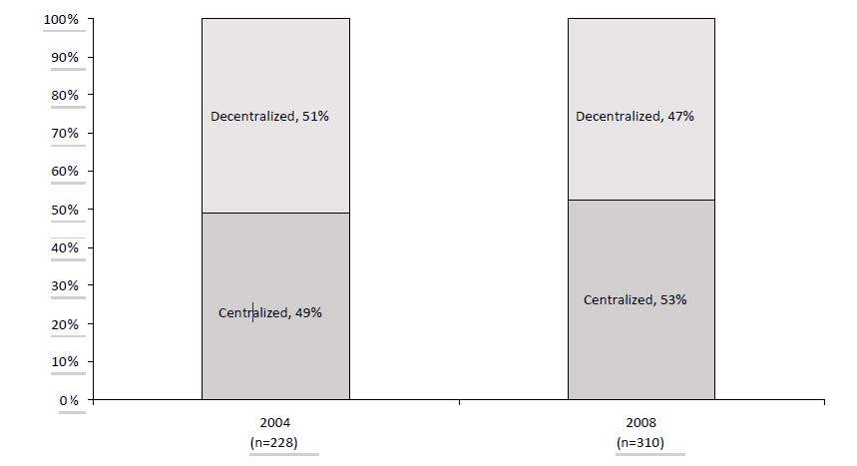
Structure of Management in Global Compensation ProgramsSource: World at Work, 2008
Furthermore, the 53% of organizations that indicated a “centralized structure” for their global compensation management were next asked to rank (on a scale of 1-9) the objectives of this structure. The top three objectives in both 2004 and 2008 were in order: “consistent link between rewards and results,” followed by “consistent position versus market,” and “internal equity.”
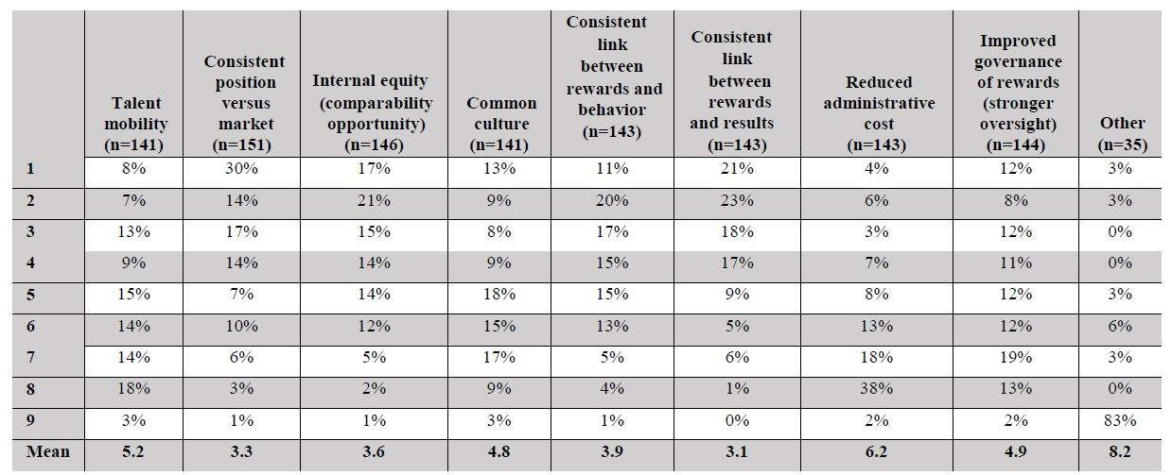
Objectives of Centralized Global Compensation StructureSource: World at Work, 2008
The survey continues by asking that for those with a decentralized global compensation structure: what is the unit of structural organization — geographic, business unit, or a combination of both? Country-specific seems to be most prevalent.

Reward Strategies
Lesson 25 of 69
A primary objective of a compensation program is to motivate the employee behaviors needed to achieve business goals. Motivation begins with a pay program that employees perceive as fair and equitable. A good compensation program clearly links efforts to outcomes and behaviors to rewards. Some reward theories are discussed below.
Equity Theory (Adams)
Equity theory is based on an individual’s subjective determination about his or her perception of pay fairness by comparing their pay against others. There are three types of equity:
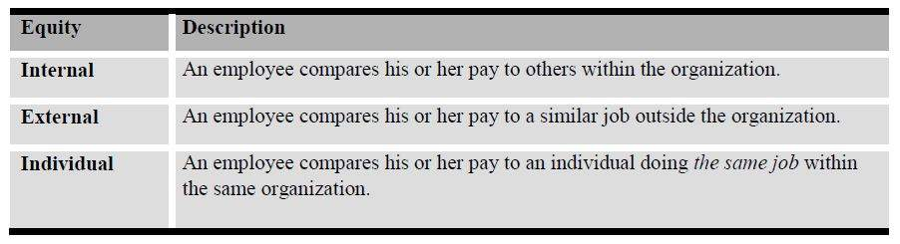
Expectancy Theory (Vroom)
Expectancy theory holds that employees’ expectations determine effort and performances, and indicates that compensation policies and practices can influence the extent to which employees believe performance will be rewarded. A performance appraisal system ensures employees receive the feedback they need to perform well; a well-designed pay system ensures their performance is rewarded appropriately. Over time, effective performance appraisals and rewards can influence employees’ expectations and behaviors. Therefore, the better they perform, the more pay they expect.
Reward Theory or Reinforcement Theory
Similar to expectancy theory, reward theory is based on the idea employees will repeat behaviors that are rewarded and will avoid behaviors that are not rewarded. According to reward theory, paying for time worked fails to motivate high performance because it automatically rewards average or standard levels of performance. Reward theory supports the idea that pay contingent on high performance can directly influence behavior.
Maslow’s Needs Hierarchy
Maslow identified five levels of needs, which are best seen as a hierarchy with the most basic need emerging first and the most sophisticated need last. People move up the hierarchy one level at a time. Gratified needs lose their strength and the next level of needs is activated. As basic or lower-level needs are satisfied, higher-level needs become operative. A satisfied need is not a motivator. The most powerful employee need is the one that has not been satisfied. Maslow’s hierarchy of needs is often depicted as a pyramid consisting of five levels: the four lower levels are grouped together as deficiency needs associated with physiological needs, while the top level is termed growth needs associated with psychological needs.
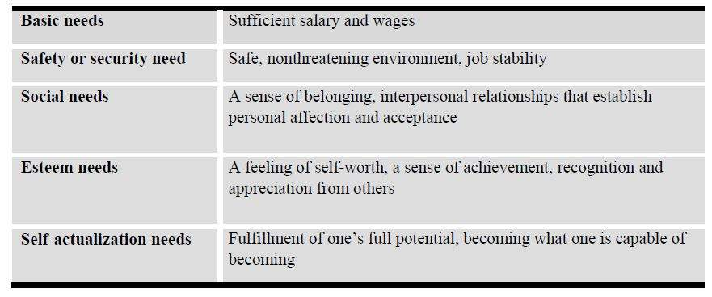
Goal-setting Theory (Management by Objectives)
According to goal-setting theory, only those rewards employees value can motivate behaviors. The key is to set mutual goals for an organization and its employees — goals that will reward both the company and its workers. Goal-setting theory holds that pay can motivate employees if:
- Employees participate in setting the goals for which they will be rewarded and accept these goals as their own,
- The goals are specific and set at a sufficiently challenging level, and
- Specific monetary rewards are designated for each goal achieved.

Intrinsic vs. Extrinsic Rewards
Lesson 26 of 69
Total compensation consists of intrinsic and extrinsic rewards. Intrinsic rewards are the psychological and intellectual rewards inherent in the job itself, such as the opportunity to perform meaningful work or gain a sense of accomplishment. They depend on the nature of the work and the values of the individual who performs the work. Extrinsic rewards derive from sources external to the job itself. They include non-financial rewards (such as prestige and positive feedback), and financial rewards (such as wages and benefits. Herzberg’s Hygiene Theory classifies motivation as either hygiene factors (extrinsic), those basic entitlements that employees expect (pay, benefits, working conditions), or motivators (intrinsic), those factors that truly change people’s behavior (praise, recognition, challenging work).

Designing the Compensation System
Lesson 27 of 69
A pay structure guides an employer’s decisions about what jobs receive what rates of pay. Most employers use a pay structure consisting of “pay grades” and “pay ranges.” Under such pay structures, jobs of similar value are grouped within the same grade. Employees within a particular grade are paid a rate between the minimum and maximum rate, or pay range, specified for their grade.
Pay structures should be designed to support the company’s overall business strategies and to provide management with an internal control mechanism for achieving compensation objectives.
One of the fundamental questions an employer must address in designing a pay structure is how the company wants its pay rates to compare to pay rates in the marketplace. This is known as external equity.
Constructing a pay structure involves four basic steps:
- Determining the relative worth of benchmark jobs within the company and collecting data on market rates for those jobs;
- Analyzing how actual pay rates compare to market rates;
- Deciding where target pay rates should be relative to the market rates; and
- Establishing appropriate pay grades and pay ranges.
The process of creating a pay structure usually begins after the employer has established the relative worth of jobs using job evaluation techniques. A first step in establishing a pay structure is to take the job-worth hierarchy established through job evaluation and compare it to market surveys of pay rates for similar jobs. An employer then decides how the company’s actual pay rates should be positioned relative to the market rates. Finally, the employer establishes appropriate pay grades and pay ranges. However, before this process begins, the employer must first quantify and define the job through a job analysis.

Components of International Compensation
Lesson 28 of 69

Compensation for employees of global organizations operating in an international environment consists of four components: base salary, indirect monetary compensation (benefits), equalization benefits, and incentives.
Base Salary
Two alternatives exist for determining base salary for an expatriate:
- Adhering to the established policies and procedures of the parent company’s country (standardization), including formal job evaluation; or
- Following the policies and practices of the country in which the expatriate works (localization).Since many international assignments are for short durations, usually 3 to 5 years, it may be wise to keep base salary aligned with salaries in the home country. Doing so makes the transition back to the home country less complicated since major salary changes do not have to be made.
Indirect Monetary Compensation (Benefits)
The benefits package for expatriates is generally the same as the one provided in the home country. However, an organization must be aware that specific countries require benefits that may not be offered in the home country. For example, in France employers are required by law to provide every employee with 25 days of vacation. Although an American working for an American company in France is not legally entitled to such a vacation, the organization may want to follow this practice to avoid morale problems with expatriates. Other countries may have retirement, disability, and termination policies that are different from the expatriate’s home country.
Equalization Benefits
Equalization benefits are benefits intended to keep expatriates in the same/equal financial condition they were in before accepting an overseas assignment and to reduce any negative aspects of living in a foreign country.
Often, expatriates require additional benefits to equalize the standard of living they enjoyed in their home country. This adjustment of benefits is referred to as equalization.
A limited selection of the benefits available includes the following:
- Housing allowance
- Educational allowance for children
- Foreign Service premium
- Assignment completion bonus
- Emergency leave
- Home leave
- Language training
- Domestic staff
- Club membership
- Spousal employment
- Cultural training for family
- Company vehicles
This list only scratches the surface of the equalization benefits that can be offered in terms of financial allowances, social adjustment assistance, and transitional support for the expatriate’s family.
Incentives
Expatriates may receive a variety of incentives ranging from cash bonuses of various kinds, to stock options, and performance-related payments. Crafting an effective international compensation plan requires a careful consideration of the various types of compensation as well as the specifics of the assignment and employee involved. In other words, many expatriates receive a customized and unique rewards package

Differential Pay
Lesson 29 of 69
Differentials are adjustments to base pay made to address factors that create pay inequities. A “differential” is pay an employer provides to employees for working in less desirable countries, assignments, or for performing particularly unpleasant or arduous work.
Hardship Allowances
Hardship allowances are designed to compensate expatriates assigned to areas that are challenging in which to live due to culture, climate, language, or remoteness. Hardship allowances are usually determined by the U.S. Department of State, with rate determinations based primarily on surveys conducted on a regular basis. Intelligence data, reports, and the media help to further refine the indices used.
Hardship conditions are divided into several categories, including:
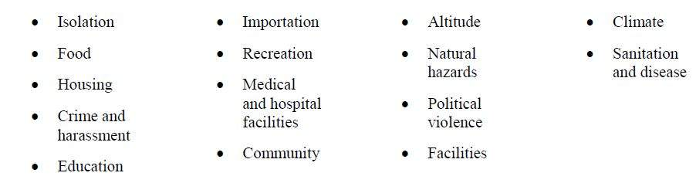
These categories are then sub-divided into approximately 124 factors, which are given point weights. Depending on the given post, the point weights determine the differential classification on an increasing scale that ranges from a minimum payment of 5% of basic salary up to a legal maximum of 25%. Rates are adjusted up or down depending on changes in hardship conditions. Not all U.S. companies use the rates determined by the State Department, however. Some MNEs rely on rate recommendations provided by consultants or consulting organizations, and these may vary considerably from State Department rates.
For example, some employers may use an area allowance or “blended” premium ranging from 0% to 35%, and sometimes up to 60%, to pay for identified and designated hardship locations. Such an allowance takes into account physical threat or unhealthful conditions, the availability and quality of goods and services, and social and geographical conditions. Sometimes, the area allowance combines the hardship and danger allowances, and some companies include a hidden Foreign Service premium, as well.
Area allowances are frequently used by oil and oil service companies to lure expatriates to so-called undesirable locations. For example, one company with expatriates in Tehran, Iran, applies an area allowance of 60% without a maximum in addition to a Foreign Service premium of 15%. In this case, the area allowance represents both the hardship and danger allowance.
Danger Pay
Danger pay allowances are often given to expatriates who live and work in a foreign location that is plagued by civil revolution, civil war, or terrorism—conditions that threaten physical harm or imminent danger to expatriates’ health or well-being.
Rates for U.S. citizens are determined by the U.S. State Department and issued when and where applicable; they usually do not exceed 25% of base pay. However, depending on their need for expatriates and other requirements, some companies opt to exceed the 25% rate.
The calculation of the danger pay allowance is somewhat less scientific than the hardship allowance and depends on the wartime conditions described earlier. During the Gulf War, for example, danger pay allowances were granted by the State Department for most of the Gulf countries; however, these were quickly rescinded when hostilities ceased.
In many cases, companies put a cap on both hardship and danger pay allowances. One company, for example, determined that the sum total of hardship and danger allowances would not exceed 40%. In another case, the cap was applied to base salary, with the total hardship and danger allowances applied to a maximum of $80,000 base pay. A variety of combinations of caps on the sum total of hardship and danger pay allowances exist, with and without caps on base salary.
The Foreign Service Premium
The Foreign Service premium is generally paid only to employees who are on an overseas assignment of at least 1 year or more in duration or who receive a full expatriate compensation package.
These extra moneys are provided to the assignee to offset many out-of-pocket expenses that come with an international assignment.
Typically, employees on training or short-term assignments are not eligible. The premium is paid on a periodic basis and continues as long as the expatriate is overseas.
Foreign Service premiums can be structured in several ways:
- As a flat percentage of base salary, such as 10%,15%, or sometimes, 20%;
- As a graded or tapered percentage of base, for example: 15% of $20,000, 10% of the next $50,000,and 5% on the excess; or
- As a variable percentage of base dependent upon the foreign location — 10% for Region X; 15% for Region Y; 20% for Region Z.
Generally, the use of a cap is more prevalent than no cap. Again, variations are limitless and are typically industry-driven. This is a common worldwide compensation practice for expatriates.
Mobility Premiums
The mobility premium is a payment given upon transfer to another foreign post or repatriation to the home country to indemnify the assignee for both the actual cost and the challenges associated with a relocation.
It is sometimes given to phase out a Foreign Service premium.
Few companies, however, give both types of premiums. The mobility premium is most frequently expressed as a multiple of a month’s base pay, with or without a cap, but it can also be a lump sum dollar amount.
Some representative mobility premium formulas include:
- 3 month’s base pay up to a maximum of $15,000.
- A lump sum amount of $10,000 or $12,000.
- A lump sum amount as a variable multiple of 1 month’s base pay, depending on the foreign post.
Mobility premium payments vary from company to company. Some companies divide up the payment to be distributed throughout the assignment, while others pay the full premium within the first 3 years of the assignment. Rarely is the full amount given at one time. Additionally, as with all premiums or allowances, tax and other considerations play an important role in the method and timing of the payments.
Relocation or Transfer Allowance
The relocation or transfer allowance is a lump sum payment designed to cover the incidental expenses that inevitably arise during a transfer to a different work location, and which may not be itemized.
Payment is generally made at the time of the transfer to, from, or between foreign posts.
Formulas for such allowances differ widely. Some specific examples include:
- From $1,000 to up to $5,000 per transfer.
- 1 month’s base salary, up to a maximum of $3,000.
- 1 month’s base salary, with a maximum of $5,000 for furnished accommodations and $3,000 for unfurnished.
Again, some companies’ mobility premiums may include the transfer or relocation allowance. During the last few years in particular, a variety of methods have been introduced.

Keeping Costs Down

Hardship, danger pay, and other allowances are currently under scrutiny as they represent a major cost item in the expatriate compensation package. More often than not, these allowances are also provided tax-free, and therefore, have become a favorite cost-containment target.
Pressure from the top, especially from the corporate finance department, has prompted managers to examine what other companies are doing and more closely scrutinize the costs of their own expatriate packages. Practitioners in the field of expatriate compensation often weigh how much should be given away to lure an employee to a foreign location. Many believe employees have different reasons or motivations for accepting—or rejecting—a foreign assignment. Thus, it makes sense to have more than one assignment policy to differentiate between expatriates and their needs, i.e., developmental versus managerial assignments or regional versus global assignments. For this reason, many companies are revisiting their existing assignment policies, giving particular attention to the rationale and payment of incentive allowances, and placing greater emphasis on proper tax planning procedures to determine the method, location and timing of payment.
Other differential pay programs for international assignees (IA) may include:
- Financial incentives can help encourage employees and their families to move. Unsurprisingly, it’s more challenging to get employees to accept long-term assignments than short ones, especially to difficult locations. Also, short-term assignments are more likely to be perceived as an integral part of an employee’s career development.
- Spousal support is often required to convince IA candidates to take an assignment. Therefore, it is commonplace for companies to include spouse support in their international assignments policy.
- Home leave is a normal part of many expatriate packages. This usually covers the travel costs to the home location, or a flat amount that the employee can use for travel to any location.

Balance Sheet Approach
Lesson 30 of 69

Many multinational companies have an international compensation policy designed to ensure employees on international assignments receive total compensation, housing, living standards, and other benefits which are comparable to what they would have if living in their home country. The intent is to keep the employee “whole,” regardless of assignment location. The procedure of keeping an employee whole is known as the “balance sheet” approach.
By employing the balance sheet, the assignment costs to an employer can vary significantly, depending upon the location of an assignment. For example, an employee who is transferred from Toronto to Tokyo will be subject to increased housing expenses. To keep the employee whole, the employer would have to reimburse the employee for these additional costs. The assignment costs are magnified by income tax reimbursements.
Most industrialized countries consider employer-provided foreign assignment benefits to be income to that employee, which would be subject to the local country’s income tax.
Furthermore, tax reimbursements provided by the employer to pay for the additional income taxes incurred on assignment benefits are also considered taxable compensation. The “tax on tax” impact can be a major expense to an employer.
For example, the tax reimbursement required to reimburse an employee residing in Japan in the 65% marginal tax bracket to a company-provided taxable benefit of $10,000 would be $18,571. Therefore, the employer would have to give the employee a cash benefit of $28,571 in order to provide a cost of living benefit of $10,000 plus a tax disbursement of $18,571.
Tax reimbursement policy is designed to ensure that an employee will not suffer combined taxes on income (host country taxes, Social Security taxes and home country taxes) in excess of that which would have been paid if the employee were living in the home country. The most common methods utilized to accomplish this objective are either: tax protection or tax equalization.
Tax Protection
Tax protection plans are designed to reimburse an employee to the extent that the employee’s combined total income and Social Security taxes equal or exceed the amount that he/she would have paid if he/she remained in the home country. If combined actual taxes are lower because of the foreign assignment, then the employee realizes a benefit from the foreign assignment, since he/she is entitled to keep the tax benefit.
Generally, a company will compute a hypothetical tax for the employee.
The hypothetical tax is typically the home country tax the employee would incur if employed in the home country at the same compensation level, but without the foreign assignment benefits.
If the actual tax incurred by the employee exceeds the hypothetical tax, the employee would claim a refund from the employer for the difference between the actual tax and the hypothetical tax. If the actual tax incurred by the employee does not exceed the hypothetical tax, the employee would not file for tax reimbursement from the employer, but would just pay the actual taxes incurred.
Tax Equalization
Many global employers have tax equalization policies which attempt to adjust the expatriates net take home pay so the amount they receive overseas is the same as the expat would receive if they remained working in their home country.
These policies use formulas which take into account the home country tax, home country state tax (if any), and the foreign tax, with adjustments for the foreign tax credit and foreign earned income exclusion. They sometimes adjust for housing reimbursements and differences in the cost of living between the home country and the expatriate’s assignment country.
Tax equalization plans are designed to provide an employee with neither a tax benefit nor tax detriment from the foreign assignment. If combined actual taxes are higher because of the foreign assignment, the employer would reimburse the employee for the additional costs incurred. However, if combined actual taxes are lower because of the foreign assignment, then the employee must reimburse the employer for the difference. Regardless of the tax jurisdiction where the employee works, the employee will be subject to the same level of taxes, net of reimbursement (or payment) from the employer.

Under a tax equalization policy, a company will typically withhold a hypothetical tax from each payroll payment to the employee. The hypothetical withholding is based on the projected tax the employee would have incurred on compensation in the home country, assuming no foreign assignment benefits. After the end of the tax year and after preparation of all the relevant tax returns, a reconciliation would be prepared based on actual income received during the year. The reconciliation would determine whether the employee is due a refund of hypothetical taxes, or whether he/she must reimburse the company for underpayment of hypothetical taxes.
In its purest form, the balance sheet would favor a comprehensive tax equalization policy. Deviations from the balance sheet include tax protection (as discussed above), and tax gross-up (which reimburses the tax and the “tax on tax” on specific taxable benefits).
Some companies apply an “ad hoc” tax reimbursement policy where each individual is treated separately. This may be workable for a company with only a handful of international employees, but would be inappropriate for a company with hundreds of international assignments.

Higher of Host or Home
Lesson 31 of 69
This rewards system proposes to pay the assignee a salary that is based on either the local pay rates or their home country wage rates, whichever is higher. The assignee gets to choose which one they want.
A home- or headquarters-based build-up is prepared using traditional elements of base salary plus incentives, the cost of host housing, and any positive cost-of-living adjustment. Deducted from this amount are hypothetical tax and a home-housing contribution. At the net pay level, this build-up is compared with the result of placing the employee in the host pay structure. This approach may be attractive to companies that seek some of the benefits of a host-country approach but recognize that a host approach will often not be sufficiently attractive to persuade employees to relocate.
One variation is to make the calculation net of home-country savings (or, reserve), thus focusing primarily on the costs of goods and services. Another option is to factor in allowances (e.g., education)—representing a straightforward cost of employing an expatriate that arises from the expatriate's personal situation—on the host-country side of the comparison.
Advantages:
- Allows clear selection of the highest net compensation.
- Offers a fair and competitive compensation package.
Disadvantages:
- Is not generally cost-effective.

Net-to-Net Approach
Lesson 32 of 69
The net-to-net approach is best used for integrating assignees into local pay programs when the relocation is permanent or for an indefinite period.
In this approach, base pay is typically reduced by a hypothetical home-country tax, with the “net” salary paid to the expatriate. Due to the often-significant differences in tax rates, retirement, housing costs, and general cost of living between cities, a simple conversion of salary would be meaningless. Therefore, home-country net pay is adjusted for any cost-of-living difference, then grossed up for local/state taxes and housing costs. Then, the home country net pay is converted to a local net pay level to afford the transferee the same standard of living. Thus the net-to-net.
Companies generally develop the following two alternative packages, and pay the higher amount:
- A competitive local salary within the host structure, factoring in job experience, work skills, and peer salaries; or
- A salary package that includes adjustments for differences in taxes, housing, and cost of living between home and host.
Advantages:
- Preserves standard of living in the assignment location.
Disadvantages:
- Requires extensive home and host data.

Purchasing Power Parity (PPP)
Lesson 33 of 69

The purchasing power parity (PPP) theory uses the long-term equilibrium exchange rate of two currencies to equalize their purchasing power. Developed by Gustav Cassel in 1918, it is based on the law of one price. The theory states that, in ideally efficient markets, identical goods should have only one price.
This purchasing power rate equalizes the purchasing power of different currencies in their home countries for a given basket of goods. Using a PPP basis is arguably more useful when comparing differences in living standards on the whole between nations because PPP takes into account the relative cost of living and the inflation rates of different countries, rather than just a nominal gross domestic product (GDP) comparison.
PPP exchange rate fluctuations are mostly due to market exchange rate movements. Aside from this volatility, consistent deviations of the market and PPP exchange rates are observed. For example, market exchange rate prices of non-traded goods and services are usually lower where incomes are lower. A U.S. dollar exchanged and spent in India will buy more haircuts than a dollar spent in the United States. PPP takes into account this lower cost of living and adjusts for it as though all income was spent locally. In other words, PPP is the amount of a certain basket of basic goods which can be bought in the given country with the money it produces.
Efficient Purchaser Index
The Efficient Purchase Index (EPI) is a comparison of the prices of goods and services between the home country and assignment location that assumes familiarity with local brands and shopping in local outlets in the assignment location. The EPI is a type of cost of living index, less generous than a “Standard” index, used to calculate a cost of living allowance. An EPI index assumes that the expatriate will adjust their purchasing behavior in the host country by buying local brands, in place of more expensive brands with which they are familiar in their home country.
Big Mac Index
The Big Mac index is an informal way of measuring the purchasing power parity (PPP) between two currencies and provides a test of the extent to which market exchange rates result in goods costing the same in different countries. As stated in the Economist, it “seeks to make exchange-rate theory more digestible.”
One suggested method of predicting exchange rate movements is the rate between two currencies should naturally adjust so a sample basket of goods and services should cost the same in both currencies. In the Big Mac index, the “basket” in question is considered to be a single Big Mac sandwich as sold by the McDonald’s fast food restaurant chain. The Big Mac was chosen because it is available to a common specification in many countries around the world, with local McDonald’s franchisees having significant responsibility for negotiating input prices. For these reasons, the index enables a comparison between many countries’ currencies.
The Big Mac PPP exchange rate between two countries is obtained by dividing the price of a Big Mac in one country (in its currency) by the price of a Big Mac in another country (in its currency).
This value is then compared with the actual exchange rate; if it is lower, then the first currency is under-valued (according to PPP theory) compared with the second, and conversely, if it is higher, then the first currency is over-valued.

Lesson 34 of 69

Laissez-Faire Method

Some companies employ the “Laissez-Faire” or “hands-off” method. This method generally implies that the employee is on his/her own with respect to pay taxes or other benefits. This system (or lack of system) would promote assimilation to the foreign environment, but may create unexpected surprises to the employee at tax time. Such surprises may impact job performance.

Lesson 35 of 69

Bona-Fide Residence Test

Planning the timing of a foreign assignment will save money. One benefit of an expatriate assignment is reduced U.S. income tax resulting from the foreign earned income and housing exclusions, if the assignee is U.S. based. These provisions allow the expatriate to annually exclude up to approximately $100,000 of foreign earned income plus his foreign housing costs. There are very specific qualifications for these exclusions: the individual must meet either the bona-fide residence or the physical presence test. The timing of the assignment is critical to meeting these requirements.

The bona-fide residence test is simple: The employee must maintain a foreign tax home for one full calendar year, January through December. The physical presence test is more complicated, but crucial for short-term assignments where the individual will not be in a foreign country for a full calendar year. This requires the expatriate to be overseas for 330 days during a consecutive 12-month period.

Thus, an individual with a foreign assignment beginning April 1, 2018, and ending March 31, 2019, does not meet the bona-fide residence test. He or she does not meet the physical presence test if more than 35 days are spent in the United States per year. For example, a lovesick expatriate made 10 trips to the United States to see his fiancée, each lasting five days. His assignment ended abruptly after only 11 months. Obviously, he did not qualify under the bona-fide residence test. The trips caused him to fail the physical presence test.

International Social Security Agreements (Totalization)
Lesson 36 of 69
International Social Security agreements, often called “totalization agreements,” have two main purposes. First, they eliminate dual Social Security taxation, the situation that occurs when a worker from one country works in another country and is required to pay Social Security taxes to both countries on the same earnings. Second, the agreements help fill gaps in benefit protection for workers who have divided their careers between their home country and another country.
Without some means of coordinating Social Security coverage, people who work outside their country of origin may find themselves covered under the systems of two countries simultaneously for the same work. When this happens, both countries generally require the employer and employee or self-employed person to pay Social Security taxes.
U.S. Social Security extends to American citizens and U.S. resident aliens employed abroad by American employers, without regard to the duration of an employee’s foreign assignment, and even if the employee has been hired abroad.
U.S. law provides compulsory Social Security coverage for services performed in the United States as an employee, regardless of the citizenship or country of residence of the employee or employer, and irrespective of the length of time the employee stays in the United States. Unlike many other countries, the United States generally does not provide coverage exemptions for nonresident alien employees or for employees who have been sent to work within its borders for short periods. For this reason, most foreign workers in the United States are covered under the U.S. program.
Paying dual Social Security contributions is especially costly for companies that offer “tax equalization” arrangements for their expatriate employees. A firm that sends an employee to work in another country often guarantees that the assignment will not result in a reduction of the employee’s after-tax income. Employers with tax equalization programs, therefore, typically agree to pay both the employer and employee share of host country Social Security taxes on behalf of their transferred employees.
The aim of all totalization agreements is to eliminate dual Social Security coverage and taxation while maintaining the coverage of as many workers as possible under the system of the country where they are likely to have the greatest attachment, both while working and after retirement.
A general misconception about these agreements is they allow dually covered workers or their employers to elect the system to which they will contribute. This is not the case. The agreements, moreover, do not change the basic coverage provisions of the participating countries’ Social Security laws—such as those that define covered earnings or work. They simply exempt workers from coverage under the system of one country or the other when their work would otherwise be covered under both systems.
Each agreement (except the one with Italy) includes an exception to the territoriality rule designed to minimize disruptions in the coverage careers of workers whose employers send them abroad on temporary assignment. Under this “detached-worker” exception, a person who is temporarily transferred to work for the same employer in another country remains covered only by the country from which he or she has been sent. A U.S. citizen or resident, for example, who is temporarily transferred by an American employer to work in an agreement country continues to be covered under the U.S. program and is exempt from coverage under the system of the host country. The worker and employer pay contributions only to the U.S. program. The detached-worker rule in U.S. agreements generally applies to employees whose assignments in the host country are expected to last 5 years or less. The 5-year limit on exemptions for workers is substantially longer than the limit normally provided in the agreements of other countries.
Employee Provident Funds (EPF)
Provident Funds are usually found in countries that have no formalized Social Security or government sponsored/funded retirement system. A provident fund is a mandated savings scheme that requires workers to make pre-determined contributions to a savings/investment program that builds equity for the worker’s eventual retirement.
India (among other countries) has such a mandatory retirement savings program. India’s compulsory program is managed by the Employees’ Provident Fund Organization (EPFO). This system is a state sponsored compulsory contributory pension and insurance scheme. It is one of the largest Social Security organizations in the world in terms of members and volume of financial transactions undertaken.
Established in 1952, the organization is administered by a Central Board of Trustees, comprised of representatives of the Government of India, provincial governments, employers and employees. The total financial investments managed by the EPFO is in excess of 2,000 billion Rupees (US $50 billion) and there are a total of about 40 million contributing and non-contributing members in about 450,000 covered establishments.
Membership is compulsory for employees in establishments with 20 employees or more. The employee contribution is set at 12% of basic salary and is matched by the employer. In addition to the compulsory Provident Fund (where the present rate of interest is 8.5%), the EPFO also provides a service pension on retirement, death, or disability and a lump sum insurance payout in case of death of the member, to his nominee/family.
Currently, expatriates who work in those countries with mandated EPFs have no compulsion to contribute to the EPF and usually continue to pay into their home country’s Social Security system so their pension account doesn’t show a “break in service.” However, there is a movement to require expatriates, who are from countries that have not negotiated a bilateral Social Security pact (totalization agreement), to contribute to the EPF.
Unlike many countries, EPFO allows premature withdrawal, which means international workers can pull out their money when leaving India. Indian workers working abroad aren’t allowed the same facility. They have to complete at least 10 years of service to be eligible for a withdrawal.

Global Talent Development
Lesson 38 of 69
Typical Training Issues for Expatriates
Training needs in an MNE are predictable and ongoing.
Do expatriates take the time to learn a bit of the host-country's language?
Expatriates don’t have to be fluent. Just learning enough of the host-country's language to say “please” and “thank you” will go a long way to opening the door to better relations and understanding.
How is the host culture different from the expatriates?
Not showing the soles of one’s feet, not pointing to the left hand — there are a variety of things that are no-no’s in different cultures. They should learn these things prior to their posting.
Can the expatriate be humble?
The U.S. approach is one way to solve problems. It’s not necessarily the only way. The expatriate should take the time to appreciate what the host-country culture has to offer. The expatriate might even learn a better way to deal with organizational problems.
What does the expatriate know about the local competitors, their challenges, and their marketplace?
Learning about the host-country’s politics, economics, and culture is vital prior to the commencement of the assignment. Host-country workers will embrace the expat if they can “talk the talk.”
Global Communication
Global communications present some interesting challenges. In times of globalization the aspects of cultural diversity and cross-cultural communication become more and more important. People have the possibility to travel across continents, and meetings are organized all around the world.
The knowledge of at least one foreign language is an essential skill globalists/expatriates should have.
But nevertheless, just translating a word or a sentence from one language into another does not guarantee a successful course of negotiation. According to Mattock (2003), the actual talk is just the tip of the iceberg. The major, and thus bottom, layer is culture. Therefore, international managers should be aware that transcultural competence can only be achieved by “being aware of cultural differences, respecting them and ultimately reconciling them.”
Even when two people think they can speak each other’s language, the chance of error is high. Usages and contextual inferences may be completely different between cultures. So even though one speaker may have learned the vocabulary of the other’s language, selecting the most appropriate words, with the correct intonation, spoken with appropriate eye contact while standing a proper distance from the other are all critical even before one considers the propriety of the topic to be discussed.
The English use understatements and reservations; they may be vague in order to avoid confrontation and to be polite. Spaniards, French, and Italians use language to be eloquent and expressive. Germans use logic. American speech tends to be direct and to the point. The Japanese use words that can sound like diplomatic platitudes, while their tone, gestures, and body language convey what they are really saying. Hard negotiating may be veiled in pleasantries, which can mislead the Westerner. In Asian cultures, “yes”may mean “I understand” and not “I agree.”
When language skills are unequal, clarifying one’s meaning in 4 ways will improve communication:
- Avoid using slang and idioms; choose words that will convey only the most specific denotative meaning;
- Listen carefully and, if in doubt, ask for confirmation of understanding (particularly important if local accents and pronunciation are a problem);
- Recognize that accenting and intonation can cause meaning to vary significantly; and
- Respect the local communication formalities and styles, and watch for any changes in body language.
Most global corporations are continually designing and developing communication-skills training classes. While not entirely necessary, it is a great advantage for an expatriate to possess some knowledge of the culture and language prior to an assignment.
Types of Training Programs

Training Needed by Executives
Executives create a corporate culture through the effective management of organizational values, performance, and systems. As a result, budding executives need training in such areas as:
- Long-term planning, strategy, and forecasting;
- Corporate goals and the global business environment;
- Policy formulation;
- Strategic leadership, both in and out of the company; and
- Succession planning, including the development of middle management.
Some types of executive training, however, are better covered through in-house programs. For example, the corporate controller, marketing vice president, or industrial relations director can present overviews of problems facing the organization in the financial, sales, or HR areas. The company’s legal counsel likewise can do a better job than an outsider could when explaining how a new law or government regulation affects the organization.
Other types of executive training fit into the category of self-improvement courses. Most executives can benefit from courses in effective speaking and writing; others may want to master speed-reading. In some industries, top managers may need to learn computer science basics, foreign languages, and other skills that could simplify their jobs or give them a competitive edge. If designed as a self-study course, this type of training can accommodate an executive’s hectic schedule.
However, the most common way for executive training to be delivered is by use of the informal method of one-on-one coaching. Executives are often less willing to attend public seminars or formalized development scenarios that include a classroom presentation. They are more willing to listen to a trusted and more experienced individual that they perceive to have the same challenges they face on a day-to-day basis.
Coaching was once viewed by many as a tool to help correct underperformance, today it is becoming much more widely used in supporting top producers. As individuals advance to the executive level, development feedback becomes increasingly important, more infrequent, and more unreliable. Having a coach that will allow the global executive to privately discuss daily issues, is considered a highly desirable way of assisting the leader in their own professional development. The idea to engage a coach can originate from HR, leadership development professionals, or from executives themselves.
Four T’s of Training
To develop effective global leaders, organizations often utilize the so-called Four-T’s of training. Travel, Teamwork, Training, and Transfer. These measures have proven to be an extremely effective tool for developing global executives.
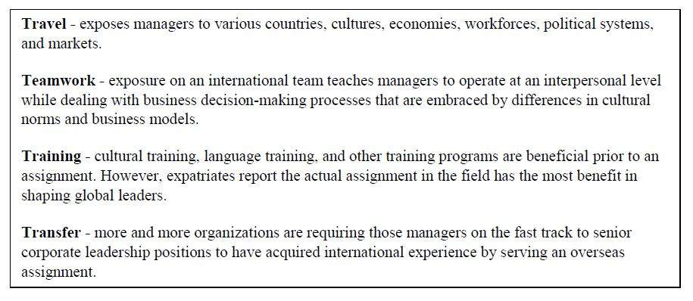
Team Skills
To develop and implement work teams, many employers cross-train employees so team members know each other’s jobs. Normally, the effort begins by explaining cross-training to employees, including an introduction to the team concept. Then team members participate in courses designed to teach essential skills: solving problems, making decisions, resolving conflicts, and giving feedback. At the same time, employees undergo extensive technical training. Team members often serve as peer trainers to make sure each person can do every job on the work team. This enables the employer to be more flexible in reacting to emergency situations such as economic slowdowns, loss of key employees such as an expatriate, or implementing a standardized pay system.
Virtual Teams
A virtual team, also known as a geographically dispersed team (GDT), is a group of individuals who work across time, space, and organizational boundaries with links strengthened by webs of communication technology. They have complementary skills and are committed to a common purpose, have interdependent performance goals, and share an approach to work for which they hold themselves mutually accountable. Geographically dispersed teams allow organizations to hire and retain the best people regardless of location.
Members of virtual teams most often communicate electronically and may never meet face-to-face.
However, most teams will meet at some point in time. A virtual team does not always mean teleworkers. Teleworkers are defined as individuals who work from home. Many virtual teams in today’s organizations consist of employees both working at home and small groups in the office but in different geographic locations.
Why virtual teams?
- The best employees may be located anywhere in the world;
- Workers demand personal flexibility;
- Workers demand increasing technological sophistication;
- A flexible organization is more competitive and responsive to the marketplace;
- Workers tend to be more productive (i.e., they spend less time on commuting and travel);
- The increasing globalization of trade and corporate activity;
- The global workday is 24 vs. 8 hours;
- The emergence of environments which require inter-organizational cooperation as well as competition;
- Changes in workers’ expectations of organizational participation;
- A continued shift from production to service/knowledge work environments; and
- Increasing horizontal organization structures characterized by structurally and geographically distributed human resources.
Benefits of virtual teams:
- Some members of virtual teams do not need to come in to the workplace, therefore the company will not need to offer those workers offices or parking spaces;
- They reduce traveling expenses for employees;
- They allow more people to be included in the labor pool;
- They decrease both air pollution and congestion because there is less commuting;
- They allow workers in organizations to be more flexible; and
- Physical handicaps are not a concern.
Problems with virtual teams:
- Misunderstanding in communications are more likely;
- Working on a project over the virtual workspace causes lack of project visibility;
- Difficulty contacting other members. (i.e. email, instant messaging, etc.);
- Differences in time zones; and
- It can be difficult for team members to obtain the meanings of text-based messages.
Cross-Cultural Training
Multinational organizations and international workers must learn to cope with and survive in cultures that are often quite different than their home culture. Often, international assignees must receive pre-departure training on the destination culture and language to enhance the probability of assignment success. The global training manager must be prepared to design programs that will support the corporation’s goals by understanding and dealing with cultural differences.
Cultural Orientation Programs
These programs explain the host country’s geography, history, politics, economy, culture, religion, education, general attitudes, and business and social customs. This type of orientation training is best delivered by a citizen of the foreign country or by an expatriate who has spent considerable time working and living in the country. Cross-cultural specialists and seasoned multinational expatriates make good trainers since they have learned to read the behavioral nuances that accompany communication in a particular country.
Communication Skills
In different cultures, the same behaviors can have entirely different meanings.
For example, the same types of eye contact, body posture and positioning, facial gestures, and personal space considered normal, business-like, and friendly in one culture can be seen as rude, insensitive, or even threatening behaviors in another culture.
International employees need to develop sensitivity to various cultural norms for greeting people, developing rapport, using formal speech, responding with appropriate directness, and so on.
As a result, cross-cultural adjustment training should cover verbal and non-verbal communication skills. Communication skills training should include lessons on how to:
- Ask questions or get information without seeming intrusive or rude.
- Identify what social protocol to use and when.
- Use body language to indicate trustworthiness and attention.
- Provide feedback or communicate changes.
- Select methods for focusing on and solving problems.

Diversity Training
In the age of globalization, effective trainers must learn to reach and teach workers in a manner that allows for individual differences among the class participants and helps foster understanding among workers.
Diversity training is training for the purpose of increasing participants’ cultural awareness, knowledge, and skills, which is based on the assumption that the training will benefit an organization by protecting against civil rights violations, increasing the inclusion of different identity groups, and promoting better teamwork. Better teamwork translates into enhanced productivity, improved communications, more innovative problem solving, and a pleasant work environment.
The Three R’s
A great challenge for the MNE is to design and develop professional programs that are cross-cultural. Fons Trompenaars and Charles Hampden-Turner have developed their theory of the Three R’s that help explain the challenge and process of successfully integrating multi-cultural operations into a cohesive unit.
Their core finding is that great leaders reconcile seemingly opposing values—that’s what they do, that’s what makes them effective, and that’s what makes them great.
Senior leaders usually seem to know how to integrate objectives to deliver results. Successful leaders rarely give orders; rather, they create a culture of reconciled values. This transcultural competence encompasses three R’s: recognition, respect, and reconciliation.
Recognition
The first step for leaders is to help all players recognize that there are cultural differences, and to recognize their importance and how they have an impact.
Respect
Different cultural orientation and views about “where I am coming from” are neither right or wrong; they are just different. It is all too easy to be judgmental and distrust those who give different meaning to their world from the one you give to yours. Thus, the next step is to respect these differences and to accept other’s right to interpret the world in the way they see fit.
Reconciliation
Once managers in multi-cultural environments are aware of their own cultural predispositions, and once they can respect and understand that those of another culture are legitimately different, then it becomes possible to reconcile differences, yielding positive business benefits. Reconciling cultural differences of their workforce is the optimal challenge for the multi-cultural organization.
Hofstede’s Dimensions of Culture
Geert Hofstede is an influential Dutch expert on the interactions between national cultures and organizational cultures. Hofstede demonstrated that there are national and regional cultural groupings that affect the behavior of organizations, and that are very persistent across time.
He has identified 5 dimensions of culture in his study of national influences:
- Power distance
- Individualism/collectivism
- Masculinity/femininity
- Uncertainty avoidance
- Long- and short-term orientation
Power Distance
Power distance is the degree to which the less powerful members of society expect there to be differences in the levels of power. A high score suggests that there is an expectation that some individuals wield larger amounts of power than others. A low score reflects the view that all people should have equal rights. Latin American and Arabic nations are ranked the highest in this category; Scandinavian and Germanic speaking countries the least. Countries with high power distance rating are often characterized by a high rate of political violence.
In High Power Distance cultures, obedience to authority (parent, boss, officials) is expected, language is filled with power or hierarchy indicators, and managers/teachers tend to be autocratic while subordinates expect direct supervision. In Low Power Distance cultures, the emphasis is on challenging decisions, expecting autonomy, and gaining independence.
Germany has a 35 on the cultural scale of Hofstede’s analysis. Compared to Arab countries where the power distance is very high (80) and Austria where it very low (11), Germany is somewhat in the middle. Germany does not have a large gap between the wealthy and the poor, but has a strong belief in equality for each citizen. Germans have the opportunity to rise in society.
The power distance in the United States scores a 40 on the cultural scale. The United States exhibits a more unequal distribution of wealth compared to German society.
Again, Hofstede’s power distance index measures the extent to which the less powerful members of organizations and institutions (like the family) accept and expect that power is distributed unequally. This represents inequality (more versus less), but defined from below, not from above. It suggests that a society’s level of inequality is endorsed by the followers as much as by the leaders.
Individualism vs. Collectivism
Individualism is contrasted with collectivism, and refers to the extent to which people are expected to stand up for themselves, or alternatively act predominantly as a member of the group or organization.
Highly individualistic cultures believe the individual is the most important unit.
They encourage:
- People taking care of themselves,
- Making decisions based on individual needs, and
- An “I” mentality.
Highly collectivistic cultures believe the group is the most important unit.
They encourage:
- Primary loyalty to group (nuclear family, extended family, caste, organization),
- Decision-making based on what is best for the group,
- Dependence on organizations and institutions (expectation that organization/institution/group will take care of individual), and
- A “We” mentality.
Latin American cultures usually rank low in this category, while U.S.A. is the most individualistic culture in the world.
Masculinity vs. Femininity
Masculinity vs. femininity refers to the value placed on traditionally male or female values.
Masculine cultures value competitiveness, assertiveness, ambition, and the accumulation of wealth and material possessions, while feminine cultures place more value on relationships and quality of life.
Japan is considered by Hofstede to be the most “masculine” culture, Sweden the most “feminine.” The U.S. and U.K. are moderately masculine.
Masculine societies tend to see men as assertive and women as nurturing. Men tend to be competitive, visible, focused on success, and vocation-oriented. Feminine societies tend to have both men and women in nurturing roles and place much less emphasis on assertiveness for either. Both men and women focus on cooperation and awareness of those who are in need. Social accommodation is important in feminine societies.

Uncertainty Avoidance
Uncertainty avoidance reflects the extent to which a society attempts to cope with anxiety by minimizing uncertainty.
Cultures that scored high in uncertainty avoidance prefer rules (e.g. about religion and food) and structured circumstances, and employees tend to remain longer with their present employer.
High Uncertainty Avoidance cultures are more resistant to change, often characterized by more elaborate rituals/religious practices. Low Uncertainty Avoidance cultures tend to accept competition and conflict, and tolerate dissent and deviance.
Mediterranean cultures and Japan rank the highest in this category. Sweden shows up in several of these charts as the most extreme culture in both the country most willing to embrace uncertainty and as the most feminine society.
Long- vs. Short-Term Orientation
Long- vs. short-term orientation describes a society's “time horizon,” or the importance attached to the future versus the past and present.
In long-term oriented societies, thrift and perseverance are valued more. In short-term oriented societies, respect for tradition and reciprocation of gifts and favors are valued more.
Eastern nations tend to score especially high here, with Western nations scoring low and the less developed nations very low; China scored highest and Pakistan at the extreme lowest level.
Trompenaars’ and Hampden-Turner’s Cultural Models
Trompenaars and Hampden-Turner created a model that derived seven relationship orientations, along with attitudinal dimensions towards time and the environment, that have considerable implications for international human resources management (IHRM). These dimensions are:
- Universalism vs. Particularism
- Individualism vs. Communitarianism (see Hofstede’s model on Individualism vs. Collectivism)
- Affective vs. Neutral
- Achievement vs. Ascription
- Specific vs. Diffuse
- Sequential Time vs. Synchronous Time
- Inner Directed vs. Outer Directed
Universalism vs. Particularism
Universalism vs. particularism indicates how a society applies rules of morals and ethics.
In a universal society, such as the U.S., rules and contracts are developed which can apply in any situation. No exceptions.
In universalism, there is a belief that what is good or true can be discovered, defined, and applied to every situation. Because of their universalistic approach, in a business situation, Americans will want to rely on a contract to communicate the terms of an agreement and to define the relationship between the parties. China is a particularistic culture where people look at relationships and circumstances in a specific situation to decide what is right. For the Chinese, the legal contract communicates a starting point for an agreement. As circumstances change so too should the terms of the agreement. For the Chinese, the situation and the particular individuals involved are what define the relationship.
Particularism is based on logic of the heart and human friendship. Many universalists are more common in Protestant cultures because of the religious beliefs in good and bad (laws).
Strong universalist cultures use the court to mediate conflicts.
Therefore, Americans have many more lawyers per citizen than any other country. The more universalistic a country is, the greater the need to protect the truth. International operating businesses more likely think in a universalistic way. When universalistic business people agree to a contract relating to a high value deal, there are always lawyers involved to assure that every detail is correctly mentioned and protected by a paragraph. In particularistic cultures, they trust, rely, and believe in the business relationship which was built up in the time before the contract was discussed.
Chinese business people put much trust in relationships between the partners. Strict regulations and formulations would probably offend/insult the partner because they would get the idea that they are not trustworthy or are prone to cheating. Chinese try to keep the contracts vague. It might happen that Chinese business people will still try to negotiate afterwards, even when the contract is already signed/closed and agreed from all sides. In negotiations, the Chinese will spend a lot of time in building up a relationship with their business partners so the actual negotiation will be at the end of the meeting time. On the other hand, Americans dealing with Chinese often try to close deals as fast as possible.
Universalistic cultures normally focus more on rules than on relationships. For instance, American employees compete hard for better job positions and the opportunity to climb up the hierarchy and earn more money. They sometimes do this without caring for colleagues and the relationship with them. In comparison, particularistic cultures like China focus heavily on relationships. When working with/managing particularists, universalists should build informal networks and create private understandings as well as try to look for fairness in doing business by treating each case as a specific one.
Particularistic cultures avoid rigid or standardized systems to manage across cultures.
In a recent survey from Working Resources of 46 countries, respondents in predominately Protestant areas (Switzerland, U.S., Canada, Sweden, Australia, UK, and the Netherlands) stated it is more important to follow the law than to protect a friend (Universalism).
Respondents in Catholic countries (Brazil, Spain, Poland, France, Mexico, Cuba, and Venezuela) stated it is more important to help a friend than uphold a law when the two are in conflict (particularism). Those in Buddhist, Confucian, Hindu, and Shinto countries (South Korea, China, Indonesia, Nepal, Japan, and Singapore) side even more towards defending a friendship than upholding the law.
Affective vs. Neutral
In highly affective cultures, people tend to openly express their feelings. In highly neutral cultures, emotions are not expressed as openly and naturally. People from highly affective cultures are more likely to smile, talk loudly when excited, and greet each other enthusiastically.
People from highly neutral cultures experience the same emotions, but are less inclined to express them, and they express them more subtly. Implications for behavior in the workplace include how demonstrative people are when showing appreciation and affection for each other and when celebrating successes.
Achievement vs. Ascription

This dimension relates to how status is accorded to people in different cultures. The contrast between an achievement culture and an ascriptive culture is fairly straightforward. Achievement means people are judged on what they have accomplished and on their record. Ascription means status is attributed to persons by things like birth, kinship, gender, age, interpersonal connections, or educational record.
Ascribed status is a position assigned to individuals or groups based on traits beyond their control, such as sex, race, or parental social status. This is usually associated with “closed” societies. Achieved status is distinguished from ascribed status by virtue of being earned. Many positions are a mixture of achievement and ascription; for instance, a person who has achieved the status of being a doctor is more likely to have the ascribed status of being born into a wealthy family.
Achieved status refers to doing; ascribed status refers to being. Take a look at the difference from another angle. Achievement-oriented societies or organizations justify their hierarchies by claiming that senior people have “achieved more.” In ascription-oriented cultures, however, hierarchies are justified by “power-to-get-things-done.”
Therefore, designing a system which rewards people based solely on their individual performance could be risky in a multinational corporation. This application would not be welcomed or understood in ascriptive cultures. An ascriptive-oriented superior could have in his/her mind that he/she is, by definition, responsible for increased performance. If rewards are to be increased, it has to be done proportionately to ascribed status and not simply given to the person who may have contributed the most.
Hopefully, this makes it easier to understand how the U.S., an achievement culture, is different from Taiwan, an ascriptive culture. Also, the UK is an especially achievement-oriented culture.
In caste systems, ascription is the overpowering basis for status. Traditional society in India was comprised of many castes. Each person’s caste group was determined at birth (children joined their parents’ caste group) and each group was limited to certain occupations.
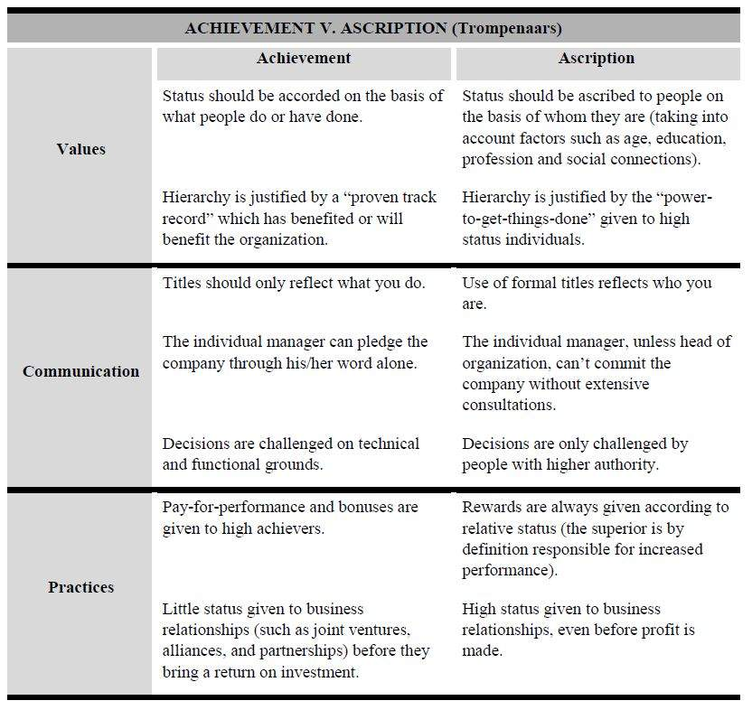
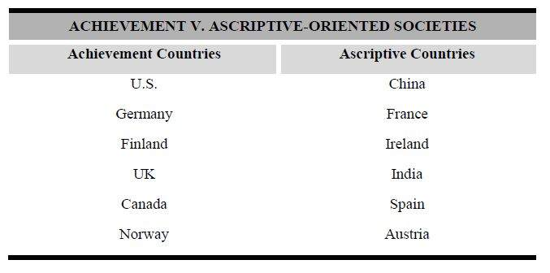

Specific vs. Diffuse
The dimensions “specific” and “diffuse” refer to the extent life is compartmentalized or diffused.
Specific cultures refers to societies in which people play different roles in different situations.
Diffuse cultures are societies where roles are blurred. In such cultures, a position in one life space may carry over into another. Example: The boss is the boss. Whether at work or away from work, he is still the superior and is accorded that status (even though he may be treated with deference in non-business matters where he has little to no expertise).
People from diffusely oriented cultures start with the whole and see each element in perspective of the total. All elements are related to each other. These relationships are more important than each separate element; so the whole is more than just the sum of its elements.
Diffuse individuals have a large private sphere and a small public one. Newcomers are not easily accepted into either. But once they have been accepted, they are admitted into all layers of the individual’s life. A friend is a friend in all respects: tennis, cooking, work, etc. The various roles someone might play in your life are not separated. Qualities cherished by diffuse cultures include style, demeanor, ambiance, trust, understanding, etc.
Interactions between people in specific cultures are highly purposeful and well-defined. People’s roles in their business life are kept strictly separate and apart from their personal life. We don’t do business with a person merely because they are a friend. There is little expectation that personal involvement with an individual will transfer into favorable treatment in the workplace. Specific cultures focus on the hard facts, standards, and contracts (not personal relationships outside of work).
The UK and U.S. are both very specific cultures.
Sequential Time vs. Synchronous Time
According to some cultures, time can be sequential or synchronous. Sequential represents a series of passing events. Sequential time is also known as “clock time.” Time passes in seconds, minutes, hours, days, etc. It is sometimes called “monochronic”—or linear— time. This dimension is based on the work of anthropologist Edward Hall, who coined the term polychronic for societies that expect many things to happen at the same time (such as socializing and work), and monochronic to societies that do things one at a time. Western society is monochronic, and we schedule our time carefully, always keep track of it, try not to be late, are concerned with saving time, not wasting time, and getting time “off.”
Time as sequence sees events as separate items in time, sequenced one after another. It finds order in an array of actions that happen one after the other.
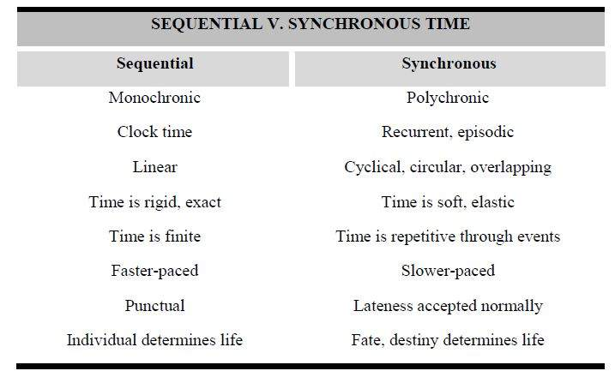
Synchronous cultures tend to view time as cyclical, episodic, and circular. Time as synchronization sees events in parallel, synchronized together. It finds order in coordination of multiple efforts. Eastern cultures tend to view time synchronously which highlights cycles of growth and decay, or birth, life and death, etc. Time is therefore never lost, it recurs in cycles. Reincarnation is part of this viewpoint. Synchronous time is sometimes called, “polychronic.”
In sequential societies, people tend to set tight time schedules. However, in synchronic cultures, people tend to set loose schedules.
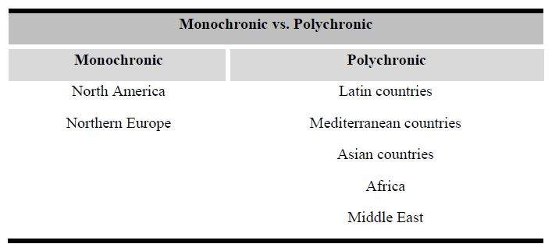
Trompenaars and Hampden-Turner add to this dimension concerns about whether a society is past-, present-, or future-oriented. Monochronic societies tend to be future-oriented and progressive, while polychronic societies tend to be past-oriented and conservative.
Japan is a country to be known as very future-oriented, where people focus on what will come rather than what has happened. Germany and France might be countries perceived as past-oriented, meaning that the past of the countries has a greater importance and effect on how people live and behave.
Inner vs. Outer Directed Cultures
This is the degree to which a society values inner direction and personal freedom versus an outer direction, such as the beauty and power of nature in the environment and in relationships. American managers are the most inner-directed and believe they are masters of their fates. Managers in other countries may perceive this in a negative way, believing that Americans are not concerned with others or the consequences of their actions on the whole group.
The inner-directed person listens to their own heart. The outer-directed person follows advice and instructions from outside sources.
Cultures with an organic view of nature see human beings as immersed within, and hence part of, the larger eco-system. To survive, they “go-with-the-flow.” They adapt to natural forces and allow themselves to be outer-directed. Cultural norms and activities are determined and enforced by the outer agency. Underachieving outer-directed people tend to complain about “bad luck” since they aren’t in control of their fate.
In contrast, some cultures have a more mechanical view of themselves as controlling, mastering and subjecting nature to their will. Such a view is inner-directed. The members of these societies view nature as something that is controlled. In an inner-directed culture, all of the activities allowed by the culture are determined by the members of the culture as they face its emerging needs. Inner-directed is about thinking and personal judgment.
Other Cultural Models
Single vs. Multiple Focus
One consideration that a multinational corporation must take into account is the opposite and opposing orientations different cultures have in approaching the planning and execution of the organization’s work.
Specifically, team members from single focus versus multiple focus societies may prove frustrating for workers of opposing approaches when they must work together to accomplish the corporation’s goals.
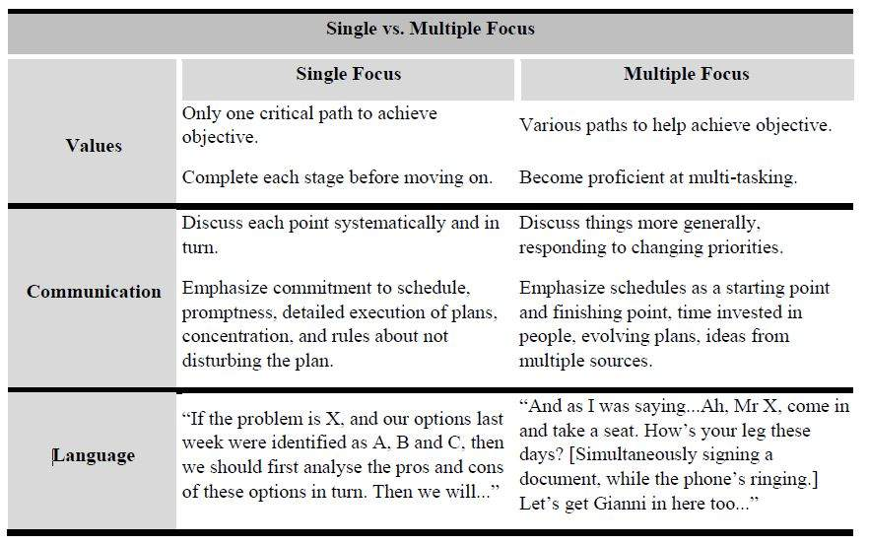
In single focus societies, there is little ambiguity in project management because everything is clearly defined. The opposite of single focus is multiple focus, where there is much flexibility as mutual interests change while maintaining a focus on broad intentions.
High-Context vs. Low-Context
In order to communicate successfully, one must consider the cultural differences and the predominating communication process in individualistic and collectivistic cultures. It is best to explain these differences in terms of low- and high-context communication. Context has to do with how much one must know before communicating effectively.
When workers from high-context and low-context cultures have to work together, problems often occur through the exchange of information. Employees from high-context cultures like China and France adapt to their good friends, families, and also to close colleagues (in-group members). They communicate with them intensively and exchange specific/detailed information about many different topics. The result is that every in-group member is constantly up-to-date with the facts around the business.
In comparison, low-context cultures like the U.S. and Germany orientate on many people of their daily life because they don’t differentiate as much as high-context cultures between in- and out-groups. They mostly communicate within their out-groups in a broad and diffuse way. They exchange information just to the necessary extent so that work can be done and they don't discuss or exchange information constantly in their work environment.
In China, communication tends to be very efficient because of their information flow at work and in private. They discuss everything in advance and consider meetings as an official “ceremony” where the already commonly agreed decision will be announced. This is important in the way of “giving and keeping face.” Americans and Germans, in contrast, inform the participating attendants in a meeting about the hard and necessary facts. The decision-making process takes place within the meeting. The French, similar to their Asian counterparts, are well informed before they meet each other. Explicit and detailed discussions during a meeting would probably be seen as an insult because everything is already clear.
In France, it might be hard for outsiders to feel fully accepted within their culture because of their big diffuse connections. In comparison, members of individualistic cultures using low-context communication (like Germans, Americans, and Finns) sometimes ignore those differences from high-context cultures. In a meeting where countries from low- and high-context cultures will have to work and discuss, the French, and especially the Chinese, will not interact and express their disagreement or reservations. For the Chinese, their issues, circumstances, and relationships are as important as work, so they will comment only in a more private or appropriate occasion.
Chinese people tend to be reserved, which is considered as active behavior in collectivistic cultures. They first need to build up an interpersonal relationship—a foundation where it is possible to find the right level of context. In contrast, low-context cultures argue about each other’s opinions within the decision-making process and take discussions in their own hands to come to an agreement. Within this process, members of low-context tend to be precise and provide just the required information. Silence must be filled.
In contrast, the Finns have a different cultural behavior regarding silence. Silence is seen as polite and doesn't have to be replaced with communication. In this point they differ immensely from the Americans’ who are seen as the characteristic low-context country. They need to know what is going on and have to be provided with detailed background information. Information is freely available in an American company.
Additionally, regarding communication, the Germans try to hide information even within a company or department. The French are a high-context culture; they assume the listener knows everything. It is common for the French to assume that Americans think they are stupid because they start explaining everything, and vice versa

Recruitment and Selection
Lesson 39 of 69

Most global recruiters claim they resort to “strategic recruiting techniques” for hiring the best for the international organization. However, not many abide by the strategic talent management process.
In the contemporary business arena, success is measured in recruiting terms: cost per hire and the time devoted in filling the vacant posts. The talent function focuses on the qualitative aspect rather than the quantitative aspect while recruiting a person. Thus, it is important for an organization to resort to talent management techniques and discard the traditional recruiting process.
With the disturbing phenomena of failed international assignments and the high number of expatriates who leave the MNE shortly after repatriation, HR managers must find newer ways to execute and measure the success of their recruiting and selection programs.
The development of a global staffing strategy includes providing the conceptual outline of the strategy, defining the resources required and establishing a timeline for its implementation. Elements of the strategy include developing a transparent recruitment system and creating a core standby capacity as a main component of advance planning.
To remain competitive, organizations have to expand their search for the best talent globally and must nurture their brands and reputations in countries that were once viewed as cheap suppliers of labor. The new global talent manager emphasizes the local, cultural components of globalization.

Non-Compete Agreements
Many companies require key employees (such as expatriates) to sign agreements, called covenants, not to compete, stating they will not take after-hours jobs with competitors or in any other way compete with the company. Some of these agreements also prohibit terminated employees from going to work for a competitor or setting up a competing business within a limited distance from the company or within a certain time period after termination.
Companies should have legal counsel review any employment agreement containing a non-compete clause, but in general, the following guidelines may help:
- Make sure a legitimate business interest justifies the non-compete clause. Trade secrets, confidential information, customer lists, or loss of unique services supplied by the employee generally qualify as legitimate business interests.
- Set reasonable time and geographic limits. As a rule, a non-compete clause should bar former employees from competing only within those jurisdictions where the employer does business, or, for multistate or international companies, within those areas the ex-employee had worked directly. As for time, courts generally view two to three years as sufficient time for an employer to replace whatever assets it lost when the former employee departed.
- Limit former employees from seeking employment only in specific positions. Any non-compete clause that bars employees from using their only job skills or that covers all positions in a particular field is not likely to hold up in court.

Internal Workforce Planning
Lesson 40 of 69
Accommodating Organizational and Individual Needs
A career development program must be one that both management and employees see as valuable.
Assignees are often reluctant to accept international posts unless they see a clear line between the assignment and career enhancement.
International career managers setting up a career development program should take the following steps:
- Communicate the program’s purpose and benefits. Since home-office and assignment supervisors' support is critical, stress what the program can do for these managers. The best way to get managers to buy into the program is to create managerial development plans.
- Define roles and responsibilities. Initiating a global career development program often requires a cultural change in terms ofsupervisor-employee relationships.
- Identify a champion who is committed to the candidate’s career development and can sell the program to other management.
- Start small and provide adequate support. Avoid elaborate career development programs. Stress preparation for particular types of work, not for particular job titles, and emphasize career opportunities rather than actual job openings.
- Keep the career development program and on-assignment individuals visible. Gradually phase in the program, publicize results at each stage, and communicate future plans.
- Support career development with training opportunities. Offer both knowledge-based and skill-building training, and include programs for managers and non-managers. Make training a voluntary aspect of participation in the career development program.
- Get managers and employees involved. Make career development the responsibility of supervisors and assignees, not of the HR department. Get managers and employees to decide directions, to teach others, and to create support materials.
- Evaluate efforts. Focus on business needs and check the program’s effectiveness in meeting these needs.

Mobility within the Organization
Once a company has a career development program in place, the next step is to develop a career plan for each employee.
Checklist for Creating a Career Development Program
Predict long-term staffing needs. Staff planning supports employee development in several ways. It supplies information that employees need to select realistic long-term career goals. It guarantees that openings become available as employees are ready to move up.
These planning efforts can promote career development:
- Succession planning. Forecasting executive and managerial vacancies helps employees assess potential promotional opportunities worldwide.
- Anticipating organizational change. Organizational change includes foreign and domestic expansion, downsizing, changes in product lines, and other restructuring efforts.
- Planning for technological change. Technological advancements can make some jobs obsolete, change the skills required for other jobs, and create new positions and responsibilities.
- Forecasting economic changes and market shifts. Data on market changes indicate whether job openings will exist when training and development are completed.
- Analyze the knowledge, skills, and abilities required for each job (job analysis). By identifying the skills required for positions, HR managers can group jobs into categories and identify the additional skills and knowledge that employees must acquire to move into higher-paid positions.
- Make employees aware of career opportunities. The following programs can help employees recognize and evaluate career opportunities:
  - Job posting. Posting descriptions of available job openings provides employees with information about actual job opportunities. Posted information should include the reporting relationship, required skills, and preferred experience. This information, particularly experience requirements, lets employees see the typical career path into a posted job.
  - Career paths. Employees should have several routes into a job and several opportunities for advancement. Career paths encourage employees to acquire the skills needed for upward
- Motivate managers to develop and promote subordinates. Employee development must have line supervisors' support. To get this support, upper management can offer the following incentives:
  - Bonuses and rewards. Supervisors who do a good job of developing employees can receive cash awards and other types of recognition.
  - Links between evaluations of supervisors and employee development. Supervisors’ performance ratings, promotions, and pay raises should depend partly on how well they counsel and develop employees.
- Provide formal opportunities for employees to plan their careers. Such opportunities include:
  - Career planning workshops. Workshops guide employees in setting career goals and in learning how to realize them.
  - Individual career counseling. Employees benefit from individual counseling, whether conducted by a career guidance professional or a manager.
  - Performance appraisals. Regular performance appraisals provide an opportunity for employees and supervisors to discuss goals and training needs. Have managers and employees collaborate on a career development plan for the upcoming year and assess progress toward achieving career goals in the preceding year.
- Help employees get the knowledge and skills needed for advancement. Efforts can take several forms:
  - Formal training. Training should develop skills for promotion, not just for a current job.
  - Tuition assistance. To achieve some career goals, employees may need outside education.
  - Special projects and responsibilities that let non-supervisory employees develop and demonstrate supervisory skills. Activities could include helping train new employees, participating in quality circles or employee-management committees, or serving as liaisons with other work units. These experiences should foster competencies, such as creative thinking, that are not found in the employee's regular work.
Secondment Agreements
An employee secondment agreement is a legal document drawn up by an employer that allows an employee to work for another company (or an internal transfer to another subsidiary of a large corporation) for a set period of time. These documents are often, long, complicated, and difficult to read if you don’t have a law background. Both companies involved need to adequately protect themselves from harm (intellectual property rights, company secrets, etc.), while also laying out the time frame in which the employee transfer is going to occur, how it is going to occur, what the compensation and benefits are, and what sort of return the original company receives for such a transfer.
While every employee secondment agreement is different, due in large part to the sheer amount of customization present in each one, some generalizations can be made. Often times, the first main part of the contract is the term under which the contract is valid. The term can be anywhere from a few days to a few years depending on the length of the working agreement between the two companies. The first section of a secondment agreement typically goes over which employees are being assigned, how those employees can be used, and in what capacity. This section is extremely important because it limits how much the employees can do once at their new jobs and it also limits the amount of access they have when it comes to the new companies’ intellectual property. There can also be a section that goes over what kind of reparations the original company receives for lending members of their workforce to the other company.
The next part of an employee secondment agreement resembles a typical employment contract, with sections reviewing financial compensation, medical benefits, workers’ compensation, and other employee-employer information. It will state clearly here who is responsible for paying things like workers’ compensation should an employee get injured on the job, the temporary employer or the permanent employer. The final part of such a contract often reviews intellectual property rights, corporate secrets, and what kind of obligations the employees have to their now duel employers. This section alone can span many pages of exact legal wording. It is important, however, that the employee completely understand what their obligations are, as a misunderstanding could lead to immediate termination.

Global Succession Planning
Lesson 41 of 69
Most business leaders have well-defined plans for developing their global corporate culture, driving market presence and increasing their people assets. But a strategy for replacing key talent should they suddenly leave is just as important.
The act of replacing an unexpected termination is normally called “replacement staffing” while the long-term approach to identifying and developing individuals who may eventually take over positions vacated by promotions, transfers, or terminations is called “succession planning.”
Growing global competition is placing increased importance on international succession planning as a source of competitive advantage. Earth-spanning corporations are recognizing talent must be managed in ever-more-globally-sophisticated ways. They know the term “global business” is quickly moving beyond its restricted 20th century meaning of geographically dispersed products, services, technology, marketing, and brick-and-mortar offices.
Managers, new recruits, technologists, region heads, and others up to and including the CEO need to demonstrate critical competencies and embody the company’s strategy, values, and intellectual capital while generating profits in unfamiliar locations and cultures.
These “talents” operate not only across value systems but also virtually, requiring a level of world-wise communication sophistication that has now become indispensable for sustainable success.
Worldwide talent management, therefore, has become the new critical success factor for corporations that are extending their reach as well as their grasp. And this implies, in turn, a robust global leadership development system.
The fundamental paradigm shift taking place among leading firms is a change from a “staff-replacement” view of succession planning to an “anticipatory deployment” model.
Here are several steps to help the MNC with this important challenge.
- Database Management Systems. Organizations need systems that note the international work experience and foreign language skills of employees. Training professionals need to be able to make ad hoc queries on a database to access work histories and assignment locations.
- Selection. Candidates must be interviewed to verify their interest in a foreign assignment. Even when talent is available, the uncertain willingness of key people to accept foreign assignments further compounds the complexity of international succession. The globalist may not feel that the assignment is a good fit for his or her current professional and personal situation. It is far better to have this information before the employee is chosen than to risk a failed assignment.
- Pre-Assignment Training and Preparation. It is estimated that 70% of U.S. business people sent abroad are given no cultural training or preparation prior to the assignment. The potential expatriate should be prepared by receiving pre-departure training on the necessary KSAs to survive the assignment. Otherwise, “failing to plan” is “planning to fail.”
- Mentoring Programs. Providing the global professional with a mentor is critical to the success of the assignment. The mentor, ideally someone at a higher level in the organization who has completed a successful international assignment, can inform the professional on how to navigate his or her assignment and also let the professional know what is happening back at the home office.
- Keeping in Touch. By installing a computer, internet, fax machine, or global satellite phone in an expatriate’s home, he or she can receive daily messages from the home office. This helps keep him or her informed and feeling part of the team. Some firms have created special newsletters for expatriates to help them stay current with organization news and information. Regularly scheduled “home-leave” is another key to keeping the expatriate up on the latest company news and to meet with their mentor and/or assignment manager.
- Repatriation. The organization needs to sit down with repatriates and help them map out a personal action plan noting the challenges they feel they may face. Another challenge is deciding how the knowledge and information that repatriates have gained can best be shared with home-office professionals.
- Retention. It is not uncommon for repatriates to leave the organization after an overseas assignment. Losing a key global professional can be very costly. Having a clear career path for repatriates is critical, as is allowing them to serve as mentors and providing a forum for them to share the knowledge they have gained with future expatriates.
- Redeployment. A key to reducing repatriated assignee terminations is to provide them meaningful and challenging assignments post-assignment. Too often they are placed in lower priority positions, due to neglect and poor planning, thus underutilizing the new skills and experiences and driving them to look for other employment. Plan ahead and redeploy them as soon as possible to continue their growth process.
In summary, today’s rapidly globalizing marketplace requires companies to do a better job of selecting candidates for overseas assignments, planning their development and selection, retaining the best performers, and building a global talent pool. The key is to involve senior management in the process of global succession planning.

Human Capital
Lesson 42 of 69
Human capital refers to the stock of productive skills and technical knowledge embodied in labor. Simply put, human capital is the collective skills, education, experience, and knowledge of the workforce.
Human capital is tied directly to productivity growth, economic development, and innovation. Those organizations possessing a fair amount of human capital are usually the richer and more desirable employers that can attract and retain the best and brightest. Those organizations that cannot provide a suitably competitive rewards or management package often suffer from “brain drain” or “human capital flight” that leaves them weakened and vulnerable to their competitors.
As new technologies and innovative processes unfold, the demand for human capital increases. Current trends indicate the need for a future skilled workforce in developed countries.
An organization needs a creative and structured approach to the management of its human capital. Not all highly skilled and intelligent workers come from outside the organization. Many must be nurtured and developed from within. This is the primary argument for organizations investing in the HRD function. The end result is that by enhancing its human capital an organization gains a competitive edge.
Contingent Workforce
A contingent workforce is a provisional group of workers who work for an organization on a non-permanent basis, also known as freelancers, independent professionals, temporary contract workers, independent contractors or consultants. Contingent Workforce Management (CWM) is the strategic approach to managing an organization’s contingent workforce in a way that reduces the company’s cost in the management of contingent employees and mitigates the company’s risk in employing them.
According to the U.S. Bureau of Labor Statistics (BLS), the nontraditional workforce includes “multiple job holders, contingent and part-time workers, and people in alternative work arrangements.” These workers currently represent a substantial portion of the U.S. workforce, and “nearly four out of five employers, in establishments of all sizes and industries, use some form of nontraditional staffing.” “People in alternative work arrangements” includes independent contractors, employees of contract companies, workers who are on call, and temporary workers.
Among several other contributing factors, globalization has had a large impact on the growth in using contingent labor.
Globalization contributes to rapid growth in industries, increased outsourcing, and a need for flexibility and agility to remain competitive.
By engaging contract workers, organizations are able to be agile and save costs.
The contingent workforce acts as a variable workforce for companies to select from to perform specific projects or complete specialized projects. Also, as organizations make efforts to be more agile and to quickly respond to change in order to be more competitive, they turn to the contingent workforce to have on-demand access to professionals and experts. Organizations also see the opportunity to reduce benefits and retirement costs by engaging the contingent workforce. However, there is risk involved in avoiding these costs if an employee is improperly classified as a contingent worker. Using the contingent workforce is cost-effective in that using contingent labor allows for adjustments to employment levels and employment costs depending on what kind of expertise and labor is needed and at what time it is needed.
A knowledge-driven economy also contributes to the growth in the use of the contingent workforce, because organizations rely more on their specific and expert knowledge and expertise. As demand increases for highly-skilled and knowledgeable people, the expertise of contract workers becomes more attractive.

Outsourcing
Lesson 43 of 69

Outsourcing is the term applied when an organization hires an outside agency to handle some aspect of its internal services. In other words, they go outside the organization to a vendor with special expertise to source a particular element of their services. Within the HR arena, typically outsourced functions include: payroll processing, relocation logistics for new hires and expatriates, employee assistance programs, benefits administration, safety administration, training, etc.
Since this chapter is dealing with talent acquisition, typical elements of the recruitment process that may be outsourced include:
- Sourcing;
- Screening;
- Testing;
- Interviewing;
- Conducting background checks and drug testing;
- Hiring;
- Coordinating the offer letter;
- Onboarding;
- Maintaining applicant tracking logs, requisition, and candidate files;
- Reporting; and
- Training.
There is continued momentum for more multinational outsourcing relationships.
Organizations operating in several countries can no longer afford the costs and incompatibilities created by duplicative, locally managed systems; they want a single, global HR operating environment. Outsourcing assists in this pursuit.
The additional benefit of going global, of course, is the ability to allocate work more efficiently, with high-volume transactional work going to low cost locations, and high-touch culturally specific work going to local delivery centers.
Externalizing multiple processes to a single provider can deliver very significant business benefits. Global service providers will be well positioned here too. They have the infrastructure, the transformational and operational skills, and the quality control processes to reduce the risks for their clients and to respond quickly to changes in demand.
Beyond more efficient payroll and benefits administration, we will see organizations outsourcing more and higher-value functions. Clients want help from providers in managing complex, large-scale challenges, such as talent acquisition and management, workforce re-skilling, knowledge retention, succession planning, and exit management.
Lastly, companies are turning to their human resources outsourcing (HRO) vendors for innovative services. In-house departments are stretched with handling the day-to-day issues, so there is rarely time left for strategic initiatives, much less the demands of managing assignees in far-away countries and cultures.

Offshoring
Lesson 44 of 69
One of the areas of talent management that many HR functions have utilized is the high-impact strategy of moving hourly and professional-level work overseas, a strategy known as offshoring.
Offshoring is the continuous process of moving work away from traditional home-country operations to areas around the world where both high-quality and low-cost workers are available.
The key to off shoring is to put work where the talent is. Although a handful of multinational firms have begun to identify top talent around the world, very few have taken the next step, which is realizing that it is not necessary (and often more expensive) to bring talent to the home country in order to take advantage of it.
There are three basic elements of offshoring:
- Letting the very best individuals work wherever they choose to live.
- Moving hourly (e.g., production and customer service) work to areas with very low labor costs.
- Moving professional work to locations where the supply of talent more closely fits the company’s demand.
Nearshoring is similar to offshoring, but the destination country is next to or close by (in the same region) the country sourcing the work.

Onboarding
Lesson 45 of 69

Onboarding is getting your newly hired talent up to speed with the policies, processes, culture, expectations, and day-to-day responsibilities of your company. It is making them feel welcome and excited, and confirming why they joined your company. Onboarding is a special challenge for international assignees. They are frequently nervous, lost, and confused when arriving at their new work-site. All too frequently, many companies and local managers are pressured with short-term needs and don’t want to spend the extra time and attention required for the long-term need of providing quality orientation and onboarding for the new expatriate.
The goal of a good onboarding program is to build bonds between the employer and employee that are deep, meaningful, and strong.
The stronger the emotional bonds, the greater the likelihood of that employee engaging with the company and remaining with the firm for a long time. Proper preparation and advanced training go a long way to creating a successful onboarding experience for the new assignee. More information on ways to do this is covered in the International Assignment section.
In summary, whether you’re a huge brand name corporation with thousands of employees, or a small start-up with 2 employees, all businesses have a similar goal: to attract talented employees and to keep them motivated to continuously contribute to the success of the business. Onboarding is one tool international human resource management (IHRM) needs to execute well.

Localization vs. Standardization
Lesson 46 of 69
People are an organization’s most valuable resource in the modern age of globalization. Thus, as the role of HRM is to help organizations make the most effective use possible of their human resources, it is clearly an increasingly important area to understand. As scholars such as Bartlett and Goshal have pointed out, without good human resource management systems, leadership and most functions of an organization will struggle.
A considerable body of research indicates that investments in the firm’s human resources tend to have positive effects on firm performance.
Companies with more extensive and comprehensive human resource (HR) systems and practices (e.g., recruitment and selection, performance appraisal, training and development, company-internal communication, performance-based rewards, and career management) are likely to have employees that are more competent, better motivated and committed, more empowered and involved, and more innovative and flexible.
However, HRM practices may not be universally applicable, and both executives and international management scholars are wrestling with the question of the extent to which a firm’s practices for people management should be modified across countries. For instance, should a company implement the same HRM practices in Russia as in Finland?
The localization stream in the literature, which suggests that the HRM practices should be adjusted to fit the local environment, has been advanced by scholars such as Rowley and Benson. Other scholars such as Pfeffer argue that one set of practices for people management works in most situations and that standardization is important to ensure that a MNE function efficiently and preserve its identity.
Furthermore, global standardization of HRM is one way in which a multinational corporation may attempt to control the ways in which a foreign subsidiary operates. The above discussion builds on the longstanding debate on overall MNE strategy between the need for MNEs to pursue global “integration” or “standardization” versus local “responsiveness” or “localization.”
Scholars have argued that successful multinational corporations sometimes have a HRM strategy that blends global standardization with local responsiveness.
Taking this a step further, it may even be beneficial for a firm to standardize different HRM practices to a different degree around the world.

Global Employee Discipline and Terminations
Lesson 47 of 69
While employment contracts covering all employees are common worldwide, that is not the case in the United States. There, the standard employment contract is considered to be at-will in much of the country, meaning the employer and employee are both free to terminate the employment at any time and for any cause, or for no cause at all.
Common reasons for terminations include:
Misconduct
Many countries have disciplinary policies that allow termination of employees for gross misconduct, such as theft, dishonesty, violence, or insubordination. Other forms of misconduct leading to discharge include disrespect to co-workers or customers, unsafe acts, violation of work rules, or unprofessional behavior.
Unsatisfactory Performance
Dismissal for unsatisfactory performance can follow repeated absence or lateness, failure to meet deadlines or quotas, or inability to do the work.
Organizational Change
Permanent layoffs occur when positions are eliminated or employees’ knowledge, skills, abilities, and/or attitudes do not meet job demands after a reorganization or a change in control. Unlike other forms of involuntary termination, many countries require severance pay for long-service employees who lose their jobs due to reorganization, downsizing, or change in control. Always check the local laws before initiating a layoff.
Resignation
Most countries allow employees to voluntarily leave employment to pursue more attractive job opportunities, to spend more time with family, to deal with personal problems, or merely to escape an unappealing job.
Employers should be aware that different countries require workers to be compensated (fully or partially) until the worker finds suitable reemployment. Therefore, before any termination of employment is initiated, the global HR Manager should be intimately familiar with local laws and customs.
For example, the International Labor Organization (ILO) requires, “The employment of a worker shall not be terminated unless there is a valid reason for such termination connected with the capacity or conduct of the worker or based on the operational requirements of the undertaking.” Even should a U.S. employer comply with the provisions of the ILO, it may find that it has incurred a significant financial obligation. Canada, for example, requires one week’s pay for each year of service as a severance bonus. Many European countries require a separation agreement that is commonly valued at around two years of the employee’s pay.
Finally, remember the “acquired rights” directive when considering a termination. In many countries the labor code does not allow at-will terminations. Many U.S. managers find it confusing and expensive to release an employee from employment in these other countries.

Visas
Lesson 48 of 69
In many cases, citizens of foreign countries will need a visa to enter the United States or other countries. A visa doesn’t permit entry to the U.S., however. A visa simply indicates that the application has been reviewed by a U.S. consular officer at an American embassy or consulate, and that the officer has determined the candidate is eligible to enter the country for a specific purpose. Consular affairs are the responsibility of the U.S. Department of State.
A visa allows a person to travel to the United States as far as the port of entry (airport or land border crossing) and ask the immigration officer to allow them to enter the country.
Only the immigration officer has the authority to permit a person to enter the United States.
The officer decides how long a person can stay for any particular visit. Immigration matters are the responsibility of the U.S. Department of Homeland Security (DHS) as the United States Citizenship and Immigration Services (USCIS).
Visa Types
There are two categories of U.S. visas:
- Immigrant
- Nonimmigrant
Immigrant visas are for people who intend to live permanently in the U.S. Nonimmigrant visas are for people with permanent residence outside the U.S. but who wish to be in the U.S. on a temporary basis – for tourism, medical treatment, business, temporary work or study.
While there are multiple visa types that may appear on the exam, the GPHR candidate needs to pay special attention to H-1B and L-1 visas.
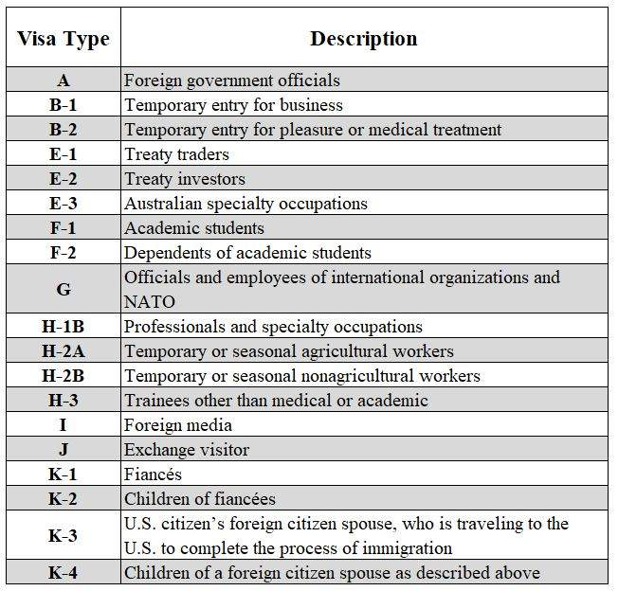
Visa Summary (Non-Immigrants)
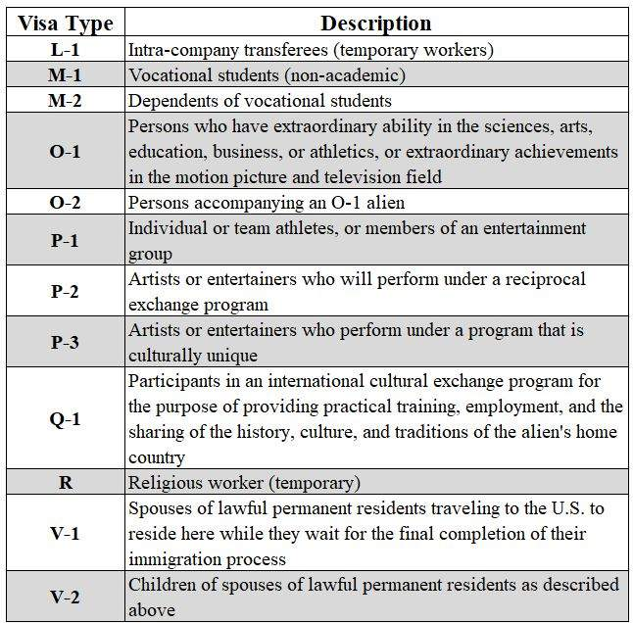
Visa Summary (Non-Immigrants)
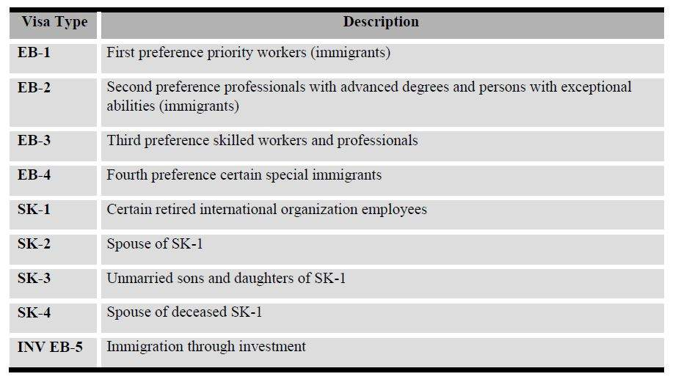
Visa Summary (Immigrants)

B-1 Visas (Business Visitor)
B-1 employment visa allows a business person to work only for his or her company’s business concern and not for any other company while in the United States.
Selling
An individual travelling to the United States to take part in an exhibition, set up an exhibition booth, display samples, sign contracts, and take orders for merchandise produced in and delivered from a foreign country, may be eligible for a B-1 visa or visa free travel under the Visa Waiver Program (VWP). The holder of a B-1 visa or a VWP traveler may not actually sell or take orders for merchandise produced in the United States.
Voluntary Work
Individuals participating in a voluntary service program which benefits a U.S. local community, who establish they are a member of, and have a commitment to, a particular recognized religious or non-profit charitable organization, may be eligible for a B-1 visa or visa free travel under the Visa Waiver Program (VWP) if the work to be performed is traditionally done by volunteer charity workers; they will receive no salary or remuneration from a U.S. source, other than an allowance or other reimbursement for expenses incidental to their stay in the United State; and they will not engage in the selling of articles and/or the solicitation and acceptance of donations.
Conference
Participants in scientific, educational, professional, or business conventions, conferences, or seminars may travel to the United States on B-1 visas or visa free travel under the Visa Waiver Program (VWP). The B-1 visa or travel under the VWP is also appropriate if presenting a paper at the conference, provided there is no remuneration from a U.S. source other than expenses incidental to the stay.
Researcher
An individual who will engage in independent research may be eligible for a B-1 visa or visa free travel under the Visa Waiver Program provided there is no remuneration from a U.S. source and the results of the research will not benefit the American institution. Those who will receive payment from a U.S. source and/or the U.S. institution will benefit from the results of the research, will require an exchange visitor (J-1)or temporary work (H-1) visa.
Business Venture
The B-1 visa or visa free travel under the Visa Waiver Program is the appropriate visa classification to travel to the United States to survey potential sites for a business and/or to lease premises.
However, the holder of a B-1 visa may not remain in the United States to manage the business. An L-1 (intra-company transferee) visa is required. This would enable the holder to travel to the United States for a temporary period to open up and operate a branch, subsidiary or affiliate office of the business there. To qualify, the new U.S. operation is required to file a petition on the employee's behalf with the nearest office of the United States Citizenship and Immigration Services (USCIS) in the United States.
Medical Elective
A medical student studying at a foreign medical school and who seeks to enter the United States temporarily in order to take an “elective clerkship” at a U.S. medical school’s hospital without remuneration from the hospital may be eligible for a B-1 visa, or visa free travel under the Visa Waiver Program (VWP). Note: The medical clerkship is only for medical students pursuing their normal third or fourth year internship in a U.S. medical school as part of a foreign medical school degree.
Telecommuters
Individuals temporarily residing in the United States who will be working from home as computer programmers for foreign-based companies may be eligible for B-1 visas if the individual:
- Is employed by a company outside of the United States; and
- Will receive no remuneration from a U.S. source, other than expenses incidental to the stay; and
- Is working in an occupation which requires the attainment of a bachelor’s or higher degree in the specific specialty and the individual has that level of education.

B-2 Visas (Visitors for Pleasure)
The following are acceptable B-2 (visitor) activities:
- Tourists,
- Individuals wishing to enter the U.S. for shopping trips,
- Individuals wishing to enter to visit friends or relatives in the U.S.,
- Individuals wishing to enter the U.S. to seek medical attention, and
- Individuals wishing to attend conventions and or conferences not related to business.

L-1 Visas (Inter-company Transfers)
Qualifying criteria for the L-1 visa are that the:
- Employee must have worked abroad for the overseas company for a continuous period of one year in the preceding 3 years;
- Overseas company must be related to the U.S. company in a specific manner;
- Employee to be transferred must have been employed abroad in an “executive” or “managerial position or a position involving “specialized” knowledge;
- employee must be coming to the U.S. company to work in an executive, managerial, or specialized knowledge capacity; and
- Employee must qualify by virtue of his or her prior education and experience.
The L-1 non-immigrant visa category is one of the most popular visas available to small, mid-sized, and large multinational companies wishing to transfer their foreign employees to the United States.
Foreign nationals meeting the criteria for the L-1 visa category are considered “priority workers” in the first preference, which has 40,000 annual immigrant visas allotted to it. Foreign nationals may be admitted to the United States in L-1 status as either an L-1A (manager and executives) or L-1B (specialized knowledge). L-1A visa holders may be admitted to the United States for a maximum of 7 years. They also have a fast track route to permanent residency as a Labor Certification Application is not required for these visa holders. L-1B visa holders may stay in the United States up to a maximum of 5 years. The initial period for applicants under the L-1 visa category is 3 years.

F Visa (Academic Studies)
The F visa is for those foreign nationals who wish to enter the U.S. to engage in academic studies. Those who are granted F visas are also allowed to engage in a specific period of practical training in the U.S. after completing their studies. This practical training is possible as long as the practical training is not available in their home country.
Foreign students under the F visa category are allowed to stay in the U.S. for the “duration of status.” What this effectively means is the student can remain in the U.S. in valid status during enrollment in any number of academic programs. For example, high school followed by university/college, which is then followed by a Master’s degree. When the period of study is complete, the foreign national is given a 60-day grace period to depart the United States.
It is important to note that under the F visa, foreign students must enroll in a full course of study not part-time study.
Foreign students must also prove they have sufficient means of support to cover their stay in the U.S. through their full academic program.
Eligible family members of F visa students are allocated F-2 visas. F-2 visa holders are not allowed to work. F-2 spouses are not allowed to engage in full-time study and the F-2 child may only engage in full- time study if the student is in elementary or secondary school. F-1 students are not subject to any special requirement to return to their home countries for two years prior to accepting employment in the U.S. as a non-immigrant or prior to immigrating.

P Visa (Entertainers & Athletes)
The P visa covers those entertainers and athletes who cannot qualify under the O visa scheme.
As with the O visa, individuals granted a P visa are allowed to enter the U.S. for a non-specific amount of time. The initial period of stay can be approved for the time required for the specific event, competition or performance attended, up to a period of one year.
However, P-1 athletes may be granted an initial period of stay for 5 years, up to a total of 10 years.
Activities that qualify a foreign national for a P visa are as follow:
- Athletic competitions
- Athletic seasons
- Tournaments
- Tours
- Exhibits
- Projects
- Entertainment
- Events
- Engagements

J Visa (Exchange Visitors)
The J visa is for those foreign nationals entering the U.S. as exchange visitors in U.S. government approved Exchange Visitor Programs. The Exchange Visitor Program is used for the purpose of gaining valuable experience, studying, or undertaking research in their respective fields of study.
The duration of stay under the J visa varies. It is understood that secondary school students may be admitted for a 1-year period. College/university students are admitted for the anticipated length of their academic program. Non-degree college and university students are admitted for a 2-year period. Additional regulations include:
- Scholars who will be in the United States for a short period of time are admitted for a 6-month period and there are no extensions allowed.
- Trainees may be admitted for up to an 18-month period. Those enrolled in in-flight training programs may be admitted for a 24-month period.
- Those who enter the U.S. as college/university professors or research scholars are admitted for 3years. A 6-month extension may also be granted.
- Specialists are admitted for up to 1 year.
- Foreign medical graduates participating in U.S. internships and residencies are admitted for the length of their program with a maximum of 7 years.
- Summer student work/travel program applicants are admitted for 4 months.
- Au pairs are admitted for 1 year.
- International visitors are admitted for 1 year.
- Government visitors are admitted for a maximum of 18 months.
- Camp counsellors are admitted for 4 months.
It is important to note that unlike the F visa, where the applicants are not subject to any special requirement to return to their home countries for 2 years prior to accepting employment in the U.S. as a non-immigrant or prior to immigrating, J visa applicants have this requirement. J visa applicants are ineligible for permanent residence or non-immigrant visas in the H or L category until he or she has spent 2 years in his or her own country of last residence.

Also note that eligible family members of J visa holders which are designated the category of J-2 foreign nationals may accept employment with USCIS authorization. However, the rule states the foreign national under J-2 category may only undertake work to compensate their own support and not the support of the principal foreign national.

Permanent Residency (Green Card)
Lesson 49 of 69
Employment-Based
An immigrant is defined as a foreign national who has been authorized to live and work permanently in the United States.
Eligibility
There are five categories for granting permanent residence to foreign nationals based on employment skills:
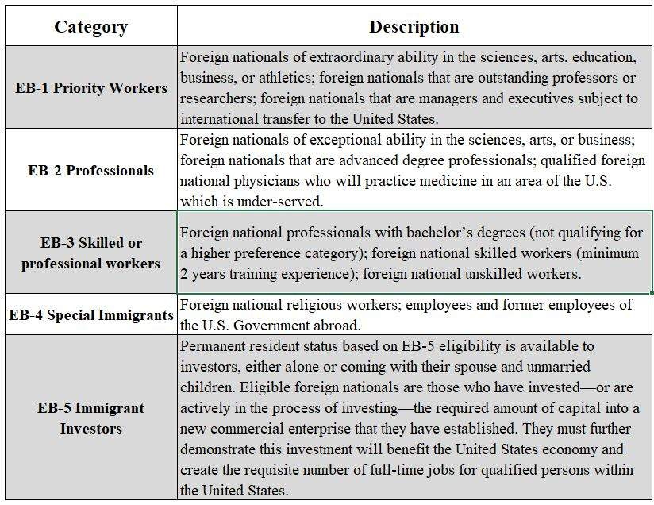
Family-Based
A foreign national who has been granted the privilege of permanently living and working in the United States is defined as a lawful permanent resident. Based on the fact they have a relative who is a citizen of the United States or a relative who is a lawful permanent resident, they must go through a multi-step process in order to become themselves a lawful permanent resident. This includes:
- Eligibility with regard to sponsoring a relative must meet the following:
- They must be a citizen or a lawful permanent resident of the United States and be able to provide documentation proving their status;
- They must prove they can support their relatives at 125% above the mandated poverty line, and
- If they are a U.S. citizen, they may petition for the following foreign national relatives to immigrate to the United States; they must be able to provide proof of the relationships:
  - Husband or wife;
  - Unmarried child under 21 years old;
  - Unmarried son or daughter over 21;
  - Married son or daughter of any age;
  - Brother or sister, if at least 21 years old; or
  - Parent, if at least 21 years old.
The Diversity Visa Lottery
Each year, the Diversity Lottery (DV) Program makes 50,000 immigrant visas available through a lottery to people who come from countries with low rates of immigration to the United States.
The State Department (DOS) holds the lottery every year, and randomly selects approximately 110,000 applicants from all qualified entries. The DOS selects the approximately 110,000 applications since many will not complete the visa process. However once 50,000 are issued or the fiscal year ends, the DV program is closed. If a person receives a visa through the Diversity Visa Lottery Program, they will be authorized to live and work permanently in the United States. They will also be allowed to bring their spouse and any unmarried children under the age of 21 to the United States.

International Assignments (IA)
Lesson 50 of 69
Have you ever thought about moving your family to Europe, Asia, South America, or Australia? The more you think about the possibilities, the more questions come to mind. The discussion with a spouse won’t be quite the same as one about a move across country. Where will my pay come from? What schools will my children attend? Can I afford to live there? What language do they speak? What about my employee benefits? Do I need a work permit and can my spouse work? Who is going to help me with all of these questions? International assignments come in different shapes and sizes with each having different objectives.
Assigning employees to posts outside their home countries raises both strategic and tactical issues for global firms.
At the strategic level, global firms need to ask: Are overseas assignments right for our business? How can we contain or reduce the related costs? Would an expatriate be a better choice than a local hire? If assignments are critical to meeting global business demands, how can we facilitate mobility and ensure equitable treatment among similarly situated employees?

Types of Assignments
Lesson 51 of 69
The differences between a short-term assignment and a long-term expatriation of 1 to 5 years are enormous. Tangible costs for international assignments – short-term versus long-term – can range from that of a long business trip to more than 4 times annual base salary. Planning and preparation are critical to the success of any international assignment, long or short. The potential return on investment (ROI) of a successful international assignment can be significant both for a global organization with a presence in many countries and for a domestic company expanding its business abroad for the first time.
The cost of a failed assignment can first be measured by the costs to transfer a family and then relocate them home again. In addition, there are intangible costs of a failed assignment that are much more difficult to measure: lost productivity, delay in starting up or reorganizing a management team, lost sales and production, etc.
The decision to accept a foreign assignment is very complicated, to say the least. An employer and their service provider’s consultant will discuss all of the issues that will impact an assignee and his/her family, in order to maximize the company’s ROI and minimize the risk of an assignment failure. From cost of living, housing allowances, and dependent tuition, to language instruction, work and resident permits, foreign income tax and cross-cultural training, an international assignment presents many new concerns and challenges.
Short-Term Assignments
The majority of companies acknowledge use of short-term assignments, and the number is growing from year to year. The use of short-term assignments (STAs), often treated as “extended business trips,” has grown substantially because of their cost effectiveness compared to full, long-term expatriate assignments.
Most companies consider temporary assignments as extended business trips lasting from 3 months to 1 year. Trips of only a couple weeks to 90 days are usually treated as normal business travel. Short-term assignments are often characterized by their duration, and the employee is the only family member transferred.
There are exceptions within any organization, but generally, the family remains at home while the assignee works at a foreign location, returning home on a pre-approved and often frequent schedule. Employees working abroad typically remain on their home country payroll, and they maintain all of their home country benefits.
Many companies will provide additional “international” health and welfare benefits since many managed care programs common in the U.S. will not extend coverage abroad. Otherwise, an employee can expect to receive their compensation and benefits as they always have. Families of assignees on short-term assignments usually maintain their homes, thereby reducing typical relocation costs of selling or managing a home country property.
On assignment, the company typically provides corporate housing, such as a furnished apartment. Furnished housing eliminates the need to ship household goods abroad and back again for such a short period of time. Most companies, however, will allow an assignee to take some personal items of convenience. These features of a short-term assignment reduce costs significantly compared to a long-term expatriation.
Business trips are often characterized by the traveler submitting weekly expense reports for meals, lodging and incidentals. This can become burdensome and expensive for “extended trips” for assignments lasting 6 to 12 months. Therefore, many companies provide company paid housing and a daily per-diem for meals and incidentals. There are firms that specialize in the calculation of short-term assignment allowances, and the U.S. Government publishes per-diem guidelines for locations around the world as well.
A company’s policy will designate what source of information will be used on a consistent basis. International assignees planning to stay and work in a foreign country for more than 90 days must seek assistance from their local human resource department to secure the appropriate work authorization permit or visa.
Travelers to and from countries recognizing the visa waiver program may allow a visitor to enter temporarily for a period not to exceed 90 days. Other countries may require a visa to enter in every situation. Unauthorized stays in a foreign country can have serious consequences from an immigration perspective. Work authorization for a foreign country is typically handled or coordinated by the “host” country sponsor. Preparation and application for work visas should be started well in advance of a scheduled arrival because it may take a couple months to get approved. Companies should seek legal counsel before every assignment because immigration laws are constantly changing.
One of the most often overlooked aspects of short-term assignments is the possibility of foreign income tax liabilities. Even though these are considered temporary assignments or extended business trips by nature, it doesn’t mean there aren’t any foreign or local tax costs associated with the assignment.
Timing of an assignment start date and the number of days in the destination country in the previous 12 months prior to the start date, are all important considerations for tax liability.
Every country is different but, for many, in-country residence of 183 days in any 12-month period could trigger a foreign tax liability.
Many, if not most, U.S.-based companies, will offer tax protection or they will tax equalize their international assignees to their home country. This means the company will reimburse any additional tax liabilities that are a direct result of the assignment. It is highly recommended that companies seek professional tax advice and counsel when planning any foreign assignment.
International Transfers
The United States is among the top 3 countries that pose the most challenges to transferring employees and their families. The reason? The threat of terrorism.
The United States became a difficult assignment location due to bureaucratic difficulties and newer security measures since 09/11/01. International employees have difficulties in obtaining Social Security numbers and visas, experience immigration restrictions, and they have expressed dissatisfaction with the U.S. Citizenship and Immigration Services (USCIS), formerly known as the Immigration and Naturalization Service (INS). The current political climate has exacerbated this situation; proposed travel bans and a potential wall to limit illegal immigrants coming into the U.S. has made the U.S. seem even less welcoming to legal immigration (for work or travel).
China and Japan offer the most challenges to relocating U.S.-based employees, mostly because of language and cultural differences.
There are business repercussions involving mobility to the U.S. in an environment of increased security. Much of this burden appears to be falling to HR professionals to balance the new security policies with the needs of their business.
The United Kingdom, United States, China, Singapore, and Germany are the most frequently cited “active” destinations, yet the United Kingdom, United States, and France have experienced the greatest reduction in expatriate activity due to stepped up security measures.
Surveys of U.S. expatriates generally find that despite perceptions that an overseas assignment might be more dangerous, few respondents reported they would refuse a future assignment due to world events.
Most assignees work overseas because of the interesting work challenge while only a small minority cite salary and benefits as influence on assignment decisions.
Fewer relocating employees are taking their children along and many companies are beginning to choose employees without children for international assignments to avoid the costs of “host country” education.
Companies are beginning to question the wisdom of international transfers. Most companies rate their ROI as good or excellent, but only a minority report they were able to compare actual costs to estimated (budgeted) costs, and an even smaller number indicated they were not sure about the value of international experience for an expatriate’s career.
In this globally competitive marketplace, most companies report they are attempting to reduce international assignment expenses in response to current economic conditions. Most are seeking alternatives to long-term assignments, and more are turning to local hiring.

Expatriation and Repatriation
Lesson 52 of 69
In developing candidates for foreign assignments, a few companies are beginning to go beyond quickie cultural awareness and language courses. Realizing that grooming of candidates should start long before employees are picked for overseas assignments, some companies are implementing plans to ensure ongoing development of candidates. Whatever the exact methods used, companies can help develop international employees by projecting a global mind-set and showing that value is placed on international exposure. The sections that follow outline some of the ways to develop a pool of potential expatriates.
Companywide Education Programs
Informational or orientation programs may help employees develop an image of themselves as an integral part of a global organization. Employees gain knowledge and exposure just by learning about the company’s activities and the cultures in other parts of the world.
Internal Referral Networks
One of the best ways a company can help ease transitions for employees and their families is by letting them talk to someone who has been through a similar experience. The concept resembles assigning the whole family to mentors for guidance on personal as well as professional issues.
Employees who are living abroad or who have come home from foreign assignments are usually willing to share the knowledge they have gained. The family of an employee about to embark on an overseas assignment will be less jittery if they have someone to ask simple questions like, “What should webring?” “What should we leave behind?” “How do the schools compare?” and “What would you do differently?” HR can facilitate sharing of information by setting up an internal referral network.
Expatriates willing to serve as mentors to the company’s future expatriates can be encouraged to fill out a form volunteering their services. It lists the overseas locations to which expatriates have been assigned, their job titles, and ways they can be contacted. If a company is very active in some areas of the world, HR may have a constant flow of returning expatriates who could help candidates’ families learn about what they could be signing up for. In some cases, HR may be able to match family compositions; a family with teenagers will obviously have different experiences than those of a family with infants or no children. Where activity levels are lower, the best match may be someone who has been to a similar area or someone who could talk generally about what it is like to be away from one’s home country for extended periods.
Referring a candidate to someone in the employee’s own job function can help familiarize the employee with concerns unique to that function. For instance, people in sales and marketing may be very curious about cultural differences in buying habits and decision-making, while someone assigned to transfer technology in a manufacturing plant may be more interested in locals’ work habits and job expectations.
Counseling and Employee Assistance Programs
Like anyone undergoing stress, employees and their families need ways to deal constructively with the stresses they will encounter. Preventive programs and counseling on substance abuse and depression may be especially needed.
Support Networks Within the Expatriate Community
As the numbers of expatriates grow, employers are forming support networks in various industries and regions so that expatriates can help each other adjust. For example, firms involved in overseas construction and engineering have formed the International Occupational Program Association, a group that deals with alcohol, emotional, and other problems of overseas assignees.
Repatriation
Many employees experience problems reentering the workforce and lifestyle of their home country when their “off-shore” assignment is over. Common issues include:
Increased Communications with Home
The culture shock of returning to an unfamiliar place can be decreased if expatriates are encouraged to keep up with events at home. Offer to buy them a subscription to a local newspaper for a few months before the end of the assignment, so they can read up on the latest trends and the prices of goods. Encourage them to write to old friends and exchange photos with family members. A relative’s new beard, receding hairline, or cane may be less surprising if first absorbed in small doses through photographs or social media. Assign them a home-country manager who communicates with the assignee on a regular basis and keeps them informed and connected to home-country and home-office happenings.
Reentry Counseling and Workshops
Providing reentry workshops can help participants examine their overseas experience; identify important changes that have taken place in themselves, their company, and their country; explore the reentry shock process; and develop strategies to minimize stress during the transition period. Practical advice offered during such workshops can run from discussions of changes in the local real estate market to introductions to the latest technology.
Spouse Career Assistance Programs
These programs are designed to support the spouse who seeks employment or career-enhancing activities while abroad and at reentry. In some cases, companies offer financial reimbursement for career-related activities. At reentry, career counseling, job-search tips, resume-writing assistance, and other placement support are offered to the spouse (similar to outplacement services).
Monetary Rewards and Assistance
Rather than reward the employee “up front” for taking an overseas assignment, many companies save all or part of the expatriate’s bonus for the return trip. This extra money not only serves the practical purpose of helping the employee cope with the expense of reestablishing a household, but there is a psychological boost provided in the sense of reward for a job well done.
Time Off
Understand that, above all, the re-entry process takes time for the expatriate and the expatriate’s family. Children will need time to adjust or readjust to schools and neighborhoods, and spouses may need extra consideration while re-establishing careers. The expatriate may have postponed visits to the doctor or dentist until the “hometown” doctor could be consulted. Just the process of unpacking household goods can take weeks to complete. A supervisor’s and HR specialist’s awareness that all these personal pressures are compounding new work pressures can go far towards easing the strains of readjustment for the expatriate. Let the employee know that reasonable requests for time off are expected, and that the company will do what it can to allow “flex time” during the readjustment process.
Reasons for Failed Assignments
Looking at the reasons expatriates come home early or embittered can help HR managers increase their success rate. The good news is that the problems are in areas where effective selection, training, and HR planning can make a difference.
A study of 123 U.S. corporations by On Strategy (a strategic management company) boiled down the most common reasons for failure to:
- The spouse’s inability to adjust (69%);
- The employee’s inability to adjust (51%);
- Other family-related problems (30%);
- The employee’s lack of skill to conduct business in the host country (30%);
- The employee’s inability to merge talents with international scope (26%);
- Personality or emotional immaturity (25%); and
- Inability to adapt to changing business priorities or organizational alignment (20%).
Among the worst aspects of foreign assignments, according to a survey of expatriate managers: family consequences, personal consequences, separation from company headquarters, lifestyle/location, negative career consequences, and financial/material consequences. Note that family and personal consequences are considered worse than any job-related aspects in the list.

Expatriate Failures
Lesson 53 of 69
While there are definite benefits to be derived from undertaking international assignments, there are also costs, the most salient of which is expatriate failure. The costs associated with expatriate failure include:
Moving Cost
To compensate for the cost-of-living differentials associated with living abroad and to make an international assignment financially attractive, multinationals often have to pay various types of premiums. The compensation paid to an expatriate is typically two to three times base salary. For assignments to high cost areas, such as London, it can cost as much as $500,000 per year for a family of four.
Down Time
It takes time (weeks, maybe even months) before the person can adjust and settle comfortably into his/her job abroad.
Burn out/Brownout
This refers to a situation where the expatriate is not performing at peak efficiency because he/she is operating under a lot of stress and strains. While the brownout expat may complete the assignment, few goals are met.
Turnover upon Repatriation
Research has shown that approximately 20%-40% of repatriates leave their companies within 1 year of return from an international assignment. This may stem, in part, from their frustration with not being able to utilize the skills and experience they have acquired abroad.
Downward Spiraling Cycle
In general, a single failure tends to get magnified a hundred-fold. Thus, high flyers that might be interested in pursuing an international career may be discouraged from undertaking such an assignment for fear of career setbacks.
Damage to Corporate Reputation
When an expatriate fails to adjust in a foreign country, he/she may undertake actions that could damage his/her company’s reputation in the host country.
There are several explanations for why expatriate employees leave their companies at a much higher rate than the companies’ general employee populations. Some of the reasons given for expatriate attrition are:
- Expatriates are more marketable and receive more attractive offers from other employers as a direct result of their international experience.
- Expatriates find overseas assignment compensation packages to be more generous than home and jumped from one company to another to maintain/enhance their expatriate status and related benefits.
- Expatriates anticipate a lack of attractive positions to return to in the home country and seek better opportunities outside their company.
- Expatriates feel out of place and dissatisfied both during and after an assignment, causing them to search for new employment.
The critical importance of the “trailing spouse” to overall success of an expatriate assignment has been known for more than 20 years. Research has shown repeatedly that, among expatriates abroad, spousal dissatisfaction is the leading cause of aborted assignments (early returns) as well as of expatriate “brownout” (expatriates performing poorly but remaining on assignment).
The reasons why spouses are critical to assignment success has long been well understood. She (and increasingly he) is fully and intimately involved with the employee in every facet of the overseas experience except the actual performing of job responsibilities. The spouse and employee select and organize a home together, explore the new community together, try to learn new customs and language together, socialize with others together, eat and sleep together, all on a continuing daily basis. So when the spouse is distracted or distressed, it affects the employee and his or her on-the-job performance suffers.
For example, when confronted by the myriad differences of an unfamiliar community and culture, and in the absence of neighbors, friends, and relatives to whom they can turn for support, some spouses become quite upset. This unhappiness can be expressed in several forms, from constant complaining to deepening depression all the way to substance abuse and extramarital affairs. This is what the employee comes home to each evening; this is the person they spend their weekends with. As would be the case back home, such an on-going situation at home distracts the employee from being effective on his job.
The employee also is encountering the unfamiliar values and expectations of the new culture, which puts them under adjustment stress as well. But here is the crucial difference: Because they go to an office almost every day, they have both a potential source of guidance and support and something productive to do with their time. Very often, the spouse has neither of these advantages. Most spouses are prohibited from working abroad. And if the spouse had been gainfully employed prior to the couple’s transfer, the sudden absence of fulfilling daily work may require one of the spouse’s most demanding adjustments.
A globalizing company invests a tremendous amount of money in each of its expatriates, which is why it is so critical to give it every opportunity for success.
Such a substantial investment gives the company a compelling interest in ensuring that each expatriate quickly becomes effective and productive abroad. A way of accomplishing this is to provide intercultural training and support. Intercultural training professionals, recognizing the critical role of the expatriate spouse, are as well prepared to train and support the spouse as they are the employee.
Adjustments for the Spouse:
- New country
- New community
- New language
- New customs
- school systems
- New job status for spouse
- New personal status or lack thereof
Spouse involvement in deciding to relocate:
- 30% never involved,
- 36% involved after decision made,
- 28% involved during the process, and
- 9% involved before the process begins.
Major issues for kids/teens:
- Insecurity
- Loneliness
- Identity crisis
- Visibility
- Conflicting values
- Unresolved grief
Cross-Cultural Adaptation
Everyone who goes to live in a foreign country must grapple with the issue of how to deal with a culture whose customs and values differ from, and often conflict with, their own. There are four basic ways of responding:
- Assimilation: acceptance of the new culture while rejecting one’s own culture.
- Integration: adaptation to the new culture while retaining one’s own culture.
- Separation: maintenance of one’s own culture by avoiding contact with the new culture.
- Marginalization: the inability to either adapt to the new culture or remain comfortable with one’s own culture.
Adjustment Period for Expatriates
In a recent survey by Simon Fraser University in Canada, respondents were asked how long it took them to feel completely comfortable in the foreign country. 22.3% said it took 1-3 months, 25.3% indicated it took 4-6 months, another 33.7% said it took 6-12 months, while 5.2% indicated that they never felt completely comfortable abroad.
The “U-Shaped” Curve hypothesis, first put forward by Gullahorn and Gullahorn in the mid-fifties, and confirmed many times since, holds that it takes about 6 months for minimal adaptation to take place, for those sent overseas. This 6-month period is often marked by the same progression of reactions on the part of the person being relocated and their partner (the trailing spouse) and/or family.
The process of encountering and accepting the new changes, or in other words process of acculturation, can be classified in four stages.
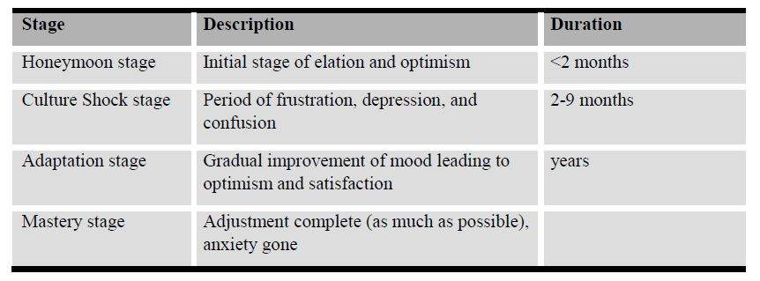
In a similar theory, Oberg described four stages of adjustment: Stage I, the initial, or honeymoon stage; Stage II, the disillusionment, or culture shock stage; Stage III, the adjustment, or adaptation stage; and Stage IV, the mastery stage. The honeymoon stage is a period lasting less than two months. Here the employee is thrilled with the new experience. The culture shock stage occurs as the individual copes seriously with living in the new culture on a daily basis, as a lack of understanding of the culture inhibits awareness of what is appropriate, or inappropriate, behavior in the new cultural environment, resulting in confusion, frustration, tension, and depression. The frustration occurs as the person begins to realize that past behaviors are inappropriate in the host culture, but has not yet learned what behaviors to substitute. The adjustment stage is characterized by increased ability to adapt in the new culture; in the mastery stage, adjustment is about as complete as possible, and anxiety is largely gone.
It is worth noting, repatriation (being brought home) often involves readjustment problems even greater than initial expatriation - and such problems are not often expected by those involved. Prices have risen, and friends have moved away, in one’s absence—one’s contacts may be gone, or rusty from disuse.

Repatriation and Post-Assignment Issues
Normally, little in the way of a reintegration strategy is offered to those who work overseas for a period of time for their employer before repatriating to take up their old position, and nothing in the way of a set repatriation plan exists for many independent expatriates who blithely assume they will pick up where they left off when they “go back home.”
And yet, according to expert analysis of the emotional upheaval suffered by expats and “repats,” repatriation shock lasts three times as long as the culture shock endured by new expatriates.
For those who have been expatriated by an employer, an increasing number are being offered repatriation training or a home-finding trip because over the years, surveys, statistics, and the experience of international employers have proven that those who repatriate after a prolonged period of 4 or more years overseas find it incredibly hard to settle back in.
One of the main issues is a feeling of displacement, of not belonging and of ultimately having nowhere to call home which can result in feelings of panic and depression. The repatriation shock issues manifest themselves in various ways and come about from an ongoing, underlying sense of confusion in the expat’s mind. On the one hand, they know they should feel “at home” in their country of birth and possibly in their old house. However, because significant issues have changed, what should feel like home actually feels alien and the repatriating individuals have not prepared themselves for the feelings of displacement and confusion they will encounter.
Expatriates are often key employees of an organization, and proper repatriation or end of assignment process is a crucial part of employee mobility management. Normally, repatriation terms are included in the international assignment policy for most companies. However, this is a common area of weakness in many IA plans.
An overwhelming majority of the respondents to a recent survey were very satisfied with their current/last international assignment (mean score of 4.07 on a 1-to-5 scale). However, when satisfaction was decomposed into “satisfaction with expatriation” and “satisfaction with repatriation,” a different picture was revealed. The mean score for “satisfaction with expatriation” was 3.37, lower than that of overall satisfaction. This might stem from the fact that expatriates were dissatisfied with certain aspects of their company's expatriation policies and programs, such as the company's failure to guarantee a job upon successful completion of an international assignment, inadequate pre-departure training and failure to provide a realistic job preview of what was to be expected overseas. The mean score for “satisfaction with repatriation” was even lower (2.61). This relatively high level of dissatisfaction may be attributed to the lack of an acceptable repatriation policy at many companies. 59.1% of the respondents were not guaranteed a job at home upon successful completion of the international assignment. 32.9% were guaranteed re-entry at the same organizational level at which they were expatriated, while only 8% were promised a promotion upon return.
A possible explanation for the apparent paradox ̶ high level of overall satisfaction with international assignments and perception of the importance of an international assignment to overall career development, on the one hand, and high level of dissatisfaction with repatriation, on the other ̶ may be found in Schein’s distinction between internal versus external careers. Increasingly, a career may no longer be viewed as a progression of jobs within a single firm or industry. Rather, career progression may be perceived as a series of jobs in different companies held together by a “subjective sense of where one is going in one's work life.”
Thankfully, employers are beginning to realize they are losing key staff as a result of not reintegrating them properly. Over time it is hoped that large employers will all offer a home finding trip for international employees and that independent expatriates will learn more about how it feels to be “going home” and how to cope with the culture shock that will ensue.
Expatriate Coping Mechanisms
Many expatriates have great difficulty adjusting to life abroad. The following are the results of a survey of common mechanisms used in coping with the stress and strains associated with foreign assignments. 1-5 point scales were used, with 5 = “to a very great extent.”
- Learn more about host country (4.16)
- Socialize primarily with host country nationals (3.67)
- Spend more time with family (3.47).
- Communicate with family/friends back home via phone, fax, social media, etc. (3.37)
- Socialize primarily with other expatriates (3.25)
- Keep busy with sports/athletics (3.16)
- Keep busy with work (3.14)
- Engage in stress-relieving activities, e.g. consume alcohol (1.90)

Women on Assignment
Lesson 54 of 69
The world’s expatriate workforce is becoming increasingly female.
North America and Asia/Pacific lead this trend. The most dramatic change in the percentage of female expatriates has occurred among companies based in Latin America. 5 years ago, only 1% of their expatriate employees were female, but today the figure is 11%. Companies in Europe now lag other regions in terms of growth, with females accounting for 10% of their expatriates in the most recent survey, compared to 7% 5 years ago.
World-wide diversity is among the big trends in HR management and gender diversity is part of this trend. In many regions of the world, women are more and more eager to develop professional careers and their competencies are becoming more and more recognized. In expatriate program management, the increased presence of expatriate women may strengthen the need for well-defined spouse support policies since current policies assume women are the spouse, not the employee.
However, there are parts of the world where international assignments for women will prove challenging. Female American executives transferred to Japanese locations will normally experience a large amount of culture shock. Japanese firms have traditionally refused to hire women or promote them into management positions. The accepted rationale is the belief that female managers will quit to get married or have babies after only a few years.
China, the Middle East, and some Latin American countries have also proven challenging for female expatriates due to their respective male-dominated cultures. However, the biggest obstacle for women to overcome is often their own company and their own culture. Companies often do not trust the female expat to succeed and will limit the scope of their assignment. Further, this creates a self-fulfilling prophecy when the home company communicates their lack of confidence to their foreign clients and local coworkers. The host country nationals then take the home company’s lead and fail to take the female expat seriously.
Additionally, companies may be less willing to post females to dangerous regions of the world.
Despite these obstacles, women assigned to international posts are growing. Studies indicate that female assignees have as high or higher a success rate while on assignment as their male colleagues. Global organizations are finding that female expatriates may be more successful in a country that values softer skills. In a country like China where personal relationships are highly valued, sound interpersonal skills can be an advantage, and females often outperform their male colleagues in this endeavor.
Also, in strongly patriarchal cultures, host-country nationals do not accord the same limitation to women expatriates as they do to local women. Women expatriates have skills and knowledge that organizations have not previously identified as valuable that allows them to be successful in such countries. In summation, most countries do not hold the foreign woman to the same professionally limiting roles that restrict local women.
Some countries have created organizations to help empower women on a global scale. In July 2010, the United Nations General Assembly created UN Women, the United Nations Entity for Gender Equality and the Empowerment of Women. In doing so, UN Member States took an historic step in accelerating the Organization’s goals on gender equality and the empowerment of women. The creation of UN Women came about as part of the UN reform agenda, bringing together resources and mandates for greater impact. (UNWomen.org)

Strategic HR Management
Lesson 56 of 69
Transportation and communication advances have created a global economy. Speedy telecommunications and cost-competitive air transportation allow international sales and far-flung operations that once proved too cumbersome to manage. The availability of low-cost natural resources and/or skilled labor drives business decisions and global competition, with government regulations posing the only restriction.

These changes have tremendous implications for MNCs and their HR managers. The consumer market has expanded from millions of home-country citizens to 6 billion potential purchasers worldwide. However, competition has increased along with expanding markets; international competitors exceed domestic ones by a wide margin.
To help their companies succeed in the global free-for-all, HR managers must prepare to manage an increasingly international workforce. In addition, they must retain and train domestic employees who have the skills to produce and sell products and services that appeal to overseas customers. As a result of this global focus, training in foreign languages and customs will become part of employee development efforts.
Types of employees an HR manager may be responsible for include:
Expatriates - A home-country citizen or permanent resident who is assigned to work at a foreign location.
Third-country Nationals - A third-country national (TCN) is a nonresident alien who is paid by a parent country based company, but works in a foreign country other than his or her home country. Nonresident aliens hired by U.S. employers to work in a third country generally are not subject to federal income and employment taxes on their earnings in the host country, but are subject to U.S. taxes with respect to any U.S.-source income.
Resident Aliens - Individuals are resident aliens if they pass either the “green card“ test or the “substantial presence test” or if they elect to be treated as a resident alien during their first year working in the United States.
Host Country National - Residents of the country they are working in. These people are normally paid by the parent country based company but have a legal right to work in their country of residence.

Legal Aspects of International HR
Lesson 57 of 69
International Law
International law concerns the relationships between the entities or legal persons which are considered the subjects of international law, including sovereign nations, international organizations (i.e. United Nations), and in some cases, movements of national liberation (wars of national liberation) and armed insurrectional movements. Norms of international law have their source in either:
- Custom, or customary international law,
- Globally accepted standards of behavior, or
- Codifications contained in conventional agreements, generally termed “treaties.”
International law has existed since the Middle Ages, but much of its modern corpus began developing from the mid-19th century. In the 20th century, the two World Wars and the formation of the League of Nations (and other international organizations such as the International Labor Organization) all contributed to accelerate this process and established much of the foundations of modern public international law. After the failure of the Treaty of Versailles and World War II, the League of Nations was replaced by the United Nations, founded under the UN Charter. The UN has also been the focus for the development of new advisory (non-binding) standards, such as the Universal Declaration of Human Rights.
Other international norms and laws have been established through international agreements, including the Geneva Conventions on the conduct of war or armed conflict, as well as by agreements implemented by other international organizations such as the ILO, World Health Organization, the World Intellectual Property Organization, the International Telecommunication Union, UNESCO, the World Trade Organization, and the International Monetary Fund. The development and consolidation of such conventions and agreements has proven to be of great importance in the realm of international relations.

Employment or Labor Law
This is the body of laws, administrative rulings, and precedents which address the legal rights of, and restrictions on, working people and their organizations. As such, it mediates many aspects of the relationship between trade unions, employers, and employees. In Canada, employment laws related to unionized workplaces are differentiated from those relating to particular individuals. In most countries, however, no such distinction is made. There are 2 broad categories of labor law. First, collective labor law relates to the tripartite relationship between employee, employer, and union. Second, individual labor law concerns employees’ rights at work and through the contract for work.
The basics of labor law in almost every country include that the rights and obligations of the worker and the employer are mediated through the contract of employment between the two. This has been the case since the collapse of feudalism and is the core reality of modern economic relations. Many terms and conditions of the contract are, however, implied by legislation or common law, in such a way as to restrict the freedom of people to agree to certain things in order to protect employees, and facilitate a fluid labor market. One example in many countries is the duty to provide written particulars of employment with the essentialia negotii (Latin for essential terms) to an employee. This aims to allow the employee to know concretely what to expect and what is expected in terms of wages, holiday rights, notice in the event of dismissal, job description, and so on. An employer may not legally offer a contract in which the employer pays the worker less than a minimum wage. An employee may not, for instance, agree to a contract which allows an employer to dismiss them unfairly. There are certain categories that people may simply not agree to because they are deemed categorically unfair. However, this depends entirely on the particular legislation of the country in which the work is to be performed.
Workers’ Rights
The earliest English factory law was drafted in 1802 and dealt with the safety and health of child textile workers.
After England, Germany was the first European country to pass labor laws; Chancellor Bismarck’s main goal was to undermine the Social Democratic Party of Germany (SPD). In 1878, Bismarck instituted a variety of anti-socialist measures, but despite this, socialists continued gaining seats in the Reichstag. The Chancellor then adopted a different approach to tackling socialism. In order to appease the working class, he enacted a variety of paternalistic social reforms, which became the first type of Social Security. The year 1883 saw the passage of the Health Insurance Act, which entitled workers to health insurance. The worker paid two-thirds, and the employer one-third, of the premiums. Accident insurance was provided in 1884, while old age pensions and disability insurance were established in 1889. Other laws restricted the employment of women and children.
In France, the first labor law was voted on in 1841.Convention number 158 of the ILO states that an employee “can't be fired without any legitimate motive”and “before offering him the possibility to defend himself.”
The laws of some countries place requirements on unions to follow particular procedures before certain courses of action are adopted (e.g., the requirement to ballot the membership before a strike, or in order to take a portion of members’ dues for political projects).
Workplace consolation statutes exist in many countries, requiring that employers consult their workers on issues that concern their place in the company. Industrial democracy refers to the same idea, but it is taken much further. Workers should have not only a voice to be listened to, but also a vote to be counted.
Originating in Germany, some form of co-determination (or “Mitbestimmung”) procedure is practiced in countries across continental Europe, such as Holland and the Czech Republic. This involves the rights of workers to be represented on the boards of companies for whom they work. The German model involves half the board of directors being appointed by the company trade union. However, German company law uses a split board system, with a “supervisory board” (“Aufsichtsrat”) which appoints an “executive board”(“Vorstand”). Shareholders and unions elect the supervisory board in equal number, except that the head of the supervisory board is, under co-determination law, a shareholder representative. While not gaining complete parity, there has been solid political consensus since the Helmut Schmidt social democrat government introduced the measure in 1976.
Many foreign countries require that U.S. employees residing within their borders be included in their social benefit programs. Areas to check for legal compliance include the following 4 items:
Workers’ Compensation
Many foreign countries have workers’ compensation or similar laws to cover employees’ work-related injuries and illnesses. Employers should ascertain whether U.S. expatriates are covered under local workers’ compensation laws and whether the protection under the local law is at least equal to that provided under U.S. workers’ compensation laws. If not, the employer may want to arrange for supplemental disability insurance.

Health Benefits
Countries such as the United Kingdom, Sweden, and Israel provide free medical care to foreigners employed within their boundaries. Some multinational employers may not extend additional benefits to expatriates covered under national health programs, while other employers may provide supplementary health coverage to allow expatriates to opt out of the government system to consult with a private doctor. Multinational employers sometimes provide special insurance to expatriates assigned to countries with substandard medical care to cover medical emergencies and serious conditions for which the expatriates cannot receive adequate care unless they return to the home country or travel to a third country.
Pensions
U.S. expatriate employees who are assigned to work for a foreign subsidiary of their U.S. employer usually are directly covered under the U.S. employer’s qualified plans.
However, the plan document must permit the inclusion of the nonresident employees of the foreign subsidiary. If coverage under a U.S. qualified plan is not available, employers frequently provide coverage under a nonqualified plan or arrange for coverage under a host-country pension plan.
Social Security
U.S. expatriates often are subject to coverage and taxation under the Social Security system of the country to which they are assigned, while simultaneously being covered and subject to taxes under the U.S. Social Security system.
Social Security totalization agreements allow many expatriates to avoid problems of double taxation.
Totalization agreements generally allow U.S. expatriates to receive credit under the U.S. Social Security system for payments to a treaty-country’s Social Security system. Moreover, an exception to the general rule allows U.S. expatriates transferring to a treaty country for less than 5 years to be exempt from that country’s Social Security taxes provided that such individuals maintain their coverage under the U.S. Social Security system. The United States currently has signed totalization agreements with Austria, Belgium, Canada, France, Germany, Italy, The Netherlands, Norway, Portugal, Spain, Sweden, Switzerland, and the United Kingdom. See a more complete listing in the Global Compensation chapter.
Different Tax Laws
Transferring employees to work in a foreign country requires an employer to be knowledgeable about the resulting tax consequences and about how to minimize tax liability under home country and foreign tax laws.
U.S. citizens and resident aliens are taxed on their worldwide income. Thus, a U.S. citizen or resident alien transferred to a foreign country often faces taxation under U.S. tax law and the foreign country’s tax law. Such employees may be able to reduce their U.S. liability by using the foreign income exclusion or foreign tax credit and by taking advantage of available tax treaty provisions.
The two primary methods employers use to reimburse expatriates for extra tax costs are tax equalization and tax protection. These two methods are discussed briefly below.
Tax Equalization
The objective of a tax equalization policy is to ensure an expatriate’s tax burden is equal to what it would have been had the employee remained in the United States. Generally, the expatriate’s periodic pay is offset with a hypothetical U.S. income tax — i.e. a deduction equal to the income taxes the expatriate would have owed had he or she stayed in the country. Any foreign taxes owed by the expatriate are paid or reimbursed by the employer, and thus are not part of the expatriate’s total tax burden. The result of this method of tax reimbursement is the expatriate’s tax position is neither better nor worse than if he or she had remained in the United States.
Tax Protection
Tax protection policies leave open the possibility that an expatriate’s total tax bill may be reduced compared to what the individual’s tax liability would have been had he or she remained in their home country. Reimbursements are calculated by comparing an expatriate’s hypothetical income tax — i.e. the income taxes the expatriate would have owed had he or she stayed in their home country — with actual income taxes plus any foreign taxes paid. If the expatriate’s actual income taxes are greater than the hypothetical home country tax rate, then the company reimburses the expatriate for the excess. However, if the expatriate’s total tax burden is less than the home country hypothetical tax, the expatriate retains the tax savings as a windfall.

Issues of Multinational Corporations
Lesson 58 of 69
Multinational operations begin when a company expands into additional countries and begins to manufacture, distribute, and/or sell products from overseas.
At this stage, HR staffers need to learn how to manage local workers at overseas subsidiaries and how to coordinate headquarters’ policy and procedures with local requirements in all areas: accounting, staffing, policy development, strategic planning, product development, and marketing. Training still embodies the authoritarian, top-down, and forceful presence of a national, headquarters-dominated organization.
As businesses and governments expand their activity around the world, they need meetings to discuss mergers, sales, laws, and other matters. As a result, meetings will assume a more international flavor, and planners will have to consider the different languages, customs, and cultural values of participants. Again, technological tools such as electronic copy boards and keypad-based group decision support systems will be useful. Also, the growing number of diverse racial and ethnic groups in the labor pool will require staff meetings and training sessions to accommodate employees’ cultural differences.
HR should develop a country cluster or profile that takes into account the foreign subsidiary’s environment. This profile should review the factors that may affect the expatriate’s performance (e.g. languages, culture, politics, economy, government interference, labor and labor relations, financing, market research, advertising, money, transportation, communication, control, contracts, and trade barriers). These factors should be used to group the multinational firm’s subsidiaries into country clusters based on similarity of environmental factors.
In order to succeed as a MNC, the employees need to trust their HR department. In the past, this has been an issue. Luckily, the importance of training department-wide has become a bigger focus for many MNCs.

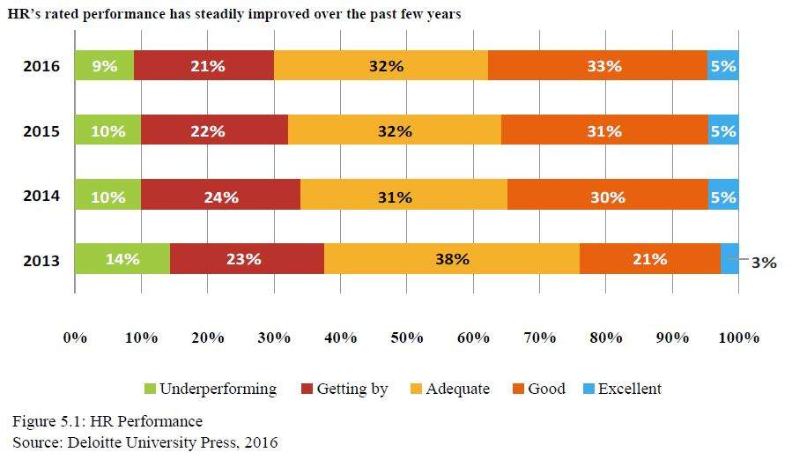
Multidomestic vs. Global Firms
Firms adopting a multidomestic strategy focus on achieving maximum responsiveness to the local market conditions (Bartlett & Ghoshal, 1989). In this instance, multidomestic firms extensively customize their products and skills and marketing strategies to better conform to variations in local market conditions. In support of a multidomestic strategy, firms often establish a full value chain of activities (from production to end product or service marketing) in each national market it serves. Firms following this strategy tend to face low-cost pressures but must contend with high pressures for local responsiveness.
The situation is reversed for firms following a global strategy (standardization). These firms face high cost pressures and low pressures for local responsiveness. They attempt to concentrate specific activities in a few favorable locations, wherever the costs are lowest, and thereby reap cost reductions from location-specific economies. In following this strategy, the product or service is not customized to local market conditions because customization would necessitate an increase in costs. Rather, the strategy is to standardize their product and service offerings to take advantage of scale economies (Bartlett & Ghoshal, 1989).
Characteristics of multidomestic products are as follows:
- Products differ greatly among countries or local cultures;
- Products have high transport costs or import costs;
- Industries lack sufficient economies to yield a globally competitive edge;
- Lead times for profits are short (such as in the fashion industry); and
- There exists government barriers to trade.
Characteristics of global industries are as follows:
- Benefits are gained from worldwide volume through reduced unit cost and increased reputation;
- Benefits are greater than costs for the increased volume; and
- High volume can support higher levels of research and development that is needed in high technology industries like jets and pharmaceuticals.

Mergers and Acquisitions (M&A)
Common ways for companies to expand their operations into the global marketplace are through mergers and acquisitions.
A merger is a tool used by companies for the purpose of expanding their operations, often aiming at an increase of their long-term profitability.
Usually mergers occur in a consensual (occurring by mutual consent) setting where executives from the target company help those from the purchaser in a due diligence process to ensure the deal is beneficial to both parties. (Note: the HR Manager frequently conducts a due diligence on people-related items such as funding of pension plans, employment law compliance liabilities, retention of key personnel, etc., in addition to the financial and business reviews.)
An acquisition, also known as a takeover, is the buying of one company (the “target”) by another. An acquisition may be friendly or hostile. In the former case, the companies cooperate in negotiations; in the latter case, the takeover target is unwilling to be bought or the target’s board has no prior knowledge of the offer. Acquisition usually refers to a purchase of a smaller firm by a larger one. Sometimes, however, a smaller firm will acquire management control of a larger or longer established company and keep its name for the combined entity. This is known as a reverse takeover.
Types of Acquisition
Full Acquisition. The buyer buys the shares, and therefore control, of the target company being purchased. This form of transaction carries with it all of the liabilities accrued by that business over its past and all of the risks that company faces in its commercial environment.
Asset-Only Acquisition. The buyer buys the assets of the target company. A buyer often structures the transaction as an asset purchase to “cherry-pick” the assets that it wants and leave out the assets and liabilities that it does not. This can be particularly important where foreseeable liabilities may include future, un-quantified damage awards such as those that could arise from litigation over defective products, employee benefits or terminations, or environmental damage. A disadvantage of this structure is the tax that many jurisdictions, particularly outside the United States, impose on transfers of the individual assets, whereas stock transactions can frequently be structured as like-kind exchanges or other arrangements that are tax-free or tax-neutral, both to the buyer and to the seller’s shareholders.
The rise of globalization has exponentially increased the market for cross border M&A. This rapid increase has taken many M&A firms by surprise because the majority of them never had to consider acquiring the capabilities or skills required to effectively handle this kind of transaction. In the past, the market’s lack of significance and a more strictly national mindset prevented the vast majority of small and mid-sized companies from considering cross border intermediation as an option which left M&A firms inexperienced in this field.
Due to the complicated nature of cross border M&A, many cross-border actions have unsuccessful results. Cross border intermediation has many more levels of complexity to it than regular intermediation seeing as corporate governance, the power of the average employee, company regulations, political factors customer expectations, and countries’ culture are all crucial factors that could spoil the transaction.
Greenfield vs. Brownfield Investment
A greenfield investment is a form of foreign direct investment where a parent company builds its operations in a foreign country from the ground up. In addition to the construction of new production facilities, these projects can also include the building of new distribution hubs, offices, and living quarters. As opposed to a brownfield investment, where leasing existing facilities and land results in relatively lower expenses, greenfield investments forwarded by multinational corporations entail higher risks and higher costs associated with building new factories or manufacturing plants. Developing countries tend to attract prospective companies with offers of tax breaks, subsidies, and other incentives to set up greenfield investments. While these concessions may result in lower corporate tax revenues in the short term, the economic benefits and the enhancement of local human capital can deliver positive returns over the long term.
The term “greenfield investment” refers to a project where a company builds the entirety of its operations in a foreign market starting from scratch, or a so-called green field. These projects are foreign direct investments that provide the highest degree of control for the sponsoring company. In these projects, the company’s plant construction is done to its own specifications, employees are trained to company standards and fabrication processes can be tightly controlled. This type of involvement is completely different than indirect investments, where companies may have little or no control in operations, quality control, sales, and training.

The Global HR Role
Lesson 59 of 69
Creating Global Mindsets
HR professionals lead the effort in developing globally minded managers. Most global organizations see international experience as a prerequisite for promotion to the top jobs. Although this experience can be gained from working in cross-border teams and projects, expatriation remains the preferred way of creating a global mindset amongst managers. However, there is a need for new skills and abilities amongst expatriates, and for far more careful planning and monitoring of assignments by organizational headquarters. This is the result of 3 main factors.
The first is the changing nature of international organizations, with many more joint ventures and alliances across national boundaries. In just one example, the value of European acquisitions in the technology sector in the U.S. increased 293% to $72.8 billion.
Working effectively in an international joint venture or alliance requires high levels of interpersonal and cross-cultural skills on the part of expatriate managers.
The second factor is a change in host locations, with a decline in the proportion of expatriates going from the developed world to the third world. At the same time, there has been an increase in assignments between developed countries as a result of extensive European, Japanese, and U.S. foreign direct investment and cross-border developments in New World trading blocs. Expatriate managers working in countries with highly educated and professional employees can no longer adopt an autocratic approach. Motivation and development of local country nationals is an integral part of creating a truly global operation and as such should be reflected in performance measurement of expatriate managers.
The third key factor concerns the changing nature of international assignees themselves. The traditional profile of the male, married, career expatriate is rapidly giving way to well-educated managers undertaking one or two assignments in the course of their career in order to gain international experience. Women still represent only a small proportion of international assignees, but this number is increasing. For these people, the costs and benefits of undertaking international assignments have to be very carefully assessed.
Some companies decide to create diversity councils (which are comprised of employees and management to initiate and support diversity programs) to help employees adopt an inclusive global mindset. An effective diversity council helps promote acceptance and support of every member in the organization. It can link diversity initiatives directly with the overall strategic goals.

Global Business Models of an MNE
Lesson 60 of 69
The future of multinational corporations’ competitiveness in the global market is contingent on corporations’ ability to change and adapt their resources strategically to the nuances of the broadening global playing field. Business strategies, which organizations adapt to maintain competitiveness, should be developed in conjunction with their human resources departments. To enable a strategic approach, human resources practices are expected to maximize employee’s effectiveness in accordance with their organizations’ mission, objectives, and goals as well as adapting a thorough awareness of cultural assumptions embedded in HR practices themselves and those which prevail in local subsidiaries. The following figure expresses the weak assessment many companies have in global HR operations and management.
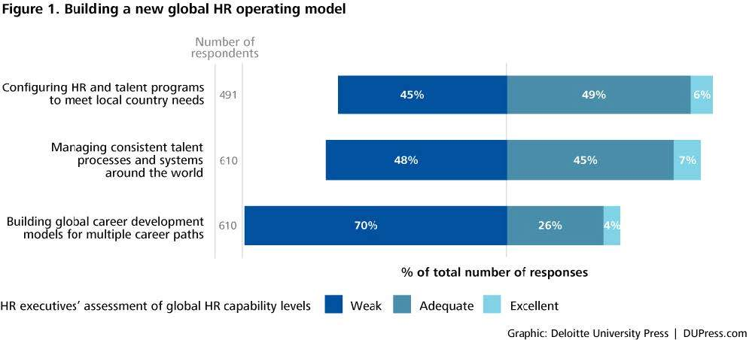
HR Operating Model
Source: Deloitte University Press, 2014
To expand upon this figure, Deloitte University continued by saying: While businesses today operate in a pervasively global environment when it comes to customers, talent, and supply chains, each local labor market has vastly different dynamics. To balance strong global HR strategies and platforms, companies should build flexibility and agility into HR so it can be customized for local markets.
The talent markets in Asia, for example, are far different from those in Western Europe and North America. In Asia, critical skills are in short supply, top candidates change jobs every nine to twelve months, and salaries are increasing nearly 10% annually. To adapt to these conditions, talent strategies should focus on recruiting, rapid talent mobility, onboarding, and accelerated leadership development.
Of course, these variances are not limited to Asia. Localized challenges drive demand for local talent solutions in every region where a company does business. Labor regulations, compensation expectations, workplace culture, and many other factors vary significantly among regions. While global consistency and standards drive efficiency and scale, local flexibility powers growth and employee engagement. To achieve both, companies should move toward a new HR operating model. (DUPress, 2014)
There are many theoretical models of strategic international Human Resource Management (HRM). The Heenan and Perlmutter (1979) classification of strategic international HRM is one popular theory that relates to the recruitment, selection, and development process of international staff.
Management strategies and the processes and practices of their implementation in multinational corporations (MNEs) will vary greatly by location. Developing global strategies, which will maintain congruence with the overall strategic plan of MNEs, while taking into account the economic, social, political, and legal constrains of the various host countries, can be difficult for international human resource managers. The conflicting demands often arise as MNEs attempt to maximize their ability to respond to the needs of the host counties (local responsiveness), while trying to maintain their controlled corporate structure world-wide (global integration or standardization).
Not much has changed since Heenan and Perlmutter (1979) carried out their original work on classifying MNEs management strategies. More recently, however, these strategies have been reconceptualized in terms of the MNE life-cycle—consistent with the product generation and sales phase of developing MNEs. Using either the life-cycle model or the classification model, the resulting management strategies often involve the interplay between global integration and local responsiveness.
Heenan and Perlmutter (1979) classify four such management strategies: ethnocentric, polycentric, regiocentric, and geocentric.
Commonly, the ethnocentric approach corresponds to the domestic phase (stage one), the polycentric and regiocentric approach correspond to the international and multinational phases (stages two and three), and the geocentric approach corresponds to the global phase (stage four) in the MNE life-cycle literature.
Ethnocentric
The ethnocentric approach focuses on a full-scale transfer of the parent organization’s HRM system to the subsidiary at the cost of local responsiveness and makes use of parent-country nationals (PCNs, i.e. expatriates) for staffing key positions in an overseas subsidiary.
From a strategic international HRM perspective, an exportive orientation facilitates organizational control while at the same time providing important international developmental experience for promising managers of the parent organization.
Polycentric
A polycentric orientation has relied on recruiting primarily host-country nationals (HCNs; i.e. individuals within the country) to manage the subsidiary operation. The subsidiary adapts its HRM policies, philosophies, and personnel to the local environment with limited intervention or control from the parent organization.
Regiocentric
The regiocentric approach is defined as functional rationalization on a more-than-one country basis. Regions are consistent with some natural boundaries, such as the Europe, America, and Asia-Pacific. Staffing patterns allow the integration of personnel from throughout the region. The polycentric and regiocentric approaches both allow for more local responsiveness, with less corporate integration. The regiocentric approach requires that headquarters maintain control over regions.
Geocentric
Geocentric international HRM practices utilize the best people for key positions throughout the organization, regardless of nationality.
The geocentric organization has the most complex organizational structure, requiring a higher level of communication and integration across national boundaries. It attempts to balance both global integration and local responsiveness.
The regiocentric and geocentric approaches typically include the use of third-country nationals (TCNs); experienced managers from neither the parent nor the host country, who have the skills to run subsidiary operations and often take on regional management responsibilities.
These policies tend to reflect the managerial philosophy towards international operations held by top management at headquarters. Each approach has important implications for international recruitment and selection and development practices.
Bartlett and Ghoshal’s Theory
Bartlett and Ghoshal (1989) proposed four types of international strategy for organizing MNEs:
- International
- Multidomestic
- Global
- Transnational
International
An international strategy is adopted when firms try to create value by transferring valuable products and skills to foreign markets where indigenous competitors are lacking those same products and skills (Hill, 1998). Production and marketing functions tend to remain in the home country. The product or skills are tailored to individual markets only to a limited extent. Firms following this strategy face low cost pressures and low pressures for local responsiveness. Entrepreneurial firms entering international markets tend to follow an international strategy. However, as will be discussed more fully in the next section, we propose that all entrepreneurial firms do not follow the same type of international strategy.
Multidomestic
These companies have a portfolio of independent subsidiaries operating in different countries as a decentralized federation of assets and responsibilities under a common corporate name. Companies operating with a multidomestic model typically employ country-specific strategies with little international coordination or knowledge transfer from the center headquarters. Key decisions about strategy, resource allocation, decision making, knowledge generation and transfer, and procurement reside with each country subsidiary, with little value added from the center (headquarters). The pure multidomestic organizational structure is positioned as high on local adaptation and low on global aggregation (integration).
Global
This strategy is the antithesis of the traditional multidomestic company. It describes companies with globally integrated operations designed to take maximum advantage of economies of scale and scope by following a strategy of standardization and efficient production. By globalizing operations and competing in global markets, these companies seek to reduce cost of research and development (R&D), manufacturing, production, procurement, and inventory; improve quality by reducing variance; enhance customer preference through global products and brands; and obtain competitive leverage. Most, if not all, key strategic decisions—about corporate strategy, resource allocation, and knowledge generation and transfer—are made at corporate headquarters. (Global Strategy 10.4 v1)
Transnational
The fourth type of strategy proposed by Bartlett and Ghoshal is a transnational strategy. Firms employ this strategy in response to high pressures for both low cost and local responsiveness. Thus, transnational firms must exploit cost and location economies, like global firms, while simultaneously adapting to the pressures for local responsiveness, like multidomestic firms. Trying to manage and achieve these objectives simultaneously is very complex and generally contended to be beyond the limited resources and capabilities of a start-up firm.
Note: start-up firms that immediately begin business on a global scale are said to be “born global.”

Corporate Evolution Process
Lesson 61 of 69
In most cases, firms have historically evolved from domestic, to international, to multinational, and finally to global operations.
At each phase, the approach to human resource management changes significantly along with the changes in competitive strategy, company structure, the product or service being marketed, profit margin, and expenditure required for research and development. For a deeper understanding of the Bartlett and Ghoshal theory, consider the following:
Phase I: Domestic
Company Profile
The company comes into the market with a product or service researched and developed at home, produced at home, and then marketed to people at home. The profit margin is high because the product or service is new and unique and therefore has no competitors. The organization structure is centralized. There are no exports because the competitive strategy is primarily domestic. The importance of international business is marginal. The dominant orientation is the product or service.
Culture
In domestic firms, international cross-cultural differences are not important.
Because domestic firms make and sell their products or services at home to local consumers, they assume there is only one way to operate: the company’s home culture way.
Human Resources
There are no expatriates, therefore cross-cultural training and development is not an issue.
Phase II: International
Company Profile
As a firm expands to international markets, it changes orientation from emphasizing the creation of a new product or service to marketing. Technology is now shared among several firms.
A logical first place to expand is across the nearest border.
For American and Canadian firms, the pattern of expanding across the U.S.-Canadian border is typical. Companies expand to similar countries before moving into unfamiliar parts of the world. Once the product is exported to a foreign country, that country often begins to demand local jobs. Low-level assembly jobs frequently are offered first. Later, as the foreign country demands higher level jobs, the parent company starts setting up multi-domestic production facilities, perhaps a plant in Canada for the Canadian market, a plant in France for the French market, etc. Each plant is operated with a great deal of autonomy.
Culture
Cultural sensitivity becomes very important to market to clients in each foreign country. The expatriate manager sent to Brazil must know how to market to the Brazilians and once production starts, how to motivate and manage the Brazilian workers. However, the domestic core of the company does not need to understand how to manage cultural differences. Cross-cultural communication is very important but only for the few people assigned to the international division and/or working in foreign countries.
Human Resources
The international firm now includes many expatriates. Good people but not great people (not future CEOs) are sent abroad. Re-entry for these managers is often difficult. Generally, people in marketing are sent abroad in this phase. Unfortunately, as many as 50% of expatriates sent by international firms find their foreign experience hurts their career. This is primarily because international operations are neither highly valued nor well integrated into the core of the home company.
Phase III: Multinational
Company Profile
Unlike the prior multi-domestic international phase, firms in the multinational phase become more centralized, pulling decision-making back to headquarters.
As firms change from international to multinational strategies, they change their focus from marketing to price.
In this phase, companies source factor inputs, produce, assemble, and market in multiple countries around the world. Labor and other resource inputs are selected on the basis of least cost for desired quality. Distribution is worldwide, and profits are made through large scale sales. For example, in the l980’s multinational consumer electronics firms focused on price. Because each firm’s fax machines, VCRs, and microwaves had become almost identical, consumers did not care whether a particular item was made in Europe, North America, or Asia. The consumer strictly looked for quality equipment with the lowest price.
Culture
In the multinational phase, cultural sensitivity becomes slightly less important outside the firm (with clients). While multiculturalism begins to become less important outside the firm, it becomes more important inside of the company. Staff from different parts of the world work together on a day-to-day basis. Unfortunately, assumptions are made, often mistakenly, that, inside the organization, personnel from different countries will have no problems understanding each other because they all belong to the same organization. By this stage, attention to developing cross- cultural skills is needed for working both inside and outside the organization.
Human Resources
Fewer expatriates are necessary as the participation of host nationals increases. The person making decisions for foreign operations is no longer an expatriate marketing expert, but rather a valued manager of a worldwide line of business. In this phase, as the approach changes to multinational, the managers who are sent abroad tend to be more senior and therefore more central to the company’s core management.
Phase IV: Global
Company Profile
With strategic alliances, mergers, acquisitions, and more fluid organizations, Phase IV dynamics become more complex than in prior phases. In this phase, the importance of world business becomes dominant. The primary orientation of the firm is strategic in the sense of balancing the different businesses, functions, and geographies within the company. Products and services become “mass-customized.” “Mass,” in the sense that they draw on the best ideas worldwide, and “customized” in that they are modified to fit the needs of specific local populations. Examples of this approach include Campbell’s, which modifies its tomato soup using different spices adjusted to the tastes of local consumers; Benneton, which produces sweaters dyed to order; Volvo, with thousands of decisions per car which can be tailored to individual request; and the Japanese prefabricated housing industry, which combines construction components in endless ways to fit the needs of individual home buyers. In the global phase, profit margins are initially high while the business has a “first mover” advantage. However, research and development costs are also extremely high as firms struggle to remain innovative. Product life cycles shorten considerably.
Culture
A global organization needs to understand cross-cultural differences both inside and outside the organization. In order to mass-customize products, it is necessary to keep well informed about ideas from all parts of the world, about the sources of raw materials worldwide, and about political and economic trends across geographies. Managing global boards and senior executive committees requires a sophisticated understanding of cultural differences in interaction patterns and in attitudes towards time, influence, and problem solving styles.
In one company, a joint design team composed of executives from Singapore, Canada, and France had to make daily decisions on when to hold teleconferencing meetings and how to minimize the inconvenience to members based on the time chosen.
EXAMPLE
For example, the North American approach of arranging very closely managed schedules for meetings with time allotted for each topic according to its financial impact is incompatible with some non-North American cultures. Asian or European executives require more time initially for individuals to get to know each other.
Human Resources
In the global phase, the number of expatriates again increases. Managers are sent abroad as the “glue of the company” to coordinate and integrate strategic activities, not merely to complete particular tasks. Who goes? Managers (who are considered high potential), or executives (who already hold senior positions) are the best candidates for international assignment. These executives know that it is necessary to have a global perspective for their own careers and for the organizational development of their company, and they can only achieve such a global perspective through significant exposure abroad. Professional re-entry therefore becomes easy.
Phase V: Transnational
The highest form of globalization. Corporations have gained the ability to operate globally, yet still maintain a semblance of local flexibility and control.
Global alliances and global networks are evolving rapidly. Once a company has evolved to the global phase, culture is seen differently. Because global strategic alliances and joint ventures are negotiated by senior executives, there is a significant increase in executives' interest in cross-cultural management and communication skills. Cultural differences suddenly become highly significant when the “foreigner”—rather than being an assembly line worker—is the CEO at an important meeting “who isn’t acting as I am and who doesn’t understand me as I thought he or she would.”
Senior managers and executives, in working throughout the world, must understand multiple perspectives.
In general, many European firms have had more practice at using multinational approaches than have North Americans. However, leading firms from all geographies are becoming increasingly transnational.

Strategic Planning
Lesson 62 of 69

Evolution of the HR mission
Increased international competition has shaken U.S. complacency in the world market. The United States no longer dominates markets nor dictates management and business practices.
Government regulation and legislation have grown, which further restricts U.S. competitiveness and increases the chances of government fines and employee litigation.
Technological advances make training increasingly important, especially as the pool of skilled workers shrinks. Employers have to train new recruits in the skills that U.S. high school graduates lack, and retrain current employees to handle new skill demands.
Economic stagnation, downsizing, and reorganizations have emphasized employee involvement, HR development, and career counseling. Companies must involve and develop employees to maximize productivity and achieve total quality management goals without increasing staff. Today's leaner organizations also must find creative ways to reward talented employees despite declining job security and advancement opportunities.
Changing workforce demographics have created new employee needs and demands that companies must address to attract and retain talent. Diversity in recruitment and employment practices has become essential for employers to maintain critical labor force levels. Besides hiring more women, minorities, and immigrants, highly competitive organizations adopt HR policies that respond to the needs of the new workforce such as flextime, child care, and telecommuting.
Changing HR roles
Over the last few decades, the role of an HR manager has changed from processor of personnel paperwork to strategic, proactive global business partner. Today’s HR professionals act as conduits between employees and management, monitor compliance with employment laws, and manage an organization’s human resources to meet corporate goals and objectives.
HR’s primary mission now is to design and implement legally sound HR policies that will support strategic business goals and fulfill the organization's workforce needs as economic conditions change.
HR’s Role in Strategic Planning
To serve as a global strategic business partner, an HR manager must fully understand the organization’s business, its competitors, and the internal and external factors affecting short- and long-term planning in order to align HR operations with the overall business plan.
This knowledge is essential, not only to develop HR plans consistent with the overall business strategy, but also to establish HR as a valuable player in organizational planning. Top executives value input from HR managers who can foster organizational development, predict future legislation and regulations, and recommend corrective actions.
In hiring, training, motivating, and retaining employees, HR managers increasingly must think like senior management. In one survey, 63% of respondents rated the goal of “providing management with more sophisticated data for strategic planning” as very important, thus making the goal the top challenge for participating HR departments.
A business focus in HR is becoming more important for the following 2 reasons:
Accelerated Competitive Change
Given the rapid pace of global change, senior managers cannot afford the time and patience to instruct HR managers of each new development. The effective HR manager, like the effective CEO, follows the industry news and reads the trade journals. In fact, HR executives increasingly are expected to instruct senior management of pending changes and appropriate responses.
Increased Demand for Skilled Labor
The increased value of skilled employees reflects several trends:
- Skilled labor is becoming scarce, and any scarce commodity increases in value;
- Cost-conscious managers are subcontracting out production work and reducing finished-product and materials inventories, so these resources account for a smaller percentage of a company’s value;
- More employers are leasing buildings and equipment, which reduces a company’s physical assets; and
- The value of intangible assets like patents and technology is more volatile and has a shorter half-life due to the faster pace of competitive and technological developments.
As a result, the success of an organization and its HR manager may depend on finding people with the right skills, training, ability to motivate employees appropriately, and retain them successfully.
Forecasting Models
In any planning process, there is a certain amount of guesswork involved. The prudent planner will hedge their bet on future predictions by employing a scientific approach to forecasting. Commonly accepted models include:
- Judgmental forecasting. This is where the planner uses their own experience, education, and opinion to form the basis for a prediction as to what the future may bring. In other words, it is an educated guess.
- Delphi technique. This is a systematic forecasting method that involves the use of a panel of experts who are kept separate and isolated from one another while rendering opinions and predictions within their area of expertise. Usually, several rounds of questions and answers are conducted. After each round, a consensus forecast is compiled on the subject being analyzed.
- Nominal group technique. A variant of brainstorming, the Nominal Group Technique requires a group of knowledgeable team members to write down their ideas or predictions, on a specific subject, independent of the other team members input. Once the ideas are written down, they are discussed and prioritized one by one by the team. The steps of this process normally follow:
- Generation of ideas or predictions,
- Record the ideas or predictions,
- Discuss the ideas or predictions, then
- Vote on the ideas or predictions.

Human Resource Information Systems (HRIS)
Lesson 63 of 69

Before global HR managers can understand human resources information systems uses and intelligently assess the benefits of automating various HR management functions, they must have knowledge of computer systems and relevant technical terminology.
Like all computer systems, the components of an HRIS fall into two broad categories: hardware and software. The individual hardware components and how they fit together is largely determined by the type of computer system or platform used to operate the HRIS: mainframe computer, minicomputer (also known as midrange or midframe computer), microcomputer (commonly called personal computer or PC), or some combination of these three platforms.
The sophistication and efficiency of an HRIS depend not only on the hardware and software used, but also on the extent of the database of personnel information. Together, the platform, hardware, software, and database make up the system’s design, or what computer professionals refer to as system architecture.
An HRIS database contains information, or data, regarding an organization’s personnel and HR services, as well as the software required to carry out various HR activities. A database is like a filing system: Similar data can be grouped into records, and similar records can then be placed into files.
An HRIS can bring about both direct and indirect savings for the HR department and the entire organization. Direct dollar savings occur when an HRIS reduces the number of clerical positions or eliminates the need to contract outside agencies or hire temporary help to perform HR activities and analyses. Besides the dollar benefits of higher HR staff productivity, a more efficient HR process can produce savings in every department affected by that process. For example, lower turnover, faster applicant processing, and more rigorous applicant screening can reduce costs of recruitment ads and agencies, relocation reimbursements, training expenses, lost productivity due to vacancies and inexperienced personnel, and so forth.
The challenge for the Global HRIS Manager is whether to attempt to standardize recordkeeping and data gathering worldwide or to localize HRIS activities to host country areas. HRIS standardization does not usually allow for the variations in government compliance between different countries. Often, a localized approach to data gathering (equal employment opportunity, safety compliance, and other regulatory reports) is required due to governmental compliance.
Finally, while an HRIS can reduce workloads, improve efficiency and accuracy, its main purpose is to provide management with data they can use as a basis for decision-making. Simply put, an HRIS system is a tool managers use to make better decisions on organizational operations.
Enterprise Resource Planning
Enterprise resource planning (ERP) is a business strategy that combines all the various company-wide computer programs into one cohesive system. By linking all the different software and hardware packages together, the organization is better able to facilitate a single cohesive business approach to customer service and operational excellence.
By providing management with immediate access to all daily operational information and financial data, better decision-making results from the more immediate analyzing of data, identifying trends, planning for the future and the tracking of goals.
Traditionally, the various company functions such as accounting, inventory, customer service, human resources, etc., did not share their information through a common technological link. Each department acted autonomously and only indirectly shared information with other departments. By bringing together all the functions into one harmonious system that is tied together, the left hand will know what the right hand is doing. This approach replaced a tangle of complex computer applications with a single, integrated system.
In today’s global marketplace, reacting swiftly and taking proactive steps to gain competitive advantage requires speed. To gain this competitive advantage, businesses must process information in a seamless and integrated manner. ERP is the backbone of this initiative.
While the HR department holds employee records such as employee compensation, payroll, medical, benefits, staffing compliance, etc., it must integrate these programs with Sales, Finance and Manufacturing. What occurs in these other departments has a down-stream impact on compensation and the other HR records that are based on headcount in these departments.

Human Resources and Other Technology
Technology is an increasingly important field in HR. It has many benefits (communication with expatriates abroad, streamlined online surveys and feedback forums, etc.) and creates many concerns (security, the cost of training to learn new online systems, etc.). Most HR professionals, whether global or regional, recognize the trend of technology is an integral part of HRM and can open up a variety of different techniques to communicate with employees. HRIS is arguably the most important, but 2 other notable platforms include intranet and social media:
Intranet
The Human Resources Department has a lot at stake in the success of an intranet. By making information and forms accessible through the intranet, HR frees up a lot of its time enabling them to focus on more value-added tasks. Useful HR content also increases employee satisfaction. HR typically already provides a lot of the content in intranets. Some HR departments own the intranet. The usual HR intranet content are:
- Company policies
- HR forms, such as leave applications and claim forms
- Staff appointments
- Calendar of holidays and training events
- Employee birthdays and anniversaries
- Job vacancies
More recently, companies have been adding more engaging content such as:
- Training
- Video tutorials
- Career enhancement tools
- FAQs
- Applicable laws
Noodle, designed by Vialect, is one example of Social Intranet Software. They, and their competitors, provide companies with the ability to share ideas, documents, and schedules, upload photos, and work on projects on a single site. (Vialect.com) Regardless of the software used, HR should make sure the information is up-to-date, functional, and engaging.
As noted in the Wall Street Journal, some emerging trends include:
- Mobile emerges as a new HR technology platform.
- ERP vendors catch up as credible talent management providers.
- “Built for the Cloud” technology providers redefine HR functions.
- New software categories include feedback, engagement, and cultural management.
- Startups move to integrate learning content from disparate sources.
Social Media
Social media can often be overlooked as a tool to make a company competitive in their field. More and more, however, companies have found that if used correctly, it can be a powerful business strategy. The incoming workforce, mostly meaning college students, have integrated social media as part of their daily lives. To recruit new talent, companies should be forward-thinking when it comes to social media. Villanova University offered the following steps to build a solid social media presence:

Five steps to establishing a social recruiting strategy
Identify your goals – What does your company need from social media? What are you trying to accomplish? Establish and document your short-, mid- and long-term goals.
Write a guiding statement – Establish what job seekers can expect from your company and what the company will ask of them in return.
Define your culture – Figure out what makes your company uniquely different. Why do current employees enjoy their work? What will attract more top talent to your organization? Communicate the pluses of working for your company.
Target your best-fit employees – Your social recruiting strategy should be targeting candidates who will work well with your current employees.
Strengthen the culture – Focus on the skills and personalities of the candidates you’re recruiting to strengthen the company culture.
Once the strategy is established, it can be executed throughout the company social media accounts. Remember to keep your online content relevant, fresh and updated, and always avoid the hard sell. Interacting with potential hires will keep them engaged while building trust in your company. Encourage employees to spread the word about open positions through their own social networks.
Social media has transformed the way we learn and communicate in our personal lives. Now, organizations are increasingly incorporating it into their strategic planning for recruiting, hiring, and other HR functions. (Villanova)
ISO 9000
Recognized worldwide, ISO 9000 is a family of standards for quality management systems. ISO 9000 is maintained by ISO, the International Organization for Standardization, and is administered by accreditation and certification bodies.
Some of the requirements in ISO 9001 (which is one of the standards in the ISO 9000 family) include:
- A set of procedures that cover all key processes in the business;
- Monitoring processes to ensure they are effective;
- Keeping adequate records;
- Checking output for defects, with appropriate and corrective action where necessary;
- Regularly reviewing individual processes and the quality system itself for effectiveness; and
- Facilitating continual improvement.
A company or organization that has been independently audited and certified to be in conformance with ISO 9001 may publicly state that it is “ISO 9001 certified” or “ISO 9001 registered.” Certification to an ISO 9001 standard does not guarantee any quality of end products and services; rather, it certifies that formalized business processes are being applied.
The ISO Standards are considered a consensus on “good management practices with the aim of ensuring that the organization can time and again deliver the product or services that meet the client’s quality requirements” (International Organization for Standardization, 2002). In other words, the ISO 9000standards are not quality control standards for products per se, but are instead management systems standards that help businesses assure that they are following a set system for the production of their goods and/or services.
ISO 9000 standards essentially outline what requirements a good quality system will meet. Because ISO standards are implemented by individual businesses, corporations, and government organizations, the ISO 9000 “family” also provides auditing tools to make sure that the organization has properly implemented the standards and are meeting the quality requirements.
The ISO 9000 standards target a large range of businesses-from “Mom and Pop” operations to multinational corporations. ISO 9000 standards are designed to define what requirements a good quality system will meet, but they do not dictate how businesses must reach those requirements.
Participative Management
Organizations that aggressively pursue lower costs, higher quality, and improved customer service have borne out the efficacy of participative, high-involvement management. Radical and positive transformations in cost, quality, and service based on participative management principles have been documented across industry, government, and non-profit sectors.
The following principles are important to keep in mind when embarking on a change effort to increase participative management:
- The top level must commit to the effort. This commitment assures effective role modeling and reinforcement and communicates that the change effort will not go back to “business as usual” when resources are short or the organization experiences a crisis.
- The idea is not to implement participative management for participative management’s sake or solely to improve the quality of work life. Participative management, like any other management tool, needs to be focused on attainment of organization goals and improvement of quality, service, and costs.
- Changing management style alone often does not yield the desired results. Implementing participative management usually needs to be accompanied by changes in structure, work and job design, compensation, and other systems. For example, gainsharing programs that provide incremental financial incentives/rewards for measurable improvement in key areas, have produced good results when introduced with participative or high-involvement management efforts.
- Attempts to increase participative management mean change, and are subject to all the change management principles covered earlier.
Some people will naturally resist change. Middle managers may resist a switch to participative management because they feel their roles are threatened and they will lose power. Non-managers or those who directly get a bigger say and more responsibility can also resist change. Change is different from what they know, and for some managers, anything different represents a potential threat. Empathy, clear communication, and training for all parties can minimize the potential downside of attempts to increase participative management.
Top Management’s Role
It is essential to tell employees the company is interested in their ideas, and these ideas matter. After increasing employees’ awareness of the demand for their input, management must begin to increase the amount and quality of communication among the different corporate levels. Involving employees will make them feel they are an important part of the company team. Employees who feel their work contributes to the success of the company will likely work more productively and be more amenable to helping cut costs.

Organizational Models
Lesson 64 of 69
Organizational Structures
Design of the global HR department reflects overall organizational design. As a result, HR department structures vary from company to company according to several factors: line vs. staff functions, centralization vs. decentralization, span of control, responsibility and authority, availability of personnel, etc. There are many approaches to the design of the organizational structure; the one that is most effective is the one that takes into account the purpose and the work of the company. Typical examples of organizational structures include:
Centralization vs. Decentralization
Centralization is said to be a process where the concentration of decision making is in a few hands. All the important decision and actions at the lower level are subject to the approval of top management. Decentralization refers to the systematic effort to delegate to the lowest level of authority except that which can be controlled and exercised at central points.
Larger organizations typically have multiple locations and handle more than one line of business or service. Most large companies set up line organizations for each location or business. In contrast, staff functions, like HR, can remain centralized at headquarters, be decentralized to each site or business, or be divided between the corporate and unit levels. In practice, while some decentralized functions, such as legal and finance, may continue to report directly to a corporate manager, most decentralized functions like HR report to a local line manager on straight-line basis and to a corporate staff head on a dotted-line basis.
Functional Structure
In the functional structure of organizational design, work is organized around typical functions within the organization. Such as, the payroll function, employee relations function, hiring function, etc. This leads to operational efficiencies within the group or the department. Coordination and specialization of tasks are centralized in a functional structure.
Divisional Structure
Divisional structure is sometimes known as product structure. Work is divided along product lines. Each division within a divisional structure contains all the necessary resources and functions within it. For example, a telephone company may divide its divisions into product specific topics such as cell phones, land lines, Internet access, etc. Other divisions may be divided based on geographic location such as Southeast United States, Northeast United States, or West Coast.
Matrix Structure
In a matrix structure, employees serve two masters. They have a direct line reporting relationship to their immediate department head or supervisor, while also maintaining a dotted line reporting relationship to a project manager or team manager that they may have been temporarily assigned to. Matrix organizations frequently use teams of employees who are temporarily assigned to a project team to accomplish the work of the company. This type of organizational structure is often confusing to employees who are trying to satisfy both of their reporting relationships.
Line vs. Staff Functions
Organizations with line functions establish separate departments for different products or services. Each line manager has direct responsibility for a single area with little crossover of authority between departments. Examples of line functions include shipping and mailing, production, and marketing and sales. Staff functions supplement the line function and have an advisory, facilitative, or specialized support role. Unlike line managers, staff managers generally are responsible for providing services across all departments within a company. Examples of corporate staff functions include HR, legal, accounting, and the like.
Span of Control
The number of subordinates reporting directly to a supervisor determines that manager’s span of control.
An appropriate span depends on the nature of the work, the capabilities of the staff, and the organizational culture. The current trend is to eliminate management layers and establish flat organizations, which usually increases a manager’s span of control.
EXAMPLE
Ford of Europe recently removed two of seven management layers, and British Airways reduced the number of levels between CEO and front-line managers from an average of eight or nine to five. Spans of control at some General Electric divisions have increased from the traditional five to eight staffers, to 15 or more.
Responsibility and Authority
Responsibility and authority are two key organizational imperatives. Clear lines of responsibility facilitate the flow of information, let subordinates know to whom they report, and establish firm control over operations. Authority goes hand-in-hand with responsibility. Although one management principle says that authority, unlike responsibility, can never be completely delegated, managers must have the requisite authority to accomplish their objectives.
Available Personnel
The optimal organization structure is always affected by the availability of competent personnel. At times, an organization’s structure may need modification to adapt to changing personnel availability. For example, staff shortages may make it necessary to merge different functions into one; in other cases, an organization might need to create new positions to retain qualified incumbents or to recruit new employees. For HR departments, the current trends toward downsizing and outsourcing have prompted some departments to abandon functional specialization and hire staff with a generalist orientation suited to handling different activities.
Corporate Culture
Fons Trompenaars & Charles Hampden-Turner have created a model of corporate cultures that help explain the differences between societies and how they affect the process of doing business. Trompenaars and Hampden-Turner have theorized that most corporate cultures fall into one of four categories.
The Incubator
Typical of Silicon Valley, this model is both people oriented and egalitarian. It is highly creative, incubating new ideas. Anyone, regardless of status, may come up with a winning idea.
The Guided Missile
This is a task oriented culture. There is a multidisciplinary project, and the teamwork aims at bringing it to a successful end. They take the people whose expertise is needed to solve their problems. One example is NASA: it took over 100 disciplines in science and engineering to land on the moon. The relative contribution of each one had to be negotiated among equals. The only boss was the task.
The Family
This is the oldest form. On a global scale, there are more family-owned companies than any other kind, but we are speaking of family culture, not legal ownership. It is hierarchical: the gap between “parents” (owners) and “children” (employees) is wide. The boss may be respected or feared. He considers his employees as members of his family, whose burden he carries. An example of this are many Japanese corporations. They are person oriented: who you are is more important than what you do. Family members may not be fully professional. Insiders have advantages over outsiders. Such cultures are often warm, intimate, and friendly, but not always very efficient. Creativity cannot be inherited.
The Eiffel Tower
This culture rewards precise, detailed, and routine tasks without errors. Everyone has a precise job description (e.g. attaching a mirror to a succession of automobiles on an assembly line) and strict orders come from the top, telling workers what to do, when, and at what pace. Workers are seen as a pair of hands, extensions of big machines, obeying the orders of their boss. The culture is stable, predictable, safe, routine, and reliable. Examples are Henry Ford and Frederick Winslow Taylor

Leadership Theories
Lesson 65 of 69
Blake and Mouton Model
Robert Blake and Jane Mouton characterize leadership style as the degree of concern for production a leader expresses relative to concern for people.
By plotting low, medium, and high levels of “concern for production” on the horizontal axis and “concern for people” on the vertical axis, they identified a grid of managerial styles. Under this model, managers display one of five basic leadership styles:
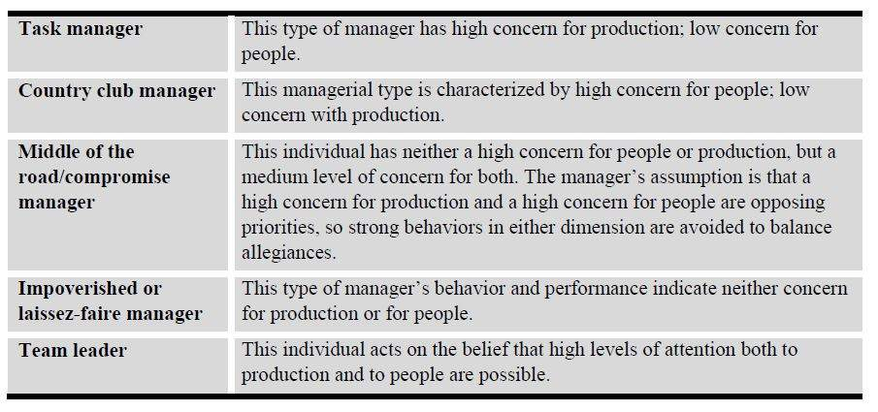
Hersey-Blanchard Model
The Hersey-Blanchard model, also known as the Situational Leadership model, plots leadership style against three dimensions:
- Task behavior involves defining the roles and organizing and directing the tasks required to accomplish a job.
- Relationship behavior concerns how a leader maintains contact and relationships with and among team members.
- Task maturity is the degree that an individual or a team is confident, competent, and experienced in a particular work or task situation.
This theory asserts that in situations where task maturity is low, an effective leadership style is one that provides a fairly high degree of task structure for team members, even telling them what needs to be done and how to accomplish a task.
At medium levels of task maturity, much contact with and among team members is appropriate. This interaction allows for adequate coaching and builds teamwork so team members develop capabilities to be more autonomous. At very high levels of task maturity, neither much direction (task behavior) nor contact (relationship behavior) is required because a team and team members function effectively autonomously. In other words, the amount of direction and control the leader exerts is dependent on the situation (situational leadership).
Likert Model
Rensis Likert portrayed a range of leadership styles on a continuum with four systems from left to right:
- Exploitative-Authoritative (System 1). This leadership style, located on the far left of the spectrum, is autocratic and task-centered.
- Benevolent-Authoritative (System 2). This style of leadership bears similarities to the first but is not as autocratic.
- Consultative (System 3). These leaders are more willing to seek employee input, but retain most decision-making responsibility and authority.
- Participative-Group (System 4). Found on the continuum’s far right, this leadership style is democratic, participative, and employee-centered.
In his research, Likert consistently found that the most successful organizations exhibit System 4 characteristics and the least successful show System 1 and System 2 characteristics. The implication of this model and research for organization effectiveness is that to develop and sustain System 4, organizations need to encourage highly participative management practices while focusing on goals.
McGregor’s Model — Theory X and Theory Y
One of Douglas McGregor’s major contributions to management/leadership theory is his Theory X/ Theory Y model. Theory X and Theory Y are meant to represent two opposite sets of assumptions about people and work teams:
Theory X managers, and by extension Theory X organizations, view people by and large as lazy, not very bright, and irresponsible and will only respond to threats and intimidation to get work done.
Theory Y managers and organizations view people as basically bright, responsible, motivated, and wanting control over their work and lives.
While no individual manager or organization may be pure Theory X or Theory Y, McGregor’s model can be a helpful tool for teams and managers to assess some of their basic orientations and assumptions about others they work with. For example, organizations and managers operating from a Theory X position will find it very difficult to make the transition to high-involvement work teams.
Theory Z
Theory Z is a participative style of management developed by William Ouchi. He uses this term, as opposed to MacGregor’s Theory X and Y, primarily in the Japanese marketplace. His Theory Z management style includes the following characteristics:
- Both leaders and subordinates are motivated by a powerful sense of commitment to be part of a greater whole (the organization in which they work).
- Employees seek out responsibility and strive for opportunities to advance in an organization.
- People are self-satisfied when they contribute to organizational success through teamwork.
- In return for their organization’s long-term commitment to providing job security (often for life),workers develop strong bonds of loyalty towards their employer.
Japanese managers contrast with Theory X managers (like those from the Middle East or Indonesia) who believe workers are lazy by nature (Theory X beliefs).
Theory Z managers from Japan also differ from leaders in China, Europe, and North America who generally follow the more paternalistic Theory Y approach. Theory Y managers assume workers will work hard and seek increased challenge and responsibility depending on the rewards associated with task achievement.
Building Leadership
The quality and extent of leadership is a significant indicator of an organization’s effectiveness. Part of an organization development project should involve assessing and developing effective leadership.
Leaders exert power of some kind to influence others. When evaluating the leadership exercised in an organization or team, analyze the source of power exercised to influence team members. Leaders can possess several distinct kinds of power:
- Position power reflects the function of someone’s designated role in an organization’s official structure or hierarchy. A person with high position power would expect orders and suggestions to be carried out by virtue of his/her position in the organization. This is especially relevant in an ascriptive culture.
- Expert power is based on the respect shown and inclination to follow directions or suggestions based on someone’s expertise, skill, or knowledge. Important in an achievement culture.
- Coercive power rests on fear and the belief that not complying or following directives will lead to punishment. (Theory X)
- Reward power is a function of people believing that compliance will lead to increased pay, recognition, promotion, or other rewards. (Theory Y)
- Personal power is based on a liking for or admiration of personal traits or accomplishments, and identification with a leader.
Employee Empowerment
Successful organizations are learning that power and influence should not rest solely with managers and those with position power. In fact, empowerment of all employees to exercise leadership in the interest of improving quality and service is generally in the organization’s and customers’ best interest.
Empowering employees involves expanding the power base in an organization by creating a work environment where employees take initiative and exercise leadership to maximize quality and service. Empowered employees, for example, will shut down a production line on their own when observing a problem that could result in poor quality. Another example is an employee who does whatever seems reasonable to satisfy an important customer without obtaining prior approval from the supervisor.
Leadership Styles
Leadership styles vary. One leadership theory is the “path-goal view,” which recognizes four kinds of leadership behavior:
- Directive leadership. Directive leaders take a structured approach to supervision, giving subordinates specific guidance about what to do, how to do it, and when to complete it.
- Supportive leadership. Supportive leaders emphasize their concern for employees’ needs and welfare. They demonstrate their friendliness to subordinates and strive to create a pleasant workplace atmosphere.
- Participative leadership. Leaders with a participative style adopt an open attitude toward suggestions from subordinates and actively solicit their input when making decisions.
- Achievement-oriented leadership. This leadership style emphasizes setting goals and communicating confidence in subordinates’ ability to meet high expectations. An achievement-oriented leader encourages employees to improve their performance and challenges them to perform at high levels.
Good executives “read” a work situation before deciding what type of approach to take with employees. For example, an executive who typically uses a consulting approach may adopt an autocratic style because the occasion demands it.
Leadership Training
Global executives must be leaders if they are to motivate and direct the rest of the company to maintain the highest possible productivity. A job title alone does not guarantee that an executive is a capable leader. The following traits distinguish good leaders from poor ones:
- Leaders are self-starters who desire to excel. They like to be in charge and make things happen and are willing to work hard to achieve success.
- Leaders have self-confidence and can make sound decisions quickly.
- Leaders are open to change and encourage subordinates to find better ways to do a job.
- Leaders devote their time and energy to supervision and planning; they do not get sidetracked into doing their subordinates’ work.
- Leaders bring order into disorganized situations and clarify a group’s goals so that they can be more easily attained.
- Leaders have the stamina to withstand the pressures of their positions and the resilience to bounce back from defeat.
- Leaders have a sense of responsibility. They are not afraid to accept obligations and challenges.
- Leaders have integrity. They are honest with themselves and with subordinates.
- Leaders have enthusiasm and communicate this enthusiasm to others. An uninspired leader attracts few followers, but an enthusiastic executive generates renewed energy and commitment from employees.
Good leaders have exceptional human relations skills. Leaders are involved with fellow employees, analyzing their needs and trying to understand their problems. Researchers have found that executives who care about employees and their problems have higher productivity than work-centered executives.
A global executive with good human relations skills engages in these efforts:
- Makes employees feel involved in reaching company goals;
- Gives credit for work well done and helps employees learn from mistakes;
- Deals fairly and frankly with subordinates, keeping them informed about their performance; and
- Shows confidence in employees’ ability to get their work done by permitting them a degree of freedom in their jobs.
Western vs. Eastern Leadership Styles
Cultural differences have a definite impact on the leadership style that is most effective in the different countries an MNE may operate. As Trompenaars and Hampden-Turner would say, recognizing, then respecting, and finally reconciling these differences is important for the global leader. The following compares some of the common differences between western and eastern leaders.
Western Leadership
- Hierarchical, egalitarian command, segmented concern
- Professional managers, position related to function
- Specialized career path, possibly with rapid evaluation and promotion, individually oriented
- Decentralization of power
- Mobility
- Diversity
- Direct approach
- Systematic analysis, standardization, categorization, classification, conceptualization, precision
- Long-term set planning
- Explicit control mechanisms
- Organizations and systems adapt for change
Eastern Leadership
- Free-form command, roles loosely defined, holistic concern
- Social leaders often with high sounding titles for low ranking jobs
- Non-specialized career paths, slow evaluation, regimented promotion, socio-oriented
- Centralization of power
- Stability
- Unity
- Indirect approach
- Ambiguity, reaction, adaptation
- Often lack of formal set planning, high flexibility in adjustment
- Implicit control mechanisms
- Leaders/managers adapt to change

Ethics
Lesson 66 of 69
Ethical Issues
Ethics in business is not an expedient concept, something to practice only when convenient; it is something that needs to be built into the innate culture of the company. It is more complicated than deciding what is “right” and what is “wrong.” A company’s ethics reflect its character, its mission, and its goals. When ethical considerations are wanting or inadequate, the enterprise itself is vulnerable. It has opened itself up to the risk of legal liability, along with—in the event misconduct is identified and punished—loss of face, customer loyalty, and market share. Investors may also shun stock in a company that does not meet their standards, or that appears to be in a precarious legal position.
Personal and Professional Conduct
When drafting guidelines for employees’ behavior, many employers choose to be as general as possible. A phrase asking employees to refrain from conduct that could be “harmful” or “viewed unfavorably” by most people covers many forms of unacceptable behavior without tying management’s hands should it need to discipline employees.
Entertainment, Gifts, Favors, and Gratuities
The area of exchange of goods and services that have intrinsic value is a murky one. What is acceptable and expected in the host country? Is treating a supplier to a restaurant meal a gift? What about sending a basket of food or a case of wine? Most would view an invitation to dinner as simple hospitality, but look askance at a weekend at a hunting lodge. Other kinds of gifts are equally ambiguous from time to time. A coffee mug will not raise red flags in most countries, but a china tea service imported from London surely would.
Some companies, and the U.S. government, settle the problem by assigning an arbitrary limit in monetary value to gifts that may be received. Others expect their employees to exercise some judgment.
“Inside” Information
So-called “inside” information is not available to the general public. For practical reasons, any company may wish its decision-making to remain confidential until signed off on, in order not to give the impression of instability while different options are being discussed. But for companies whose stock is traded publicly, the necessity to play decisions close to the vest has market implications. It is against the law to act on, or to provide to others, information about any acquisition or sale contemplated by a company before that information has been released to the general public.
Conflicts of Interest
Such conflicts usually involve compensation of one kind or another. Usually a conflict of interest is one in which an employee’s loyalty may be divided between self-interest and the interest of the employer.
Confidential and Proprietary Information
Confidential information may be of the “inside” type, which has to do with trading stock or other items of value, or it may be information with no value. For example, for a supervisor or HR professional to gossip about an employee’s credit record or medical history would be at least unethical, if not illegal.
Outside Employment
This area is one similar to conflict of interest. Employees may not usually work for a competitor, or work in a position that would compromise their work with the chief employer.
Nepotism
Here again, to do business with family members in a company’s name causes a conflict of the employee’s interest and the employer’s, and is, for that reason, usually forbidden.
Political Contributions
An employer may not interfere with an employee’s exercise of political rights, other than to forbid them on company time. It is against the law for an employer to require employees to contribute to a particular candidate or party, although a number have done so in recent years (and been caught).
Financial Reporting
This is, for the most part, a reiteration of policies forbidding theft or fraud.
Blanket and Acknowledgment Statements
It is important to have on file an acknowledgment that each employee received a copy of the ethics policy. In the event of any difficulty down the road, the employee will not be able to protest that the policy was not communicated.
HR’s Code of Ethical and Professional Standards in HR Management
The Society of Human Resource Professionals (SHRM) has a code of Professional Standards that may be the source of questions on the test. SHRM’s code covers such diverse topics as: Professionalism, Professional Development, Ethical Leadership, Fairness and Justice, Conflicts of Interest, and Use of Information.
Our summation of SHRM’s standards: they do not allow HR Professionals to abuse the power of their position for personal gain or to act unprofessionally.
Establishing Ethical Behavior in the Organization
The two basic types of conduct codes are the compliance-based and the integrity-based.
The compliance-based code, as its name suggests, aims to defend an organization from liability by making sure it is complying with all relevant laws and regulations. A code based on compliance is driven by legal considerations, drafted or reviewed by lawyers, and amounts to a defensive posture.
A code based on integrity, on the other hand, is designed to solve any dilemmas employees may face by providing an ethical basis for decision-making. If the compliance-based strategy is defensive, the integrity-based conduct code could have the motto: “The best defense is a good offense.”
The Limits of a Compliance-based Model
A compliance program based on a careful reading of applicable laws and a plan to ensure the company works within those laws, although necessary, is insufficient. Conduct that is within the law can still be ethically questionable. Selling hazardous products like DDT overseas is legal, but may not meet ethical standards. Buying goods made overseas by children, or manufactured in sweatshops or prisons, may not risk a jail sentence, but, again, can be seen as conduct that infringes on recognized standards of human rights and decency.
Differences between Compliance and Integrity Systems
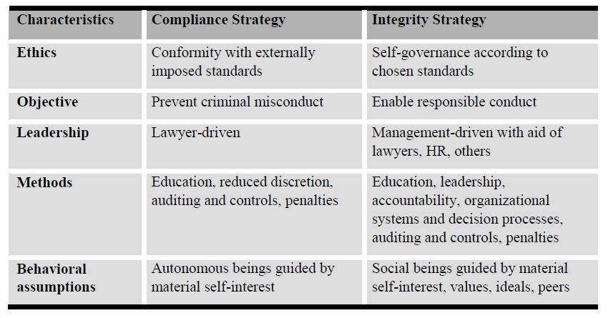
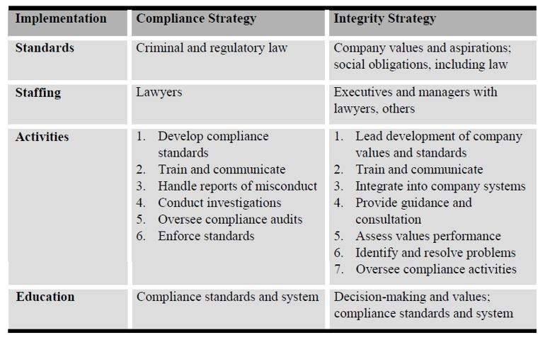
Ethical Relativism
To complicate the issue multinational organizations must deal with when deciding whether ethical behavior is judged as either right or wrong, many adopt the theory of “ethical relativism.” This concept pertains to the issue of ethics between different cultures and different geographies.
Ethical relativism is the theory that holds morality is relative to the norms of one’s culture. That is, whether an action is right or wrong depends on the moral norms of the society in which it is practiced. The same action may be morally right in one society but be morally wrong in another. For MNEs practicing the theory of ethical relativism, there are no universal moral standards (standards that can be universally applied to all its global affiliates at all times). The only moral standards against which an organization’s practices can be judged are its own. To the ethically relativist organization, there can be no common framework for resolving moral disputes or for reaching agreement on ethical matters among members of different societies. All ethical issues are resolved based on local practice.

Employee Motivation
Lesson 67 of 69
Role of HR in Employee Involvement Programs
Organizations that can get every employee involved in ensuring quality products and services can better meet customer needs, develop new markets, and become world-class competitors. HR has the crucial function of making the connection between business and quality objectives, and employee contributions to those objectives, as clear as possible.
Employee empowerment means to give employees the authority and resources they need to effectively do their jobs, without much oversight from management. Employee involvement is not possible without giving employees the power to do what they need to do. The theory behind employee empowerment is the person doing the job is best suited to make decisions regarding that job. For many employers, and especially middle managers, the idea of relinquishing control to employees has been uncomfortable. However, once put into place, managers generally find they have more power because more is accomplished by pushing tasks down the line. Managers can concentrate on planning rather than “puttingout fires.”
In some cultures, such as ascriptive or high-power distance societies, workers may become confused by empowerment initiatives as they are more comfortable taking orders.
Behavioral Science Theories
HR management can draw on a wealth of behavioral science research to understand what makes individual employees tick.
Experts agree employee motivation depends heavily on a positive work environment, sympathetic management, employee participation, and some employee control over the individual job.
In short, quality of work life (QWL) issues are important in employee motivation.Insight into the motivation needs of employees enables an employer to influence the working relationship and make everyone feel valued as individuals working toward common goals.
Reinforcement Theories (Operant Conditioning)
Another theory of motivation is behavior modification, which is based upon psychologist B.F. Skinner’s work. Instead of examining inner causes of behavior, Skinner’s theory deals with modifying external factors. An employee’s behavior, such as the performance of a specific task, can be modified by positive or negative reinforcement.
Positive reinforcement is more effective than negative reinforcement in achieving lasting change, so long as the reinforcement closely follows the behavior to be modified. Giving feedback, praise, encouragement, and recognition to employees who do a good job will motivate them to repeat the behavior.
The most important thing about using behavior modification to train and develop employees is to make certain that rewards or sanctions occur soon after the performance of the task or behavior.
Sometimes positive reinforcement can be generated by the employee, when the feeling of satisfaction from a task well done encourages the employee to perform in a similar manner (intrinsic motivation).
While money (extrinsic motivation) may seem like an incentive to do a good job, it does not appear to be connected with day-to-day accomplishments. Money is, therefore, not viewed by Skinner as an effective reinforcer.
Work Teams
Many companies find that self-directed work teams (SDT) boost productivity 30% to 50% over the long term. Team success stories have achieved more publicity than the failures, but employee work teams are not a quick fix for a company’s economic woes. Leading experts believe that employers using SDTs may not see any increase in productivity for the first 12 to 18 months after they are implemented.
Work teams can reflect the uniqueness of each company, yet they are based on a common principle: Given resources, time, and encouragement, employees can pool their ideas and experience to achieve a common goal. Teamwork can best be achieved not by just focusing on human relations, but by addressing the structures and systems of the company to prevent defects and errors.
Team-building, including virtual teams, has been defined as a process that a group of people with interrelated jobs uses for purposes of:
- Diagnosing how effectively they function as a team;
- Identifying barriers in work procedures, interpersonal relationships, and leadership functions;
- Improving team effectiveness in achieving business results or goals by reducing or eliminating barriers.
Self-directed Work Teams
Self-directed work teams, a recent innovation, may be particularly well-suited to the global HR function. Team structures have the following characteristics:
- A high level of self-determination,
- Collective control of daily activities,
- Group responsibility for solving problems and making decisions,
- Shared leadership,
- Job sharing, and
- Pay for skill attainment.
In contrast to most functionally organized HR departments, an HR function that uses self-directed work teams encourages cross-functional integration of otherwise separate HR disciplines. Clients or customers can deal with one team or one individual on a wide variety of issues, which produces more efficient service. Global work teams often have elements of both standardization and localization due to their cross-functionalization.
Job Design and Redesign
Job design involves structuring job elements, duties, and tasks to achieve effective job performance and optimal employee satisfaction. Management approaches to job design in the past were based on the concepts of employer control and operational efficiency. Today’s management approaches balance two needs: (1) the need to foster employee involvement, and (2) ownership and the need to increase productivity and improve quality.
Assessing the Need
To determine if job design is necessary in an organization, answer the following questions:
- Is the organization composed of motivated people?
- Does the organization have the flexible structure, jobs, and management that will keep employees motivated?
- Do employees have decision-making power in their jobs?
- Do employees have ready access to channels to help increase their productivity and efficiency and to improve the organization and their work?
If certain areas of the organization need job design, seek a long-term commitment from line management to change the way things are presently done and, in some instances, to give up responsibilities they currently hold. Shifting control cannot be done overnight. The mindset of both management and employees needs to be gradually transformed into a new way of thinking about work processes and management of work. The HR department should be the first to encourage a more open, less structured culture.
Common Approaches
Some of the most common approaches to job design are listed below:
- Work simplification. Work simplification gives employees direct control over the management of their work areas.
- Job enlargement. Job enlargement increases the variety of an employee’s job duties.
- Job enrichment. Job enrichment adds tasks to a job to increase the job’s complexity, challenge, and responsibility.
- Group tasking. Group tasking creates work teams to handle certain tasks and decision-making for an area of responsibility.
- Job sharing. Job sharing splits a time position so that two or more part-time employees work cooperatively to fulfill the same job responsibilities.
Lean Manufacturing & Six Sigma
Employee participation programs that are designed to improve operational performance are gaining acceptance worldwide. Lean manufacturing or lean production, which is often known simply as “Lean,” is the optimal way of producing goods through the removal of waste and implementing flow, as opposed to batch and queue. Lean manufacturing is a generic process management philosophy derived mostly from the Toyota Production System (TPS) in Japan. It is renowned for its focus on reduction of the original Toyota seven wastes in order to improve overall customer value, but there are varying perspectives on how this is best achieved.
Six Sigma is a business management strategy, originally developed by Motorola, that today enjoys wide-spread application in many sectors of industry. Six Sigma seeks to identify and remove the causes of defects and errors in manufacturing and business processes. It uses a set of quality management methods, including statistical methods, and creates a special infrastructure of people within the organization (“Black Belts,” etc.) who are experts in these methods. Each Six Sigma project carried out within an organization follows a defined sequence of steps and has quantified financial targets (cost reduction or profit increase).

International Trends
Lesson 68 of 69

More products and services are being consumed outside of their country of origin than ever before, thus increasing global competition. In addition, organizations are outsourcing offshore in order to stay competitive. Many functions are being shifted to India, the Philippines, Malaysia, Russia and other countries because of low labor costs, the availability of highly-educated workers and the stabilization of technology.
As opportunities for global expansion increase, so does the trend toward more diversity in the workplace. Successful companies are recruiting professionals with different backgrounds, cultures, styles, and motivations. Yet this great resource presents increased possibilities for misunderstanding and cultural blunders.
It is obvious organizations will need to expand the capacity for people to handle the challenges of working with other cultures if they are to participate successfully. Those companies that continue to struggle with domestic diversity will find themselves even more challenged moving forward.
Leaders must be flexible and be able to adapt to this diverse workforce and to global consumers. This requires an understanding of the historical, political, and economic references of people. Leaders must understand differences in worldviews, communication styles, ethics, and etiquette of the people they deal with, both internally and externally.
From the Global Relocation Trends Survey:
- The United States continues to be one of the world’s most challenging countries for international assignments—behind China and India, due primarily to greater delays in the immigration process, visa issues and security concerns.
- The world’s expatriate workforce is becoming increasingly female. Women account for approximately 23% of international assignees.
- Slightly more than half of expatriates are between the ages of 20 and 39.
- Only about 10% of expatriates were new hires, while 90% were employed by the company at the time of their assignment.
- Spouses accompany about 80% of married expatriates.
- Companies seeking alternatives to long-term assignments (longer than one year) are at current all-time highs (60% +). The chief reason by far was cost, cited by a strong majority of respondents.
- The most popular alternative assignment types being implemented include localizing expatriates(over half of companies), hiring local employees (half of companies), short-term assignments(one-third of companies).
- Assignment “failure,” i.e. employees not completing their assignments, is most frequently cited as a problem in China, Japan, the U.S., the United Kingdom, Saudi Arabia, and Iraq.
- The most common assignment objective is filling a skills gap, followed by launching new endeavors, and building management expertise.
- Although formal cross-cultural training was mandatory at only 20% of companies, a strong majority of respondents rated it as having great or high value in making the assignment a success.
Companies use international assignments for training and development, for cultural transfers, or to groom their executive leadership.
Rapid expansion of global enterprise, technology that enables geographically disbursed teams, the need to enhance international business relationships, the implementation of permanent or expatriate assignments, and an increasingly multi-cultural workforce are all trends that are driving global mobility.
The increasingly multi-cultural workforce calls for the development of managers who can be effective in multiple, complex, and rapidly changing environments.
In short, companies are building global leaders.
Survey data indicates the value placed on international experience. Of those who responded to the survey, a reported 24% said senior managers have completed international assignments. Also, 50% of respondents predict a 50% increase over the next five years.
A lessening of U.S. domestic transfers reveals international mobility as the real growth area, though industry watchers have seen the number of expats moving out of the U.S. decline even as expats coming into the U.S. (as well as country-to-country movement) remain steady or increase.
The face of the global workforce is changing to include more short-term and multi-country project teams, while there are continued challenges with repatriation, and problems with retention.
Cost estimates are rising, and visas and shipments are taking longer. Learning to project costs more accurately and look for ways to minimize them is critical, as is supporting the employee and family and staying in compliance with tax and immigration laws.
There are fewer fully-loaded expat packages, in fact, the need to contain or reduce costs is driving some policy changes and reductions in benefits.
From the cost standpoint, there is no magic formula that works for global transfers. Some companies say its costs three, five, or even seven times someone’s salary to move an employee, but there are many variables, many different tax situations, and many different types of services from country to country.
Employee mobility continues with companies utilizing expatriates, but not at levels that were sustained in the past.
Survey data finds the highest growth country is China for expatriate assignments.
China has opened up quickly to multinationals and this, together with its membership of the World Trade Organization (WTO), and inexpensive and plentiful labor, has made China the preferred location for foreign investors. Predictions also dictate strong expatriate growth in Central and Eastern Europe.
India has probably the greatest upside potential in expatriate growth over the long-term. The trend towards the outsourcing of call centers and administrative functions away from higher-labor cost countries should drive this emerging market in India.
More and more countries are joining the EU and growth is dynamic. With the sheer size of the union, more long-term expatriate assignments will originate from within Europe itself (cross-border assignments). However, while growth is expected to be strong in these markets, they do not hold the same potential as Asia (primarily China) and India.
Costs of international assignments are staggering. There is more interest in measuring the ROI of assignments. While cost reduction is a primary issue, there are few quantifiable and standardized ways in which to attack this problem. The vast majority of MNEs perform cost projections prior to long-term assignments and have now begun tracking short-term assignments just as vigorously.
One of the trends in cost control is the reduction in incentive premiums for long-term assignments. The complete phasing out of incentives appears impractical since they are provided as a mobility premium to sway the best candidates to accept international transfers.
The advantages of huge financial packages are also slowly disappearing as organizations move towards equalizing terms and conditions between expatriates and locals. In the future, fewer and fewer people will be career “expats.”
Great emphasis continues on the selection and retention of expatriates. MNEs expend a tremendous investment throughout the assignment and retaining these highly trained and experienced individuals is a paramount global strategy issue.
Diversity initiatives within the assignee community have been largely unsuccessful to date. Spousal assistance while on assignment is one approach companies are addressing to combat this lack of diverse growth.
Assignment refusal due to spousal concerns (managing dual careers) is still the number one refusal reason.
Research shows the most common mobility incentives include job hunting, spouse assistance, retaining search firms, work permit assistance, training, allowance for professional development, lifestyle allowance, childcare, and discretionary allowance.
With the great emphasis on cost reduction, it is not surprising to find the research indicates MNEs are utilizing permanent transfers more often.
With a home-based compensation package employed in the majority of short-term assignments, it is much more cost-effective to transfer the assignee to the local market rate when possible. This occurs most frequently in non-challenging assignments to favorable geographies and is usually employee precipitated.
Labor Trends
Several European and Asian countries are reporting lower birth rates among its population (Russia, China, etc.). This trend, combined with sub-par nationalized healthcare systems and a greater reliance on older workers, will result in fewer qualified younger workers in the future.
This potential lack of available workers will put Russia, China, and other countries in a position that sustainable economic growth will not be possible without an infusion of talent from other countries (immigrants). Further, this phenomenon will present challenges to implement and maintain productivity gains in their respective marketplaces.
Additionally, the availability of qualified workers in some countries will be affected by the current drop-out rates among higher education enrollees. The United Kingdom (UK) for one is reporting the lowest participation rates in secondary and post-secondary education in recent decades. Currently, the UK ranks the lowest among EU member states. This trend, if not reversed, will potentially leave the UK in a weakened position in regards to staffing its industrial and service organizations with qualified manpower.
The resulting indication of the above trends leads to the belief that some of these countries will have less of a local-labor force capability to meet the demands for a highly-educated, high-tech workforce. MNEs, doing business in these countries, may have to rely on globalists to fill the staffing needs. This will not be cheap.
Trends Summary
The success of MNEs continues to rely upon the need to move key individuals internationally. The above trends lead the Global HR Manager to the conclusion that future trends in staffing, compensation, training, and employee relations will prove challenging. New methods of attracting, developing, and retaining qualified personnel will have to be adopted for specific countries and regions of the world.
MNEs will have to look beyond their current selection practices in order to fulfill vacancies. Traditional approaches need to change so they facilitate greater diversity in the profile of internationally mobile employees.
Cost reduction persists as a key objective. This in turn impacts upon the choice of assignment type. Continuing growth in assignment numbers highlights the need to reduce costs and look towards a more effective approach to remunerating the expatriate. One way to reach this goal is the use of a variety of policies whereby individual policies more closely reflect the reasons for (and needs of) specific assignments.
Using local employees, where possible, is crucial to limit expatriate numbers, but it is recognized that international assignees can provide critical knowledge and experience in a new business or location and have a key role to play in knowledge transfer.
What companies are now doing is ensuring that they have the process in place to either repatriate or localize the assignee at the end of the initial assignment period or using short-term assignments rather than the traditional, more expensive long-term assignments.

