A Novel Hybrid Approach to solve Raw Material Collecting Vehicle Routing Problem
Anurag Tiwari¹, Priyabrata Mohapatra² , Chann Pie Chang³
¹Department of Operations Management, Indian Institute of Management, Rohtak, Haryana, India
³School of mechanical engineering, KIIT University, Odisha, Bhubaneswar
²Zhuhai College of Beijing Institute of Technology

Abstract
Semiconductor Manufactures are largely grown industry which contribute considerable amount in global economy. Presently one fourth of the research belongs to process industries. Supplier Selection and Raw material collection is one of the major concerns for the semiconductor packaging industries because of increasing raw material cost. In Semiconductor Industries, firms require different kind of raw material, thus the requirement of a robust logistic model is required for raw material collection. In this paper, we formulate this problem as the raw material collection vehicle routing problem (RCVRP) with an objective to minimize the total raw material collection cost. This problem can be useful for two different aspect in semiconductor industries, one raw material (Silicon, Germanium, Gallium Arsenide, Silicon Carbides) collection for semiconductor manufacturing, second the raw material (metal, chip,) packaging of electronics equipment. Practically Manufacturing industries prefer the supplier which are more profitable to them, that they can select supplier according to their preference, Thus we added, one interesting phenomenon to proposed problem is that, there is no compulsion to visit all suppliers. To guarantee the demand of semiconductor industries, all visited suppliers should reach a given raw material capacity requirement. To solved proposed (Raw Material Collection Vehicle Routing Problem (RCVRP), we developed a Novel Hybrid approach that is a combination of block recombination approach and Edge recombination Approach. Main reason for using this approach that, Edge assembly approach provide very promising result in finding the optimal route for travelling sales man problem. To avoid the biasness, we have compared proposed methodology results with other known approaches such as genetic algorithms (GAs) and Ant colony optimization (ACO). From the Computational result we can suggest that, the developed optimization approach has the promising future.
Keywords: GA, RCVRP, HERA, VRP, SCM
- Introduction
Presently we are living in the semiconductor age. The entire electronics product in our daily life is manufactured using semiconductor. Semiconductor manufacturing plays a very big share in manufacturing sector. The market of semiconductor industries increased by more than 300 billion USD around the world. Electronics products industries are most energy intensive, so it needs to be highly ecofriendly and energy structured. The biggest challenge of these industries are the complexity of integrated circuits manufacturing and the role of global competitiveness in their production. The main raw material used in semiconductor devices is Silicon, Germanium, Gallium Arsenide, Silicon Carbides. These raw materials are required for semiconductor industries and most of the cases these material are not available at same place. Movable devices such as Mobile phones, iPod, iPad and portable music players are tending towards the transforming of more comprehensive packaging material. There is lack of appropriate technology that can accumulate all requirements or needs. To reduce the manufacturing cost, Quad Flat-pack No-lead (QFN), wire bond ball grid array (BGA), and CSP are generally observed commodity. Several metals (Gold, Aluminum, and Copper) are widely used in packaging. The cost of these raw materials is very high. The semiconductor manufacturing industry in Taiwan identified as a most successfully structured for its highly efficient, quality and flexibility. Same is applicable in case of Integrated circuit packaging, the extremity of IC manufacturing process, (kang et al, 2012). According to Lara and Dan Tracy(Semiconductor Materials: Record Volumes, Record Revenues) export of Semiconductor Device shipments in 2003 increased by 2000 levels but due to small pricing the industry expected revenue wasn’t achieved by 2000. Semiconductor industries continue shipping more devices every year since 2003with compromise selling price (Figure1).
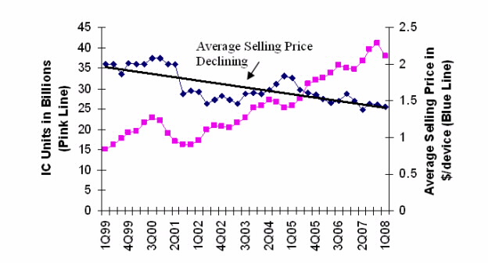
Fig1: IC Unit Shipment and Pricing Trends
Device Manufactures are not only one area to experiencing price pressure, Figure (2) illustrated the downwards pricing pressure on devices (IMF, Base Year of Index=2005, WSTS, SEMI SMG)
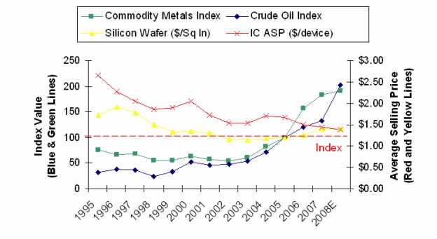
Fig2: Raw Material and Pricing
In earlier section, rising raw material cost are a major challenge to material supplier and their customers. This has spurred development efforts either to reduce the amount of material (metal) used or reduce the raw material cost by some other techniques. In this paper our motive is to reduce the total raw material cost by minimizing the total travelling cost. In this competitive environment firms requires variety of raw material at the same time with minimum cost. Specific Raw materials collections are an important part in a supply chain of the semiconductor industry. A supply chain is a network of suppliers manufactures, warehouse and distribution centers organized in such a way that customers gets maximum benefits. Supply chain network can be grouped into three stages: supplier stage, plant stage, and distribution stage (Erenguc and Simpson 1999). Supplier stage consists of all important raw materials to the manufacturing. The key part of SCM is the transportation of material between the various centers, like between suppliers to manufacturers, manufactures to warehouses and warehouses to customers. Lee (2001) proposed a supply chain model for the semiconductor industry of global market. The philosophy of Kanban is that parts and materials should be supplied at the very moment they are needed in the factory manufacturing process, Chai (2008). Mostly researcher’s objective is to minimize the total transportation cost, time and increased the reliability of network where as we want to use raw material collection is our primary goal.
- Literature Review
Vehicle routing problem is essential part of supply chain management, which plays an effective role in current manufacturing and logistic industries. Over past few decades, VRP and its variant gains enough attentiveness from researcher. A classical Vehicle routing problem having a single depot with certain number of correspondent vehicles with constant capacity, and a set of customers with known demands. The Primary objective of classical VRP is to minimize total cost by minimizing total travelling distance travelled by vehicle. Researchers have proposed many variant of vehicle routing problem such as Capacity vehicle routing Problem (CVRP) Laporte at al. (1986) , distance constrained vehicle routing problem(DVRP), Laporte et al(1987), vehicle routing problem with time window(VRPTW), Solomon.(1987), Desrochers et al (1992). Puchinger & Richard done a survey on dynamic and stochastic vehicle routing problem. Laporte et al. (1992) proposed a class of asymmetrical vehicle routing problems. Slim Belhaiza (2014) developed vehicle routing problem with multiple time windows. Dhaoui et al. (2014) proposed a bi-objective two-dimension loading vehicle routing problem with partial conflicts. Thibaut Vidal (2013) developed proposed a large class of vehicle routing problems with time-windows. The two-echelon vehicle routing problem with covering options: City logistics with cargo bikes and parcel lockers developed by David L.J.U.Enthoven (2020).
The vehicle routing problem is augmented by several constraints such as capacity constraint, demand satisfaction. Vehicle routing problem and its variant are complex problem because of its large size, so these problems are not easy to solve by exact methods. Researcher came with different heuristic and natural inspired algorithm to solve such kind complex vehicle routing problems. David Pisinger(2007) proposed A general heuristic for vehicle routing problem. Baker and Ayechew, (2003), Prins (2004) proposed an evolutionary algorithms for the VRP. Wang and Zhang. (2009) proposed a hybrid genetic algorithm to solve capacitated vehicle routing problem. Two-echelon multiple vehicle location of sustainable supply chain network of perishable food was developed by Kanan et al. (2013).Tiwari and Chang (2014) developed a recombination approach to solve GVRP. In this paper they used each cluster as a block and used recombination approach to find the optimal sequence. A route improvement algorithm for the VRP with time dependent travel times developed by Figliozzi (2009). Clarke and Wright (1964) worked on problem related to scheduling of vehicles with a central depot and number of delivery points. Mutha and Pokharel (2009) developed a strategic network for reverse logistics and remanufacturing having new and old product modules. Pisinger and Ropke (2007) proposed a general heuristic for vehicle routing problems. Prins et al. (2009), proposed a tour splitting algorithm for vehicle routing problems.

Selecting the suppliers is and order quantity has been a challenge for companies. Researcher have done enough work in the field of vendor selection (Weber et al., 1991; Weber and Current, 1993; Pan, 1989; Verma and Pullman, 1998; Yahya and Kingsman, 1999). Pongallu et al. (2012) proposed an Automation of Raw Material Transfer Process from Quarry to Silos in Cement Plant. Zhen and Tang (2003) have derived a multi-objective model for purchasing of bulk raw materials for a large-scale integrated steel plant. He described about purchasing of bulk raw materials of a certain large-scale steel plant in a sequence that how to select the vendors and amount of material required from one vendor. Coelho et al. (2016) developed an integrated CPU-GPU heuristic inspired on variable neighborhood search for single vehicle routing problem with deliveries and selective pickups. An improved petal heuristic for the vehicle routing problem proposed by Renaud et al. (1996).
The paper has been arranged in this manner that, section 3 presents the Mathematical formulation description and notation section 4 presents the proposed Novel Hybrid recombination approach, section 5 describe the result and discussion section 6 describe the conclusion and section 7 is the used reference.

3. Problem Statement:
RCVRP is a variant of vehicle routing problems which is quite similar to price collecting vehicle routing problem. In (2006) Wang and Tang have proposed an iterated local search algorithm which is based on very large-scale neighborhood for PCVRP. In proposed problem, we have consider a set of suppliers with different raw material supply capacity. An important phenomenon of proposed model is that all supplier need not to be visited compulsory but the total demand of the firms should be fulfill. The benefit of the raw material collecting vehicle routing problem is that we can select the supplier according to available raw material. If a supplier can provide the required raw material then firm don’t need to visit second supplier. We have taken one assumption that a single Vehicle can carry different kinds of raw material with the help of different container.
The main objective is to reduce the total travelling cost of the raw material collection by minimizing the total travelling distance from supplier to firm. We have minimized the total number of vehicle and at the same time fulfill the total demand of the firms. We proposed a novel hybrid approach to solve to solve the proposed problem. To generate the initial cluster we used an angle based approach. In this approach we select the supplier both clock wise and anti-clock wise based on truck capacity and requirement. Number of cluster is equal to the number of vehicle used. Initially the length of a chromosome is the combination of all clusters, further we treat each cluster as classical travelling salesman problem. We used Edge recombination approach to solve these small TSP problems. Edge recombination approach (ERX), Nguyen et al. (2002) is one of most frequently used approach to solve the travelling salesman problem. Nguyen suggests that ERX converge much faster and it provides better results for generating initial tour. To provide the best sequence of the solution we used block recombination techniques to find the best solution.
According to Figure 3 if a firm have ten different suppliers with certain availability of different kind of raw material and two trucks with certain capacity. We select the best sequence of supplier by which we can fulfill the firm demand and avoid the extra travelling distance. Further,

Fig3 Raw Material Collection Model
P3-520
P2-400
P1-80
Truck capacity-1000
 | Product Need | Product available
P1 | 450 | 500
P2 | 750 | 800
P3 | 800 | 850

P1-120
P2-350
P1-250
P3-280
P2-100
P1-50
P3-80

  - Mathematical Formulations
This problem is a variant of vehicle routing problem. The Primary objective of this paper is to find an optimal sequence to collect different kind of raw material using minimum number of vehicle with minimum distance. We consider that each vehicle used have a certain amount of minimum and maximum capacity and they collect the goods from multiple suppliers and return back to the depot area. In the proposed problem all the supplier need not to be visit compulsory. We have assume that the firm need four different kind of raw material from different suppliers, and a single vehicle can collect four different kind of raw materials at the same time. The mathematical model of proposed model is as follows
3.2 In proposed problem, we considered suppliers with different supply capacity and all the raw material collected by a single firm by m number of vehicles. Problem parameter are defined as follows:
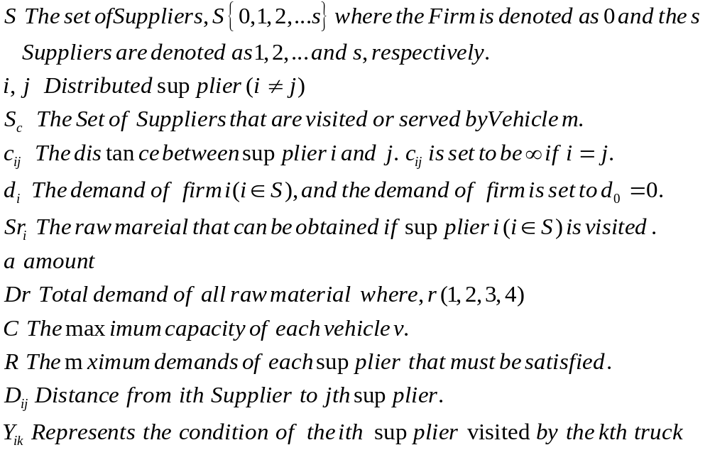
3.3 Decision Variable
K the number of vehicle used in the solution, 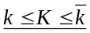.
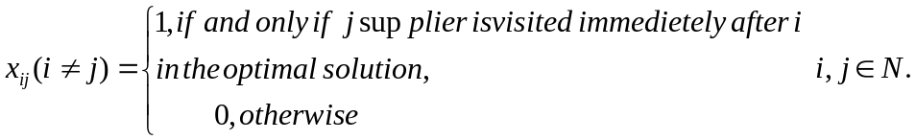
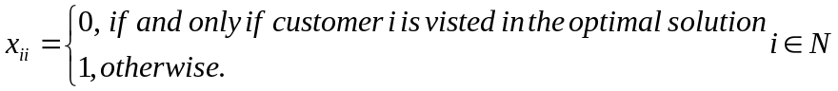
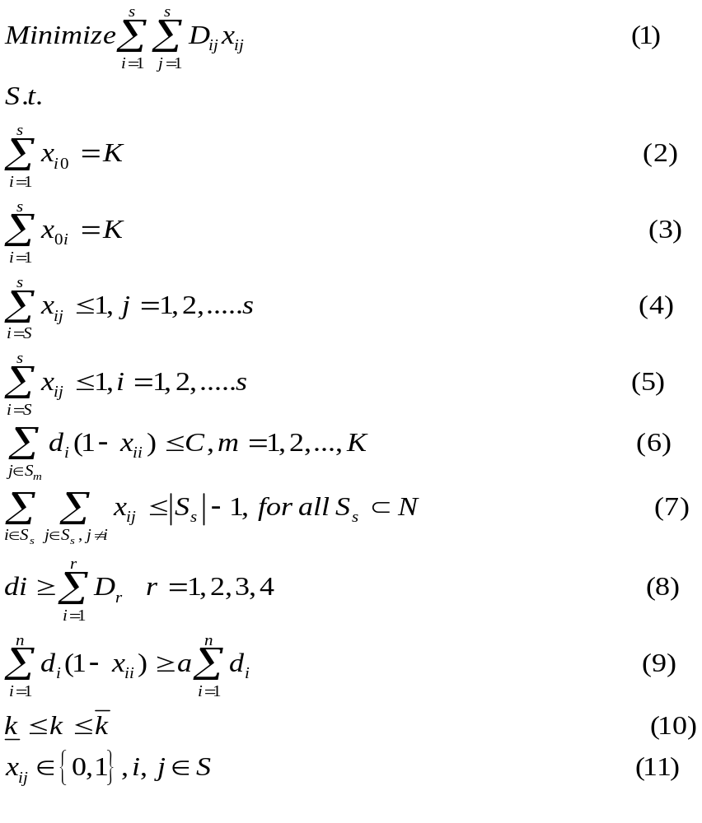
Objective of the proposed problem is to find the minimum distance travelled by vehicle is represented by equation (1). , According to definition of classical vehicle routing problem vehicle should start from firm and finish its tour at firm (Starting Point), represented by equation (2, 3). Equations (4, 5) represent that each supplier should be visited only once by at most one vehicle. Equation (6) represents the demand and capacity constraint of vehicles. Equation (7) try to eliminate the sub-tours travelled by each vehicle route. Equation (8) represent the demand of different material cannot exceed the total demand of firm. Equation (9) represents that the demand of firm should be fulfilled by visited suppliers. Equations (10, 11) are the bound and the integrity condition on the decision variables. In this paper we have assume that one truck can contain different material at the same time and it can visit the next supplier to collect the other raw material

- A Novel Hybrid Approach
This paper represents a new class of vehicle routing problem. Vehicle routing problems are complex problem and researcher derived various heuristic method to solve such kind of complex problems. To find the better route, we proposed a new novel hybrid approach that is combination of edge recombination approach and block recombination approach. We used a capacity and demand based allocation scheme to generate the initial cluster. In this problem initial chromosome is a combination of clusters formed by capacity and demand allocation method. First we select best 25 chromosome and use Edge recombination approach to find the optimal sequence. The flow diagram of proposed hybrid edge recombination approach is as shown in Figure 5. Following figure 4. Shows the Pseudo Code of proposed approach

1 select the supplier in both direction by using the polar angles.

2. Generate initial set of chromosome based on truck capacity.

3. For i=0 to every initial set of chromosome

4. For j=0 to every cluster

5. Create the initial chromosome using NEH approach.

6. End for

7. End for

8.//Reverse order

Arrange the initial set of chromosome in reverse order.

9. Repeat the steps 5 to 8.

10 Combined the entire cluster to form the final chromosome.

12. Use edge recombination approach for all individual clusters to find better chromosome.

13. Determine the final fitness value.

14. End

Figure 4: Pseudo Code of Proposed Methodology
Fig. 5: the Flow diagram of the block recombination approach
Start
Start cluster form random city
Select city according to the products requirement
If vehicle capacity reached
If total vehicle count reached
Store a chromosome
Run TSP in each cluster
If total chromosomes count reached
Find best chromosome
End
Yes
No
No
No
Yes
Yes
4.1Arrangement of the supplier according to angel: Chung-Ho Wang et al. (2009) developed a hybrid genetic algorithm (HGA) for CVRP. They used an angular approach to generate the initial clusters. In this proposed method, we combined the approach with truck capacity and demand allocation, to find the initial sequences. According to definition of proposed problem it is not compulsory to visit all the suppliers, so, once the demand of firm satisfied, vehicle can complete its tour and return to firm. It is important to determine the coordinates (X, Y) for clustering the city according to angel. The X, Y coordinate for all the suppliers relative to their firm are calculated as follows:
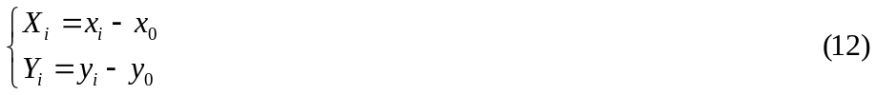
Where 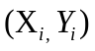the x and y is coordinates of the ith distribution point relative to the depot 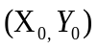is the coordinate of the depot and 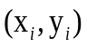is original coordinated of x and y for the ith distribution point.
4.2 Generate the Cluster based on axial clustering and capacity allocation

Chung-Ho Wang (2009) derived the formula to calculate the polar angel of different distribution points. Fallowing are formula to find the polar angel. 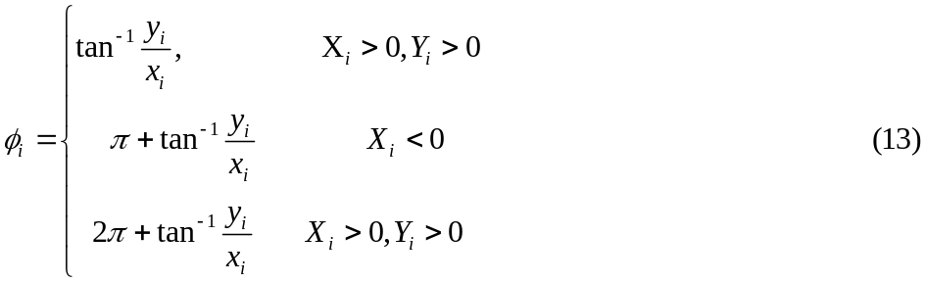
represents the polar angel of the ith distribution point. To generate the better clusters we sorted the distributions points in both ascending and descending order. Sorting of distribution points should be based on calculated from equation (13). The polar angel should be as follows:
In this proposed problem, we consider truck capacity and supplier capacity as an important factor, so, while generating the initial chromosome capacity should be priorities. We have an assumption that each vehicle have a minimum and maximum capacity limit. Once we get the distribution point, we arrange the distribution points based on capacity allocation, we used NEH method to find two consecutive distribution points. Wang and Lu (2009) derived the formula (equation 15) for capacity allocation of the distribution points.
Where C represents the vehicle capacity constraint, 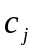 is the demand of the jth distribution points, k is the number of vehicle, is the last distribution point before the depot.
Fig. 5: Representation of supplier’s selection based on Polar angel
4.3. Calculation the limit of truck capacity based on product and demand
We have some assumption regarding to calculation of truck limit. The assumptions are as follows. Chu et al. (2005) developed a heuristic approach to assign the truck load for truckload and less-than-truckload problem.
Limit Calculation
Step1:
Pre-limit of = vehicle capacity * (number of vehicle – 1).
Limit = All required product size – prelimit.
Example
Number of vehicle = 4.
Prelimit = 180 * 3 = 540.
All required product size = 140 +130+200+210=680.
Limit=680-540=140.
Step2:
Tempsize = All required product size – finished vehicle’s size
Prelimit = vehicle capacity * (number of vehicle – finished vehicle count) – 1).
Limit = Tempsize – prelimit.
Example
Tempsize = 680 – 160 = 520.
Prelimit = 180 *((4 – 1) – 1) = 360.
Limit = 520 – 360 = 160.
Continue step 2 till last vehicle required.
4.4. Pseudo code to calculate the limit of each truck
Find next city.

If next city’s weight <= vehicle capacity
{
If vehicle have crossed limit and randomly chosen number <50
Finish vehicle
Else
If next city’s weight < required product size
Add that city in new vehicle
Else If next city’s weight > required product size
Add that city in new vehicle
Delete entire city related to that city by product wise
}

Else if vehicle capacity not empty
{
If vehicle have crossed limit
Finish vehicle
Else If vehicle capacity < required product size
Add that city in new vehicle
Finish vehicle
Else If vehicle capacity > required product size
Add that city in new vehicle
}

  - Initial Chromosome Generation
In the proposed methodology, we generate initial chromosome by combining the different clusters. Process of combination is by arranging clusters from first to last cluster based on truck capacity and availability of materials from supplier. The size of initial chromosome is depends on number of vehicle used to collect the raw material. Following Fig6 explain the process of generating the Initial Chromosome. Figure (6) represents individual cluster, which represents a complete tour by a single vehicle. For example cluster 1 represent the tour of truk1, cluster 2 represents the tour of truck2 respectively. Combination of all clusters represents the final chromosome. A final chromosome represents that the set of visited supplier.
5 11 6 4 10
7 9 12 1 13
14 3 2 21 15
25 19 16 20 8
18 17 23 24 18
CL1
CL2
CL3
CL4
CL5
C4
C5
Cluster 1
Cluster2
Cluster3
Cluster4
Cluster5
Fig6. Artificial Chromosome
5 11 6 4 10 7 9 12 1 13 14 3 2 21 15 25 19 16 20 8 18 17 23 24 18
CL1
CL2
CL3
CL4
CL5

4.6. Edge recombination Approach to find better cluster
Edge recombination crossover approach is commonly used to solve the best sequence for travelling salesman problem (TSP) using genetic algorithm. It preserves the edge information between parent tours. Strakweather proposed (1991) proposed an enhancement to the edge recombination operator by preserving common edges of the parent tours. Steps of edge recombination operator are as follows.
Step1. Identify the two parents as a parent 1 and parent 2. Select the segment of parent 1 to the offspring (The length of this segment is selected to be one fourth of the number of supplier in the tour and starting point of the segment is selected randomly.
Step 2 we make an edge map by collecting the information of edge in parent2 and the part of parent 1 not copied to the offspring.
Step3. Set the last supplier of the inherited segment in the offspring to be the current supplier.
Step4. Take-down of all happening from the current supplier in all the edge lists.
Step5. If the present supplier consists an elements in its list go to step6; otherwise got to step 8.
Step6. If there are negative elements (shared edges) in the edge list of the present supplier, choose one to be the current supplier. Ties are broken at random if more than one shared edge is available. Go to step 4, if there are no shared edges then go to step7.
Step7. Determine the supplier from the edge list of the present supplier which is nearest to the current supplier. The nearest supplier becomes the current supplier. Go to step 4.
Step8. If all suppliers are visited, then END. Otherwise, select an unvisited supplier which is nearest to the current supplier. Ties are broken at random if the two nearest suppliers have the same distance from the current supplier. Go to step 4.
There are some chances of an edge failure, when there are no edges in the edge list of the current supplier. A new edge has to be introduced that is not found in both parents, such edges are referred to as foreign edges.
  - Recombination of the cluster
In recombination of cluster, initially we created 100 chromosomes and measure the fitness value of every chromosome. We sort the chromosome based on their fitness value and selected best 20 out of 100 chromosome for the recombination techniques. We assign the number (Name) to entire cluster and measured the fitness value of individual clusters. We selected the individual cluster with less fitness value and placed it according to their number. Recombination used to generate the best chromosome with lesser fitness value. As shown in figure (7), we used different combination for each cluster and recombine them according to the minimum fitness value. Final chromosome represents the combination of all cluster with minimum fitness value.
4 5 6 10 11 9 7 12 13 1 2 3 14 15 21 8 16 19 20 25 24 21 23 17 18
1
2
3
4
5
4 10 11 6 5 7 9 13 12 1 2 3 15 21 14 16 25 8 25 20 21 23 17 18 24
4 5 10 6 11 9 7 12 1 13 2 3 15 14 21 8 16 20 19 25 23 21 24 17 18
11 10 5 4 6 13 9 12 7 1 21 3 15 14 2 25 19 16 8 25 18 21 23 17 24
11 6 5 4 10 12 9 7 13 1 21 3 14 15 2 8 19 8 16 25 18 23 24 21 17
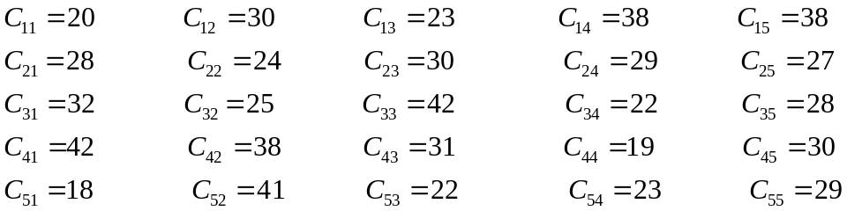
11 6 5 4 10 9 7 12 1 13 21 3 14 15 2 25 19 16 8 25 21 23 17 28 24
Figure (7) Final Artificial Chromosome
1 2 3 4 5

- Results and Discussion
To judge the performance of our proposed approach we have generated the set of test problems based on vehicle routing problem (OR Library). We have considered the customers as a supplier in proposed problem. Each supplier has a certain limit of raw material that they can supply and we generate the supplier capacity randomly. One of the assumption we took while we generate supplier point that a single supplier can provide only one kind of raw material. We have generated three different kind of instances based on the vehicle used in problem and each truck can collect 4 different raw materials. In every instances firms have different demands. We compare our results with well know evolutionary algorithm Genetic algorithm and Ant Colony optimization (ACO). For fare comparison, we used the same size of population and same number of iteration. The population size of problem is assigned 100 and number of iteration used for each instances is 100. The crossover probability is 0.1 and mutation probability is 0.01.
As shown in Table 1. We have run the algorithm on all possible instances. The minimum number of vehicle has been used in this problem. The data sets used in the table1, table2 and table 3 are different. We run the result for different number of vehicle and different demand. As shown in table 1 the results obtained from proposed approach perform better than that GA and ACO. From the table it’s clear that the proposed approach minimize the travelling distance more and it’s close to optimal result. For example instances E-n484-K-12_P4, number of suppliers are 484, and total demand of firm is 6000. Each product have different requirement. For this instance firm used 12 vehicles to collect all the raw material.
Table 1 Result Comparison
Instance | vehicle | demand | HERA  Solution  (Distance) | GA  Solution  (Distance) | ACO  Solution  (Distance)
E-n22-k4-p4 | 4 | 180 | 362.1738 | 380.1623 | 371.2124
E-n30-k4-p4 | 4 | 875 | 518.1104 | 560.2251 | 545.8575
A-n32-k4-p4 | 4 | 1140 | 844.4474 | 920.6002 | 1095.545
A-n44-k4-p4 | 4 | 5000 | 791.5521 | 895.4617 | 915.5285
A-n54-k4-p4 | 4 | 2000 | 893.8654 | 1002.139 | 960.315
E-n51-k4-p4 | 4 | 2000 | 464.4865 | 513.1548 | 498.5352
E-n76-k4-p4 | 4 | 2500 | 528.5642 | 594.1824 | 598.7815
E-n101-k8-p4 | 8 | 2125 | 813.6919 | 927.3654 | 942.5446
G-n262-k8-p4 | 8 | 5000 | 3190.466 | 3605.376 | 3525.2141
E-n484-k12-p4 | 12 | 6000 | 1021.569 | 1247.17 | 1245.5294

As shown in Table2 the number of number of truck increased for each instances. We have run the algorithm on all possible instances. The minimum number of vehicle has been used in this problem.

Table 2 Result Comparison
Instance | Vehicle | demand | HERA Solution  (Distance) | GA Solution  (Distance) | ACO  Solution  (Distance)
E-n22-k5-p4 | 5 | 144 | 440.6919 | 473.7032 | 468.6012
E-n30-k5-p4 | 5 | 700 | 645.6504 | 743.9658 | 745.8575
A-n32-k5-p4 | 5 | 910 | 978.3344 | 1256.362 | 1245.541
A-n44-k5-p4 | 5 | 4000 | 879.7185 | 1056.222 | 944.5235
A-n54-k5-p4 | 5 | 1600 | 965.3325 | 1152.135 | 1012.515
E-n51-k5-p4 | 5 | 1600 | 495.1256 | 569.1473 | 560.5532
E-n76-k5-p4 | 5 | 2000 | 574.1907 | 619.6911 | 628.7845
E-n101-k9-p4 | 9 | 1888 | 854.5004 | 1024.842 | 952.5446
G-n262-k9-p4 | 9 | 4277 | 3339.701 | 3905.115 | 3645.2141
E-n484-k15-p4 | 15 | 4700 | 1172.949 | 1356.254 | 1245.5254

As shown in Table3. We have tested our results with more number of vehicle and different capacity. We have run the algorithm on all possible instances. The minimum number of vehicle has been used in this problem.
Table 3 Result Comparison
Instance | Vehicle | Demand | HERA Solution  (Distance) | GA Solution  (Distance) | ACO  Solution  (Distance)
E-n22-k6-p4 | 6 | 120 | 490.6419 | 503.1613 | 495.2514
E-n30-k6-p4 | 6 | 583.34 | 735.808 | 845.5742 | 785.9582
A-n32-k5-p4 | 6 | 760 | 1107.306 | 1541.066 | 1343.1514
A-n44-k6-p4 | 6 | 3333 | 991.9741 | 1236.66 | 1007.2451
A-n54-k6-p4 | 6 | 1335 | 1126.982 | 1431.188 | 1312.513
E-n51-k6-p4 | 6 | 1333 | 535.3689 | 645.3216 | 745.2451
E-n76-k6-p4 | 6 | 1666 | 604.053 | 712.1459 | 710.2451
E-n101-k10-p4 | 10 | 1700 | 926.351 | 1057.698 | 955.6314
G-n262-k10-p4 | 10 | 3850 | 3507.191 | 4089.255 | 38.1451
E-n484-k18-p4 | 18 | 4000 | 1346 | 1589.166 | 1421.1214

- Conclusion
In this paper we have proposed a Novel hybrid approach to solve raw material collection problem for semiconductor industries. Most of the manufacturing industry requires raw material at cheapest cost, so we have formulated a raw material collecting problem which is variant of classical VRP. In this problem vehicle don’t need to visit all the suppliers but they need to collect all the required amount of material from suppliers. We have proposed a novel hybrid approach to solve the problem of raw material collection by using an angle and truck capacity based approach to find the best cluster and edge recombination approach to develop the artificial chromosome. As shown in above result, our proposed approach provides a better sequence. It can be concluded that the proposed technique can be used in real life problem at it’s applicable for all set of problem. In future we want to design a problem by which we can manage the deliver the goods and collect the raw material at the same time. That will save more travelling cost and will minimize the total cost of the products. For future research we can increase the complexity of problem by increasing the number of required product as well as we want to implement this model for multi depot vehicle routing problem.
- Reference
Baker, B. M., Ayechew, M. A. (2003). A genetic algorithm for the vehicle routing problem. Computers & Operations Research, 30, 787–800.
Chai L.S. Linton , (2008), “ E based inter-enterprise supply chain Kanban for demand and order fulfillment management” IEEE Conference, 1,33-34.
Chu C.W., (2005) A heuristic algorithm for the truckload and less-than-truckload problem. European Journal of Operation Research 165(3):657–667.
DavidL.J.U.Enthoven, Bolor Jargalsaikhan Kees Jan Roodbergen, Michiel A.J.uithet Broek, Albert H.Schrotenboer, (2020), The two-echelon vehicle routing problem with covering options: City logistics with cargo bikes and parcel lockers, Computer and Operation Research, 2020, Volume 118,
David Pisinger , Stefan Ropke, (2007) A general heuristic for vehicle routing problem, Computer and Operation Research, Volume 34, Issue 8,
Desrochers M, Desrosiers J, Solomon M (1992) A new optimization algorithm for the vehicle routing problem with time windows. Operation Research 40,342–354.
Dhaoui K. H., Labadie N., Yalaoui A, (2014), The bi-objective two dimensional loading vehicle routing problem with partial conflicts, International Journal of Production Research, 19,52, 5565-5582.
Errngue S.S, Simpson N.C, Vakharia A. J., ( ,1999)” Integrated production/distribution planning in supply chain: an invited review”, European Journal of Operation Research, 115 pp. 219-236
Figliozzi, M. A., (2009), A Route Improvement Algorithm for the Vehicle Routing Problem with Time Dependent Travel Times. In: Proceeding of the 88th Transportation Research Board Annual Meeting CD rom.
Kanan G., Ahmad J., Roohollah K., Devika, K., (2013). Two-echelon multiple-vehicle location-Routing Problem with time windows for optimization of sustainable supply chain network of perishable food. International Journal of Production Economics, 152, 9-28.
Kang He Yau, Lee, H, .I., Amy, Yang C.Y.2012”A fuzzy ANP model for supplier selection as applied to IC packaging “Journal of Intelligence Manufacturing , 21, 1477-1488.
Khaligh H., MirHassani S.,A., (2016), A mathematical model for vehicle routing problem under endogenous uncertainty, International Journal of Production Research, 2, 52, 579-590.
Laporte G, Mercure H, Nobert Y (1992) A branch and bound algorithm for a class of asymmetrical vehicle routing problems. Journal of Operation Research Society (43), 469–481.
Laporte G., Mercure H., Tailiefer S. (1987) A branch and bound algorithm for the asymmetrical distance constrained vehicle routing problem. Math Model 9, 857–868.
Laporte G, Mercure H, Nobert Y (1986) An exact algorithm for the asymmetrical capacitated vehicle routing problem. Networks 16, 33–46.
Lee Y.H., (2001), Supply Chain Model for the semiconductor Industry of Global Market, Journal of System Integration, 10,189-206
Nguyen, H.D. Yoshihara I. Yasunaga M., (2000), Modified edge recombination operators of genetic algorithm for the travelling salesman problem, IECON Proceeding (Industrial Electronics Conference), 4, 2815-2820.
Pan, A.C., (1989). Allocation oforder quantity among suppliers. Journal of Purchasing and Materials Management 25 , 36–39.

Pokharel S., Mutha, A., (2009). Strategic network design for reverse logistics and remanufacturing using new and old product modules, Computers & Industrial Engineering, 56. 334–346.
Prins, C. (2004). A simple and effective evolutionary algorithm for the vehicle routing problem. Computer and Operations Research, 31, 1985–2002.
Prins C., Labadi N., Reghioui M., (2009), Tour splitting algorithm for vehicle routing problems, International Journal of production Research, 2, 47, 507-535.
Pisinger D., Ropke S., (2007), A general heuristic for vehicle routing problems. Computer and Operation Research 34(8): 2403–2435.
Puchinger, Harti F. Richard , (2016) A survey on Dynamic and stochastic vehicle routing problems, International journal of production research, 1.54. 215-231.
Pongallu D.R., Zope P.H., Suralkar S. R., (2012)Automation of Raw Material Transfer Process from Quarry to Silos in Cement Plant, International Journal of Modern Engineering Research (IJMER), Vol. 2, (6), 4287-4291.
Renaud J., Boctor F.F., Laporte G (1996) An improved petal heuristic for the vehicle routing problem. Journal of Operation Research Society 47, 329–336.
Slim Belhaiza , Pierre Hansen , Gilbert Laporte , (2014), “A hybrid variable neighborhood tabu search heuristic for the vehicle routing problem with multiple time windows” Computers & Operations Research, 52 pp. 269-281,
Solomon M M (1987) Algorithm for the vehicle routing and scheduling problem with time window constraints. Operation Research, 35 (2)254–265.
Tang L., Wang X.,(2006), Iterated local search algorithm based on very large-scale neighborhood for prize-collecting vehicle routing problem, International Journal of Advanced Manufacturing Technology 29, 1246–1258.

Thibaut Vidal, Teodor Gabriel Crainic , Michel Gendreau, ChristianPrins(2013) “A hybrid genetic algorithm with adaptive diversity management for a large class of vehicle routing problems with time-windows”, Volume 40, Issue 1,
Tiwari A., Chang P.C. (2015), A block recombination approach to solve green vehicle routing problem. International Journal of Production Economics, 164, 379-387
Wang X. and Tang L. (2006), Iterated local Search algorithm based on very large scale neighborhood for prize-collecting vehicle routing problem, International Journal of Advanced Manufacturing Technology, 29 , 1246-1258.
Wang, H.F., Zhang, Y. Y., (2009). A hybrid genetic algorithm that optimizes capacitated vehicle routing problems. Expert Systems with Applications, 36, 2921–2936.
Weber, C.A., Current, J.R., (1993). A multi-objective approach to vendor selection. European Journal of Operational Research 68,173–184.
Weber, C.A., Current, J.R., Benton, W.C., (1991). Vendor selection criteria and methods. European Journal of Operational Research 50, 1–17.
Verma, R., Pullman, M.E., (1998). An analysis of the supplier selection process. Omega 26 (6), 739–750.
Yahya, S., Kingsman, B., (1999). Vendor rating for an entrepreneur development program: A case study using the analytic hierarchy process method. Journal of the Operational Research Society 50, 916–930.
Zhen G., Tang L., (2003), A multi-objective model for purchasing of bulk raw material of a large scale integrated steel plant, International Journal of Production Economics, 83, 325-334.

