Critical Chain Project Management

- The activities precedence relationship and resource requirement of a project are given as below. This project has six persons to perform all activities and the assignment of the resources is shown in the table.

Activities | Predecessor | Time | Resource requirement
A | ---- | 2 | Ryan
B | A | 15 | Carly
C | A | 18 | Ryan
D | A | 13 | Laurn
E | A | 18 | Connor
F | D | 15 | Ryan
G | B,C,F | 10 | Dawn
H | E,G | 5 | Kevin

Develop the critical chain for the above network. Insert feeder buffer, and project buffer and determine the project completion time.

- Consider the project network given below. Develop a criticla chain for the given network.

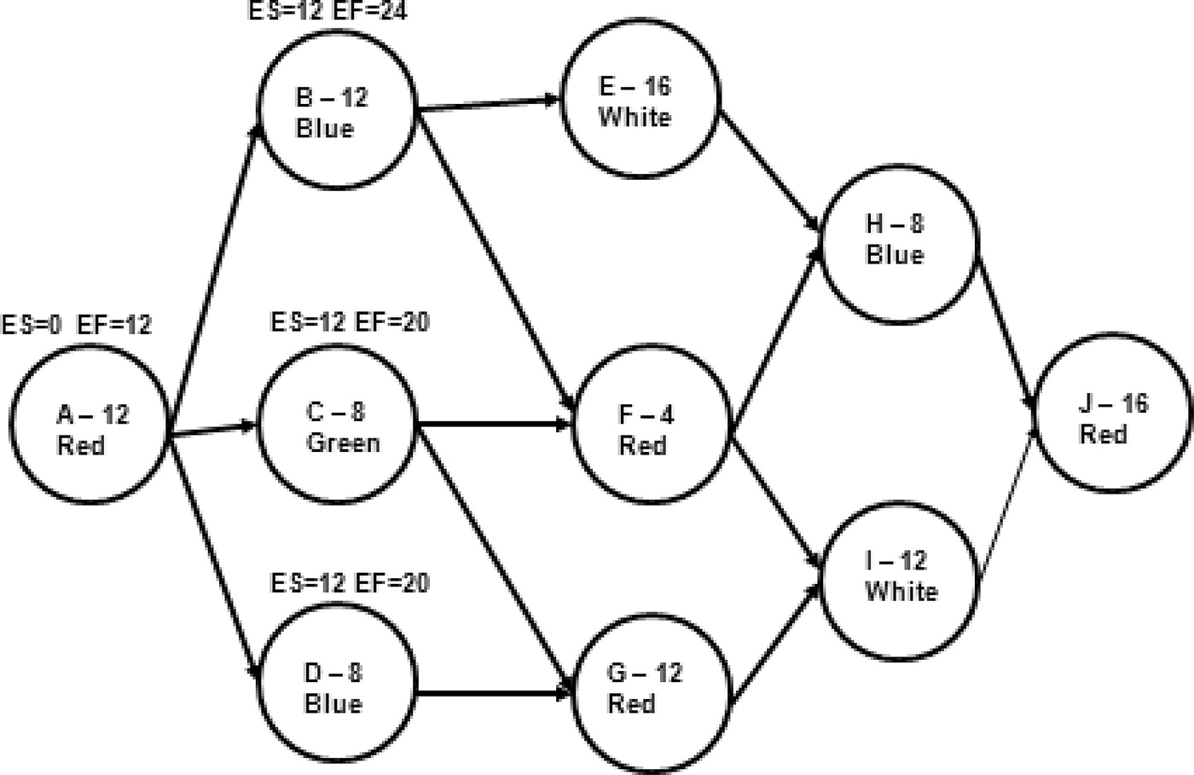

- Consider the data about project activities given in the table below. Develop the critical chain and indicate the feeder buffer and project buffer in the critical chain.
Activity | Predecessor | Duration | Resources
A | -- | 2 | Engineer
B | A | 3 | Marketing
C | -- | 3 | Engineer, Marketing
D | C | 2 | Finance
E | D,J | 3 | Marketing, Finance
F | E,B | 2 | Engineer
G | F | 2 | Production
H | -- | 4 | Marketing
J | H | 2 | Finance

Assume the size of feeder buffer, and project buffer as 50% length of non-critical path and critical chain respectively.

- Given the following information’s, compute early, late and slack times for the project network.
ID | Duration | Finish-to-start Predecessor | Finish-to-start Lag | Additional Lag relationship | Lag
A | 2 | None | 0 | None | 0
B | 4 | A | 0 | None | 0
C | 6 | A | 0 | Finish-Finish C to F | 7
D | 8 | A | 0 | None | 0
E | 18 | B | 0 | Finish-Finish E to G | 9
 |  | C | 10
F | 2 | D | 0 | None
G | 5 | F | 0 | Start-start G to H | 10
H | 5 | None | 0 | None | 0
I | 14 | E | 0 | Finish-Finish I to J | 5
J | 15 | G, H | 0 | None | 0

