BUSINESS REPORTS

Use this sheet to help you:

Produce clear and correctly structured business reports.

Considering the following questions:

Thinking about business reports, do you know…
 | Yes I do | I’m not sure | No idea!
Why you might need to write a business report?
Who you might write it for?
What details you might need to include?
How you might structure it?

A.
Design and layout: Shaw, J.
library.unimelb.edu.au/libraries/bee

What is a business report?
Organisations need accurate, timely, objective and concise information to make effective decisions. One way they can obtain such information is from a business report. This document can be defined as “an organised presentation of information to a specific audience for the purpose of helping an organisation achieve an objective” (Bowman & Branchaw, 1988, p. 12).

While business reports share similar characteristics, they also need to be customised for their particular purpose. An informal report may be a brief summary while longer reports follow a more complex and formal structure.

Informal reports may feature:

- letter or memo format
- minimal use of headings and visual aids
- personal pronouns and contractions
- a length from a few paragraphs up to five pages
- content primarily for internal audiences

More formal reports however tend to have:

- a more standard format organised into separate sections
- front and back matter (sections) along with the body of the report
- a greater number of headings (including subheadings) and visual aids
- third person pronouns and no contractions or slang
- a length from five pages to several hundred
- content designed for internal and/or external audiences

Why do I need to write a business report?
Formal business reports are often used in accounting, management and marketing. Being able to write a business report is an essential skill in business.
A business report may require giving information only (i.e. financial statements), information and interpretation (i.e. product surveys) or offering information, analysis and recommendations.

A report that makes recommendations could highlight a problem and suggest a solution which might involve analyzing a business’s history, operations, problems, competition and goals, followed by a number of possible solutions (including their advantages and disadvantages). Following this investigation, a specific solution might be recommended to aid future growth. Please note that business reports have some of the same features as research reports.

How do business reports differ from essays?
An accessible reader-centred style which includes standard formal English is a hallmark of academic writing including in essays or reports. However, there are some key differences between the two genres:

 | Essays | Business Reports
Purpose | Articulate a point of view in rela tion to a particular proposition | Often recommend action to solve a specific problem
Format & Struc ture | Have introduction, body and conclusion sections that normally do not use headings | Always have sections clearly divided by numbered headings (and often sub-headings)
Format & Struc ture | Use cohesive paragraphs to link ideas rather than list dot-points | Use shorter, more concise para graphs and dot-points where applicable
Abstract | Typically don’t normally need an abstract as readers read the text carefully from start to finish | Always have an abstract (or executive summary) as readers are typically ‘time poor’ and skim and scan through the text quickly
Graphics | Rarely use graphics as written evidence | Feature graphics (such as tables and graphs) for supporting main points
Writer | Are generally the result of  indi vidual work | Are often the result of group work
Reader | Are written for the lecturer/tutor or other academic audiences | Are addressed to a specific audience (i.e. client or manager) established by the topic

How do I write a business report?
There are several major steps typically involved in writing a business report. These include:

- planning (including determining the scope and target audience)
- researching, organising, evaluating and analysing your information sources
- drafting the body section
- devising conclusions and recommendations based on the findings
- further drafting and editing/proofreading

You need first to consider exactly what you have been asked to do-that is-the overall purpose of your report. Carefully considering the assessment task and related criteria should help you clarify:

- your objective and readership
- what information you need
- the format and level of detail required

From this, prepare an outline (including a working title and the overall structure of the report, including the major and supporting ideas). Start on your draft early so you can develop your ideas (editing can come later).

Who is your audience?
Your readers are your priority. Note that while business reports are typically written by ‘specialists’ for ‘generalists’ (most commonly the decision-makers in organisations), there can be a number of audiences for any one report.

Therefore, carefully consider your readers’:

- prior knowledge and experience with the background information, technical language, concepts and contexts covered in the report
- interest in and possible opinions regarding the report’s topic

Ask yourself the following questions:

- What do my readers know and think about the topic?
- What background, definitions and other information do they need?
- What questions or objections might they raise about the issue/s?
- Is my audience ‘internal’, ‘external’ or both?
- Is it for readers up, across or down the hierarchy of the organisation and/or people from outside?

If you can identify and assess your audience well, then you can match your content, visuals and structure to their level of expertise. Keep in mind for example that the higher up the chain of command a report goes, the more condensed and formal it should be. A more general audience, in contrast, needs less technical vocabulary and more explanation. In addition, if writing the report as a group, ensure consistency by agreeing about content, structure and presentation (including fonts and headings, line spacing and indenting) before drafting and also allocate each group member a specific role (including what area they need to research).

How should I begin gathering information?
Along with your key audience, you will also need to establish the key concepts and issues you are dealing with to generate keywords for your research. Consider whether or not your report needs either primary and/or secondary data. The former depends on first-hand sources from your own research (i.e. interviews, surveys and observations) while secondary research involves using existing information based on other people’s investigations.

Allow time to read widely to locate the best resources remembering that your report should be supported by documented sources which are authoritative, current, reliable and relevant. In particular, to ensure objectivity, if you are doing a report on a particular organisation, don’t solely rely on information from them.

If you quote, paraphrase, or summarise someone else’s ideas, acknowledge them appropriately. This will usually include indicating 1) the family name of the author, 2) date of publication, and 3) the page number when used in the text. Record these details on a separate page too at the end of the report in your reference list where you need to include other information such as the title, publisher and city of publication. Keeping a ‘research diary’ (listing such useful information as your keywords, successful search strategies and notes about indexes/databases) is also recommended.

To ensure you have researched widely, use the library catalogue and the Discovery search function - the catalogue lists book and journal titles (both paper copies and electronic) while Discovery gives you access to databases, allowing access to full text articles and also includes company, country and industry reports, data and statistics. The library also has lots of other assistance available including individual research consultations and the specialist librarians.

What format and structure should I use?
As you begin taking notes, it is useful to arrange an outline of your report – especially its particular sections – so you can ‘fill in’ these as you go along (leave the introduction, conclusion and recommendations for later). Focus here on your ideas, evidence and logical flow. Dividing your report into sections also ensures the information in your report is easy to find and follow. Sections need to be clearly labelled with headings and sub-headings outlining the logical development of your paper. Always check to find out what is required including the format and length of your sections.

The flow of information in your report can be organised in two basic ways – indirectly or directly. The indirect approach (normally required at university) means you need to persuade your readers to accept the findings of a report. This basic structure is 1) background, 2) findings, 3) discussion, 4) conclusions and 5) recommendations. A direct style however presents the conclusions and recommendations first followed by an introduction and the findings (it is often favored in the business world for ‘time is money’ audiences).

How should I use headings?
Whether you have an indirect or direct structure, headings help organise your report. If one particular section has a number of components to it, consider sub-headings under your main heading if necessary. Make sure however, this is done logically so the connections are clear and the use of font size and style, along with underlining and capitalisation is consistent (headings normally only have the first letter of the first word capitalised unless proper nouns are also used).

You can use either functional headings or more descriptive ones that incorporate content. The former ‘generic’ type focus on what each section does (as in ‘Introduction’, ‘Findings’, ‘Summary’) whereas descriptive headings reflect content more explicitly. Some reports may combine both generally starting with the former category as in ‘Findings: what our survey tell us about our customers.

Try and keep headings short, relevant and consistent. Your headings could use stand-alone verbs or nouns, adjectives and nouns together, or even more complex constructions like clauses–including statements and questions. Some examples are below:

Sample Headings (Noun and noun groups)
- Introduction Background to the issue
- Service changes
- Productivity improvements
- Future developments
- Conclusions
- Recommendations

Sample Headings (more complex noun groups & clauses)

- Why did ABC merge with XYZ?
- The main issues related to ABC/XYZ merger implementation
- What can be done to improve any merger problems?
- Should ABC consider any other mergers? Specific recommendations for action

Whatever headings you use, repeat some or all of the information in each heading in your first sentence underneath it rather than using the headings as an introduction to your text:
Issues with the merger

- A number of issues arise relating to the merger concerning both organisations.
✗ These are arising from considerations relating to both organisations.

Headings are normally numbered both in the contents page and the text itself. This system uses a combination of numbers and decimal points to do this (see the example below). Do this consistently for all headings and subheadings, using indenting to show the divisions:
- Current Market Penetration
  - India
    - New Delhi
    - Bombay
    - Other states
  - Asia Pacific region
  - Other international markets

- Possible Expansion Strategies
  - Online
    - Company website
    - Other Internet shopping options
    - Social media and ‘virus’ marketing
  - Television
    - Product placement
    - Celebrity endorsements
    - Sponsorship

What are the particular sections of a business report?
In terms of the elements of a formal report (that uses an indirect approach) there are three basic parts:

1) Front Matter
- Cover
- Title Page
- Executive Summary
- Table of Contents
- List of Figures

2) Body of the Report
- Introduction
- Findings and Discussion
- Conclusions
- Recommendations

3) Back Matter
- Appendices
- References
- Glossary (if required)

Front Matter
The front matter includes the cover, a title page, an executive summary (abstract), a table of contents, and a list of figures (if you have more than five). A letter of transmittal - a kind of official ‘cover letter’ - is sometimes required in the business
world (not normally a university requirement). Note that all pages in the front matter are numbered using small Roman numerals.

Title page

When considering the actual title of your report ensure that it is somewhat neutral and thus does not imply any particular pre-determined outcome. Your title page should comprise:

- the full title (centred, in bold or upper case)
- the person/organisation it was prepared for (optional)
- the person or people who prepared it (and student numbers where required)
- the due date
- the lecturer/tutor’s name
- the name of the subject (and its code)
- no page number (but is counted as a page)

The above is a general guide as there can be specific requirements:

Table of contents

If your report is over several pages, a table of contents helps readers to locate information quickly by giving them an overview. All section headings and subheadings should be included, worded and numbered exactly as they appear in the text. You might include a list of illustrations on a separate page (if you have more than 5 graphic aids). A list of appendices needs the appendix letter (each separate appendix labelled as Appendix A, Appendix B, etc.), its title and page number. A glossary may also be required if you have a large amount of unfamiliar vocabulary, symbols, abbreviations and/or acronyms.
Table of Contents
1.
2.

3.

4.

5.
6.
Introduction
An overview of the product
2.1 Main features Product benefits
  - Reducing heating costs
    - Heating cost reductions by season
    - Further savings through thermostat use
    - Other associated savings
  - Improving house resale value
  - Reducing household bacteria Advertising strategies
  - Traditional media
  - Web 2.0 Conclusions Recommendations Bibliography Appendices
- Product development specifications
- Advertising budget
Page
1
1
1
2
2
2
3
4
4
5
5
6
6
6
7

9
10

Executive summary
An executive summary or ‘abstract’ is very important as some readers may only read this part. Write it last, being sure to include a summary of all parts of the report (omitting examples unless essential) including the:

- ‘why’ (purpose)
- ‘what’ (scope or breadth of the investigation)
- ‘how’ (methodology)
- ‘what you found out’ (major findings with key statistics)
- ‘so what’ (analysis, conclusions and recommendations)

It should be a half to one page (around 5% - no more than 10%) of the overall length and on a separate page.

Body

Introduction
Your introduction is really the ‘start’ of the report so describe here why your report is being written answering such questions as ‘what is this about?’ and ‘how is it useful?’ This is also where your page numbering starts. Specifically you need to:

- give some brief background information
- define the problem/topic, its relevance, scope and any key terms
- state the overall purpose (are you explaining, analysing, recommending or a combination?) and key objectives
- give an overview of the report’s structure including the sections and their relationship to the issues
- detail assumptions, theoretical foundation, scope, methodology and any limitations or constraints

As this section details the whole structure of your report, you may wish to do it last when most of the report has been written.

Findings and discussion
In your findings and discussion sections, present a factual outline followed by an interpretation of what you found. Note that a frequent complaint from lecturers is that there is too much description and not enough analysis regarding what findings
actually mean. This section is usually the longest part of a report and forms the basis of your conclusions and recommendations. As a result, record all significant information (both positive and negative) and ensure you have a logical internal structure – this could be based on such organisation as chronology, order of importance, general to specific, regions or topics.

Findings can be presented in text and/or graphically. If using graphs or figures, see the relevant section in this help sheet for more detail on how to do this. This section should reflect the structure outlined in the introduction. It may try and answer questions like:

- What were the most significant findings or factors involved in the topic/ problem?
- Did the findings support the theory?
- Did you uncover any unexpected or new issues that need to be considered?

To discuss such questions you may include:

- support that the results provide for the hypotheses
- a comparison of results with other relevant theory and/or investigations
- factors which may have influenced your results, e.g. design problems
- implications of the results

Ensure that you do more than just describe – instead make it clear the significance of what you are talking about and how it might relate to the conclusions and recommendations. Phrases such as ‘therefore it is clear that X is important in Y’ or ‘With this result in mind, it follows that X is…’.

Conclusion
Your conclusion summarizes your study - its purpose, process and findings. You need to include your main ‘opinion’ here, answering the questions raised by your original purpose so there is a thematic unity to your report and the recommendations follow logically. You may also need to consider the limitations and advantages of findings and any unresolved questions or issues. Avoid including any new information.
Adjectives are useful in a conclusion as a way of condensing your main points:

‘This report therefore clearly highlights that the advertising campaign was very successful, due to its inclusive and far-reaching impact with key target audiences such as X and Y’.

Recommendations
Recommendations are the suggested actions based on the report findings. They must be both relevant and feasible covering:

- What needs to be done
- Who needs to do it
- How, when (in what order if appropriate) and where it needs to be done

Recommendations could be for change, improvement or new ideas to improve such areas as service, productivity or performance. They can be listed one at a time (often numbered). Be sure you use a consistent sentence structure for all recommendations (some examples are below). Think carefully also about the order they are in and whether or not it would be useful to group them into appropriate content areas.
These include:

- verb (directive)
Hire more technical staff to deal with the ongoing quality control issue
- passive with ‘it’ as the ‘dummy’ subject
It is highly recommended that more technical staff be hired to deal with the ongoing quality control issue
- specific subject in passive voice
Technical staff should be hired to deal with the ongoing quality control issue
- specific subject in active voice
Management consider alternative funding arrangements for the new venture

Back Matter

Appendices
Your appendices (if required) contain optional material at the end of your report, containing specialized (sometimes technical) information that may have been too detailed or lengthy to include in the body. Appendices can be in any format, however, each appendix must be separate from the others, covering only one kind of content and format on separate pages. They are generally distinguished by letters of the alphabet – e.g. Appendix A, Appendix B, Appendix C, and can be referred to in the text of the report (i.e. “for the full list of suppliers refer to Appendix B”).

References
It is essential to include an accurate reference list of the material you used in your report. You will need references when you have included any material (including statistics, facts and opinions) which is not yours. As there are several referencing systems, check with your lecturer, tutor or department for guidelines on how to reference and do this accurately and consistently as lecturers will notice mistakes in the reference list.

Do I need to add tables and figures?
Adding graphics to your report such as charts (pie, bar, line, organisational and flow), tables and timelines is a useful aid for your readers. This is because they can more clearly illustrate and reinforce your main points (especially for comparisons and projections). They are most commonly used in the findings section if they are essential to understanding the text. If they are more ‘supplementary’ (such as raw data), put them in the appendices. In any case, they should:

- be clearly and consistently labelled (i.e. x and y axis with the table title flush left with any source required) and referenced if taken from an outside source
- be placed as close to the written text they match to avoid confusion
- feature distinct shading if the report is printed in black and white

In addition, think carefully about how important the information is – that is do you want to include visuals in the body of the report to support your text or in the appendices for further reference?

When referring to visuals, subordinate them to your main idea as in ‘As Table 1 shows…’, ‘As shown in Table 2,’ or highlight as in ‘Table 1 demonstrates…’ or ‘Figure 2 clearly indicates’. Moreover, be consistent with table and figure titles (in most cases, table titles precede the tables while figure titles follow the figures). Do not leave the reader to interpret your data, but rather supply explanations in your text, e.g. ‘Table 1 shows the proportion of consumers who did not take up the premium plan option’.

Tables
Tables show information (words and/or numerical data) in rows and columns. They are especially useful in portraying details, relationships and comparisons.

Table 1: Industry Players by Ownership

Source: Melbourne University Department of Accounting and Business Information Systems (2010).

Graphs
Vertical bar and line graphs are useful to demonstrate trends. More complex information can be segmented or be presented using multiple bars.

Figure: Vertical Bar Graph (segmented)

Figure 3. New Store Sales Growth Rate vs Comparable Store Sales Growth Rate Source: Calma Corporation (2010)

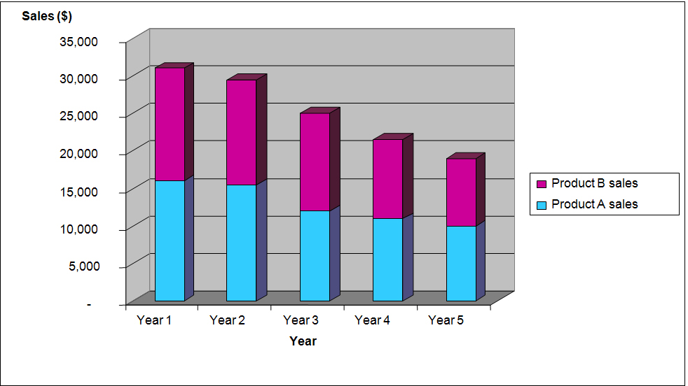

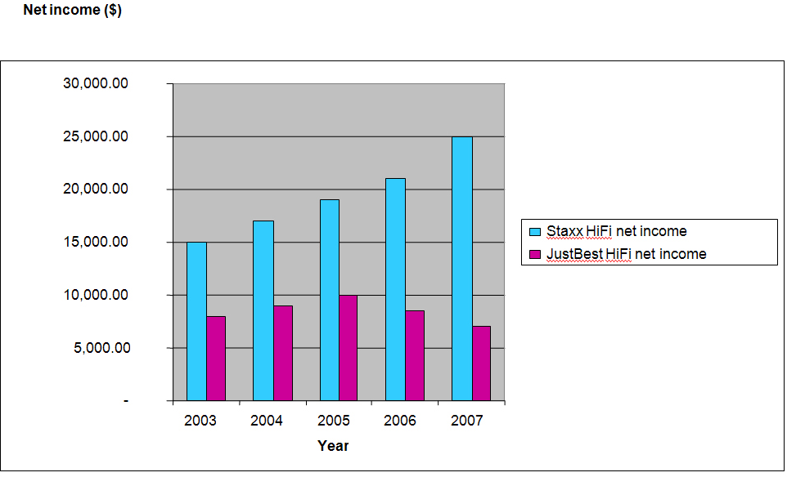
Figure: Multiple Vertical Bar Graph

Figure 4. Financial Performance: Percentage of Net Income Source: AC Holdings (2010)

Language for discussing tables and graphs
Use appropriate language to refer to the significant details in your charts and tables. Verbs like ‘show’, ‘refer’, ‘highlight’ and ‘underscore’ help emphasize the points in your visuals:

- This figure refers to the domestic sales only, however...
- The last two bars in the bar graph represent the strong increase in share performance across the whole portfolio.
- The strongest performing affiliate is X as highlighted in Graph Y

Verbs to use in describing tables and figures

articulate, demonstrate, describe, illustrate, represent, show
accentuate, affirm, agree with, assert, emphasize, establish, highlight, maintain, stress, suggest, support, underscore
contradict, disagree with, dispute, refute

When you are commenting on trends, you can choose from at least two basic patterns.

Describing trends: two basic grammatical patterns

1 | Subject | Verb (specific) | Adverb (optional)
1 | Profits | increased | significantly
2 | Subject (‘There’) | ‘be’ verb | Article ‘a’  or ‘an’ | Adjective (optional) | Noun | Preposition ‘in’ | Object (topic)
2 | There | was | a | significant | increase | in | profits.

The table on the following page contains some words you can use for the two patterns mentioned above to describe trends.

Words to describe trends
Adjectives (can also be changed to become adverbs)
Small change | constant, gentle, gradual, incremental, insignificant, minimal, moderate, modest, slight, slow, small, steady
Larger change | abrupt, dramatic, enormous, erratic, large, marked, notable, overwhelming, sharp, significant, steep, substantial, sudden, swift, wild
Nouns (can also be changed to become verbs)
Increase ▲ | ascension, ascent, climb, doubling, growth, improvement, increase, jump, lift, peak, recovery, rise, rise, rocket, surge, tripling
Decrease ▼ | crash, decline, decrease, deterioration, dip, drop, fall, fall, nosedive, plummet, plunge reduction, slide, slump, weakening
Flattening ▲ or ▼ then ►◄ | bottoming out, levelling off, plateau
Fluctuation ▲▼▲▼ | difference, fluctuation, movement, variation

To back up your claims, you may want to give extra information from the graph or figure such as a statistic (which may be a precise figure or an approximation) and the relevant time period.

Subject | Verb (specific) | Statistic + time period
Sales | increased | …by one quarter/about 25%/over 20 000 units last year.
Sales | increased | …to over two million dollars/to their highest level since last year.
Sales | increased | …in all outlets, from just under 20% in 2007 to 25% in 2008, rising again in 2009 by 10% to a peak of 35%.

- How can I make my report reader-friendly?

Once you have completed a first draft, look more closely at your style, language,
grammar and presentation. Check other members’ sections in the final draft to ensure
they have adhered to agreed specifications - and all members understand all the
content!
Some specific ways you can make your report ‘reader-friendly’ include:
Presentation
• an easily read and consistently applied font
• numbered headings and generous use of white space (in margins and at the top
and bottom of each page as well as to separate each section)
• consistent use of abbreviations and acronyms
Structure
• one main idea per paragraph
• each paragraph having a clear topic sentence
• short introduction and conclusion paragraphs
• longer body paragraphs that develop main points
• a strong and concise conclusion
• an overall ‘theme’ running throughout the paper – possibly a statement or a
question
Language
• specific, concise and clear language
• consistent and accurate verb tenses:
- simple tenses (usually the present simple) to express facts, current actions and
conclusions
- past tense for completed actions and references
- present perfect for things happening in the past up to now
• avoidance of emotional language and jargon
• the active voice with short sentences and clear actors and actions using specific
verbs and adverbs favoured as in ‘Company X considered the plan carefully’
• avoidance of too many sentences starting with words like ‘considering’ and
‘having’ instead briefly subordinating already known information as in:
- ‘Since X Corporation began operating in this region, some issues have arisen
that have impacted on profits’.

- Business Report
Business Report Checklist | Yes (✓) or No (✗)
Audience
Have I clearly identified who my readers are?
Do I know their prior knowledge about the topic?
Have I identified what they need to know?
Will they understand my vocabulary?
Content
Have I used a variety of information sources?
Are my sources relevant, credible, current and referenced appropriately?
Do I have a clear objective that has been met?
Can I put some of my data in the Appendices?
Have I been specific enough – using specific contexts, terms and figures?
Do my conclusions and recommendations flow logically from my findings and discussions?
If the report was written as a group do I (and other group members) understand all the content?
Language & Style
Have I used strong, clear and short introductions, main points and conclusions?
Do I have just one main idea per paragraph?
Do I have a clear topic sentence for every paragraph?
Have I been objective? – that is have I used the third person and the appropriate level of formality (no contractions, slang, emotional language)?
Presentation
Have I been consistent in my use of:
- headings
- fonts
- punctuation
- bold
- bullet points
- italics
- abbreviations
- acronyms
- numbering?
Does my presentation overall assist the reader in making the report easy to follow?

References
Bowman, J.P. and Branchaw, B.P. (1988). Business Report Writing, 2nd ed Chicago: The Dryden Press

Canberra University (n.d.) Academic Skills Centre: Report Writing. Retrieved January 4, 2011 from http://www.canberra.edu.au/studyskills/writing/reports

Charles Sturt University and New South Wales Department of Education and Training. (n.d.) Writing a Business Report. Retrieved November 19, 2010 from http://www.hsc. csu.edu.au/business_studies/intro/writing/writing.html

Eunson, B. (2007). Business Writing, Milton: John Wiley & Sons Australia, Ltd

Kimberley, N and Crosling, G (2008) Student Q Manual, (pp.42-46), (4th ed.) Clayton: Faculty of Business and Economics, Monash University

Meyer, C. (2010). Communicating for Results: A Canadian Student’s Guide, 2nd ed., Ontario: Oxford University Press

Murdoch University. (n.d.) Murdoch University Business School Guide to Business Report Writing. Retrieved November 19, 2010 from http://bestentrepreneur.murdoch. edu.au/Guide_To_Report_Writing.pdf

Northern Arizona University. Retrieved December 22, 2010 from oak.ucc.nau.edu/ amk35/FormalReportExample.doc

Searles, G.J. (2009). Workplace Communication: the Basics, 4th ed New York: Pearson Longman

Wollongong University. (n.d.) Unilearning: Business Report Writing. Retrieved November 19, 2010 from http://unilearning.uow.edu.au/report/rep_business.html

