Building an agile roadmap: Guide for product managers
Last updated: April 2024
Build a lovable product and give customers what they really want. This is what great product managers aim to achieve. Many product managers find an agile approach to product management appealing because of the promise of delivering value faster.
By taking an incremental approach to product development, you can be more nimble — adapting product plans and iterating often based on customer feedback and other data. But it can be challenging to move fast while making sure that you are pursuing the right work — the activities that support a truly agile product strategy. This is why an agile roadmap is so useful.
Build an agile roadmap in Aha! Roadmaps — with a free trial.
Skip ahead to any section:
- What is an agile roadmap?
- What is the difference between a waterfall roadmap and an agile roadmap?
- How to build an agile roadmap
What is an agile roadmap?
An agile roadmap is a flexible plan of action for achieving your product vision. It includes components like upcoming product releases, epics, and features — showing how each contributes to your product strategy.
You can create an agile roadmap to visualize all the cross-functional work required to build a product or enhancement and bring it to market. Depending on the level of detail you want to capture, an agile roadmap can show the high-level product goals and initiatives or a more near-term plan of the upcoming work (and when the team will do it).
It is important to note that some agile teams believe that their incremental approach to work is incompatible with the process of roadmapping. These teams may resist building a product roadmap because they do not want to commit to a firm plan or timeline. But the reality is that dates matter. Even highly adaptive product teams must adhere to schedules and delivery dates (or at least date ranges). After all, company leaders and customers alike expect new offerings and functionality within a set time frame.
No matter what type of agile methodology you use or how strictly your team follows it, you can benefit from creating an agile roadmap. Use your roadmap as a tool to make sure you are investing in the most impactful work — the efforts that are aligned with the product vision and strategy. With an agile roadmap as your guide, you can make better tradeoff decisions, measure progress, and ultimately provide more value for customers.
Top
What is the difference between a waterfall roadmap and an agile roadmap?
Before agile development methodologies, waterfall was the predominant methodology. Product managers working in a waterfall environment use roadmaps to communicate linear product plans — where features are defined upfront and each phase of work is completed before another begins.
If you are used to working with waterfall roadmaps, switching to an agile roadmap can be a big change. You want to communicate how you will achieve product goals while providing flexibility to adjust your product plans according to what customers value. This requires that you be responsive to change and account for the inevitable adjustments you will need to make to your agile roadmap.
Understanding how waterfall roadmaps and agile roadmaps differ is helpful if you are transitioning to agile product management. Here are the main differences between these two types of roadmaps:
 | Waterfall roadmap | Agile roadmap
Goals | Business-centric (e.g., financial KPIs) | Customer-centric (e.g., user growth or customer satisfaction)
Planning horizon | Years | Months or quarters
Planning cadence | Annually | Quarterly
Resource / capacity planning | Dedicated upfront by major project | Allocated by sprint velocity or team size
Investment | Committed annually | Incremental based on feedback and data
Collaboration | Sequential and segmented by department | Concurrent and cross-functional
Flexibility | Limited | Limitless
Related:
- What is agile transformation?
- Introduction to the Aha! suite of product development tools
- Best practices for configuring Aha! Roadmaps to support SAFe®
Top
How to build an agile roadmap
An agile roadmap looks like most other product roadmaps — it includes initiatives, releases, features or user stories, and timelines. What makes your roadmap agile is your approach to defining each element and your willingness to adapt when plans change. Here are seven steps for building an agile roadmap:
1. Start with product strategy and goals
Without a clear strategy, it is impossible for fast-moving agile teams to determine if you are making meaningful progress. Strategy articulates the problem you are solving for customers, while goals define what you plan to achieve over a period of time — with ﻿clear metrics for measuring success. In an agile environment, you will likely set monthly or quarterly goals.

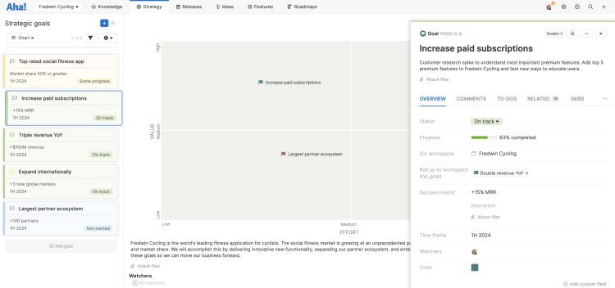

2. Turn your goals into initiatives
Initiatives (also called epics) define the themes of work that will support the product vision and help you achieve your goals. Initiatives are broken down into features and user stories, often spanning multiple releases. When your agile team wants to pivot based on new data or customer feedback, make sure the new plan aligns with your initiatives before you define new features to pursue.

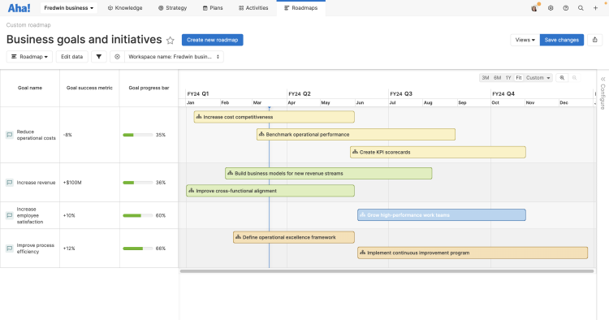

3. Gather cross-functional feedback
Gaining input from other teams is critical for building an agile roadmap that is accurate, comprehensive, and realistic. Ideally, you should incorporate feedback from every cross-functional team that contributes to planning and delivering a Complete Product Experience — engineering, marketing, design, sales, and customer support, to name a few. If you need to work with groups that are traditionally non-agile (such as budget offices or the legal team) and require longer timelines, consider using purpose-built software to build your agile roadmap. This can make is easier to coordinate and track multiple work streams and timelines.

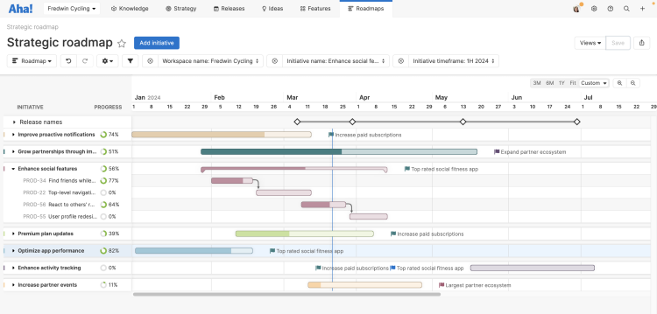

4. Define product features and tie to strategic initiatives
Now it is time to break down your large themes of work into features or user stories. Your features represent the new functionality that you will continuously deliver to customers. Development teams then break down those features into technical requirements and organize them into sprints. Use your product vision, goals, and initiatives as a guide for which features to prioritize. When all your features link to the overall product strategy, you can deliver work and iterate quickly without veering off course.

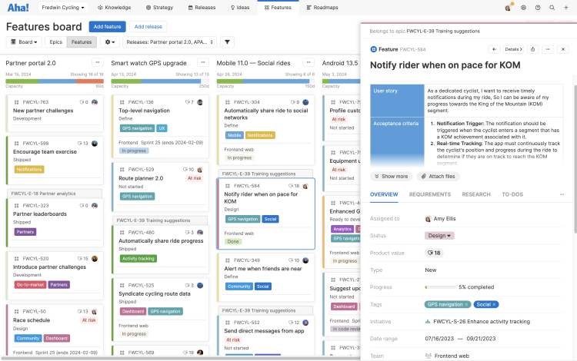

5. Plan your product releases
Organize the features on your agile roadmap into releases to deliver incremental value to customers in a defined time frame. Your release cadence can be daily, weekly, monthly, or quarterly — it is up to you. Just remember that a release differs from a sprint or iteration in that it delivers a new customer experience (rather than just shipping code) and encompasses all the cross-functional work necessary to do so. In an agile environment, releases are still important because they communicate to teammates and customers what to expect and when.
6. Capture and integrate customer feedback
Gathering customer feedback should be an ongoing part of maintaining your agile roadmap. Some teams collect ideas via user interviews, usability testing, and usage data, for example. You can also turn to purpose-built idea management software like Aha! Ideas to collect, rank, and prioritize feedback, then promote the best ideas to features on your roadmap — all in a single tool. Mapping each feature to the product strategy helps you determine when to make adjustments (versus when to stick to the plan).

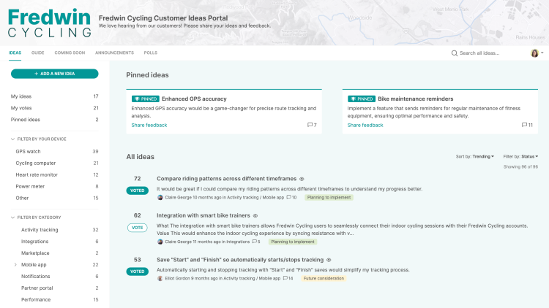

7. Measure results regularly
Moving quickly means it is even more essential to monitor progress towards your goals. Depending on your release cadence, you might review results and adjust your agile product roadmap on a weekly, monthly, or quarterly basis. Evaluate how each release or feature impacts the metrics you care about — such as customer acquisition, retention, conversion rate, and churn. Analyzing performance data can help you make more informed decisions about how to alter upcoming features.
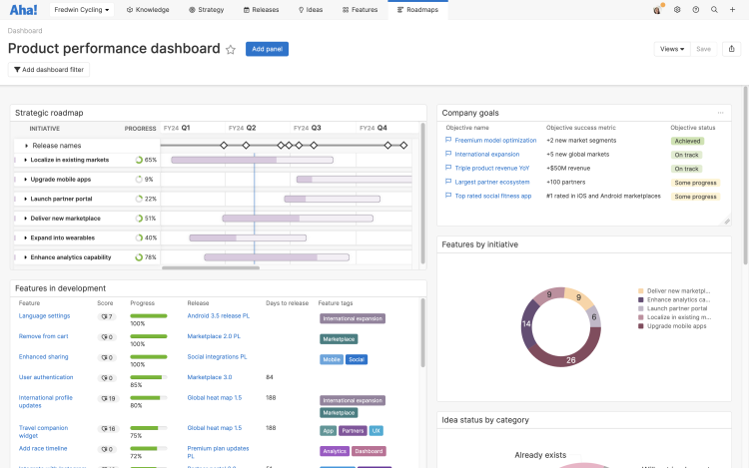
If you are adopting an agile product management approach, an agile roadmap is an invaluable tool for moving fast while achieving your product strategy. Use an agile roadmap to reach your product goals, adapt to changing customer feedback, and deliver value to customers faster.

Summary: A product roadmap is a plan of action for how a product or solution will evolve over time. Product owners use roadmaps to outline future product functionality and when new features will be released. When used in agile development, a product planning roadmap provides crucial context for the team's everyday work and should be responsive to shifts in the competitive landscape.
A product roadmap is essential to communicating how short-term efforts match long-term business goals. Understanding the role of a roadmap—and how to create a great one—is key for keeping everyone on your team headed in the same direction.
What is a product roadmap?
A product roadmap is a shared source of truth that outlines the vision, direction, priorities, and progress of a product over time. It’s a plan of action that aligns the organization around short and long-term goals for the product or project, and how they will be achieved.
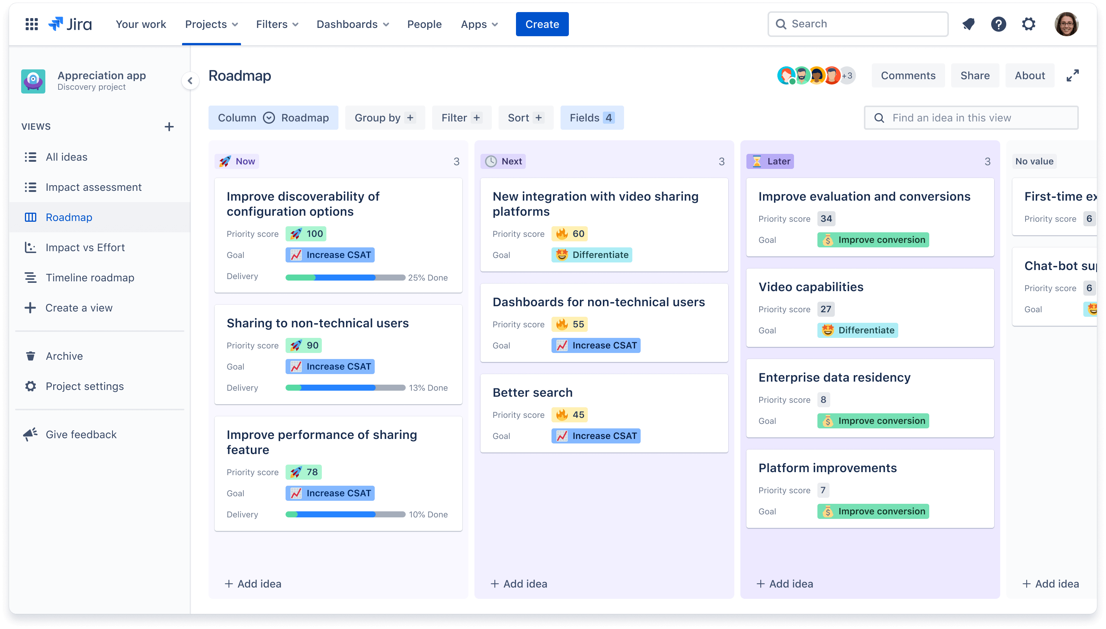
While it's common for the roadmap to show what you’re building, it’s just as important to show why. Items on the roadmap should be clearly linked to your product strategy and goals, and your roadmap should be responsive to changes in customer feedback and the competitive landscape.
Product owners use roadmaps to collaborate with their teams and build consensus on how a product will grow and shift over time. Agile teams refer back to the product roadmap to keep everyone on the same page about which product ideas have been prioritized and when, and to gain context for their everyday work and future direction.
Which teams use product roadmaps?
Roadmaps come in several different forms and serve a variety of audiences. Let's look at some product roadmap examples:
Internal roadmap for the development team: These roadmaps can be created in several ways, depending on how your team likes to work. Some common versions include the detail about the prioritized customer value to be delivered, target release dates and milestones. As a general rule, development teams should use a product roadmap to understand the product strategy, how it connects to goals, and why initiatives have been prioritized. For the actual development work, dev teams should create a separate delivery plan that maps back to the product roadmap. Since many development teams use agile methodologies, these plans are often organized by sprints and show specific pieces of work and problem areas plotted on a timeline.
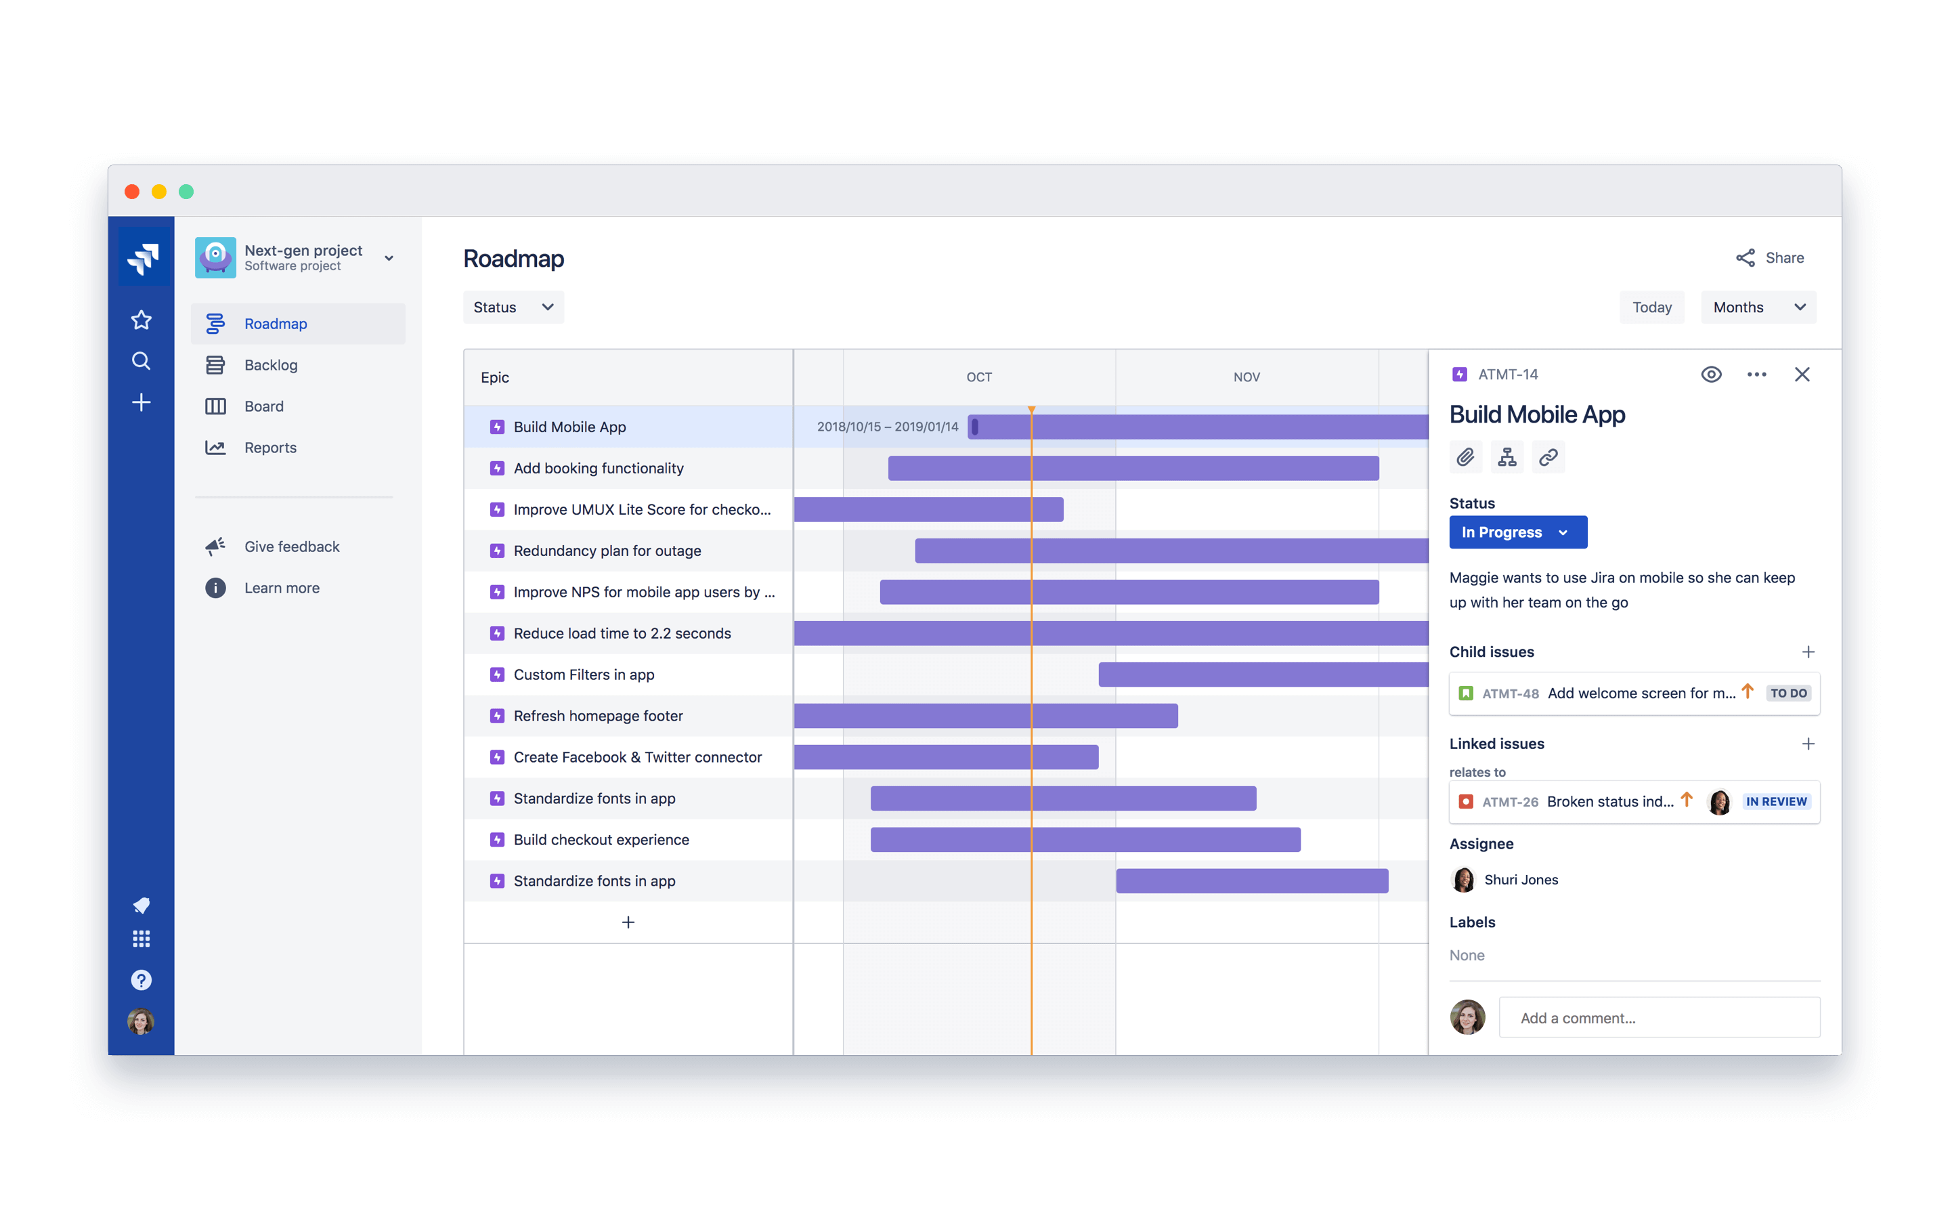
Internal roadmap for executives: These roadmaps emphasize how teams' work supports high-level company goals and metrics. They are often organized by month or by quarter to show progress over time towards these goals, and generally include less detail about detailed development stories and tasks.
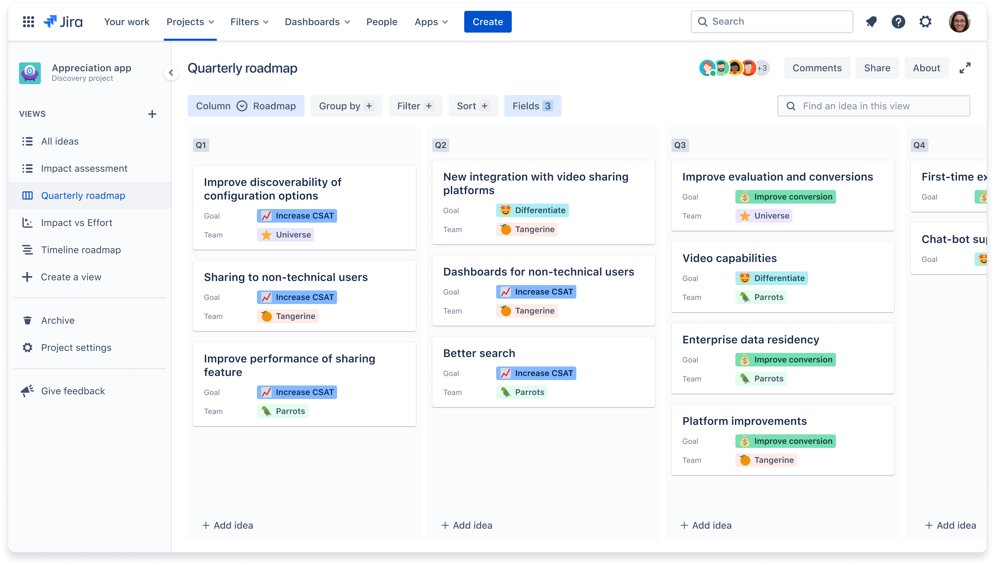
Internal roadmap for sales: These roadmaps focus on new features and customer benefits, and may even include key customers who are interested in these features in order to support sales conversations. An important note: avoid including hard dates in sales roadmaps to avoid tying internal teams to potentially unrealistic dates.
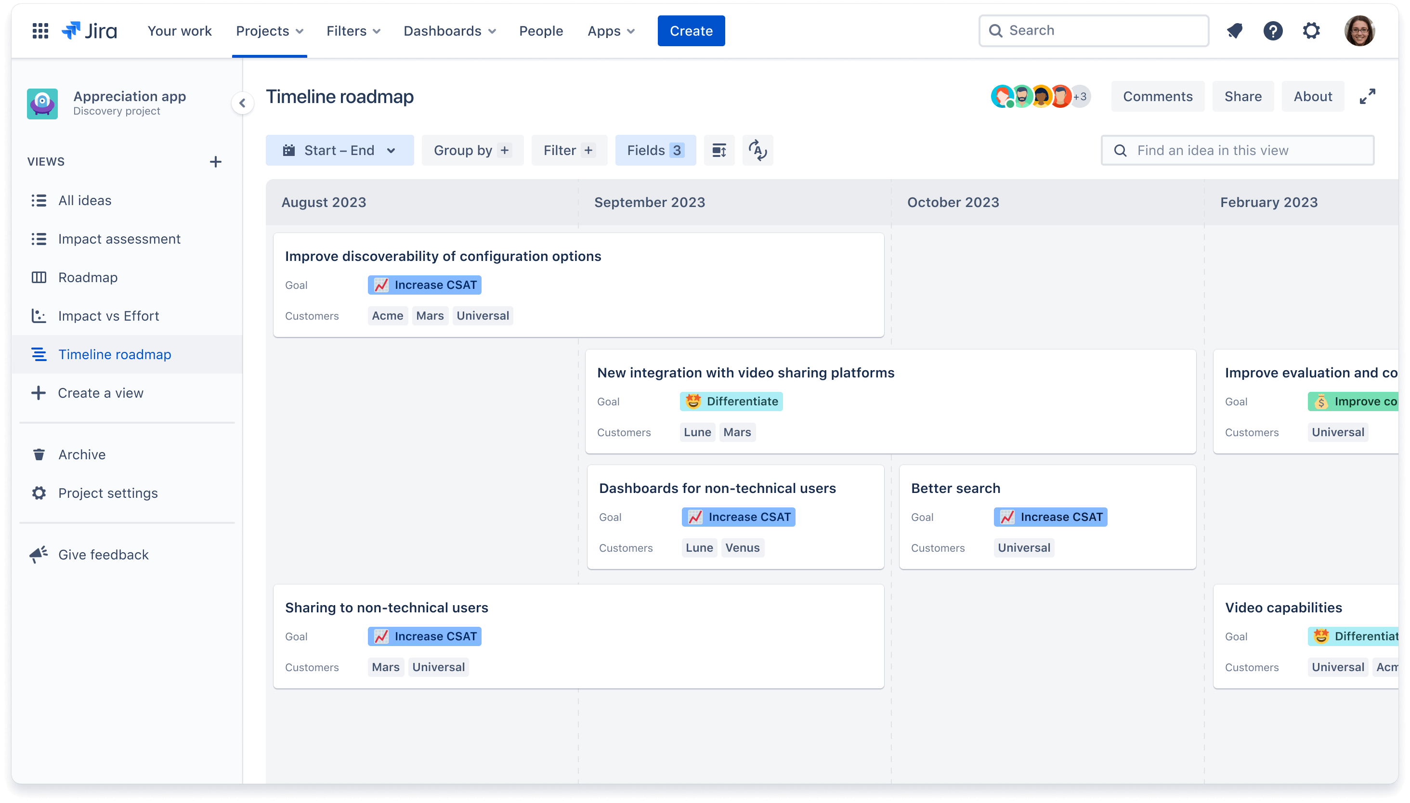
External roadmap: These roadmaps should excite customers about what’s coming next. Make sure they are visually appealing and easy to read. They should provide a high-level, generalized view of new features and prioritized problem areas to get customers interested in the future direction of the product.
Why are product roadmaps important?
The biggest benefit of the product roadmap is the strategic vision it illustrates to all stakeholders. The roadmap ladders up to broader product and company goals with development efforts, which connects work across teams and aligns those teams around common goals to create great products.
- For organizational leadership, the roadmap provides updates on the status of planned features and improvements in a format that connects back to company goals and is easily understood.
- For product owners and managers, roadmaps unify teams working on high impact product enhancements and allow them to communicate priorities and why they were prioritized effectively with adjacent teams.
- For the developers themselves, roadmaps provide a better understanding of the “big picture,” which allows team members to focus on the most important tasks, avoid scope creep, and make fast, autonomous decisions.
How to create a product roadmap
To build a roadmap, product owners should evaluate ideas based on key criteria, such as market trajectories, customer insights and feedback, company goals, and effort constraints. Once these factors are understood, product teams can work together to start prioritizing initiatives on the roadmap.
The content of a roadmap will depend on its audience - a roadmap for the development team may cover only one product, while a roadmap for executives can cover multiple products. Depending on the size and structure of an organization, a single roadmap may span multiple teams working on the same product. An external roadmap will often cover multiple products aligned with one point of emphasis or customer need.
The most important takeaway: create a roadmap that your audience can easily understand. Providing too much or too little detail on the roadmap can make it easy to gloss over, or worse, to too intimidating to read. A roadmap with just the right amount of detail and some visual appeal can earn the buy-in you need from key stakeholders.
Presenting the product roadmap
The product roadmap needs buy-in from two key groups: leadership and the agile development team. Presenting the roadmap is a great opportunity to demonstrate to key stakeholders that you understand the company’s strategic objectives, the needs of your customer, and have a plan to meet them both.
As you move through the project, make sure to link your delivery team’s work back to the product roadmap for context and visibility into progress for your team and stakeholders. A tried-and-true method: map out the ideas you're committing to on your product roadmap, then break down those ideas into epics, requirements, and user stories on your delivery roadmap. Often times, each initiative will have a corresponding epic that needs to be broken down into smaller tasks to complete. Establishing this hierarchy makes it easier for product and development teams to make decisions together, and understand how their work fits into the bigger picture.
Using and updating the roadmap
Roadmapping doesn’t end once you’ve reached your final state. As the competitive landscape shifts, customers' preferences adjust, or planned features are modified, it’s important to take any learnings or insights, feed them back into your team’s discovery process and ensure the product roadmap continues to reflect the status of current work as well as long-term goals.
The roadmap should be updated as often as necessary - this could be every week or fortnightly - so that it can remain an accurate source of truth. As we’ve all experienced at one time or another, a roadmap is counter-productive if it isn’t up to date. You’ll know if your roadmap needs to be updated more frequently because your stakeholders will start calling you for updates instead of consulting your roadmap. These one-off requests reflect a distrust in your roadmap, and a huge potential time suck.
However, on the flip side, you don’t want to spend more time updating the roadmap than is necessary to achieve alignment between stakeholders and within your team. Remember, the roadmap is a product planning tool to think through how to build great products that will make an impact on your customers and on your business. If you’re spending time updating your roadmap that you could (and should) be spending on execution, re-think the cadence and how you take in inputs, feedback, and data from across the business to prioritize your initiatives.
Best practices for the best roadmaps
Building and maintaining product roadmaps is as much an ongoing process as it is a cultural practice to embark upon with your product team. There are a few simple ways to set yourself up for success:
- Only include as much detail as necessary for your audience
- Keep the roadmap evenly focused on short-term tactics and how these relate to long-term goals
- Review roadmaps on a regular basis and make adjustments when plans change
- Make sure everyone has access to the roadmap (and checks it on a regular basis)
- Stay connected with stakeholders at all levels to ensure alignment
Ready to make your very own roadmap? Get started for free with Jira Product Discovery.
Related resources

